Machine Learning Model Deployment with IBM Cloud Watson Studio

PHASE-5: Development part-3

Submitted By: Y. Ramya

Reg.no:723921104056

Email-id: [ramyavemireddy732@gmail.com](mailto:ramyavemireddy732@gmail.com)

Project: Machine Learning Model Deployment with IBM Cloud Watson Studio

Phase-5: Development part-3

Introduction:

IBM Cloud Watson Studio is a powerful platform designed to facilitate the entire machine learning lifecycle, from data preparation to model deployment. This integrated environment provides data scientists, developers, and business analysts with a collaborative space to work on machine learning projects. With Watson Studio, users can leverage a wide array of tools and services, including data refinement, exploration, and visualization, as well as the development and deployment of machine learning models. The platform supports popular programming languages such as Python and R, making it accessible to a broad range of users. Additionally, Watson Studio integrates seamlessly with other IBM Cloud services, enabling users to take advantage of cloud-based resources and scalability. The collaborative features of Watson Studio promote teamwork, allowing multiple stakeholders to contribute their expertise and collaborate efficiently on creating, testing, and deploying machine learning models. Overall, IBM Cloud Watson Studio simplifies and streamlines the machine learning workflow, making it an ideal choice for organizations looking to harness the power of artificial intelligence in their projects.

Objectives:

1. **Data Preparation and Exploration:** Utilize Watson Studio's tools to efficiently prepare and explore data, ensuring it is clean, relevant, and well-suited for machine learning tasks.
2. **Model Development and Training:** Leverage the platform's capabilities to build and train machine learning models using popular programming languages such as Python and R. Take advantage of various algorithms and frameworks to create accurate and robust models.
3. **Collaboration and Teamwork:** Foster collaboration among data scientists, developers, and business analysts by providing a shared and integrated environment. Enable seamless collaboration on model development, testing, and refinement.
4. **Visualization and Interpretability:** Use Watson Studio's visualization tools to interpret and communicate the results of machine learning models effectively. Gain insights into model performance and understand the impact on business objectives.
5. **Integration with IBM Cloud Services:** Integrate Watson Studio with other IBM Cloud services to access a wide range of cloud-based resources, ensuring scalability, flexibility, and efficient use of computing power.

**Design thinking process:**

1. **Empathize:**
   * Understand the business problem or opportunity that machine learning aims to address.
   * Engage stakeholders, data scientists, and end-users to gather insights into their needs, challenges, and expectations.
2. **Define:**
   * Clearly articulate the problem statement and define the scope of the ML project.
   * Identify the data sources required for the ML model and explore potential data challenges.
3. **Ideate:**
   * Brainstorm potential ML solutions and algorithms that could address the defined problem.
   * Explore different features and variables that could be relevant for model training.
   * Encourage cross-functional collaboration to generate diverse perspectives on possible solutions.
4. **Prototype:**
   * Use Watson Studio to create prototypes of ML models based on the selected algorithms and features.
   * Test different model configurations and hyperparameters to understand their impact on performance.
5. **Test:**
   * Evaluate the ML prototype against the defined success criteria and KPIs.
   * Gather feedback from stakeholders, including end-users and subject matter experts.
   * Identify areas for improvement and refine the ML model accordingly.
6. **Implement:**
   * Deploy the finalized ML model using Watson Studio, considering scalability and integration requirements.
   * Leverage IBM Cloud services for efficient model deployment and management.
7. **Scale:**
   * Explore opportunities to scale the ML solution to handle larger datasets or additional use cases.
   * Leverage IBM Cloud resources for scalability and efficient utilization of computing power.
8. **Evaluate Impact:**
   * Measure the impact of the deployed ML solution on business outcomes and KPIs.
   * Assess whether the ML model is achieving the intended results and iterate further if necessary.
9. **Document and Share:**
   * Document the entire design thinking process, including decisions made, challenges faced, and lessons learned.
   * Share insights and best practices with the broader team to enhance collective learning.

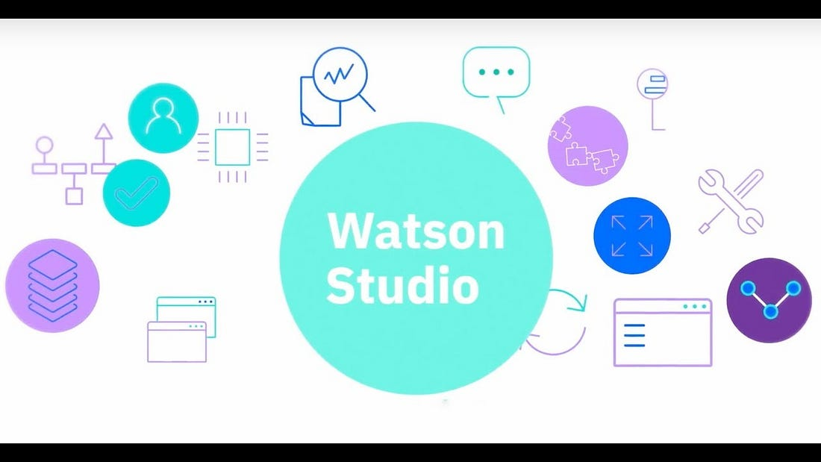

Layout:

**1.Project Overview:**

* **Description:** Provide a high-level overview of the ML project, including its goals, stakeholders, and key deliverables.

**2. Data Preparation:**

* **Data Sources:** List and describe the data sources used for the project.
* **Data Cleaning and Transformation:** Use Watson Studio tools to clean and transform raw data into a format suitable for ML.

**3. Exploratory Data Analysis (EDA):**

* **Data Visualization:** Utilize Watson Studio for visualizing data distributions, correlations, and patterns.
* **Insights and Observations:** Document key insights gained from the EDA process.

**4. Model Development:**

* **Algorithm Selection:** Specify the ML algorithms chosen for the project.
* **Model Training:** Use Watson Studio's integrated environment for building and training ML models.
* **Hyperparameter Tuning:** Document and experiment with different hyperparameter configurations.

**5. Model Evaluation:**

* **Performance Metrics:** Define and track relevant performance metrics (accuracy, precision, recall, etc.).

**Features:**

1. **Integrated Environment:**
   * **Watson Studio provides an integrated development environment for data scientists and developers, consolidating tools and services needed for ML projects.**
2. **Collaboration Tools:**
   * **Collaborative features enable teams to work together seamlessly. Users can share projects, notebooks, and datasets, facilitating efficient collaboration.**
3. **Data Preparation and Exploration:**
   * **Tools for data cleansing, transformation, and exploration assist in preparing datasets for ML. Watson Studio supports visualizations and statistical analysis of data.**
4. **Model Development:**
   * **Support for popular ML frameworks (e.g., TensorFlow, scikit-learn) and languages (e.g., Python, R) allows users to develop and train models using their preferred tools.**
5. **Auto AI:**
   * **Watson Studio's Auto AI feature automates the machine learning model-building process, making it accessible to users with varying levels of expertise.**

**Technical implementation:**

**1.Setup IBM Cloud Account:**

* **Sign up for an IBM Cloud account if you don't have one.**
* **Create a new project within the IBM Cloud Dashboard.**

**2. Access Watson Studio:**

* **Navigate to Watson Studio within the IBM Cloud console.**

**3. Create a Project:**

* **Within Watson Studio, create a new project to organize your ML assets.**

**4. Add Data:**

* **Import and upload your dataset into the project.**
* **Use Watson Studio tools for data exploration and cleaning.**

**5. Auto AI or Model Development:**

* **Choose between using Auto AI for automated model building or manually developing your ML model using notebooks.**

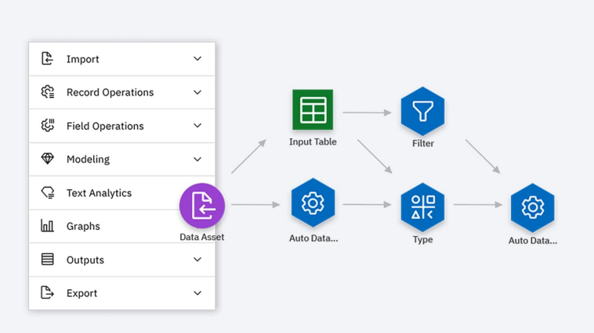

**GitHub repository link:**

[**https://github.com/ramya83931/phase-1.git**](https://github.com/ramya83931/phase-1.git)

[**https://github.com/ramya83931/phase2-2.git**](https://github.com/ramya83931/phase2-2.git)

[**https://github.com/ramya83931/Phase-3-.git**](https://github.com/ramya83931/Phase-3-.git)

[**https://github.com/ramya83931/phase-4.git**](https://github.com/ramya83931/phase-4.git)

**Instructions:**

**Step 1: Sign up for IBM Cloud and Create a Watson Studio Account**

1. **Visit the IBM Cloud website (**[**https://cloud.ibm.com/**](https://cloud.ibm.com/)**).**
2. **Sign up for an IBM Cloud account or log in if you already have one.**
3. **Once logged in, navigate to the IBM Watson Studio service.**

**Step 2: Create a Project in Watson Studio**

1. **In Watson Studio, click on "Create a Project."**
2. **Choose a project type (such as a Data Science project).**
3. **Define the project name, storage, and associate it with an existing or new Cloud Object Storage instance.**

**Step 3: Add Data to Your Project**

1. **Inside your project, go to the "Assets" tab and click "Add to Project."**
2. **Upload your dataset or connect to data sources.**
3. **Use Watson Studio tools to explore and clean the data.**

**Step 4: Model Development**

**Option 1: Auto AI**

1. **Click on "Add to Project" and select "AutoAI Experiment."**
2. **Follow the wizard to configure your AutoAI experiment, including choosing a target variable and setting experiment options.**
3. **Review and deploy the best-performing model.**

**Option 2: Manual Model Development**

1. **Create a notebook in your project.**
2. **Write code for data preprocessing, feature engineering, model training, and evaluation.**
3. **Utilize popular ML libraries such as scikit-learn, TensorFlow, or Py Torch.**

**Step 5: Experiment Tracking and Evaluation**

1. **Use Watson Studio to log and track your experiments.**
2. **Evaluate your model's performance using appropriate metrics.**

**Step 6: Model Deployment**

1. **Choose the best model for deployment.**
2. **Click on "Deploy" to create a deployment space and configure deployment settings.**
3. **Obtain the API endpoint for accessing your deployed model.**

**Step 7: Monitor and Manage Deployed Model**

1. **Use Watson Studio tools for monitoring the performance of your deployed model.**
2. **Implement procedures for model updates and maintenance.**

**Step 8: Collaboration and Documentation**

1. **Collaborate with team members by sharing notebooks, projects, and providing feedback.**
2. **Thoroughly document your ML project, including code comments and project notes.**

**Step 9: Integration with IBM Cloud Services**

1. **Explore additional IBM Cloud services for enhanced functionalities (e.g., Cloud Databases, Cloud Functions).**
2. **Integrate your ML solution with other IBM Cloud resources as needed.**

**Step 10: Security and Compliance**

1. **Implement security measures to protect sensitive data during both training and deployment.**
2. **Address any compliance requirements relevant to your ML project.**

**Step 11: Scaling and Optimization**

1. **Explore options for scaling your ML solution to handle larger datasets or increased demand.**
2. **Optimize your model for performance and efficiency.**

**Step 12: Educational Resources**

1. **Take advantage of educational resources within Watson Studio to enhance your ML skills.**
2. **Stay informed about the latest developments in the field through documentation and tutorials.**

**How to navigate the website?**

**Project Name:**

**Description:**

**A brief description of the website, its purpose, and key features.**

**Table of Contents**

1. [**Getting Started**](https://chat.openai.com/c/5c496da3-a5dd-4399-8630-8592be0701fd#getting-started)
   * [**Prerequisites**](https://chat.openai.com/c/5c496da3-a5dd-4399-8630-8592be0701fd#prerequisites)
   * [**Installation**](https://chat.openai.com/c/5c496da3-a5dd-4399-8630-8592be0701fd#installation)
2. [**Navigation Guide**](https://chat.openai.com/c/5c496da3-a5dd-4399-8630-8592be0701fd#navigation-guide)
3. [**Features**](https://chat.openai.com/c/5c496da3-a5dd-4399-8630-8592be0701fd#features)
4. [**Usage**](https://chat.openai.com/c/5c496da3-a5dd-4399-8630-8592be0701fd#usage)
5. [**Contributing**](https://chat.openai.com/c/5c496da3-a5dd-4399-8630-8592be0701fd#contributing)
6. [**License**](https://chat.openai.com/c/5c496da3-a5dd-4399-8630-8592be0701fd#license)

**Getting Started**

**Prerequisites**

**List any prerequisites or dependencies users need to have installed before navigating the website.**

**Installation**

**Provide step-by-step instructions for installing and setting up the website locally if applicable.**

**Bash Copy code**

**# Example Installation Steps git clone https://github.com/your-username/your-repo.git cd your-repo n pm install n pm start**

**Navigation Guide**

**Describe how users can navigate the website effectively. Provide information on key sections, pages, or features.**

**Home Page**

* **Briefly explain the purpose of the home page.**
* **Highlight any important features or sections.**

**Navigation Bar**

* **Explain the items in the navigation bar and their functions.**

**User Dashboard**

* **If applicable, describe the user dashboard and its components.**

**Search Functionality**

* **Guide users on how to use the search functionality.**

**Feature Sections**

* **Break down major features and how users can access them.**

**Account Management**

* **If applicable, provide instructions for managing user accounts.**

**Features**

**List and describe the main features of the website.**

1. **Feature 1: Description of Feature 1.**
2. **Feature 2: Description of Feature 2.**
   * **Include any sub-features or functionalities.**

**Usage**

**Provide examples or use cases to help users understand how to interact with the website effectively.**

**Bash Copy code**

**# Example Usage 1. Visit the home page. 2. Click on the "Login" button. 3. Navigate to the user dashboard. 4. Use the search bar to find specific content. 5. Explore feature sections for more information.**

**Contributing**

**Explain how users can contribute to the development or improvement of the website.**

1. **Fork the repository.**
2. **Create a new branch.**
3. **Make changes and submit a pull request.**

**License**

**Specify the license under which the website is distributed.**

**customize this template based on the specifics of your website, and ensure that it covers the essential information for users to navigate and utilize the site effectively.**

**Conclusion:**

**The collaborative features of Watson Studio foster teamwork among data scientists, developers, and business analysts, creating an integrated environment for ideation, experimentation, and innovation. Whether using Auto AI for automated model building or manually developing models with popular ML frameworks, Watson Studio caters to a spectrum of users with varying levels of expertise.**