Day 1 – Linux Introduction

TASK: Create 20 files with .txt extensions and rename the first to .yml extension Print the latest created top 5 files among the total no of files

1. Create 20 file with .txt

Command: touch file{01..20}.txt



1. Rename first 5 files to. yml extension

command: mv file01.txt file01.yml

Like this I did for 5 files

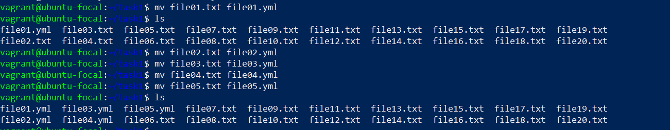

1. Print the latest created files 5 files only

Command : ls -tl | head -n 6

