**EC2 instance creation using terraform**

Launch Linux EC2 instances in two regions using a single Terraform file.

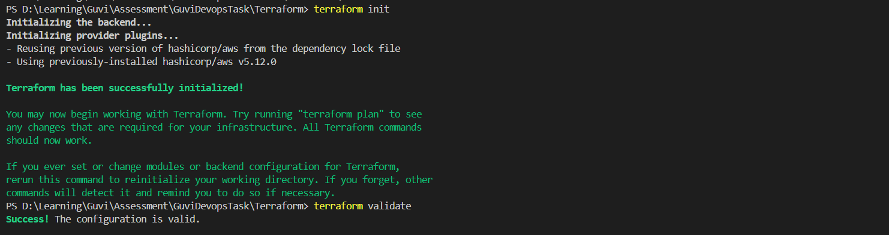

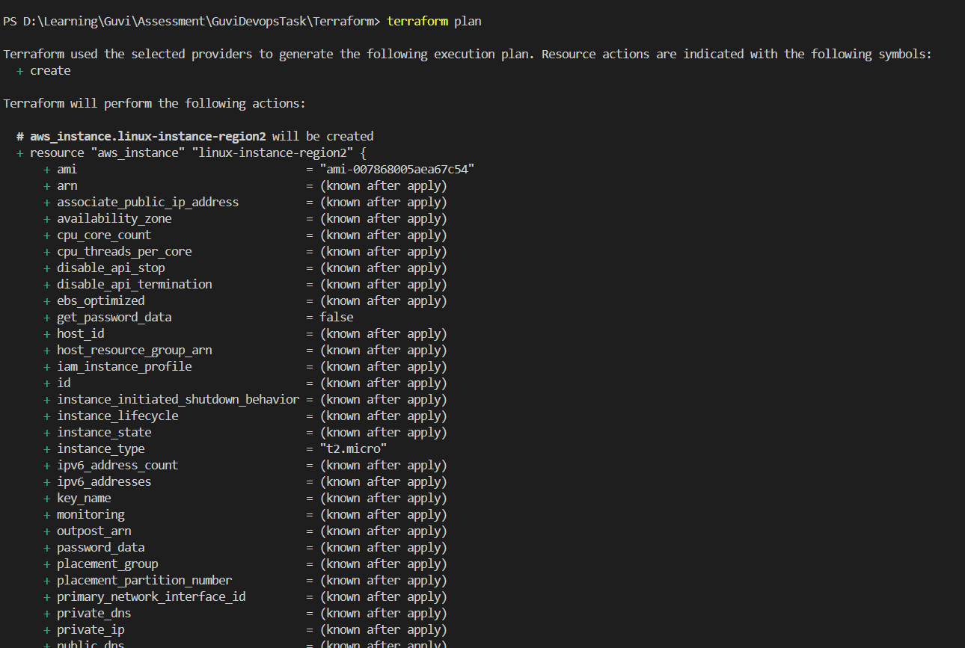

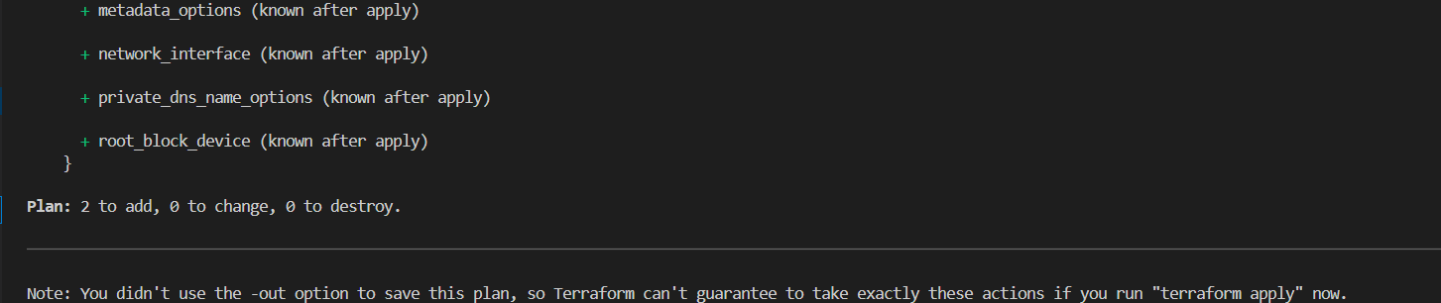

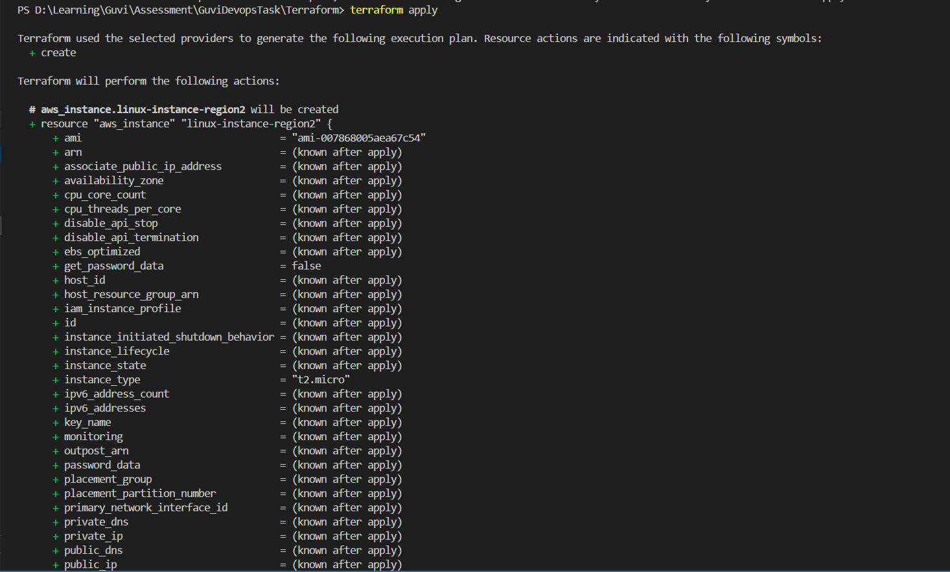

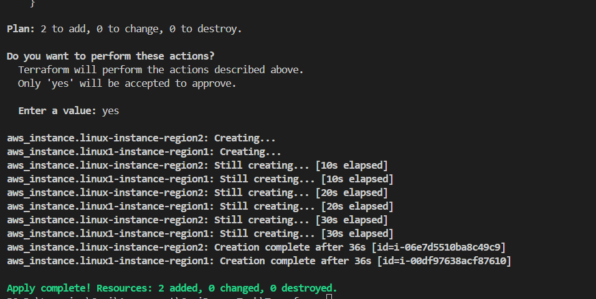

Instance in east-1

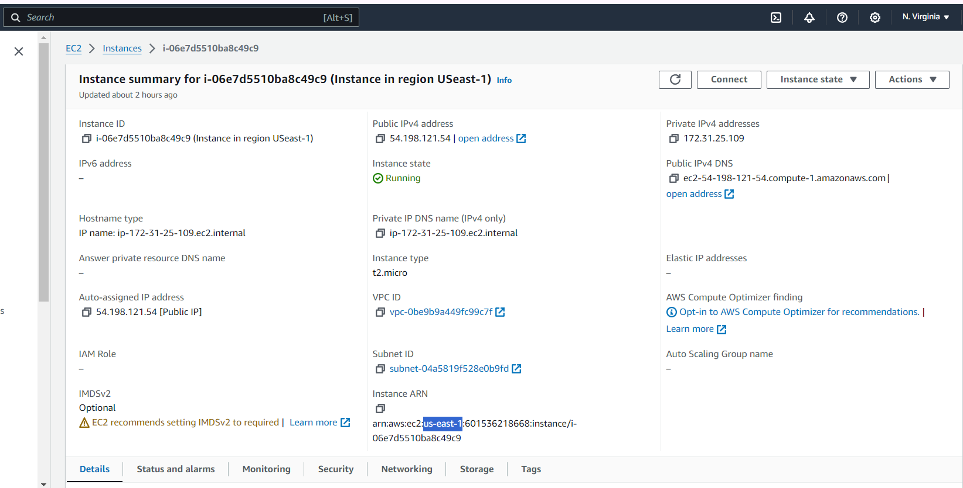

Instance in east-2

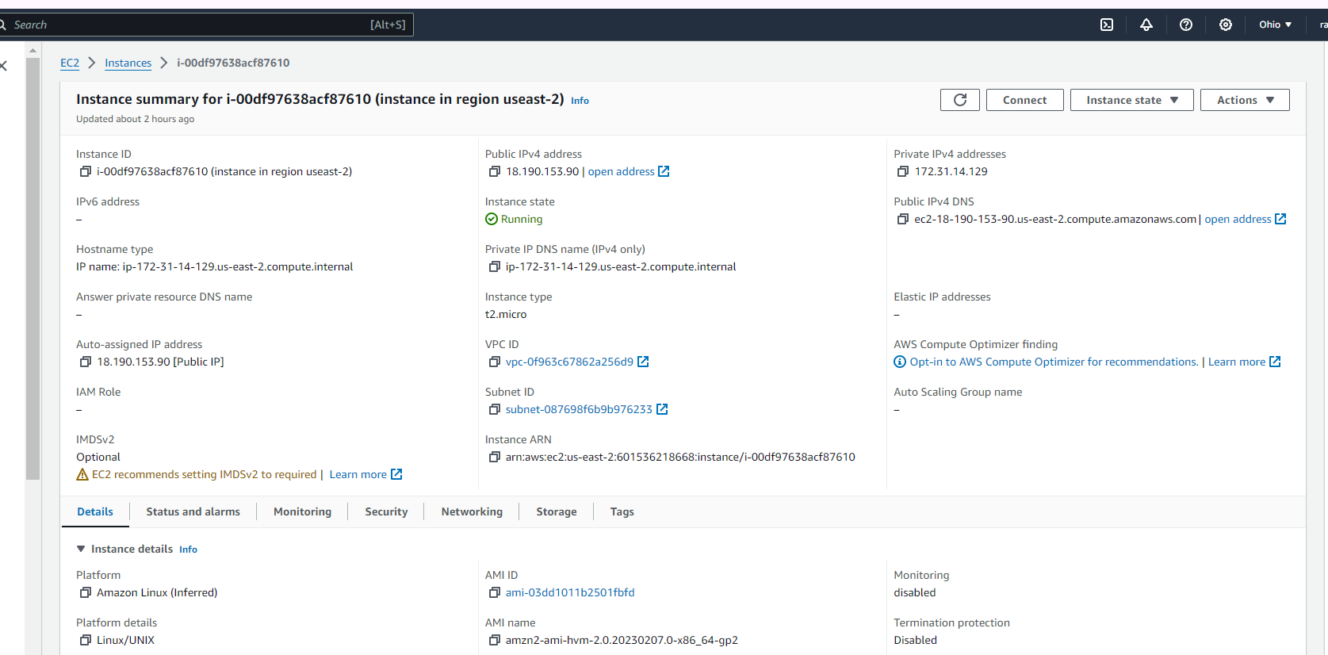

Note : Used below command to get the ami respective to region

aws ec2 describe-images --owners amazon --filters "Name=name,Values=amzn2-ami-hvm-*-x86_64-gp2" "Name=is-public,Values=true" "Name=architecture,Values=x86_64" "Name=product-code,Values=aw0evgkw8e5c1q413zgy5pjce" --query "Images[*].[ImageId,Name]" --output text --region us-east-2