**Day 3 - Containers - Microservice Architecture**

**Task :** Create a dockerfile, file which when build must display your basic details in website

Created a html file to show basic details of myself

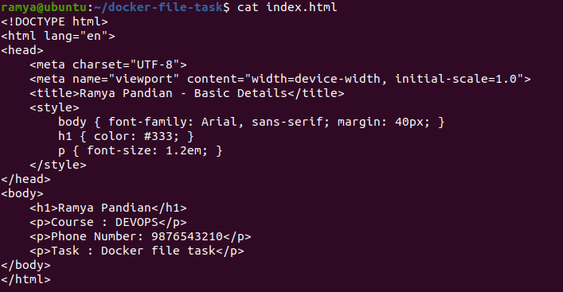

Docker file

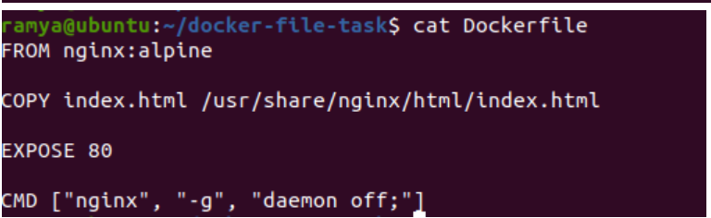

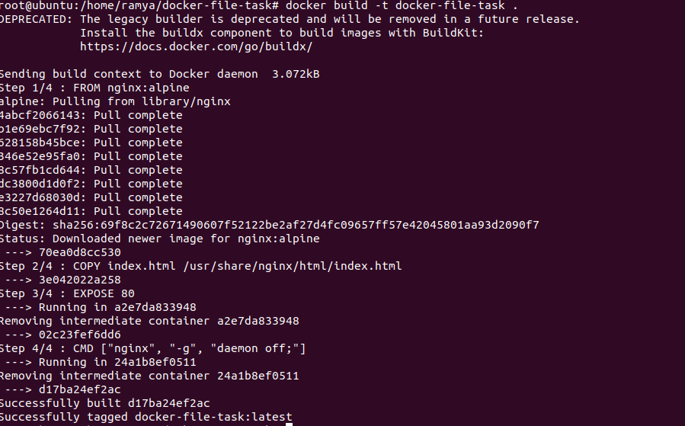

List whether the image is created.

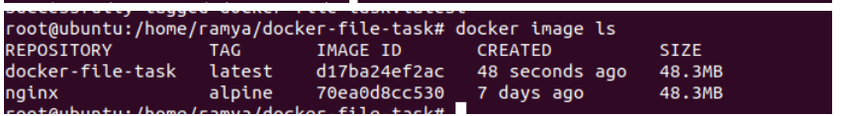

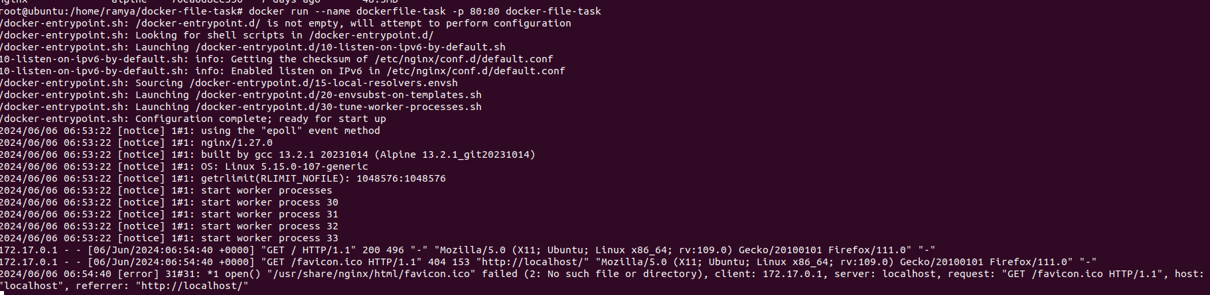

Final output :

