**Problem Statement:**

Write a query to report the names of all the salespersons who did not have any orders related to the company named "**RED**".

**Note:** Return the result table ordered by **name** in ascending order.

**Sample Input:**

**Table:** salesperson

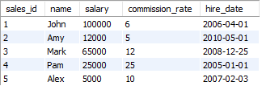

**Table:** orders

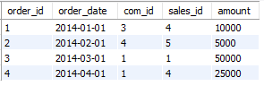

**Table:**company

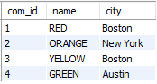

**Sample Output:**



**Explanation:**

According to orders 3 and 4 in the **orders** table, it is easy to tell that only salespersons John and Pam have sales to company **RED**, so we report all the other names in the table **salesperson**.

ANS :

select

s.name

from salesperson as s

where s.sales_id not in (

    select o.sales_id

    from orders as o

    left join company as c

    ON o.com_id = c.com_id

    where c.name = "RED"

)

order by s.name;