CAUSE ONE EXAMPLE :

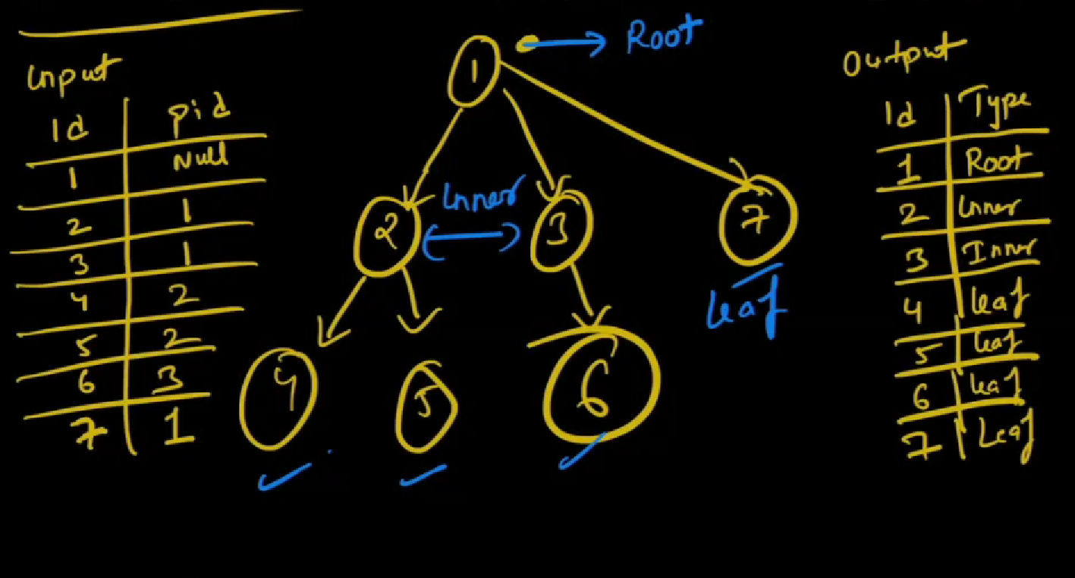

Basically we should put output has

1. ROOT – 1 which has null value
2. 2 ,3 - INNER
3. 4,5,6 – LEAF
4. Query :

Select

Id,

Case

When id IN (select id from tree where p_id is NULL) THEN ‘ROOT’

1. INNER query :

We can check like if p_id is in id column then then its inner

=🡺 When id IN (select p_id from tree) THEN ‘INNER’

WHOLE QUERY :

Select

ID

Case

When id IN (select id from tree where p_id is NULL) THEN ‘ROOT’

When id IN (select p_id from tree) THEN ‘INNER’

ELSE “LEAF”

END AS “Classification”

JOINS

LEFT JOIN

