1. View the Dataset.

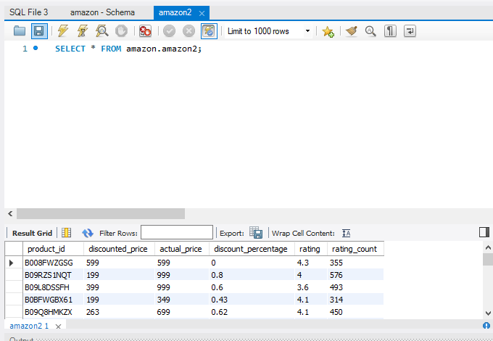

1. Find the products with the highest discount percentage.

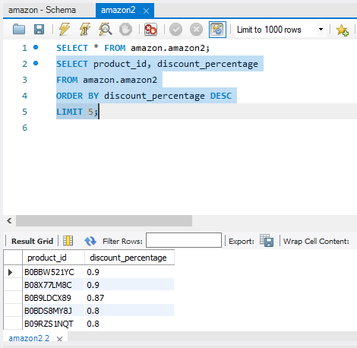

1. Calculate the average discounted prices

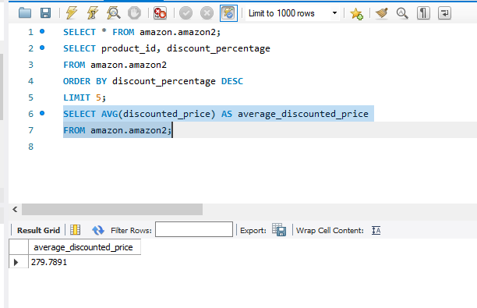

1. To know the products with the highest rating.

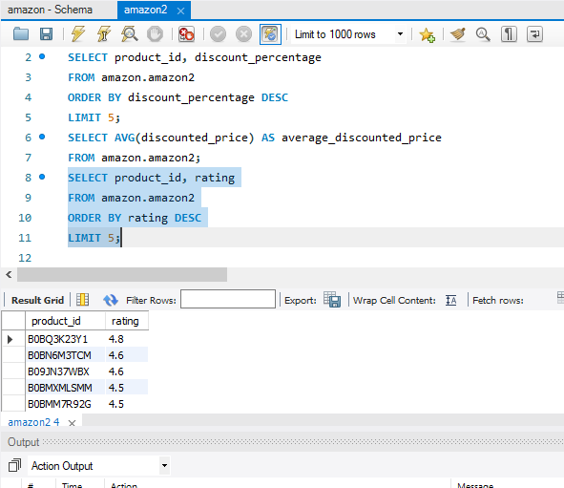

1. Calculate the total rating count for each product

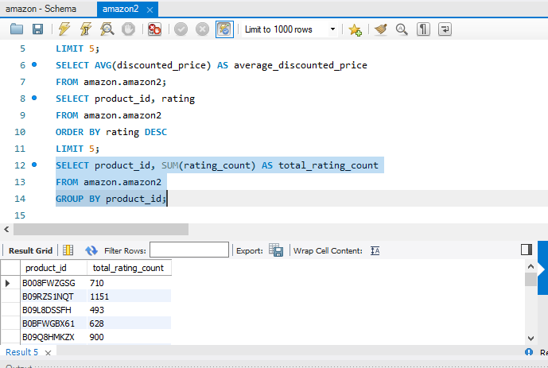

1. Find the products where actual price is higher than the discounted price.

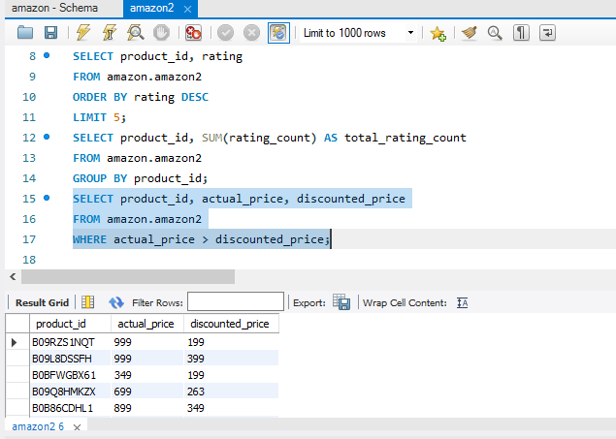

1. Calculate the average discount percentage

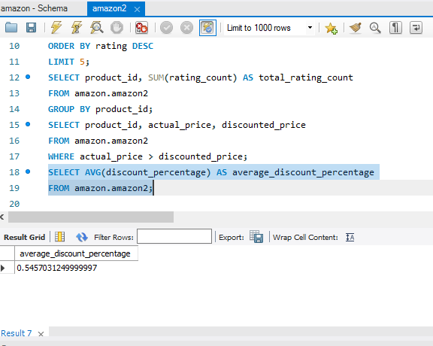

1. To find the lowest discount percentage given for a product.

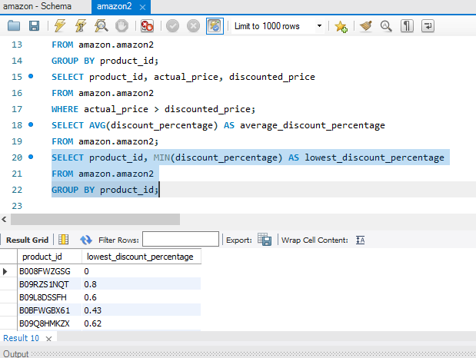

1. What is the rating for product ID B008FWZGSG

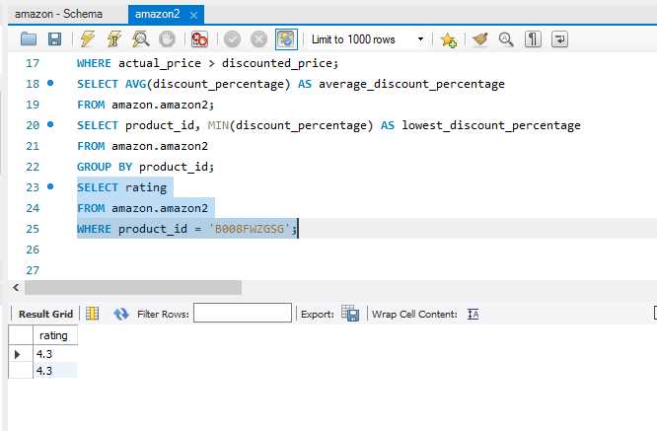

This product ID has the lowest discount percentage and Rating is found to be pretty good and suggestable for more order for sales.

1. I would like to know the product with highest discount percentage

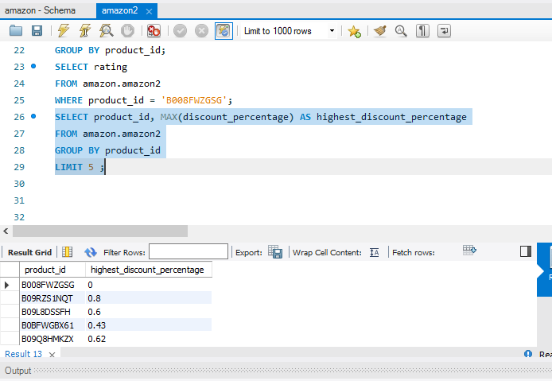

B09RZS1NQT carries highest percentage.

1. I would like to know the rating for product ID

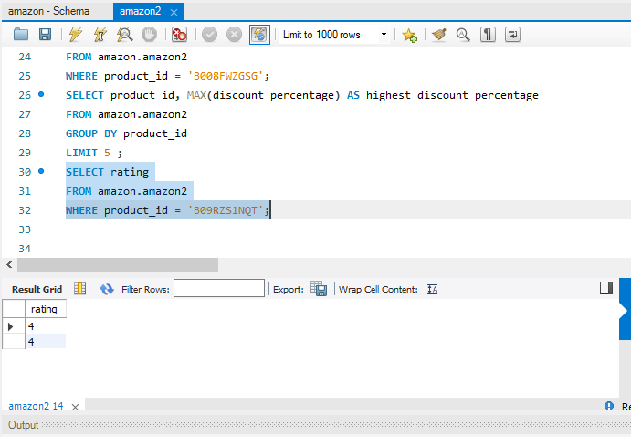

Even though highest discount percentage given to this product, the rating shows 4 which is “not bad”. It is good to consider increasing discount percentage for products with medium to high rating so as to increase sales and also we can consider ordering more of that product.

Thankyou