1. TRUE OR FALSE
   1. False
   2. False
   3. True
   4. True
   5. False
   6. semget(), semop(), semctl()
   7. True
   8. True
   9. UPD, TCP
   10. True
   11. True
   12. False
   13. True
   14. toString()
   15. True
2. a) code:

package testing;

public class main {

public static void main(String[] args) {

// **TODO** Auto-generated method stub

Square3[] sq = new Square3[125];

for (int i = 0; i < sq.length; i++) {

sq[i] = new Square3();

}

}

}

b) 1st method(parameterized constructor):

package testing;

public class main {

public static void main(String[] args) {

// **TODO** Auto-generated method stub

Vehicle v = new Vehicle();

Vehicle v1=new Vehicle("mazda");

Vehicle v2=new Vehicle("mazda","black");

System.***out***.println("3rd object vehicle color is "+ v2.getcolor()+ " and model is "+ v2.getmodel());

}

}

package testing;

public class Vehicle {

private String model;

private String color;

public Vehicle() {

};

public Vehicle(String model) {

this.model=model;

};

public Vehicle(String model,String color) {

this.color=color;

this.model=model;

};

public String getmodel() {

return model;

};

public String getcolor() {

return color;

}

};

Output:

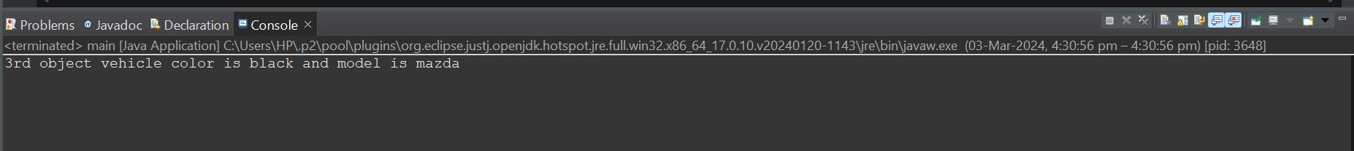

2nd method(constructor followed by getter setter methods):

package testing;

public class main {

public static void main(String[] args) {

// **TODO** Auto-generated method stub

Vehicle v = new Vehicle();

v.setcolor("white");

v.setmodel("honda");

System.***out***.println(" vehicle color is "+ v.getcolor()+ " and model is "+ v.getmodel());

}

}

package testing;

public class Vehicle {

private String model;

private String color;

public Vehicle() {

};

public String getmodel() {

return model;

};

public String getcolor() {

return color;

}

public void setmodel(String model) {

this.model=model;

};

public void setcolor(String color) {

this.color=color;

}

};

3rd method(static methods):

package testing;

public class main {

public static void main(String[] args) {

Vehicle v3=Vehicle.*createVehicle*("Toyota", "cream");

System.***out***.println(v3.toString());

}

}

package testing;

public class Vehicle {

private String model;

private String color;

public static Vehicle createVehicle(String model, String color) {

Vehicle vehicle = new Vehicle();

vehicle.model = model;

vehicle.color = color;

return vehicle;

}

public String toString() {

return "vehicle color is "+color + "model is" + model;

}

};

Output:



1. USING ONE CLASS:
2. package testing;
3. public class main {
4. private static String *k*="";
5. public static String myprintfXY(int x,int y) {
6. for(int i=x;i<y;i=i+2) {
7. *k*=*k*+i+ " ";
8. };
9. return *k*;
10. };
11. public static void main(String[] args) {
12. // **TODO** Auto-generated method stub
13. System.***out***.println(*myprintfXY*(1,20));
14. }
16. }

Output: 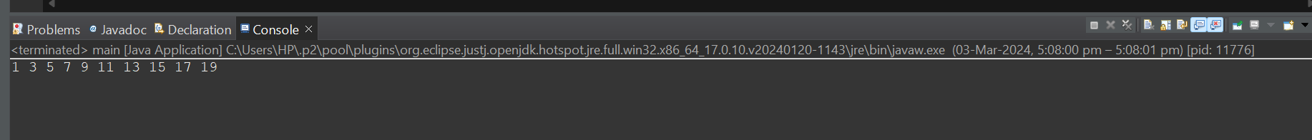

USING TWO CLASS:

package testing;

public class main {

public static void main(String[] args) {

// **TODO** Auto-generated method stub

Odd o = new Odd(1,20);

System.***out***.println(o.myprintfXY());

}

}

package testing;

public class Odd {

private int x;

private int y;

private String k="";

public Odd(int x,int y) {

this.x=x;

this.y=y;

};

public String myprintfXY() {

for(int i=x;i<y;i=i+2) {

k=k+i+ " ";

};

return k;

};

}

Output:



4)

a)

package testing;

public class main {

public static void main(String[] args) {

// **TODO** Auto-generated method stub

Circle[] c=new Circle[15];

for (int i = 0; i < 15; i++) {

c[i] = new Circle();

};

};

b)type

c) code:

package testing;

public class main {

public static void main(String[] args) {

// **TODO** Auto-generated method stub

int row=10;

int column=10;

int[][] sales=new int[row][column];

for(int i=0;i<row;i++) {

for(int j=0;j<column;j++) {

sales[i][j]=25;

};

};

for(int i=0;i<row;i++) {

for(int j=0;j<column;j++) {

System.***out***.println("sales ["+i+"]["+j+"] = "+ sales[i][j]);

};

};

}

}

Output:

