COA ENDSEM EVALUATION-SET 2

CB.EN.U4CSE18302

1.CODE:

# 1, 1, 2, 3, 5, 8, 13, 21, 34, 55, 89, 144, 233, 377, 610, 987, 1597, 2584, 4181, 6765, 10946, 17711, 28657, 46368, 75025, 121393, 196418, 317811, ...

.text

.globl main

main:

li $v0,4

la $a0,msg

syscall

li $v0,5

syscall

move $t0,$v0

li $t1,0

li $t2,1

li $t3,0

li $t4,1

while:

add $t3,$t1,$t2

move $t1,$t2

move $t2,$t3

sub $t0,$t0,$t4

bgt $t0,0,while

li $v0,1

move $a0,$t3

syscall

li $v0,10

syscall

.data

msg: .asciiz "Enter a number: \n"

OUTPUT: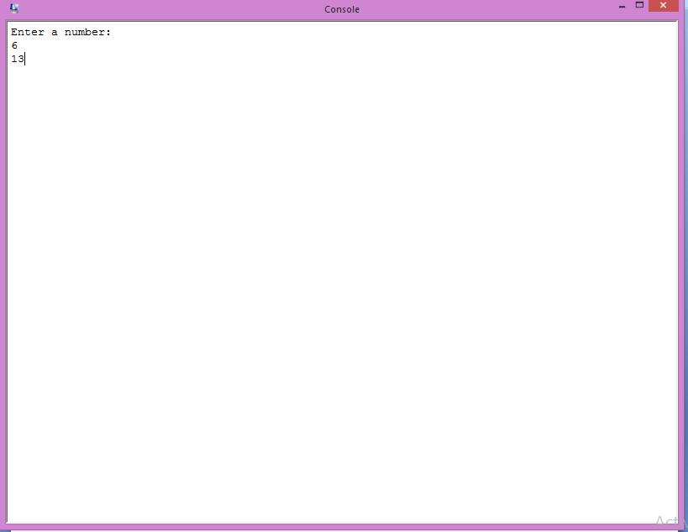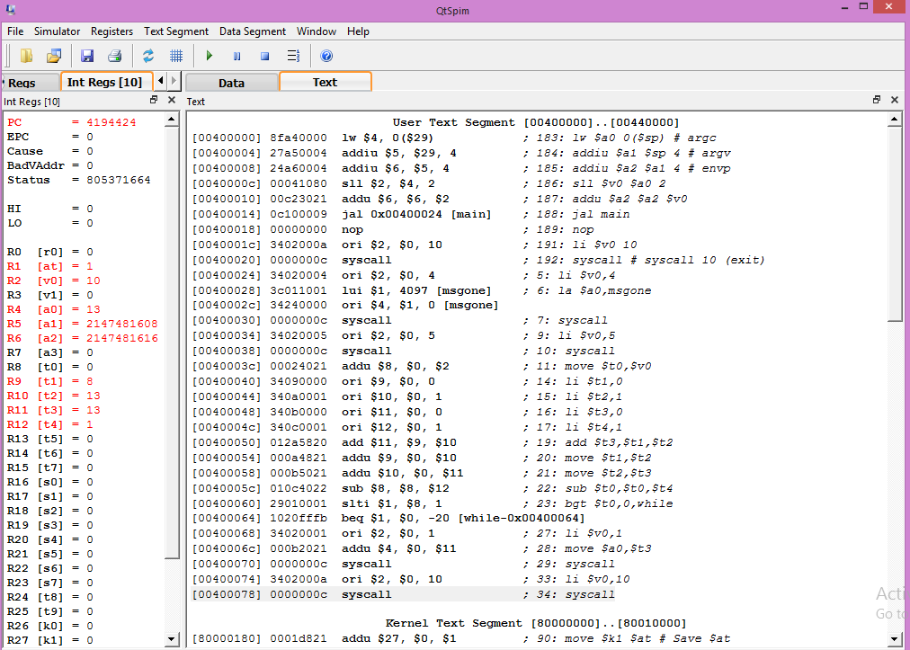

2.CODE:

mod8ctr.v:

module mod8counter(clk, reset, q);

input clk, reset;

output [2:0] q;

reg [2:0] q;

initial

begin

q = 3'b000;

end

always @ (posedge clk or posedge reset) begin

if (reset)

begin

q=0;

end

else if(q==7)

begin

q<=0 ;

end

else

begin

q<=q+1;

end

end

endmodule

mod8ctr_tb.v:

module mod8ctr_tb;

wire [2:0] q;

reg clk, reset;

mod8counter my_mod8ctr(clk, reset, q);

initial

begin

clk=1'b0;

reset=1'b0;

#30 $finish;

end

always #1 clk=~clk;

always #30 reset=~reset;

always @(clk)

begin

$monitor("%b\t%b\t%b",clk, reset, q);

end

endmodule

Output:

