DBMS ASSIGNMENT-4

-RAMYA SRI ACHANTA (2300293)

1)

**Implement the above database Customer Order using DDL query.**

**CUSTOMER TABLE:**

CREATE TABLE customer (

CID INTEGER PRIMARY KEY,

NAME TEXT CHECK(LENGTH(NAME) <= 20),

ADDRESS TEXT CHECK(LENGTH(ADDRESS) <= 50),

CONTACT_NO INTEGER CHECK(CONTACT_NO >= 0 AND CONTACT_NO <= 9999999999),

CREDIT_LIMIT INTEGER CHECK(CREDIT_LIMIT >= 0)

);

select * from customer;

**PRODUCT TABLE:**

CREATE TABLE product (

PID INTEGER PRIMARY KEY,

NAME TEXT CHECK(LENGTH(NAME) <= 20),

COLOR TEXT CHECK(LENGTH(COLOR)<=20),

MANUFACTURED_DATE DATE,

MANUFACTURED_ID INTEGER,

FOREIGN KEY(MANUFACTURED_ID) REFERENCES manufacturer(MID) ON DELETE CASCADE ON UPDATE CASCADE

);

select * from product;

**MANUFACTURER TABLE:**

CREATE TABLE manufacturer (

MID INTEGER PRIMARY KEY,

MANUFACTURER_NAME TEXT CHECK(LENGTH(MANUFACTURER_NAME) <= 20),

ADDRESS TEXT CHECK(LENGTH(ADDRESS) <= 50),

CONTACT INTEGER CHECK(CONTACT >= 0 AND CONTACT <= 9999999999)

);

select * from manufacturer;

**ORDER TABLE:**

CREATE TABLE [order] (

OID INTEGER PRIMARY KEY,

CUSTOMER_ID INTEGER,

REFERENCE TEXT CHECK(LENGTH(REFERENCE) <= 20),

PURCHASE_DATE DATE,

FOREIGN KEY(CUSTOMER_ID) REFERENCES customer(CID) ON DELETE CASCADE ON UPDATE CASCADE

);

select * from [order];

**ORDER-ITEMS TABLE:**

CREATE TABLE [order-items] (

OID INTEGER,

PRODUCT_ID INTEGER,

QTY INTEGER,

WARRANTY INTEGER,

UNIT_PRICE INTEGER,

PRIMARY KEY (OID, PRODUCT_ID),

FOREIGN KEY(OID) REFERENCES [order](OID) ON DELETE CASCADE ON UPDATE CASCADE,

FOREIGN KEY(PRODUCT_ID) REFERENCES product(PID) ON DELETE CASCADE ON UPDATE CASCADE

);

select * from [order-items];

2)

**By following the above schema, give *SQL* for the following problems:**

a)

SELECT CID,NAME from customer

where ADDRESS like'%Bay Area Blvd%' AND

CREDIT_LIMIT BETWEEN 1000 AND 10000;

b)

SELECT c.NAME

FROM customer c

JOIN [order] o ON c.CID = o.CUSTOMER_ID

JOIN [order-items] oi ON o.OID = oi.OID

JOIN product p ON oi.PRODUCT_ID = p.PID

WHERE oi.QTY > 10 AND strftime('%Y-%m', o.PURCHASE_DATE) = '2023-03';

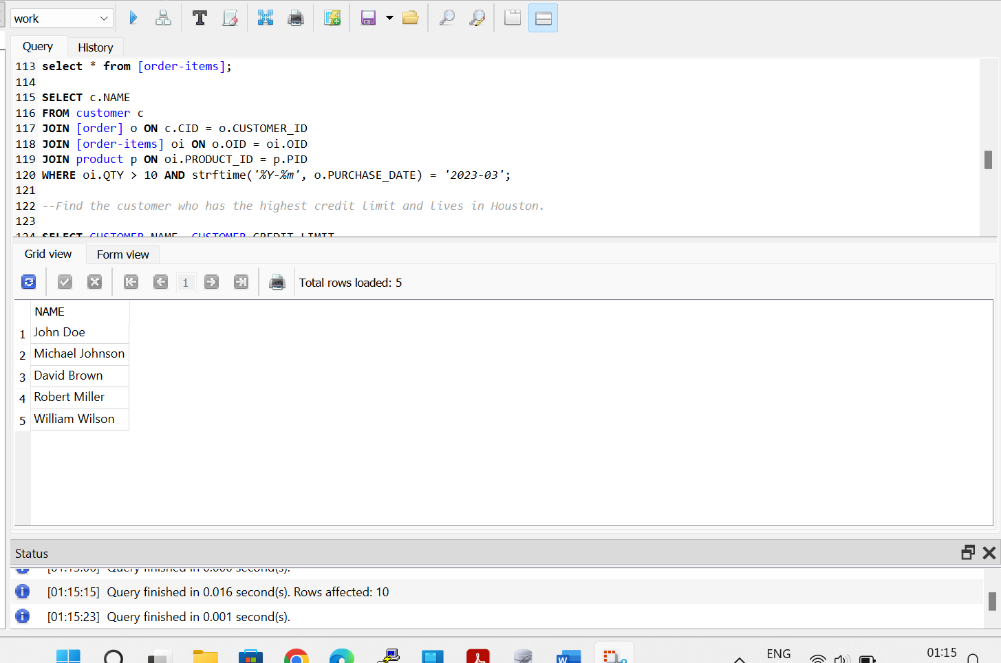

c)

SELECT CUSTOMER.NAME, CUSTOMER.CREDIT_LIMIT

FROM CUSTOMER

WHERE CUSTOMER.ADDRESS LIKE'%Houston%'

order by CUSTOMER.CREDIT_LIMIT DESC

LIMIT 1;

d)

SELECT product.NAME,product.COLOR FROM PRODUCT

JOIN MANUFACTURER ON MANUFACTURER.MID=PRODUCT.MANUFACTURED_ID

JOIN [ORDER-ITEMS] ON [ORDER-ITEMS].PRODUCT_ID=PRODUCT.PID

WHERE MANUFACTURER.MANUFACTURER_NAME='Rainbow' and [ORDER-ITEMS].UNIT_PRICE between 50 and 500;

e)

SELECT m.MANUFACTURER_NAME

FROM manufacturer m

JOIN product p ON m.MID = p.MANUFACTURED_ID

JOIN [order-items] oi ON p.PID = oi.PRODUCT_ID

GROUP BY m.MANUFACTURER_NAME

HAVING SUM(oi.QTY) > 20;

f)

SELECT c.NAME

FROM customer c

JOIN [order] o ON c.CID = o.CUSTOMER_ID

JOIN [order-items] oi ON o.OID = oi.OID

JOIN product p ON oi.PRODUCT_ID = p.PID

WHERE oi.UNIT_PRICE = (

SELECT MAX(UNIT_PRICE)

FROM [order-items]

);

g)

SELECT m.MANUFACTURER_NAME

FROM manufacturer m

JOIN product p ON m.MID = p.MANUFACTURED_ID

JOIN [order-items] oi ON p.PID = oi.PRODUCT_ID

GROUP BY m.MANUFACTURER_NAME

HAVING AVG(oi.QTY) > (

SELECT AVG(QTY)

FROM [order-items]

);

h)

customer table before updating:

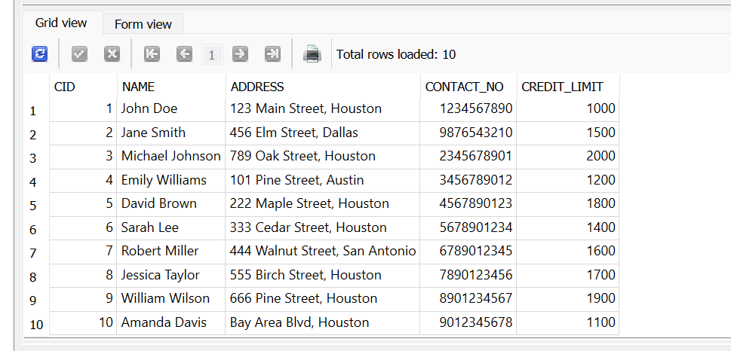

Query to update:

UPDATE customer

SET CREDIT_LIMIT = CASE

WHEN EXISTS (SELECT 1 FROM [order] o JOIN [order-items] oi ON o.OID = oi.OID WHERE o.CUSTOMER_ID = customer.CID GROUP BY o.CUSTOMER_ID HAVING SUM(oi.QTY) >= 10) THEN ROUND(CREDIT_LIMIT * 1.20, 2)

WHEN EXISTS (SELECT 1 FROM [order] o JOIN [order-items] oi ON o.OID = oi.OID WHERE o.CUSTOMER_ID = customer.CID GROUP BY o.CUSTOMER_ID HAVING SUM(oi.QTY) > 5 AND SUM(oi.QTY) < 10) THEN ROUND(CREDIT_LIMIT * 1.15, 2)

ELSE ROUND(CREDIT_LIMIT * 1.10, 2)

END

WHERE CID IN (SELECT DISTINCT CUSTOMER_ID FROM [order]);

Customer table after updating

i)

Manufacturer before updating:

Product table before updating :

Query to update:

UPDATE product

SET MANUFACTURED_ID = (SELECT MID FROM manufacturer WHERE MANUFACTURER_NAME = 'Lenovo')

WHERE NAME = 'Laptop';



Manufacturer table after updating:

j)

Before updating customer table:

DELETE FROM customer

WHERE ADDRESS LIKE '%Houston%';

Order table rows were also updated as customer_id has “on delete cascade”

Order-items table rows were also updated as customer_id has “on delete cascade”

3)

**By following the above schema, give *SQL* Triggers for the following problems**

a)

customer table:

On insert of order table  
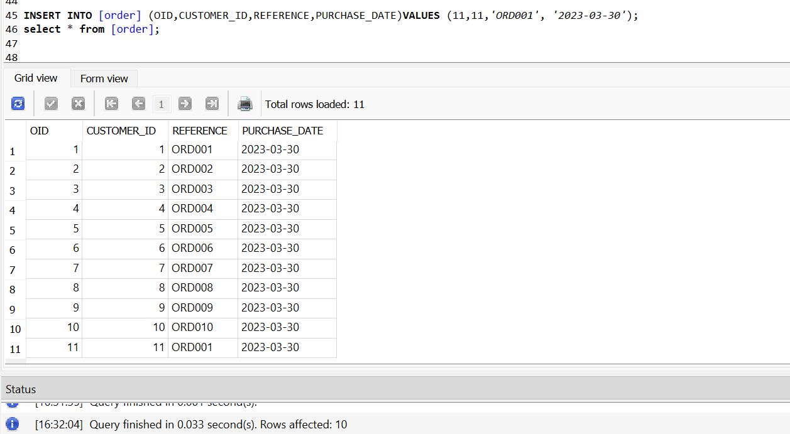

Updating of customer using trigger:

CREATE TRIGGER remove_order_if_negative_credit

AFTER INSERT ON "order"

BEGIN

UPDATE customer

SET CREDIT_LIMIT = 0

WHERE CID = NEW.CUSTOMER_ID AND CREDIT_LIMIT < 0;

DELETE FROM "order"

WHERE CUSTOMER_ID IN (SELECT CID FROM customer WHERE CREDIT_LIMIT < 0);

DELETE FROM "order-items"

WHERE OID NOT IN (SELECT OID FROM "order");

END;

b)

order-audit table create:

CREATE TABLE IF NOT EXISTS order_audit (

audit_id INTEGER PRIMARY KEY,

order_id INTEGER,

operation TEXT,

old_values TEXT,

new_values TEXT,

date_time TIMESTAMP DEFAULT CURRENT_TIMESTAMP

);

Trigger statement for update:

CREATE TRIGGER order_update_audit

AFTER UPDATE ON [order]

BEGIN

INSERT INTO order_audit (order_id, operation, old_values, new_values)

VALUES (OLD.OID, 'UPDATE', OLD.REFERENCE || ', ' || OLD.CUSTOMER_ID || ', ' || OLD.PURCHASE_DATE,

NEW.REFERENCE || ', ' || NEW.CUSTOMER_ID || ', ' || NEW.PURCHASE_DATE);

END;

Order table before updating :

Query to update:

UPDATE "order"

SET REFERENCE = 'ORD123', CUSTOMER_ID = 2, PURCHASE_DATE = '2024-03-31'

WHERE OID = 1;

order table after updating:

Order_audit table after updating:

Trigger statement for delete:

CREATE TRIGGER order_delete_audit

AFTER DELETE ON [order]

BEGIN

INSERT INTO order_audit (order_id, operation, old_values)

VALUES (OLD.OID, 'DELETE', OLD.REFERENCE || ', ' || OLD.CUSTOMER_ID || ', ' || OLD.PURCHASE_DATE);

END;

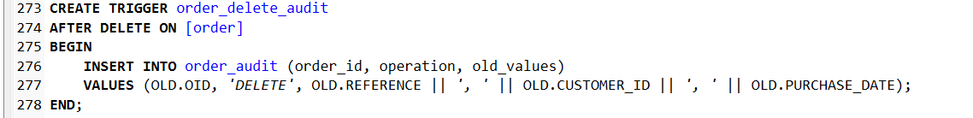

Order table before deleting :

Query to delete:

DELETE FROM "order"WHERE OID = 1;

order table after deleting:

Order_audit table after deleting:

