## Commands Utilities

This assignment expects the participant to identify specific command(s) OR perform the given action using one or commands as per the given question. You are requested to maintain the answers (i.e command(s) as per given question) for all questions below.

**Mandatory Questions**

1. Which command is used to know the current working directory?

Ans) “pwd(present working directory)” command is used to know the current working directory.



1. How would you find out its contents?

Ans) The contents of the directory can be found by using these commands:

* ls: This command is used to list the contents of the directory
* ll: It is used to list the contents of the directory and also the hidden files which are present in that directory.
* ls -la: It is used to list the contents of the directory and also the hidden files which are present in that directory.

1. Identify the commands with inputs to do the following
   1. create a directory d1
   2. create a subdirectory d2 in d1
   3. change to directory d2
   4. create an empty file “f1.txt”
   5. display the contents of “f1.txt”
   6. view the contents of d1 from current directory d2

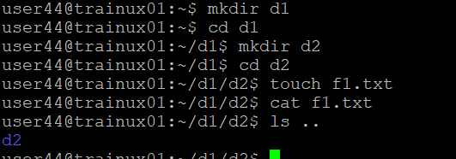

1. Use the ls command with its options. How will you identify directories from the listing?

Ans) To identify directories from the listing

* ll: It is used to list the contents of the directory and also the hidden files which are present in that directory. For the directories have “d” at the starting of the file permissions.
* ls -F: For directories have the slash at the end of the file name.

1. Use ls to do the following
   1. List files with single character names.

Ans) For listing of the files with single character names by using “find” command. This command used to shows all the files whose name is starting with e. As we have * all types of extensions are also included.

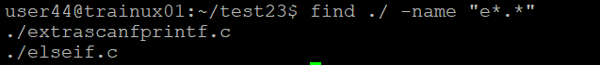

* 1. List hidden files also. [ Note : Hidden files are files having name started with a “.” ]

Ans) ls -la or ll: It is used to list the contents of the directory and also the hidden files which are present in that directory.

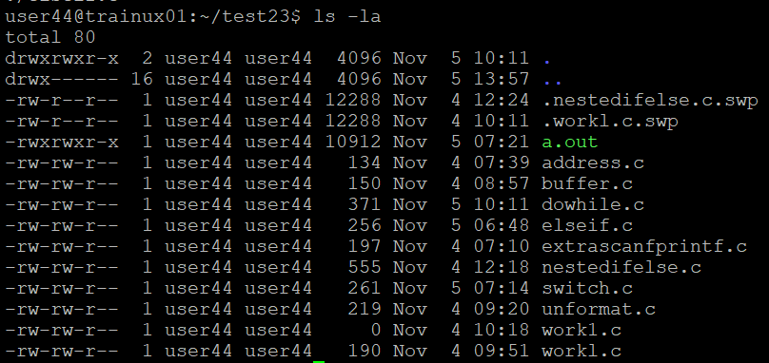

* 1. Suppose there are files tb1.1, tb2.1, tb3.1, ….tb10.1. Write command to list all the files [Hint: use wild card characters]

Ans) To list all the files with wild card characters using ls tb*.*

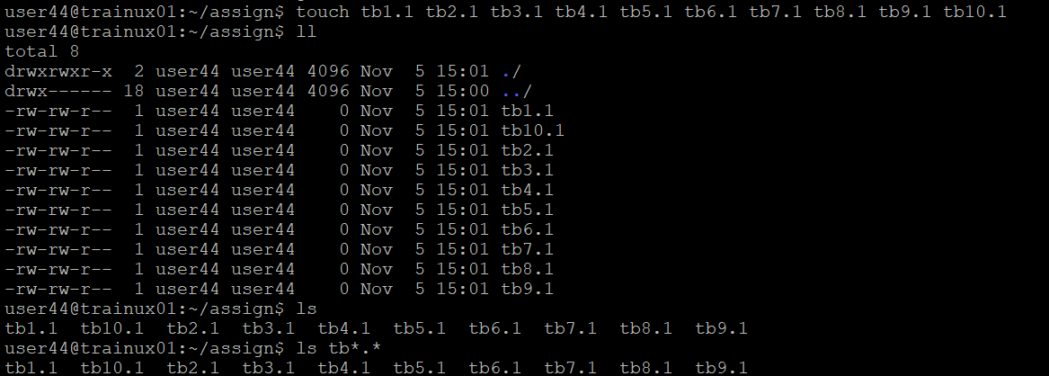

1. Write the command to list all files in descending order of their size.

Ans) The command to list all files in descending order of their size is ls -lS

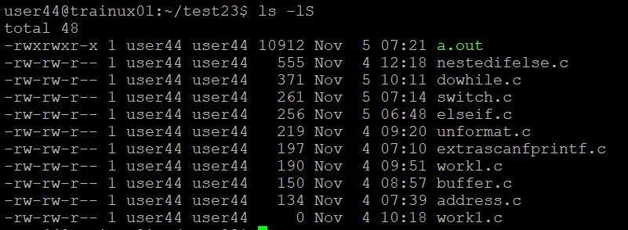

1. Suppose there are files temp1, temp2, temp3. Write command to remove the files without listing them explicitly

Ans) rm t*.* command is used to remove the files without listing them explicitly.

* In this example we remove the file without listing ,here it removes the file with starting letter which is “t” here with any extension

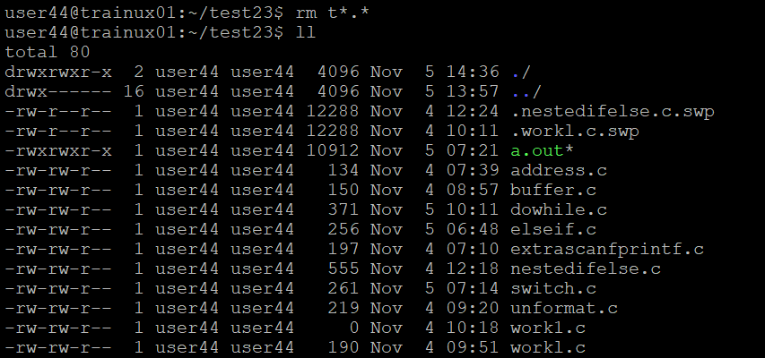

1. Which command is used to list top few lines in the file?

Ans)

* head <filename>: This command is used to list the top 10 lines in that particular file.

* head -n 5 <filename> : This command is used to list the top 5 lines in that particular file.

1. Create a directory “testdir”

Ans) create a directory using “mkdir”(make directory).



1. Use cp command to do the following
   1. Copy the file tb1.1 (created above) in the same directory.

Ans) To copy the file use the cp command as cp <source path> <destination path>

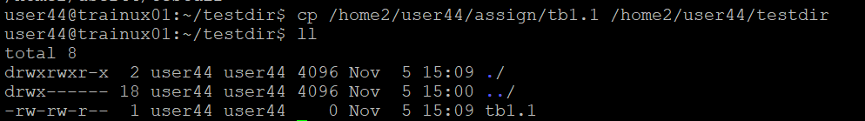

* 1. Write a command to copy all the files i.e tb1.1,tb2.1,tb3.1,…..tb10.1 in a new directory –“new”
  2. Create a subdirectory in new in named“new1”.
  3. Write a command to copy selectively only tb2.1, tb6.1, tb7.1 and tb10.1 in the directory new1.
  4. Write a command to copy the entire directory “new” to a directory “newprogs”. [Note : use the –R option of “cp” command ]

1. Find out the difference between
   1. “mv” & “cp”

**mv command:**

* “mv” stands for move or rename
* It is used to move the files/directories to a different location and rename files /directories.
* Syntax:

mv [options] source destination

**cp command:**

* “cp” stands for copy
* It is used to copy files/directories to a different location and duplicate files/directories
* Syntax:

cp [options] source destination

* 1. “rm”, “rmdir”

Ans) **rm command:**

* rm stands for remove
* Deletes files and directories
* Syntax: rm [options] filename

**rmdir command:**

* rmdir stands for remove directory
* Deletes empty directories only
* Syntax: rmdir filename
  1. “mkdir” and “mkdir -p”

Ans) **mkdir command:**

* Creates a new directory
* Syntax: mkdir directory name

**mkdir -p command:**

* Creates a new directory and its parents if they don’t exist
* Syntax: mkdir -p directory name/path

1. Use a single command rmdir once to remove “testdir” and all its sub directories and files created above.
2. Which command is used to get the manual information of a command?

Ans) The command “**man**” is used to get the manual information of a command

Eg: man printf

1. If you are not able to change to a directory what could be the likely cause?

Ans) The likely cause is:

* Directory does not exist or has been deleted
* Lack of execute(x) permission on the directory for the user or group
* Incorrect path or typo in directory name

1. Explain the differences among the following commands:  
                 a. cd / : Change directory to the user’s home directory

b. cd .. : Change directory to the parent directory (one level up)

  c. cd : Change directory to the user’s home directory same as cd/

  d. cd ../..  : Change directory to two levels up

**Advanced Optional Questions**

1. How could you display the inode number of a file?

Ans) **ls -i** is usedto display the inode number of a file

1. What is the pipe symbol? What effect does it have?

Ans) The pipe symbol redirects the output of one command as input to another command. Pipe symbol is ‘|’

Eg : ls -l | grep keyword

1. Find out the details of “ps” command ?

Ans) “ps” stands for process status .This command is used for viewing information about running processes.

Command options:

* -a : show all processes
* -p : select processes by PID