**Web programming services B.Ramya**

**1602-18-733-033**

**Assignment -1**

1. Design a responsive website for the conference with the details available in vce.ac.in/icsci with a different look and feel. Change the way the menu item are display.

Code:

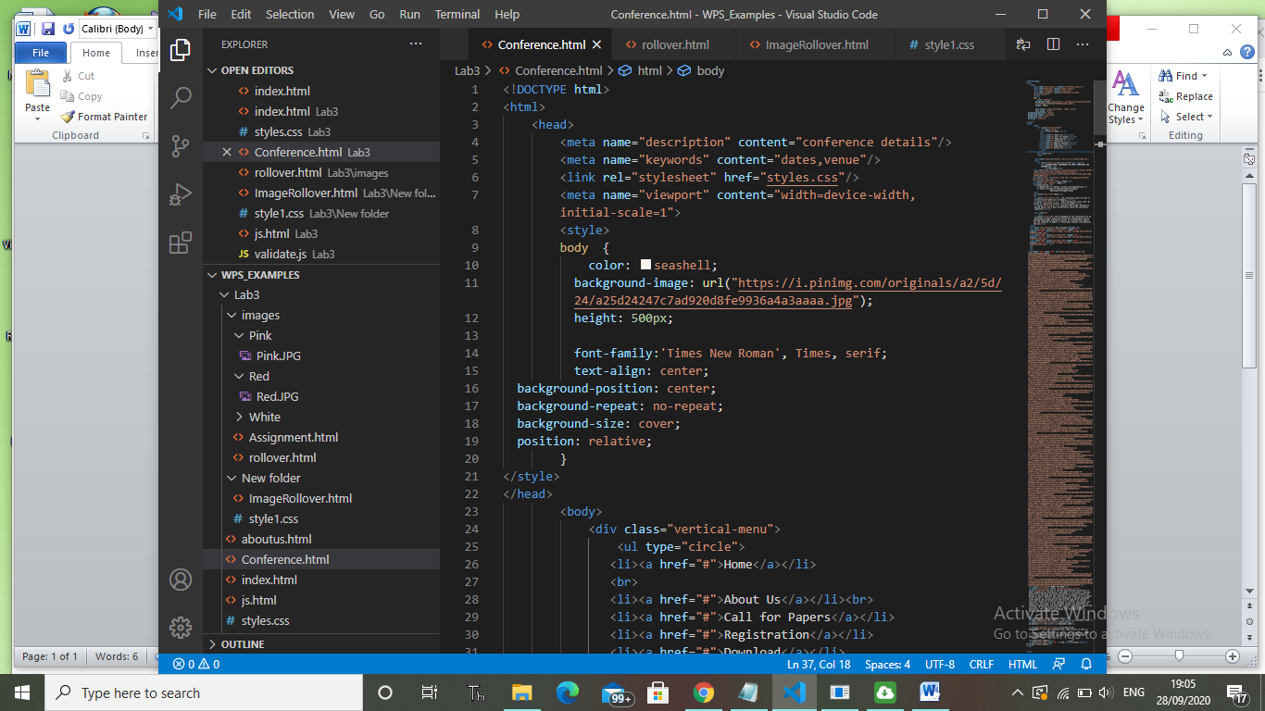

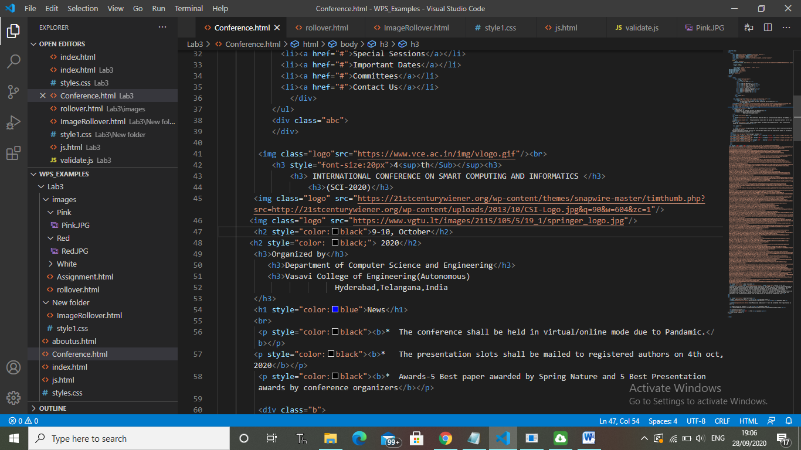

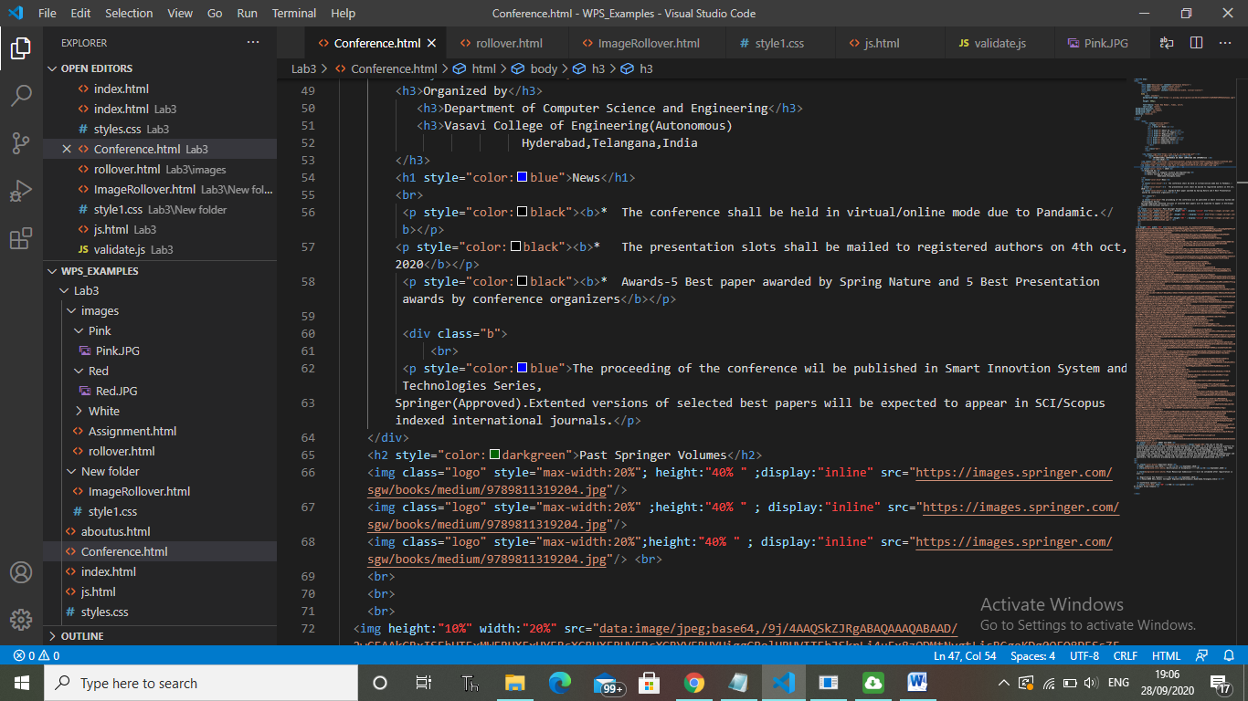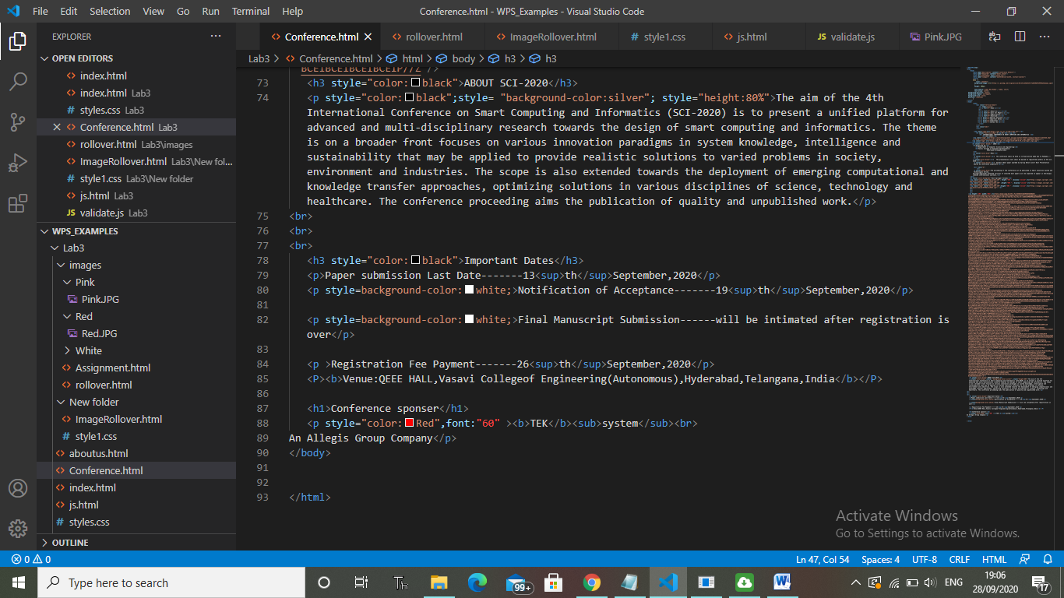**CSS Styles I used in the program**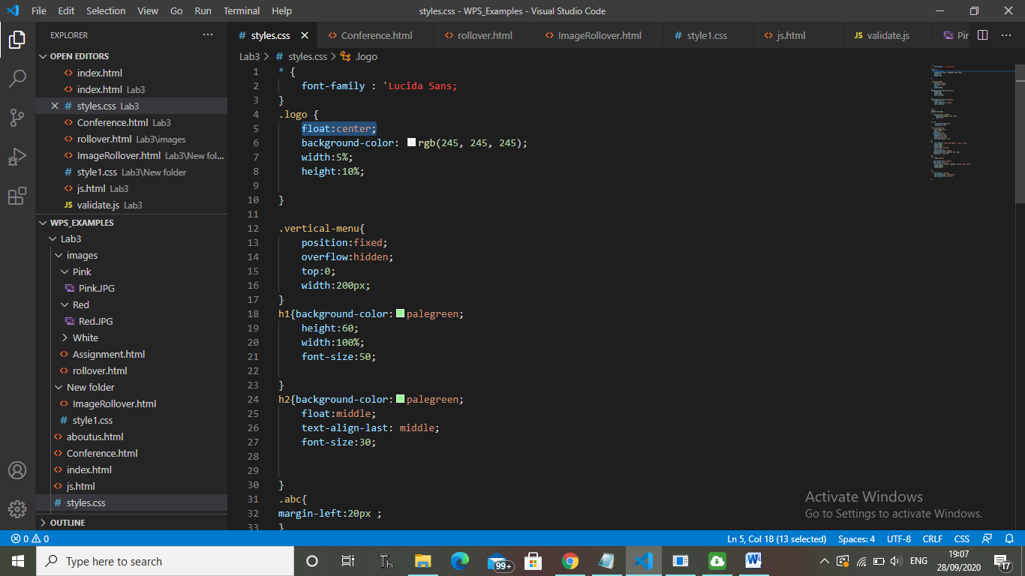

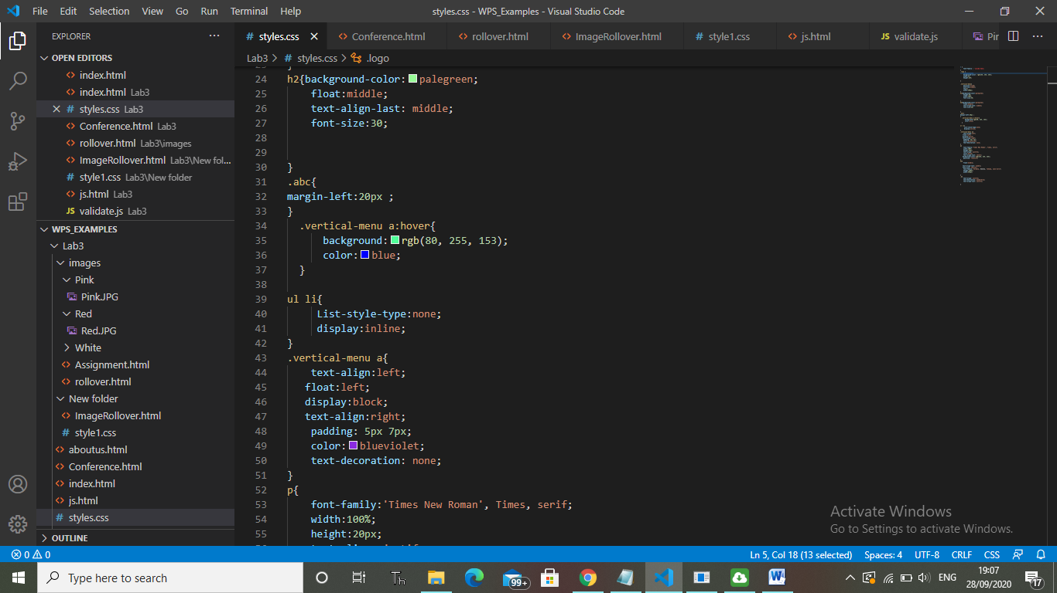

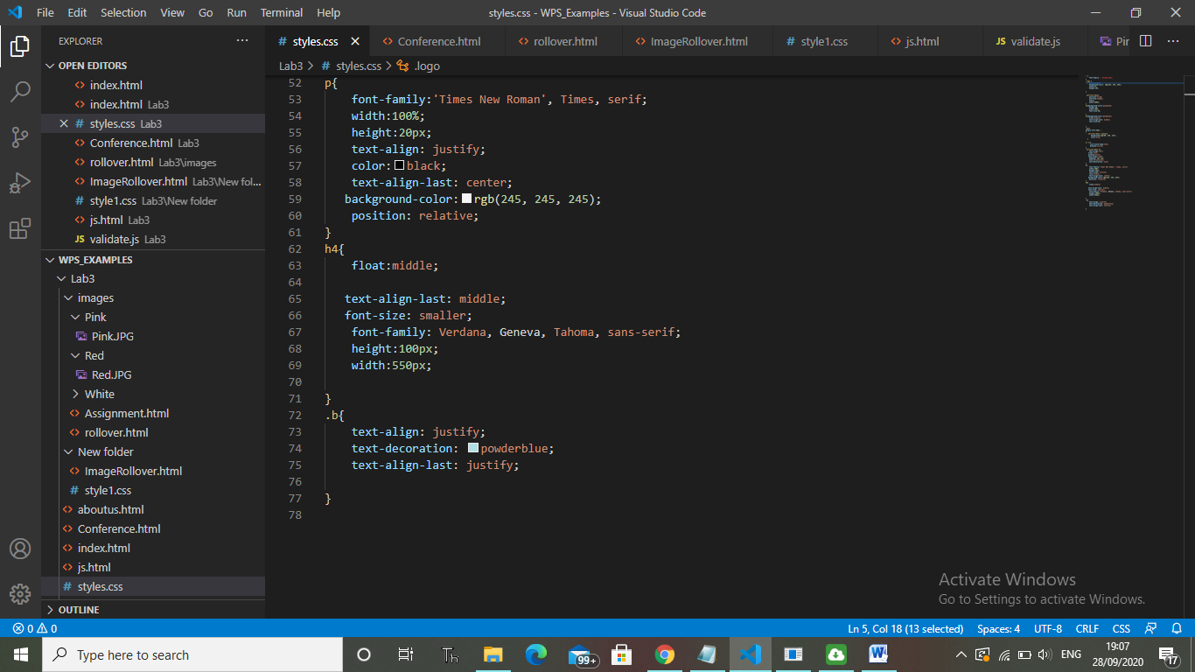

**Output screen:**

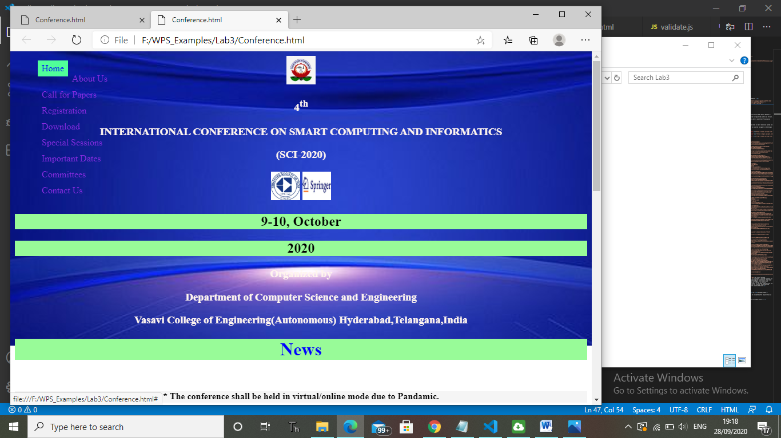

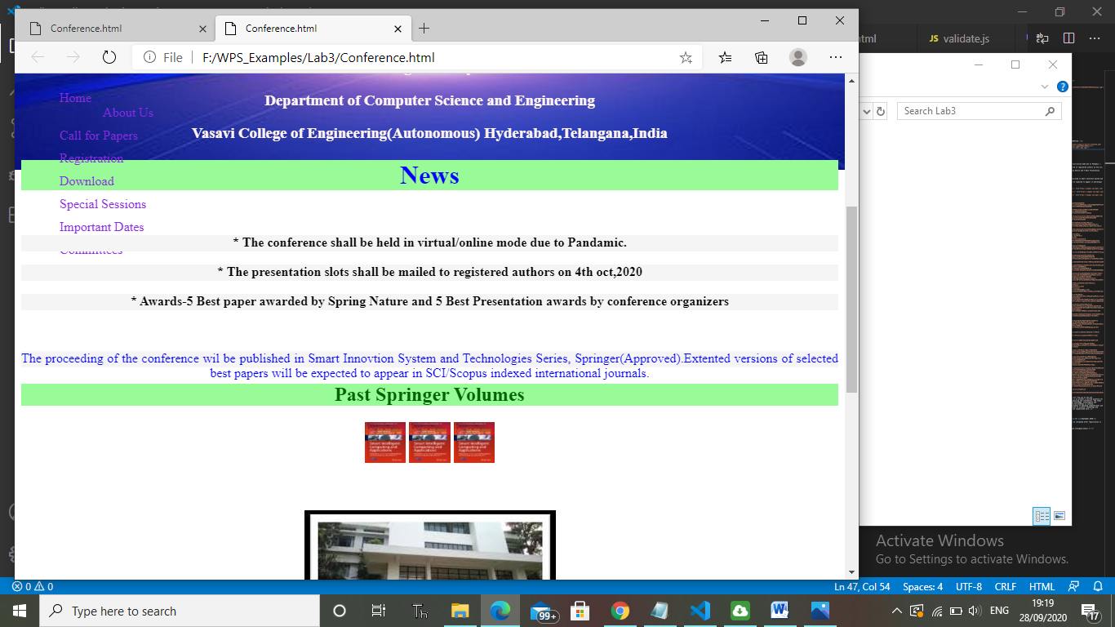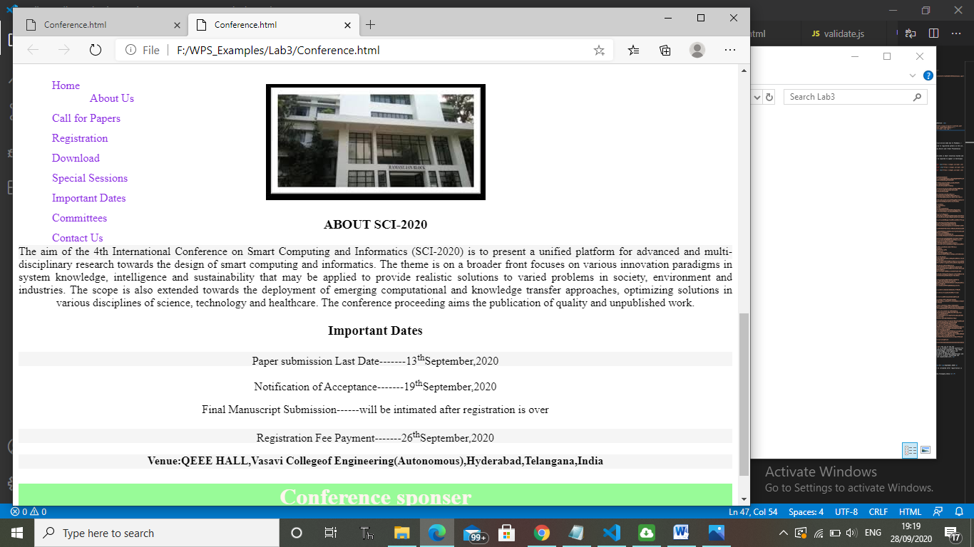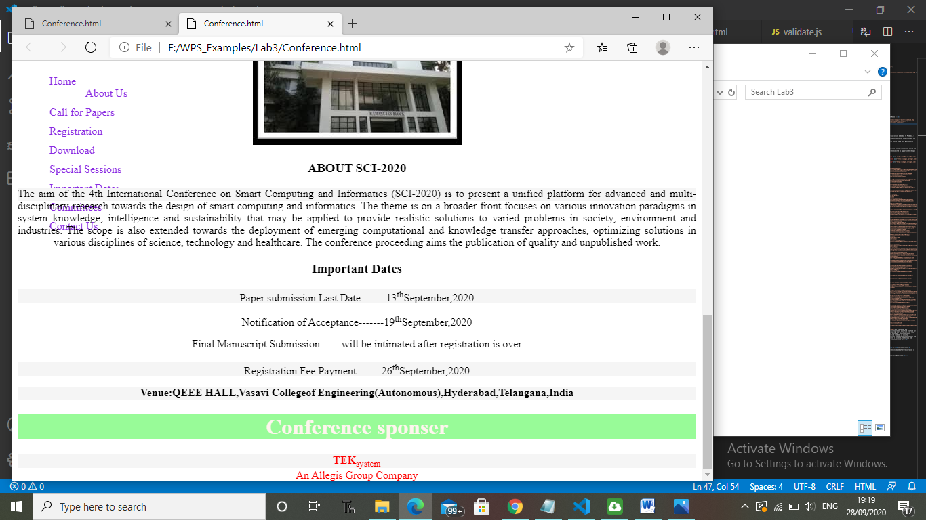

1. Create a basic page in html that displays 3 unique images. Create a separate rollover for each of these images, i.e. onMouseOver display a new, unique image, onMouseOut return it to the original image.

**Code:**

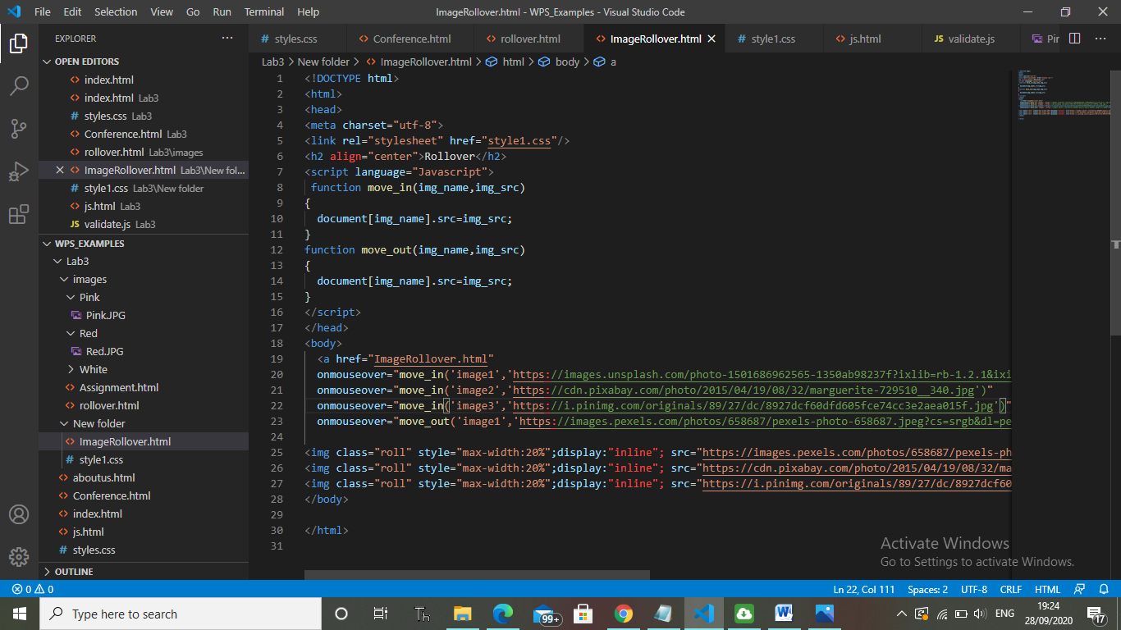

**My CSS style part:**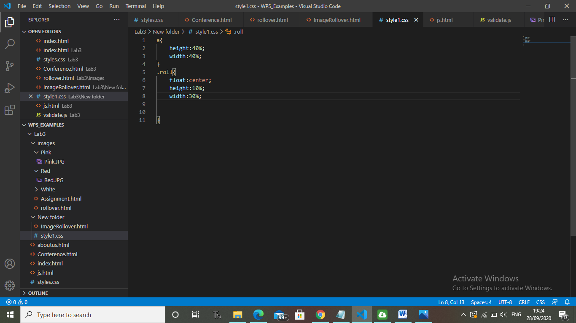

**Output screen:**

**My rollover original images:**

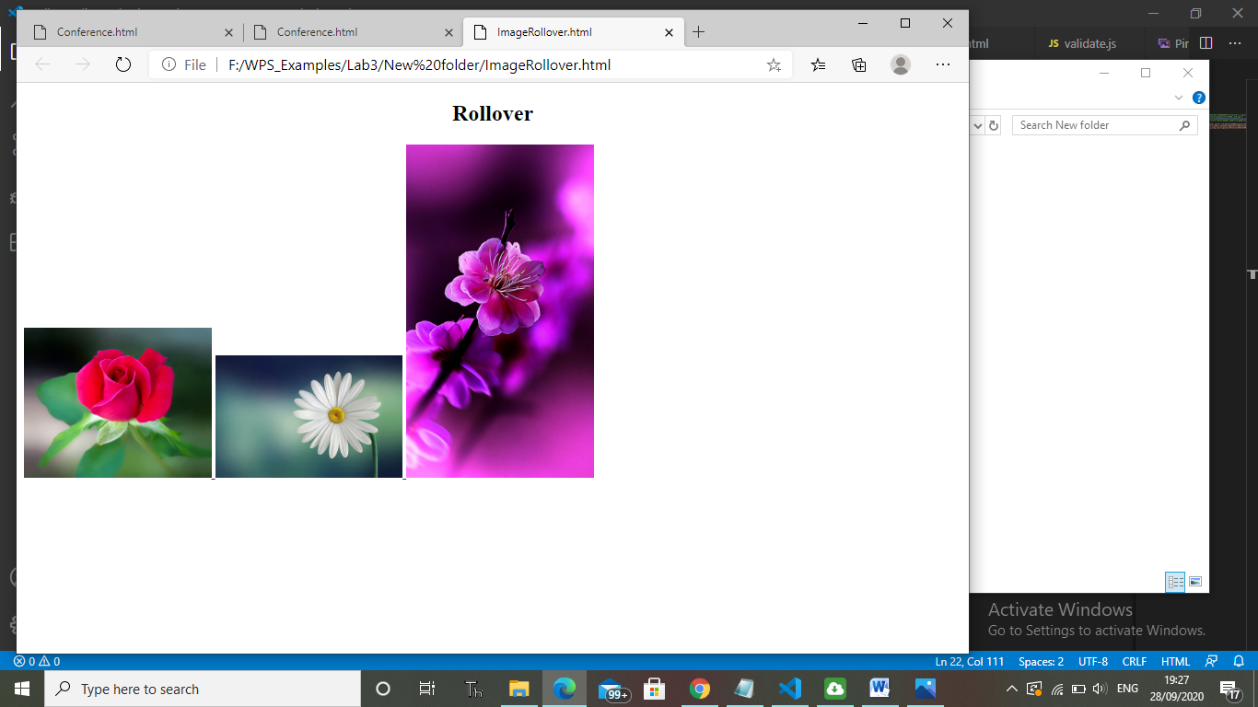

**When I onMouseover:**

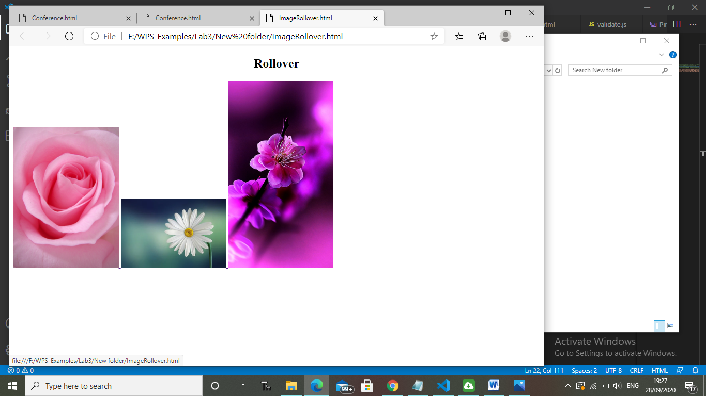

**When I onMouseOut it display original image:**

