Event-Driven Order Processing System Using AWS
Ramy Abdulwahed
¹ University of Guelph, Guelph, ON, Canada
rabdulwa@uoguelph.ca
Abstract: This project presents the design and implementation of an event-driven order processing system using cloud computing services available in the AWS Academy Learner Lab environment. Modern cloud applications must handle large volumes of requests reliably, especially during periods of increased demand. Traditional synchronous processing can lead to system overload and slow response times when traffic spikes occur. To address this challenge, an event-driven architecture was implemented that decouples request submission from backend processing. The system uses Amazon API Gateway to receive order requests, Amazon SQS to queue incoming orders, AWS Lambda to process orders asynchronously, and Amazon DynamoDB to store order data and status. Amazon CloudWatch is used to monitor system behavior and performance metrics. Experimental results show that the system processes requests with low latency, maintains minimal queue backlog under concurrent submissions, and executes Lambda functions efficiently within configured resource limits. The findings demonstrate that event-driven cloud architecture can improve scalability, reliability, and responsiveness in applications with variable workloads, while also highlighting trade-offs related to failure handling and system configuration.
- Introduction
Cloud-based applications such as e-commerce platforms, booking systems, and other online services often experience large fluctuations in user traffic. During peak periods, many users may attempt to submit requests at the same time, such as placing orders or completing transactions. If these systems process requests synchronously, where each request must be completed before the next one begins, performance issues can occur. This can lead to slow response times, system overload, or even service failures when traffic spikes unexpectedly. For systems that rely on order-based workflows, these problems can have direct consequences for both users and system integrity. Failed or delayed order processing may result in lost transactions, duplicate submissions, or inconsistent system state, which can reduce reliability and user trust. As a result, modern cloud applications increasingly adopt architectures that separate request submission from backend processing. Event-driven architecture is commonly used in cloud environments to address this challenge. In this approach, incoming requests are accepted quickly and placed into a queue, allowing them to be processed asynchronously in the background. This design improves scalability and reliability because the system can continue receiving new requests even when processing tasks take longer to complete. This project implements and evaluates an event-driven order processing system using AWS cloud services. The system allows users to submit order requests through a RESTful API built with Amazon API Gateway. Incoming requests are placed into an Amazon SQS queue and processed asynchronously by AWS Lambda functions, while order data and processing status are stored in an Amazon DynamoDB table. Amazon CloudWatch is used to monitor system behavior and performance metrics. The objective of this project is to evaluate how effectively this architecture handles concurrent request submissions, maintains system responsiveness, and ensures reliable order processing under variable workloads.
- Methodology
This section describes the design and implementation of the event-driven order processing system using AWS cloud services. The methodology focuses on how different components were configured and integrated to support scalable and reliable request handling. Each subsystem, including API Gateway, SQS, Lambda, and DynamoDB, is discussed in terms of its role within the architecture and its contribution to overall system behavior

  - System Architecture
The proposed system consists of several AWS services that work together to manage the lifecycle of an order request. Figure 1 illustrates the overall architecture of the system. When a user submits an order request, it is received through a REST endpoint exposed by Amazon API Gateway, which acts as the entry point of the system. API Gateway is responsible for handling incoming HTTP requests and decoupling external clients from backend processing components. This allows the system to scale with incoming traffic while maintaining responsiveness at the interface level. Once a request is received, it triggers an AWS Lambda function that validates the order data and prepares it for processing. This validation step ensures that only well-formed requests are forwarded into the system, preventing invalid data from propagating through downstream components. After validation, the order is placed into an Amazon Simple Queue Service (SQS) queue. The SQS queue serves as a buffering layer between request ingestion and backend processing. By storing incoming requests in the queue, the system can absorb bursts of traffic without requiring immediate processing. This prevents overload of compute resources and allows the system to continue accepting requests even when processing tasks are delayed. A separate Lambda worker function retrieves messages from the SQS queue and processes them asynchronously. Separating ingestion and processing into distinct components ensures loose coupling within the system, allowing each component to scale independently. During processing, the function updates the order status and stores relevant information in an Amazon DynamoDB table. DynamoDB provides a scalable, low-latency data store that supports high write throughput, making it well-suited for handling concurrent order transactions. System activity and performance metrics are monitored using Amazon CloudWatch. Logs generated by the Lambda functions are recorded in CloudWatch, enabling visibility into system behavior during execution and testing. Overall, this architecture enables reliable and scalable request handling by decoupling system components and distributing workload across managed cloud services.
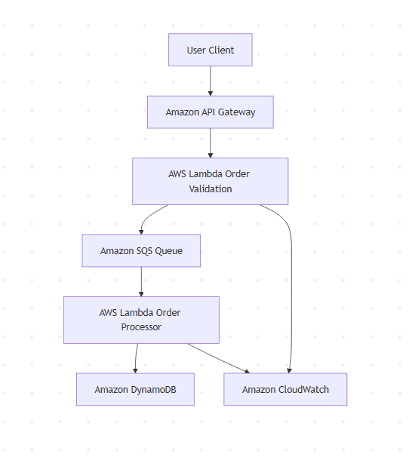
Fig. 1. Event-driven architecture used for the order processing system.

  - Event-Driven Processing
The architecture follows an event-driven model in which system components communicate through events rather than direct synchronous calls as shown in figure 1. In this system, each event corresponds to an order request that is placed into the SQS queue. When a new message becomes available, it triggers the worker Lambda function responsible for processing the order. This event-driven approach enables loose coupling between components, meaning that request ingestion and processing operate independently. As a result, the system is more resilient to fluctuations in workload, since new requests can continue to be accepted even when processing is delayed. Unlike synchronous architectures, where delays in processing directly impact incoming requests, this design isolates components and prevents bottlenecks from propagating through the system. However, this approach introduces eventual consistency, as there may be a delay between request submission and final processing. While this trade-off is acceptable for many order-processing systems, it highlights the importance of carefully designing asynchronous workflows.

  - API Gateway Configuration
Amazon API Gateway was used to expose a RESTful HTTP endpoint for submitting order requests into the system. A POST route was defined at /orders under the dev stage, resulting in a publicly accessible endpoint of the form: https://ktssk0n6re.execute-api.us-east-1.amazonaws.com/dev/orders This endpoint accepts JSON-formatted requests containing order data and forwards them to the createOrder Lambda function. API Gateway was configured using the HTTP API protocol, which provides a lightweight and cost-effective interface compared to the more feature-rich REST API option. This choice is appropriate for the current implementation, as the system does not require advanced features such as request validation, authentication, or API key management. Automatic deployment was enabled for the stage, ensuring that any updates to routes or integrations are immediately reflected without requiring manual redeployment. API Gateway serves as the entry point of the system, decoupling external clients from backend processing components. By offloading request handling to a managed service, the system can scale to handle increasing traffic while maintaining low-latency responses, since requests are quickly accepted and forwarded into the asynchronous processing pipeline.

  - DynamoDB Design
A DynamoDB table named Orders was created to store processed order records as shown in Figure 2. The table uses order_id as the partition key (String type), ensuring that each order is uniquely identifiable. Additional attributes include product, quantity, status, and timestamp, which capture essential information about each order and its processing state. The table is primarily used for write-heavy operations, as each processed order is inserted as a new record by the Lambda worker function. Since the system does not require complex queries or frequent lookups beyond individual order retrieval, a simple primary key design based on order_id is sufficient. This design supports efficient and scalable writes while keeping the data model straightforward. DynamoDB operates in a schema-less manner, allowing flexibility in storing order-related data without requiring predefined structures. This is beneficial for event-driven systems where data formats may evolve over time. The table is configured using on-demand capacity mode, enabling automatic scaling of read and write throughput based on incoming traffic. This aligns with the system’s requirement to handle variable workloads without manual capacity planning. However, the current design does not include secondary indexes or support for querying orders by attributes such as status or timestamp. While this simplifies the implementation, it limits the system’s ability to perform more advanced queries or analytics. In a production system, additional indexing strategies or data modeling considerations would be required to support more complex access patterns.

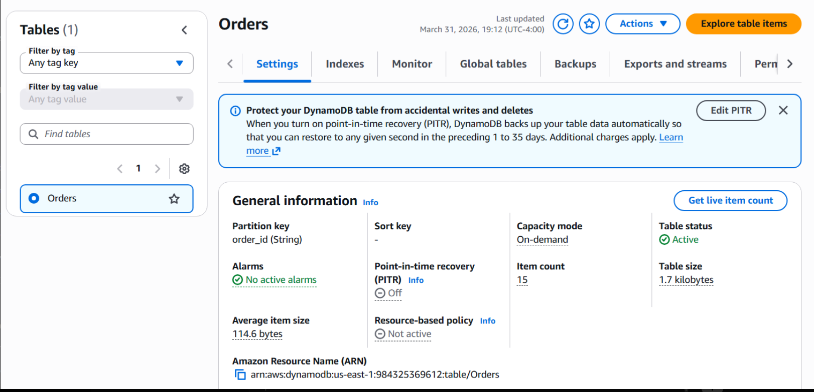
Fig. 2. DynamoDB table configuration for the Orders table, showing partition key, capacity mode, and table status.
  - Amazon SQS Configuration
An Amazon SQS Standard queue named orderQueue was used to enable asynchronous communication between system components as shown in Figure 3. A Standard queue was selected over a FIFO queue because strict message ordering and exactly-once processing were not required for this application. This allows for higher throughput and better scalability, which is more suitable for handling bursts of incoming requests. The queue was configured with a visibility timeout of 30 seconds, ensuring that messages are temporarily hidden while being processed by the consumer Lambda function. This prevents multiple consumers from processing the same message simultaneously. Given that the observed Lambda execution times are well below this threshold, the configured timeout provides a sufficient buffer to avoid premature message reprocessing. The message retention period was set to 4 days, allowing messages to remain available in the queue in case of processing delays or system interruptions. The queue operates without a delivery delay, enabling immediate message availability after submission. A dead-letter queue (DLQ) was not configured in this implementation, meaning that failed messages are retried indefinitely. Since Amazon SQS follows an at-least-once delivery model, messages may be delivered more than once, especially in cases of processing failure or timeout. Without a DLQ, messages that consistently fail processing may be repeatedly retried, potentially impacting system efficiency and resource usage. While this simplifies the system configuration, it introduces a limitation in handling persistent failures. In a production system, configuring a DLQ with a defined retry threshold would allow problematic messages to be isolated and analyzed, improving system reliability and observability.
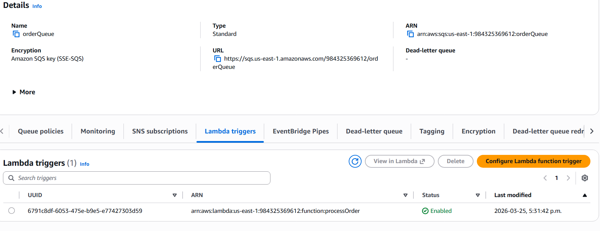
Fig. 3. Amazon SQS queue configuration showing queue type, encryption, and Lambda trigger integration.
  - AWS Lambda Configuration
Two AWS Lambda functions were used in this system: createOrder for handling incoming API requests and processOrder for processing messages from the SQS queue as shown in figure 4 & 5. The separation of responsibilities ensures that request ingestion remains lightweight, while processing is handled independently, supporting a decoupled and scalable system design. Both functions were configured using the default AWS settings of 128 MB memory and a 3-second timeout. The memory allocation determines both available RAM and CPU performance. In this implementation, the workload is lightweight, consisting primarily of request parsing, message forwarding, and database writes. Observed execution metrics show that memory usage remains well below the allocated limit, indicating that the default configuration is sufficient while avoiding unnecessary cost increases associated with higher memory allocation. The 3-second timeout defines the maximum execution duration for each function. This value is significantly lower than the SQS visibility timeout of 30 seconds, ensuring that messages are processed well within the visibility window. Based on observed execution times in the millisecond range, the configured timeout provides a large safety margin and prevents premature message reprocessing.
The processOrder function is triggered automatically by SQS through an event source mapping as shown in figure 5. Messages are delivered in batches of up to 10 per invocation, which improves processing efficiency by reducing the number of Lambda executions. However, batch processing introduces additional complexity, as failures within a batch may require retrying multiple messages, potentially leading to duplicate processing in the absence of a dead-letter queue. AWS Lambda automatically scales based on incoming request volume, allowing multiple instances of the function to run concurrently. This enables the system to handle bursts of messages from the SQS queue without manual resource provisioning. Combined with the asynchronous queue-based design, this scaling behavior contributes to the system’s ability to maintain performance under variable workloads. No dead-letter queue or failure destination was configured for the Lambda functions. As a result, failed messages are retried through SQS without isolation, which may lead to repeated processing of problematic messages. While this simplifies the implementation, it represents a limitation in terms of fault handling and system robustness.

  - AWS Lambda implementation

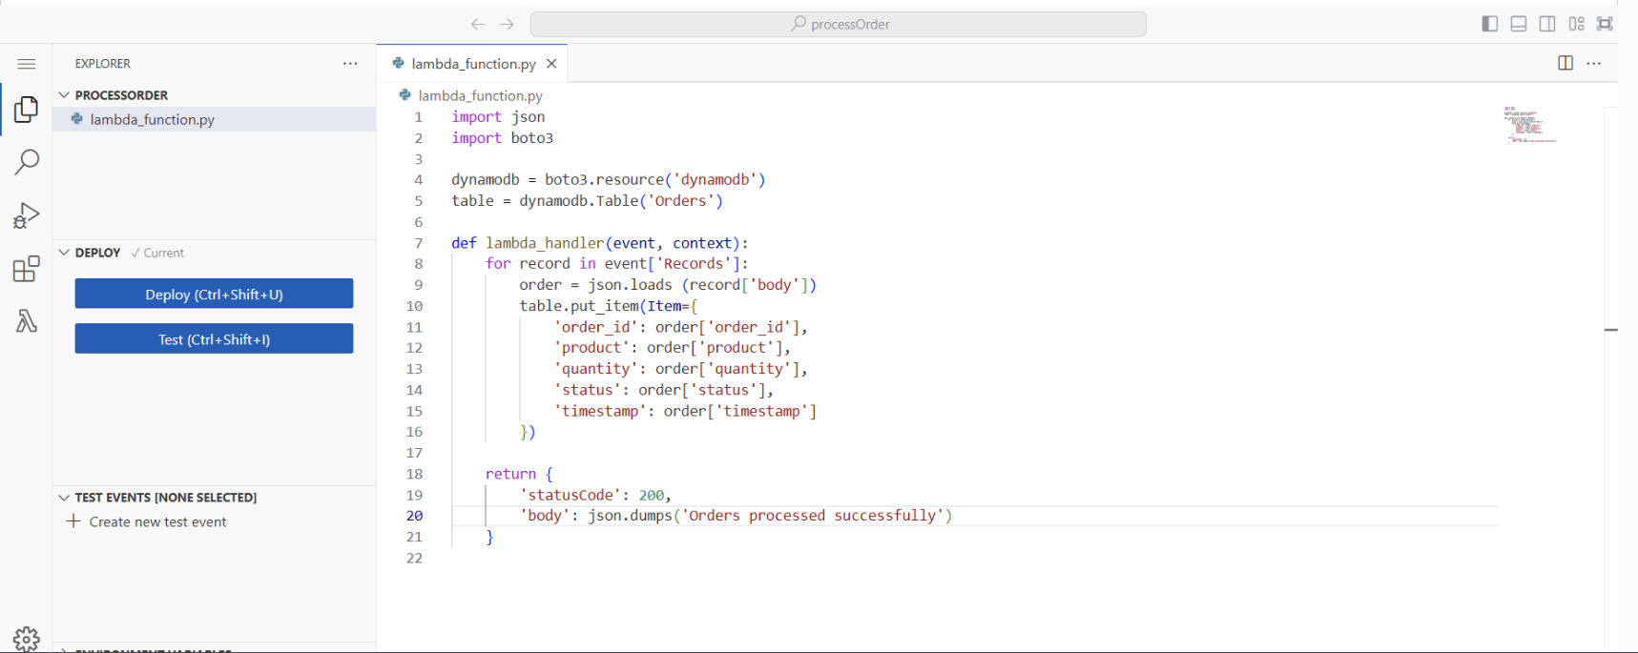
Fig. 4. The processOrder Lambda function is responsible for consuming messages from the SQS queue and persisting them into DynamoDB. The function processes incoming messages in batches, iterating over each record within the event payload. Each message is deserialized from JSON format and written to the Orders table using the put_item operation. This batch-oriented processing improves throughput by allowing multiple messages to be handled within a single invocation, reducing the number of required Lambda executions and associated overhead.
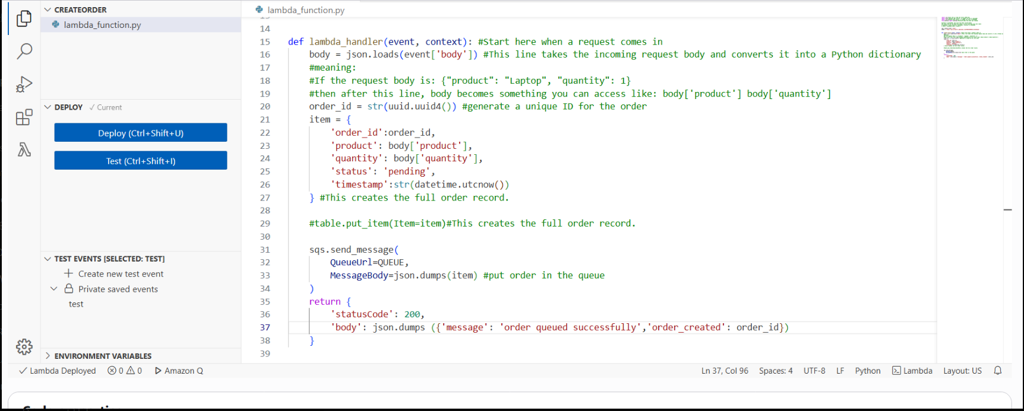
Fig. 5. The createOrder Lambda function handles incoming API requests by parsing the request body, generating a unique order identifier, and constructing an order object. Instead of directly storing the data, the function forwards the order to the SQS queue. This design keeps the ingestion layer lightweight and ensures that request handling remains fast and responsive, while deferring more time-consuming processing tasks to downstream components.

By separating request ingestion from order processing, the implementation supports asynchronous execution and enables the system to handle higher volumes of incoming requests without introducing bottlenecks at the API level.

  - Event Source Mapping
The connection between Amazon SQS and the processOrder Lambda function is configured through an event source mapping as shown in figure 6. This setup enables automatic invocation of the Lambda function whenever new messages arrive in the queue, eliminating the need for manual polling. The trigger is configured with a batch size of 10, allowing multiple messages to be processed within a single execution. This improves processing efficiency by reducing the number of Lambda invocations and associated overhead. Event source mapping also enables the system to scale dynamically, as Lambda automatically adjusts the number of concurrent executions based on the volume of messages in the queue. This ensures that the system can handle fluctuations in workload while maintaining efficient message processing.

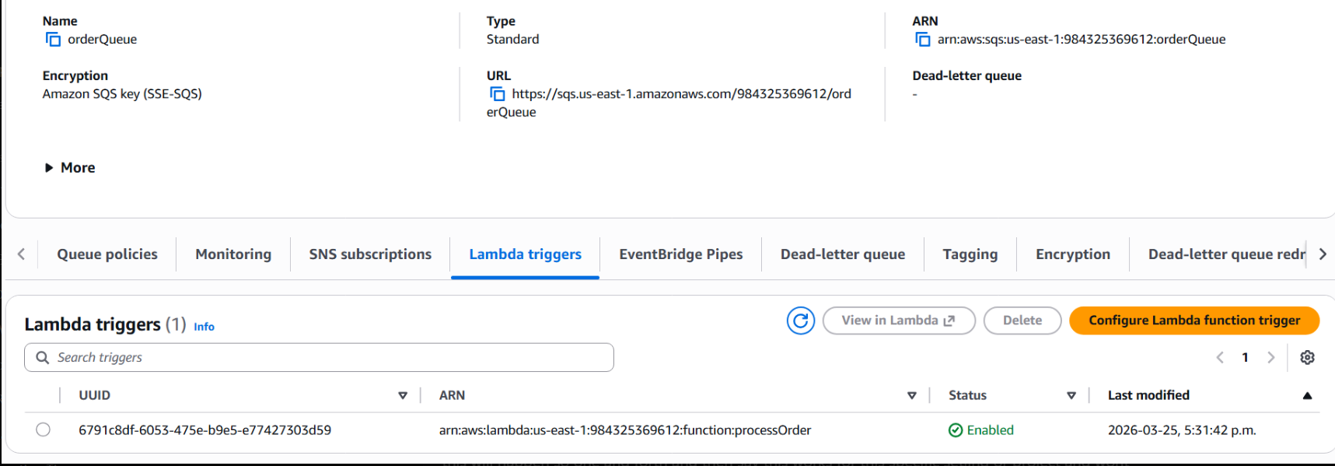
Fig. 6. Amazon SQS queue configuration with Lambda trigger integration
- Findings
To evaluate the system, multiple HTTP requests were sent to the deployed API Gateway endpoint using curl. The system consistently returned successful responses, each containing a unique order ID, confirming that requests were correctly received and processed. The submitted orders were successfully stored in DynamoDB, as reflected by the increasing number of records in the table. The close proximity of timestamps across multiple entries indicates that the system is capable of handling concurrent request submissions without data loss or inconsistency. Analysis of SQS metrics shows that the number of messages sent, received, and deleted are closely aligned. This indicates that the system is processing messages at a rate comparable to their arrival, resulting in minimal queue buildup.
The near-zero number of visible messages suggests that the Lambda consumer is able to keep up with incoming traffic under the tested workload. CloudWatch logs further show that Lambda execution durations are consistently in the range of tens of milliseconds. This low execution time, relative to the configured visibility timeout, ensures that messages are processed well within the available window, reducing the likelihood of duplicate processing. Overall, the observed results suggest that the system performs efficiently under moderate request loads, maintaining low latency and consistent message processing. However, the evaluation is limited to controlled test conditions, and further testing under higher traffic volumes or failure scenarios would be required to fully assess system scalability and robustness.
  - System Validation
The system was validated through end-to-end testing of the request processing pipeline as shown in figure 7. A curl request was sent to the API Gateway endpoint, and the response included a confirmation message along with a unique order identifier. This indicates that the createOrder Lambda function successfully received and processed the incoming request. The generated order ID was subsequently observed in the DynamoDB table, confirming that the request propagated through the full system pipeline, including message queuing and asynchronous processing by the processOrder Lambda function. This end-to-end verification demonstrates that all system components are correctly integrated and functioning as intended.

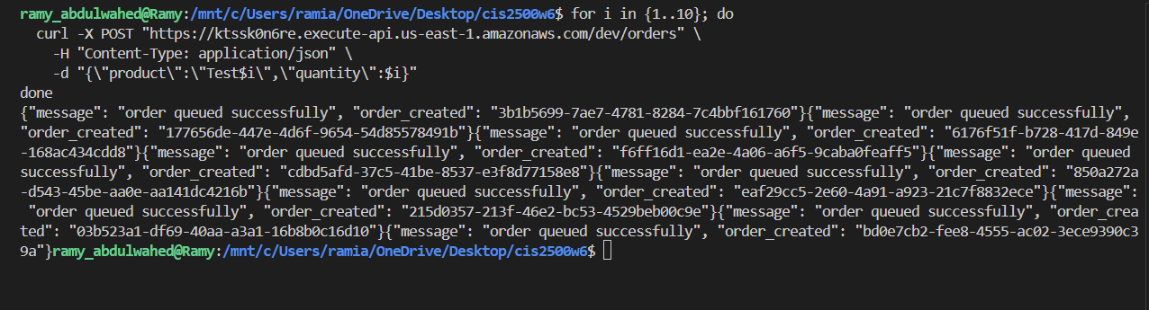
Fig. 7. API testing using curl showing multiple order requests submitted and corresponding success responses with generated order IDs

  - Data Persistence
The DynamoDB table contains multiple order entries with unique identifiers, product values, quantities, and timestamps, confirming that processed requests are consistently persisted after asynchronous execution as shown in figure 8. The close proximity of timestamps across multiple entries indicates that the system is capable of handling concurrent write operations without data loss or inconsistency. Each order is recorded as a distinct entry, demonstrating that the system avoids overwriting or duplicating records during processing. This behavior suggests that the database layer is correctly integrated into the event-driven pipeline and can support concurrent request handling under the tested conditions.
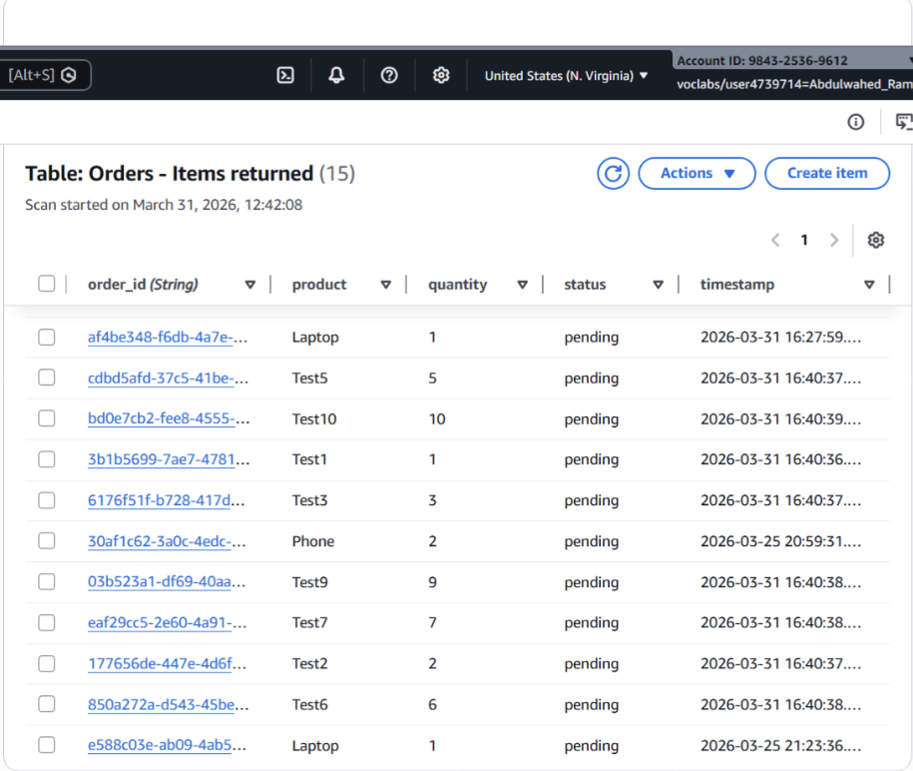
Fig. 8. DynamoDB table entries showing stored order records with unique identifiers, attributes, and timestamps.

  - Queue Behaviour and Throughput
The behavior of the SQS queue was analyzed using CloudWatch metrics, including the number of messages sent, received, and deleted, as well as the number of visible and non-visible messages as shown in figure 9. The number of messages sent to the queue closely matches the number of messages received and deleted. This indicates that messages are being processed at a rate comparable to their arrival, suggesting that the system is not experiencing significant delays in processing under the tested workload. The approximate number of visible messages remains close to zero throughout the observation period. This implies that messages do not remain in the queue for extended periods, and that the consumer Lambda function is able to process them quickly after arrival. Similarly, the low number of messages not visible indicates that there are no large batches of messages being held in-flight for long durations. The presence of empty receives reflects instances where the Lambda function polled the queue but found no available messages. This is expected behavior in systems where message arrival is not continous, and it suggests that the system is not under sustained heavy load. Overall, these metrics indicate that the queue is operating efficiently, with minimal backlog and timely message processing. This behavior is expected for an event-driven system under moderate load, where the processing components can keep pace with incoming requests. In scenarios with higher traffic volumes, the queue would act as a buffering layer, allowing messages to accumulate temporarily while Lambda scales to process them. This design enables the system to maintain responsiveness even as workload increases.
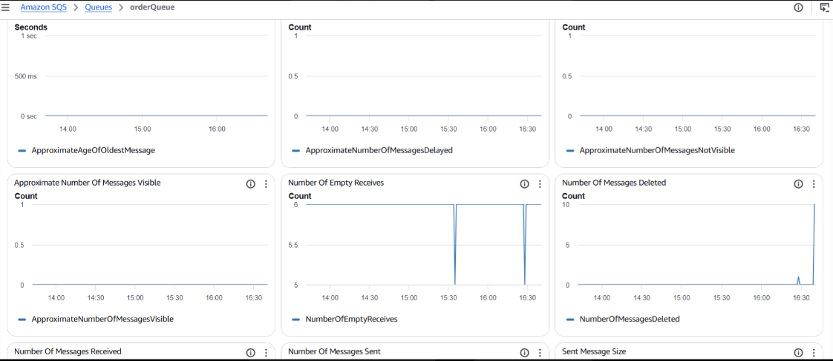
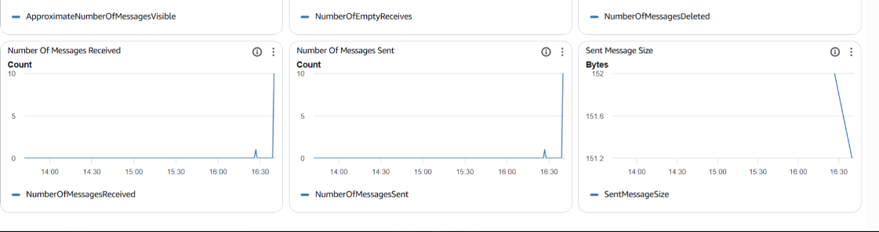
Fig. 9. CloudWatch metrics for the SQS queue showing message flow, queue visibility, and processing activity over time
Additional throughput optimization is achieved through batch processing. The SQS queue is configured to deliver messages to the Lambda consumer in batches of up to 10 records per invocation as shown in figure 10. This allows multiple messages to be processed within a single execution, reducing the total number of Lambda invocations required. As a result, the system improves processing efficiency while lowering execution overhead and cost. This batching behavior contributes to the system’s ability to handle bursts of incoming requests without creating processing delays.
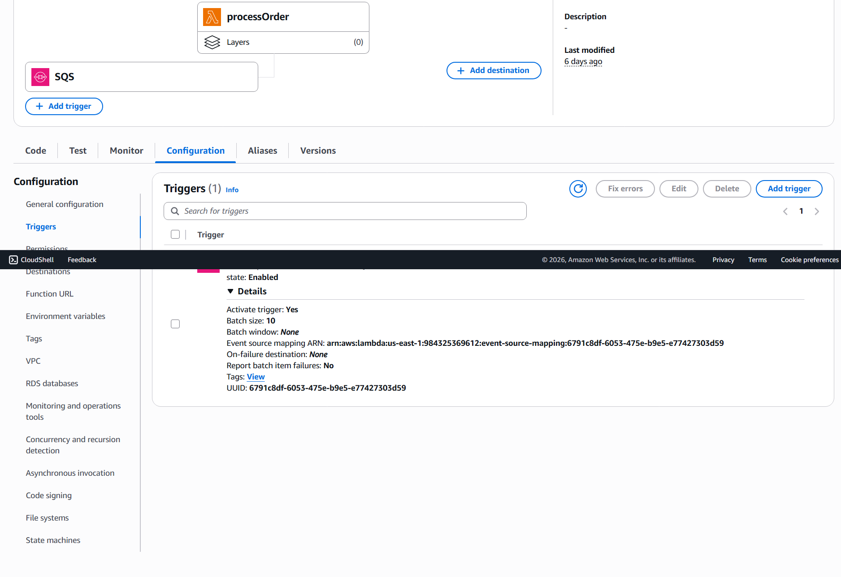
Fig. 10. Lambda event source mapping showing SQS trigger configuration and batch processing settings.

  - Lambda Execution Performance
CloudWatch logs show that the Lambda function consistently executes within a range of approximately 25 ms to 83 ms, with most executions clustering around 30–40 ms as shown in figure 11. These low execution times indicate that the processing logic is lightweight and efficient, allowing the system to handle incoming requests with minimal delay. In terms of resource utilization, the function uses a maximum of approximately 92 MB out of the allocated 128 MB, suggesting that the current memory configuration is sufficient for the workload without exceeding available resources. This indicates that the system avoids unnecessary over-provisioning while still maintaining stable performance. The billed duration closely matches the actual execution time, remaining under 100 ms for all observed executions. Since AWS Lambda pricing is based on execution duration and memory allocation, these low values imply that the system operates in a cost-efficient manner for this type of workload. From a performance perspective, the short execution time also enables higher throughput, as more messages can be processed within a given time window. Additionally, all executions complete well within the SQS visibility timeout of 30 seconds, ensuring that messages are processed reliably without being reprocessed due to timeout expiration. Overall, these results demonstrate that the Lambda-based processing layer is efficient, cost-effective, and well-aligned with the asynchronous architecture of the system.

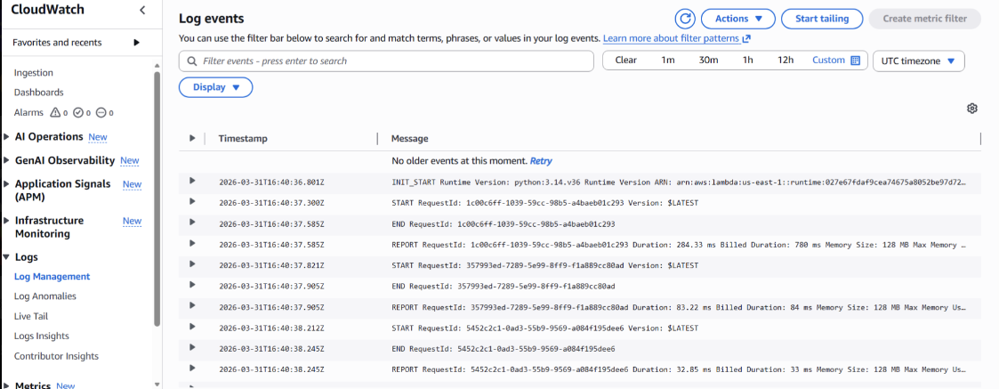
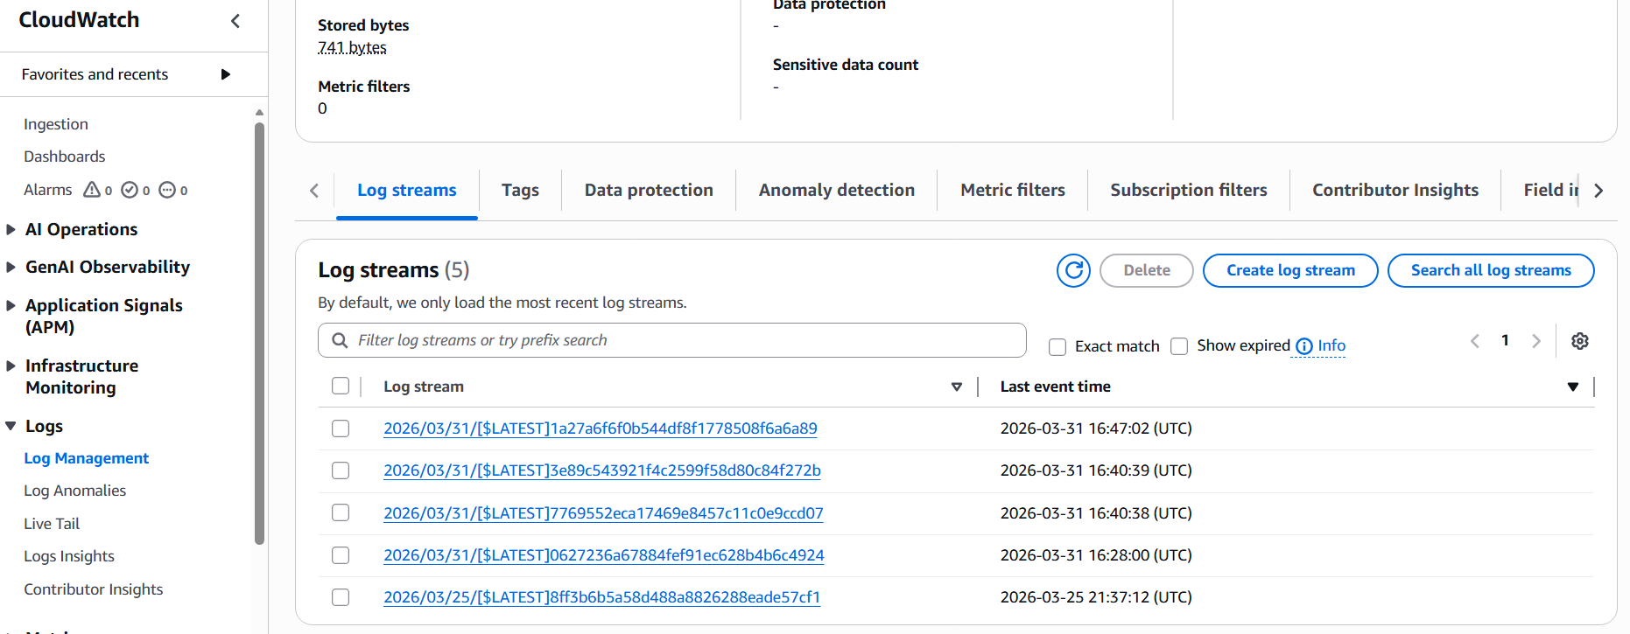
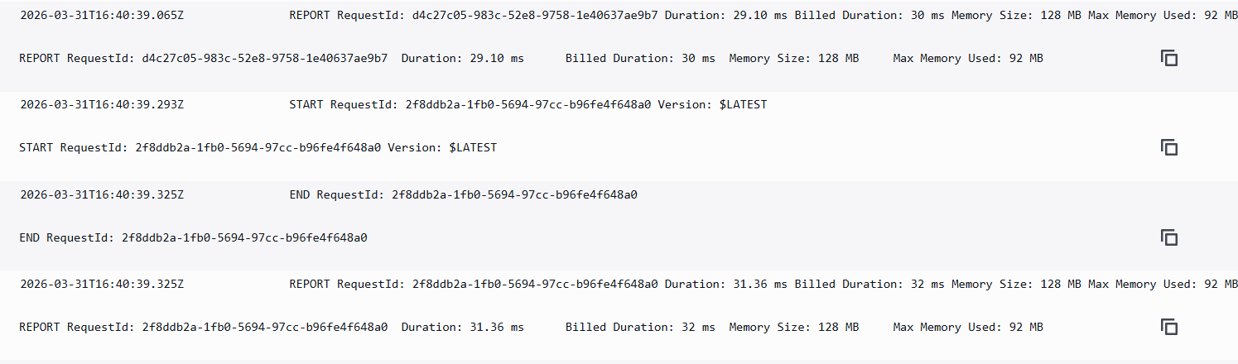

Fig. 11. CloudWatch logs showing Lambda execution details, including request duration, billed duration, and memory usage

  - System-Level Analysis
The combined results indicate that the system functions effectively as an event-driven architecture. By decoupling request submission from backend processing, the system avoids bottlenecks at the ingestion layer and maintains responsiveness under the tested workload. The integration of SQS and Lambda enables a flexible processing pipeline, where requests can be buffered and processed asynchronously as resources become available. This design allows the system to adapt to fluctuations in demand without requiring manual scaling or immediate processing of all requests. However, the current implementation lacks mechanisms for handling persistent failures and ensuring data integrity, such as dead-letter queues and comprehensive input validation. These limitations highlight important considerations for deploying such a system in a production environment. Overall, the system demonstrates the effectiveness of event-driven design for handling variable workloads, while also emphasizing the need for additional safeguards to improve robustness and reliability in real-world applications.
- Discussion
The implemented system successfully addresses the core challenge of handling incoming requests reliably under varying workloads. By using an event-driven architecture, requests are accepted immediately through API Gateway and processed asynchronously using SQS and Lambda. This prevents the system from becoming overloaded during bursts of traffic, which is a common limitation in synchronous designs. The results from testing show that the system is able to handle multiple requests efficiently while maintaining responsiveness, indicating that the chosen architecture is effective for this type of problem. Several design choices in this implementation were made intentionally based on the scope and objectives of the project. The system is designed as a prototype to demonstrate the core principles of event-driven architecture under controlled conditions, where incoming requests are assumed to be well-formed and system usage is limited. As a result, features such as dead-letter queues (DLQs), notification mechanisms like Amazon SNS, comprehensive input validation, authentication, and rate limiting were not included in order to maintain a simplified architecture and focus on the core processing pipeline.
While this approach is appropriate for demonstrating system behavior and evaluating performance, these components would be essential in a production environment. A DLQ would enable proper handling of persistent failures, SNS could provide real-time updates on order status, and input validation would ensure data integrity. Additionally, authentication and rate limiting would be necessary to protect the system from unauthorized access and misuse. Incorporating these features would significantly improve the system’s robustness, security, and overall reliability. One key lesson from this project is the importance of decoupling system components to improve scalability and fault tolerance. Using SQS as an intermediary between request ingestion and processing allows each part of the system to operate independently, reducing the risk of cascading failures. Another important takeaway is that configuration parameters, such as Lambda memory allocation and SQS visibility timeout, directly influence system performance, reliability, and cost. This highlights the need to carefully balance simplicity and robustness when designing cloud-based systems.

- Conclusion
This project presented the design and implementation of an event-driven order processing system using AWS cloud services. The results demonstrate that separating request ingestion from backend processing enables the system to maintain responsiveness while handling multiple incoming requests efficiently. The observed behavior of the system highlights the effectiveness of combining queue-based buffering with serverless compute, allowing workloads to be processed asynchronously without introducing bottlenecks. This reinforces the role of event-driven architecture as a practical approach for managing variable and unpredictable demand in distributed systems. Beyond the implementation itself, the project emphasizes the importance of understanding how architectural decisions and service configurations influence system behavior, performance, and reliability. These considerations are critical when designing cloud-based systems that must balance simplicity, scalability, and robustness. Overall, the project demonstrates how core cloud design principles can be applied to build flexible and efficient systems, while providing a foundation for further extension into more robust, production-ready solutions.
- Appendix A: Contribution and Evidence of Work Distribution
All aspects of the project were completed individually, including the problem definition, system design, implementation using AWS services, testing, and documentation.

The implementation involved configuring API Gateway, AWS Lambda functions, SQS queues, and DynamoDB tables, as well as testing system behavior under multiple request conditions. The written report, including methodology, findings, and analysis, was also prepared independently.

Evidence of work includes AWS configuration and testing outputs, such as CloudWatch logs, SQS metrics, DynamoDB entries, and API testing using curl, as presented throughout the report.

Proposed Weighted Contribution:
Ramy Abdulwahed - Contributed 100% to this project.
Signature: _____Ramy______________ Date: __28/03/26_______________
- Appendix B: AWS Academy Cloud Foundations Progress

Group Member | AWS Academy Cloud Foundations Component | Status
Ramy Abdulwahed | Module 1 (slides and videos) | Done
Ramy Abdulwahed | Module 1 Assignments (Knowledge Check 1, Lab 1) | Done
Ramy Abdulwahed | Module 2 (slides and videos) | Done
Ramy Abdulwahed | Module 2 Assignments (Knowledge Check 1, Lab 1) | Done
Ramy Abdulwahed | Module 3 (slides and videos) | Done
Ramy Abdulwahed | Module 3 Assignments (Knowledge Check 1, Lab 1) | Done
Ramy Abdulwahed | Module 4 (slides and videos) | Done
Ramy Abdulwahed | Module 4 Assignments (Knowledge Check 1, Lab 1) | Done
Ramy Abdulwahed | Module 5 (slides and videos) | Done
Ramy Abdulwahed | Module 5 Assignments (Knowledge Check 1, Lab 1) | Done
Ramy Abdulwahed | Module 6 (slides and videos) | Done
Ramy Abdulwahed | Module 6 Assignments (Knowledge Check 1, Lab 1) | Done
Ramy Abdulwahed | Module 7 (slides and videos) | Done
Ramy Abdulwahed | Module 7 Assignments (Knowledge Check 1, Lab 1) | Done
Ramy Abdulwahed | Module 8 (slides and videos) | Done
Ramy Abdulwahed | Module 8 Assignments (Knowledge Check 1, Lab 1) | Done
Ramy Abdulwahed | Module 9 (slides and videos) | Done
Ramy Abdulwahed | Module 9 Assignments (Knowledge Check 1, Lab 1) | Done
Ramy Abdulwahed | Module 10 (slides and videos) | Done
Ramy Abdulwahed | Module 10 Assignments (Knowledge Check 1, Lab 1) | Done

