HA6_Patient Readmission Prediction Agent (Healthcare IT)
Contents
1. Project Overview 1
Problem Statement 1
Goal 1
2. Target Users 1
3. Scope (Important for Freshers) 1
In Scope 1
Out of Scope 2
4. High-Level Architecture 2
5. Functional Requirements 2
5.1 Patient Data Input 2
5.2 Risk Prediction Logic 3
5.3 AI Agent Responsibilities (Core) 4
5.4 Output Requirements 4
6. Non-Functional Requirements 5
7. Technology Stack Requirements 5
8. AI Agent Design Requirements 6
Agent Should Demonstrate: 6
Agent Prompt Must Include: 6
9. Safety & Compliance Guideline 6
10. Dataset Requirement (Mock) 6
11. Demo Evaluation Criteria 6

1. Project Overview

Problem Statement
Hospital readmissions within 30 days are costly and often preventable. Healthcare staff need early indicators of high-risk patients so they can intervene.

Goal
Build an AI Agent that:
Analyzes patient discharge data
Predicts readmission risk (Low / Medium / High)
Explains why a patient is at risk
Suggests preventive actions
This is a decision-support agent, not a medical diagnosis system.

2. Target Users
- Care Coordinators
- Hospital Operations Team
- Case Managers
- Nursing Staff (non-clinical decision support)

3. Scope (Important for Freshers)

In Scope
- Rule based + LLM reasoning
- Simple datasets (CSV / JSON)
- Conversational interaction
- Transparent explanation

Out of Scope
- Deep learning model training
- Live hospital systems
- Clinical diagnosis
- HIPAA production compliance

4. High-Level Architecture
User (CLI / Streamlit)
↓
AI Agent (Ollama LLM)
↓
Patient Data Analyzer (Rules + CSV)
↓
Risk Scoring Tool
↓
Explanation + Recommendation

5. Functional Requirements

5.1 Patient Data Input
The agent must accept the following patient discharge attributes:
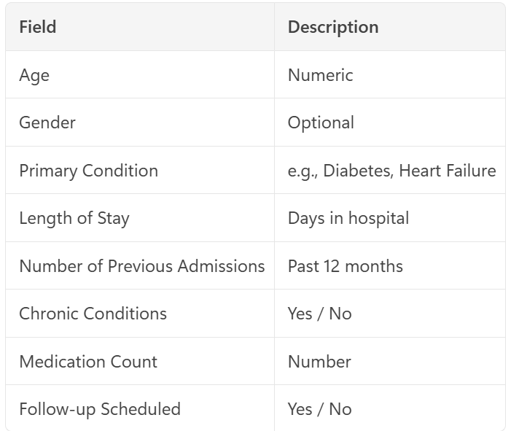➡ Data can be entered:
Conversationally
OR selected from a CSV file (mock dataset)

5.2 Risk Prediction Logic
The system must categorize patients into:
- Low Risk
- Medium Risk
- High Risk
Sample Heuristics (Simple & Explainable)
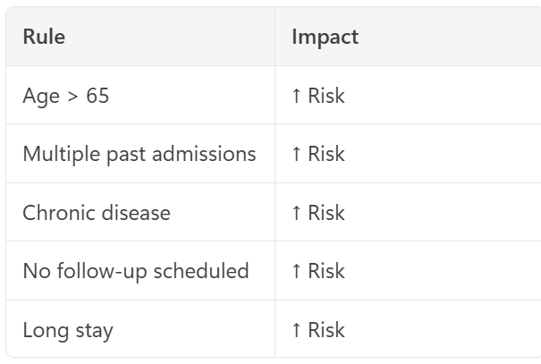 Logic must be transparent and explainable

5.3 AI Agent Responsibilities (Core)
The AI Agent must:
- Analyze patient data
- Call a risk scoring tool
- Interpret the score
- Explain the reasons
- Suggest non-clinical actions
- Apply medical safety disclaimer

5.4 Output Requirements
The agent response must include:
- Readmission Risk Level
- Top contributing factors
- Recommended preventive actions
- Safety disclaimer
Example Output
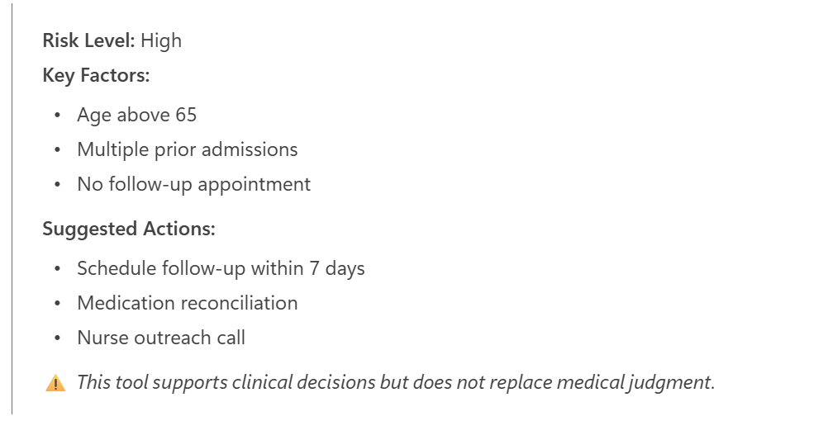

6. Non-Functional Requirements
Must run offline
Must use Ollama LLM
No internet dependency
Simple error handling
Response time < 5 seconds

7. Technology Stack Requirements
Mandatory
- Ollama (llama3:8b or mistral)
- Python 3
- CSV / JSON as data source
Optional
Streamlit (UI)
- LangChain (light usage)

8. AI Agent Design Requirements

Agent Should Demonstrate:
✅ Multi-step reasoning
✅ Tool calling
✅ Domain constraints
✅ Ethical safety handling
✅ Explainability

Agent Prompt Must Include:
- Healthcare context
- Non diagnostic disclaimer
- Structured response format

9. Safety & Compliance Guideline
The agent must:
- Avoid giving medical diagnosis
- Avoid treatment prescriptions
- Always include disclaimer
- Escalate “High Risk” with cautionary language

10. Dataset Requirement (Mock)
A small CSV file with 20–50 sample patients, including:
- Age
- Condition
- Admission count
- Follow-up status
- Final readmission outcome (for validation only)
⚠️ Synthetic / anonymized data only

11. Demo Evaluation Criteria

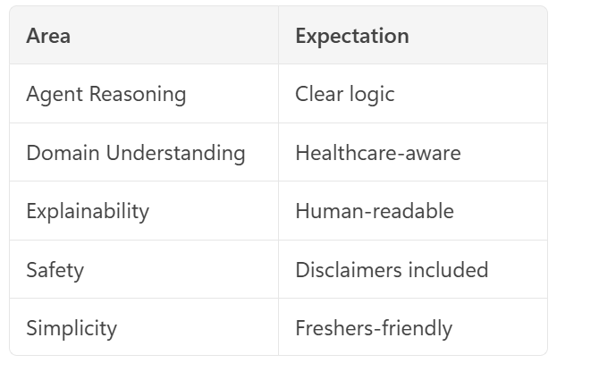
Expected Final Deliverables
Working AI Agent
Source code
Mock dataset
Demo script
Brief documentation

