Student Enrollment Management

Version 1

Contents
1 Preface 3
1.1 Purpose of this document 3
1.2 Use of this document 3
2 Introduction 4
2.1 Overview 4
3 System Design 5
3.1 PROGRAMMING Standards 5
3.2 SOFTWARE DEVELOPMENT KIT 5
4 Component Description 6
4.1 Frontend Components 6
4.1.1 Login Page 6
4.1.2 Admin page 6
4.1.3 Staff Page 7
4.1.4 Invoice Page 7
4.2 Backend Components 8
4.3 Component Identifier 9
4.3.1 Data 9

Preface

Purpose of this document
Student Enrolment Management document aims to provide insights to the clients. We have tried to explain FAQs in a clean and easy-to-understand components. The document is prepared by keeping in mind the questions such as
- Explaining how the webapp works
- Documenting internal processes

Use of this document
- To plan activities and expenses.
- To split the work and resources for effective workflow.

Introduction
Student Enrolment Management System is aimed at developing an online book purchase application for universities. This system is an online system that can be accessed throughout the organization with proper login provided. Our system has two types of accessing modes, admin, and staff. Student management and books bought are managed by the admin as well as by the staff. It is the job of the administrator to admit and monitor the whole process.

Overview
- The objective of the project is to help the admin and the staff to find the right books for various universities.
- It also helps the admin to generate an invoice regarding the book purchased as well as showing the number of books provided to each student by the university.

System Design
This Student Enrolment in .NET helps in easy management of various records of the books, students, and its staffs.

PROGRAMMING Standards
- The Naming conventions for local variables, global variables, constants, and functions are in camel casing.
- Proper indentation is very important to increase the readability of the code.
- We have ensured proper exception handling throughout the code.
- We have used Standard headers for different modules.

SOFTWARE DEVELOPMENT KIT
- For Frontend: HTML, CSS, Bootstrap and Angular
- For Backend: Asp .NET, MVC, Swagger
- For Database: SQL Server
- Tools: VS Code, Visual studio 2019, Microsoft Server SQL Management

Component Description
The following section consists of a detailed explanation of the various components used in the development of the project.

Frontend Components

Login Page
This will be the landing page where the user will have to login himself as admin or staff in order to continue.
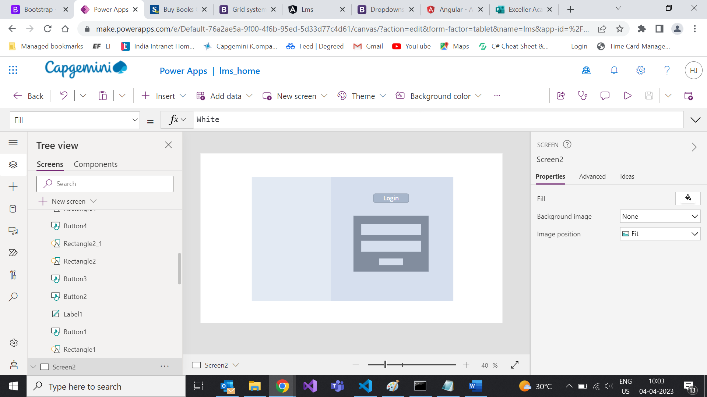

Admin page
After successful login as admin the user will be redirected to admin page where he will be taking necessary actions such as staff addition, student addition and Invoice generation.

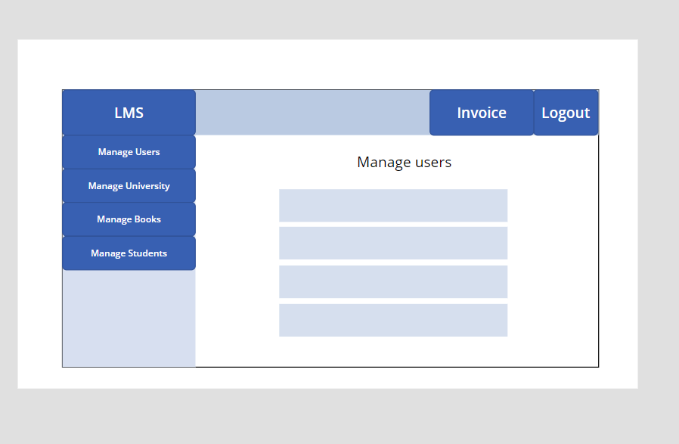

Staff Page
User can login himself as staff and will be landed to staff page. Here he can perform various functions such as student addition, course addition etc.

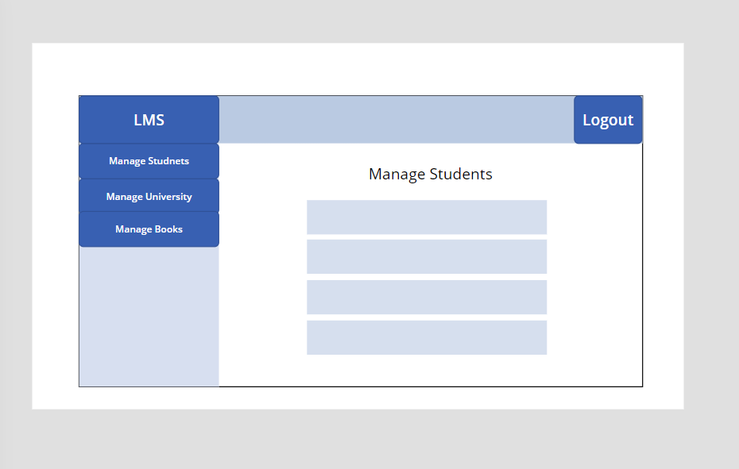

Invoice Page
Once done with the university, course and term selection admin can generate invoice for the following the books. Also, a list of students will be generated along with the books they have issued.

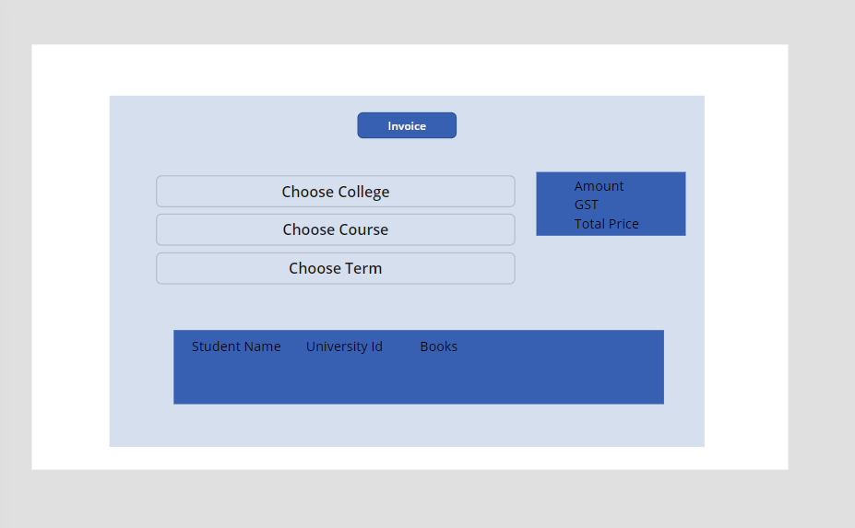

Backend Components
- Architecture Components –

AuthenticationWebAPI
- ValidateUser
- RegisterUser
- Logout

UserWebAPI
- ShowAllUsers
- GetUserById
- AddNewUser
- UpdateUser
- DeleteUser
- DownloadUser

UniversityWebAPI
- ShowAllUniversity
- GetUniversityById
- AddUniversity
- UpdateUniversity
- DeleteUniversity
- DownloadUniversity

StudentWebAPI
- ShowAllStudents
- GetStudentById
- AddStudent
- UpdateStudent
- DeleteStudent
- DownloadStudent

BookWebAPI
- ShowAllBooks
- GetBookById
- AddBook
- UpdateBook
- SoftDeleteBook
- DownloadBook

InvoiceWebAPI
- GetInvoiceDetails
- CreateInvoice
- GenerateInvoice
- DownloadInvoice

Component Identifier

Data

