[College Name]
[Department]
PROJECT REPORT
Student Performance Analysis and Prediction Using Exploratory Data Analysis, Data Visualization, Statistical Analysis, and Deep Learning
Submitted by
Name: RAMYADEVI V
Roll Number: 24AD086
Department: [Department]
Academic Year: [Academic Year]
Date of Submission: [Submission Date]

Abstract
This project studies the UCI Student Performance dataset, using the mathematics file with 395 students and 33 attributes. Exploratory data analysis, visualization and statistical tests were used to examine how study time, absences and background factors relate to the final grade G3. A pass/fail target was defined as G3 of at least 10, and the grades G1, G2 and G3 were removed from the inputs so the task is an early prediction. A neural network with two hidden layers and dropout was trained with stratified train, validation and test splits. The final multilayer perceptron achieved a test accuracy of 66.7% and a ROC-AUC of 0.614 on 60 unseen students, compared with 66.7% for always predicting the majority class. The findings are associations in one school setting and are not causal.

1. Introduction and Objectives
Identifying students who are likely to struggle early allows teachers to offer support. Schools hold data on family background, study habits and attendance, but this data needs to be explored and modelled carefully before it is useful.
Objectives:
- Understand the structure and quality of the student performance data.
- Discover patterns between study-related factors and final grades using EDA and statistics.
- Present the findings with clear, labelled visualizations following the seven-stage visualization pipeline.
- Build a deep learning (MLP) model to predict pass or fail and evaluate it honestly on unseen data.

2. Dataset Description
Source: UCI Machine Learning Repository, Student Performance dataset (https://archive.ics.uci.edu/dataset/320/student+performance), collected from two Portuguese secondary schools by Cortez and Silva (2008). The mathematics file student-mat.csv (semicolon separated) is used. It is released under the CC BY 4.0 licence.
The file has 395 rows and 33 columns (16 numeric and 17 categorical). There are 0 missing values, 0 exact duplicate rows and 0 grade values outside the valid 0 to 20 range.
Attributes cover school and demographics (school, sex, age, address, family size), family (parents' education and jobs, family relationship quality), study habits (study time, failures, extra support, tuition classes), lifestyle (going out, alcohol use, free time, health, relationship status, internet access) and attendance (absences). G1, G2 and G3 are the period 1, period 2 and final grades.
Target definition: Pass = G3 of 10 or above, Fail = G3 below 10. This is the project's chosen definition of passing. Class counts: Pass = 265, Fail = 130.

3. Exploratory Data Analysis and Preprocessing
Preprocessing decisions:
- Missing values: 0 found, so no imputation was needed.
- Duplicates: 0 exact duplicates found. The dataset has no student ID, so duplicate detection is only approximate.
- Outliers: checked with boxplots and the IQR rule (counts saved in outputs/eda). Observations were kept because high absences and low grades are real students.
- Leakage control: G1, G2 and G3 are excluded from the model inputs. G1 and G2 are earlier grades of the same course and strongly predict G3, so using them would turn the task into copying a grade. G3 is used only to create the target. An assertion in the code enforces this.
- Encoding and scaling: one-hot encoding for categorical columns and StandardScaler for numeric columns, fitted on the training set only to prevent data leakage.
- Split: stratified 70% training, 15% validation and 15% test with a fixed seed (42).
Statistical summary: the Shapiro-Wilk test on G3 gave W = 0.929, p = 8.836e-13, so G3 is not treated as normally distributed and rank-based methods (Spearman, Kruskal-Wallis) are used. Mean G3 by school: {'GP': 10.49, 'MS': 9.85}; by sex: {'F': 9.97, 'M': 10.91}; by past failures: {0: 11.25, 1: 8.12, 2: 6.24, 3: 5.69}. These are descriptive differences and do not show causes. Many comparisons were examined, which can produce false positives.

4. EDA Visualizations
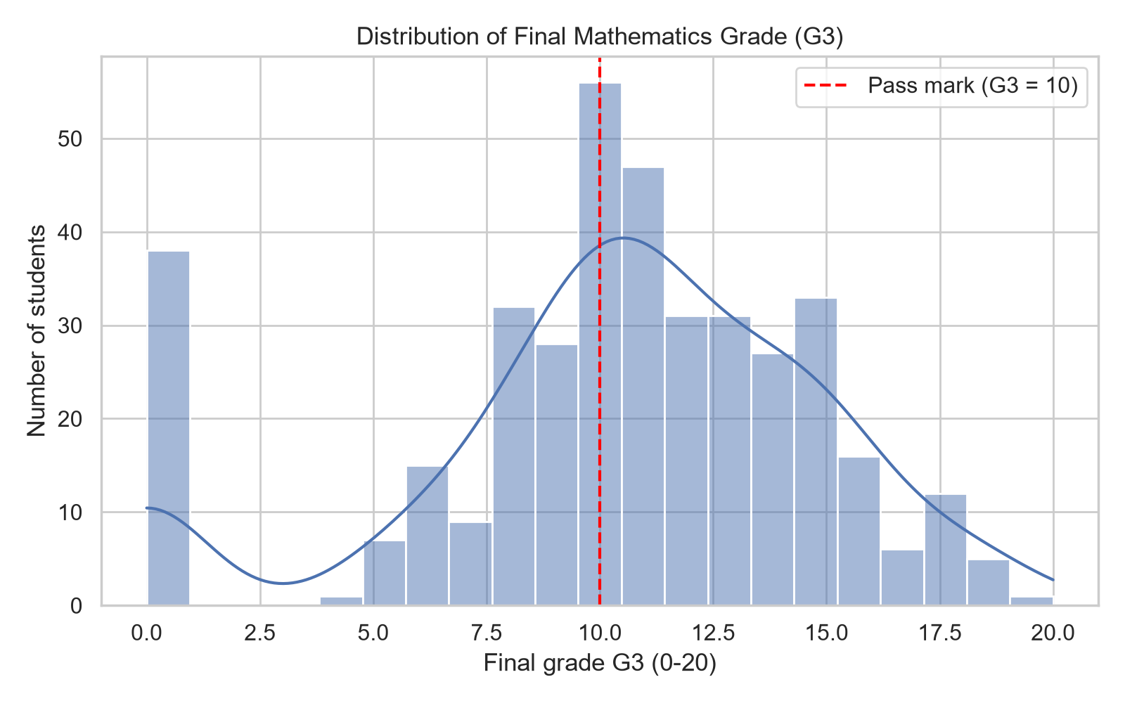
Figure 1: Histogram with KDE of final grade G3
What it shows and why: Shows the shape of the grade distribution and the pass mark. Created to see whether grades are symmetric and where the pass/fail boundary falls. Actual result: G3 has mean 10.42, median 11.0, standard deviation 4.58 and skewness -0.73. 38 students (9.6%) scored 0, which creates a second small peak at the left of the distribution. Limitation: the data are observational, from self-reported variables and one educational setting, so patterns should not be read as causes.
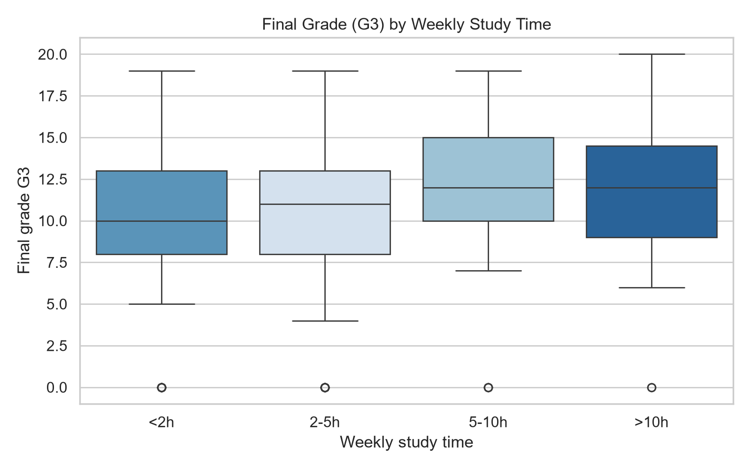
Figure 2: Boxplot of G3 by weekly study time
What it shows and why: Compares the spread and median grade of each study-time group. Actual result: Median G3 by study time: <2h = 10.0, 2-5h = 11.0, 5-10h = 12.0, >10h = 12.0. A Kruskal-Wallis test (non-parametric, used because G3 is not normally distributed) gave H = 7.58, p = 0.0556. Limitation: the data are observational, from self-reported variables and one educational setting, so patterns should not be read as causes.
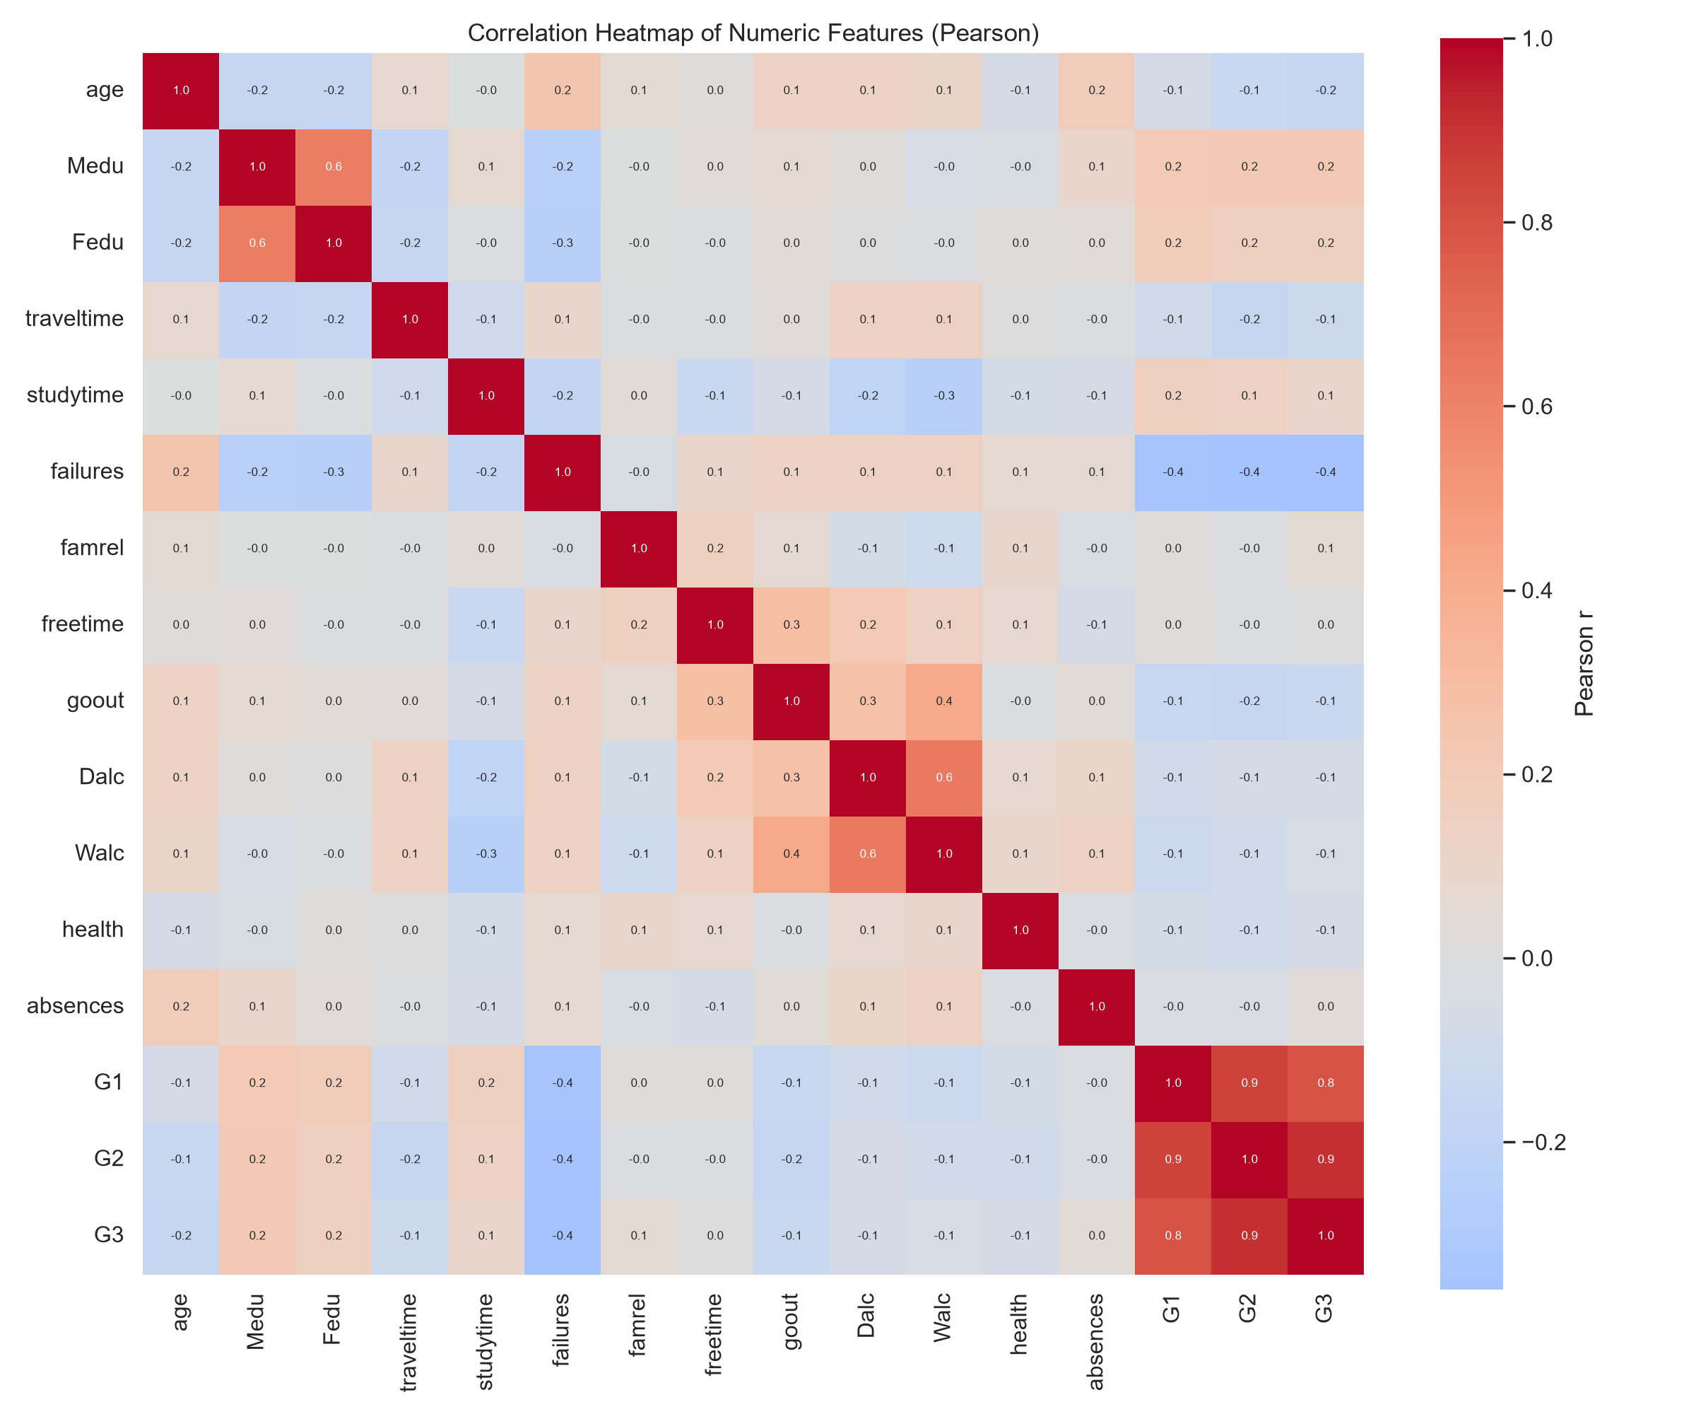
Figure 3: Correlation heatmap of numeric features
What it shows and why: Shows linear relationships between all numeric variables. Actual result: G1 (r = 0.80) and G2 (r = 0.90) are almost the same as G3, which is why they are excluded from the model. Among the allowed features the strongest Pearson correlations with G3 are failures (r = -0.36), Medu (r = 0.22), age (r = -0.16). Limitation: the data are observational, from self-reported variables and one educational setting, so patterns should not be read as causes.
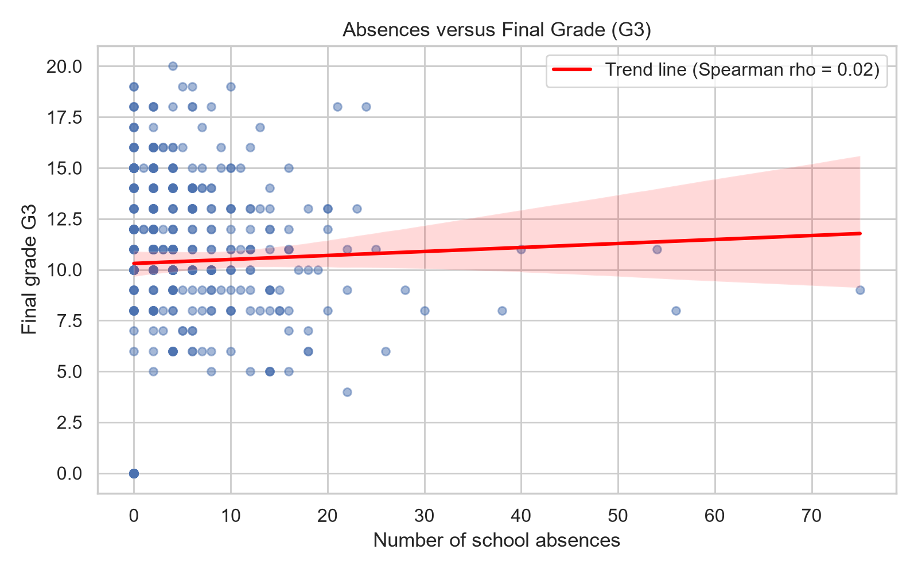
Figure 4: Scatterplot of absences versus G3
What it shows and why: Shows how attendance relates to the final grade, with a fitted trend line. Actual result: Spearman rho = 0.02 (p = 0.7254) between absences and G3. The maximum number of absences is 75; 115 students had none. Limitation: the data are observational, from self-reported variables and one educational setting, so patterns should not be read as causes.
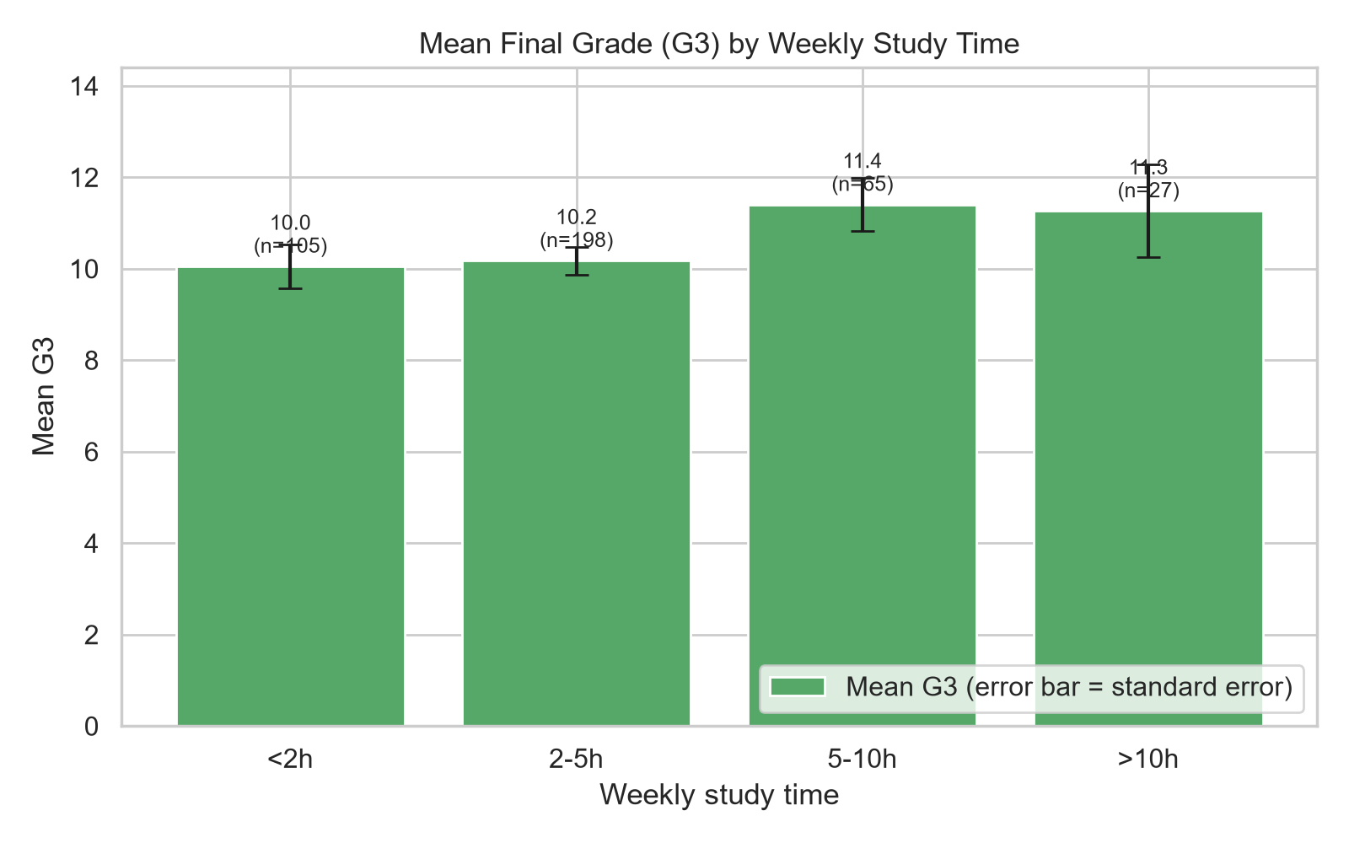
Figure 5: Mean G3 by study-time category
What it shows and why: Compares average grades across study-time groups, with standard-error bars and group sizes. Actual result: Mean G3 by study time: <2h = 10.05 (n = 105), 2-5h = 10.17 (n = 198), 5-10h = 11.40 (n = 65), >10h = 11.26 (n = 27). Group sizes differ a lot, so the highest-study group is based on few students. Limitation: the data are observational, from self-reported variables and one educational setting, so patterns should not be read as causes.
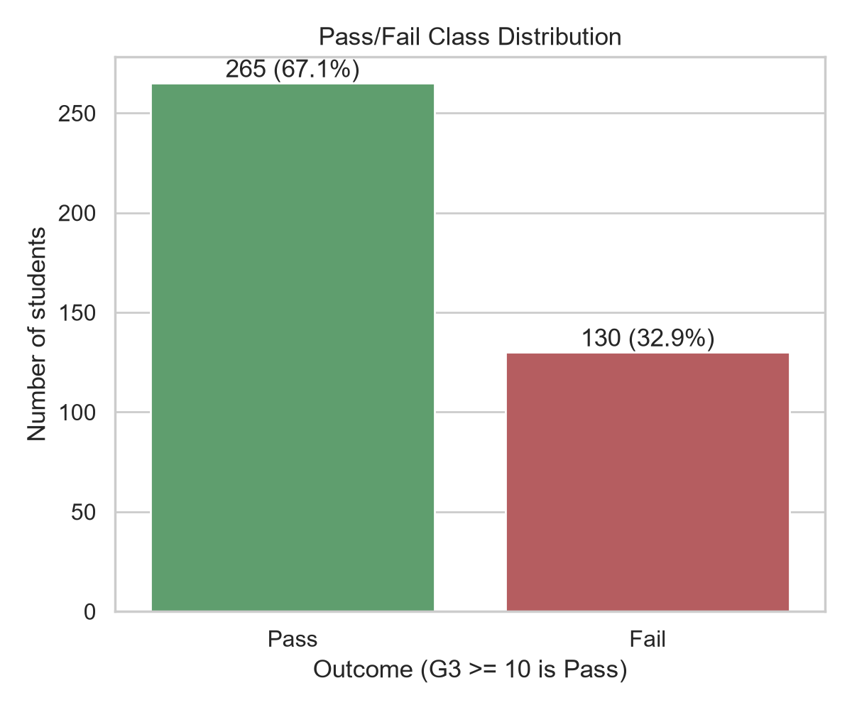
Figure 6: Pass/fail class distribution
What it shows and why: Shows class balance: Pass = 265, Fail = 130. Actual result: Limitation: the data are observational, from self-reported variables and one educational setting, so patterns should not be read as causes.
An interactive Plotly chart with hover information and a dropdown to change the grouping variable was also created and saved as outputs/figures/interactive_g3.html.

5. The Seven Stages of Visualization
- Acquire: The dataset was downloaded programmatically from the UCI repository.
- Parse: The semicolon-delimited file was loaded into a DataFrame; 33 fields were classified as numeric or categorical and data types were checked.
- Filter: Missing values, duplicates and invalid grades were checked; outliers were flagged with the IQR rule but retained; G1, G2 and G3 were removed from model inputs.
- Mine: Descriptive statistics, Pearson and Spearman correlation, a Shapiro-Wilk test and a Kruskal-Wallis test were computed.
- Represent: Histogram, boxplot, heatmap, scatterplot and bar chart were chosen to match the type of each variable.
- Refine: Titles, axis labels, legends, readable study-time labels, consistent fonts and 200 dpi export were applied.
- Interact: An interactive Plotly boxplot with hover and a dropdown was created.

6. Deep Learning Architecture and Hyperparameters
A Multilayer Perceptron (MLP) was built with TensorFlow/Keras: Input, Dense(h1, ReLU), Dropout(0.3), Dense(h2, ReLU), Dropout(0.2), Dense(1, sigmoid). Loss: binary cross-entropy. Optimizer: Adam. Batch size 32, at most 100 epochs, EarlyStopping on validation loss (patience 15, best weights restored) and ModelCheckpoint saving the best model. Random seed 42.
Three settings were compared using validation loss only. Selected setting: learning rate 0.001, hidden layers 32 and 16. Input size after encoding: 56 features. Training/validation/test sizes: 276/59/60. Class weights: {0: 1.5164835164835164, 1: 0.745945945945946}.
Learning rate | Hidden 1 | Hidden 2 | Best val loss | Epochs run
0.001 | 64 | 32 | 0.5931 | 40
0.0005 | 64 | 32 | 0.6081 | 57
0.001 | 32 | 16 | 0.581 | 45

7. Model Evaluation
The test set was used once, after model selection. Test accuracy 0.667, precision 0.750, recall 0.750, F1-score 0.750, ROC-AUC 0.614. Always predicting the majority class would give accuracy 0.667. The classification threshold was fixed at 0.5 and not tuned on the test data.
Actual \ Predicted | Fail | Pass
Fail | 10 | 10
Pass | 10 | 30

Classification report:
precision recall f1-score support
Fail 0.50 0.50 0.50 20
Pass 0.75 0.75 0.75 40
accuracy 0.67 60
macro avg 0.62 0.62 0.62 60
weighted avg 0.67 0.67 0.67 60
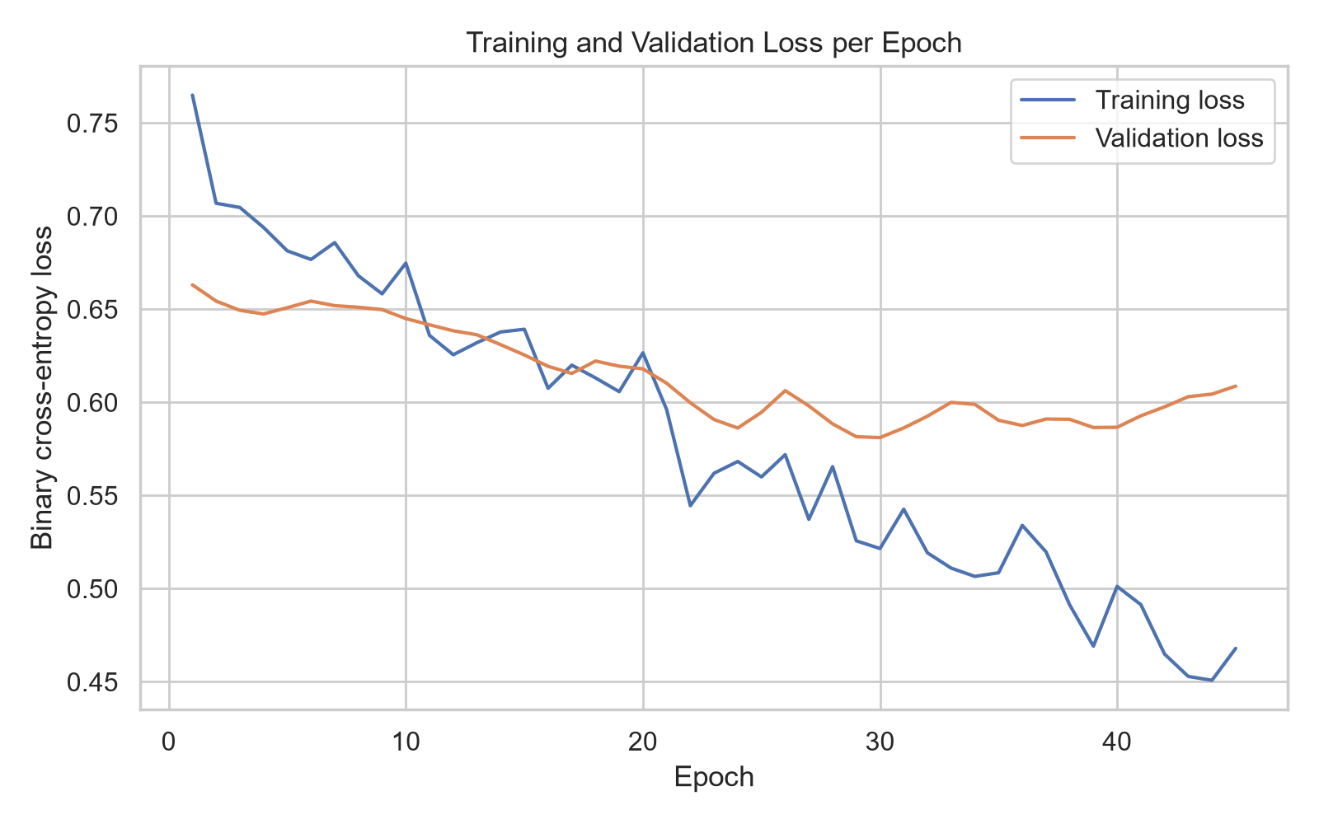
Figure 7: Training and validation loss
Shows whether the model learns and whether it overfits. Training stopped after 45 epochs. Training accuracy is 0.804 and validation accuracy is 0.729, a gap of +0.076; a large positive gap would indicate overfitting.
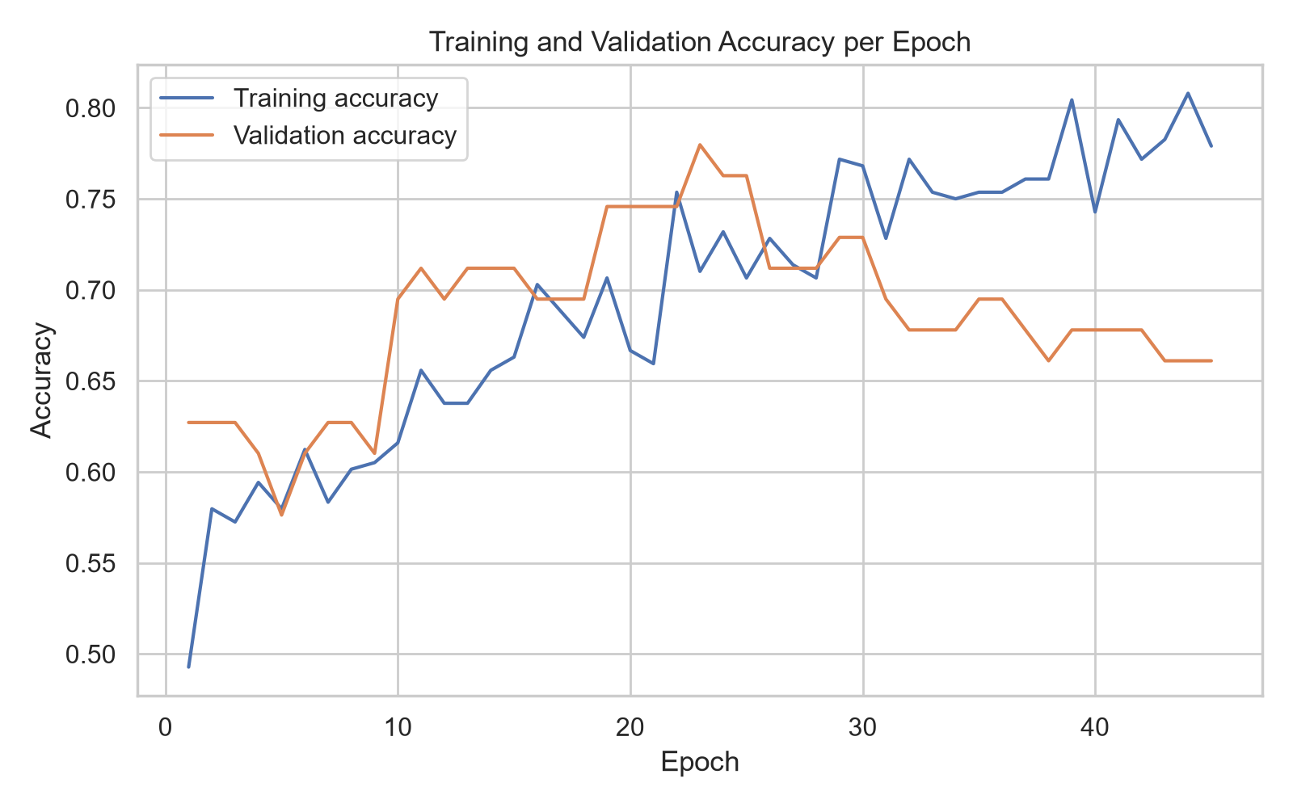
Figure 8: Training and validation accuracy
Shows how accuracy changes during training; validation accuracy is the signal used to judge generalization.
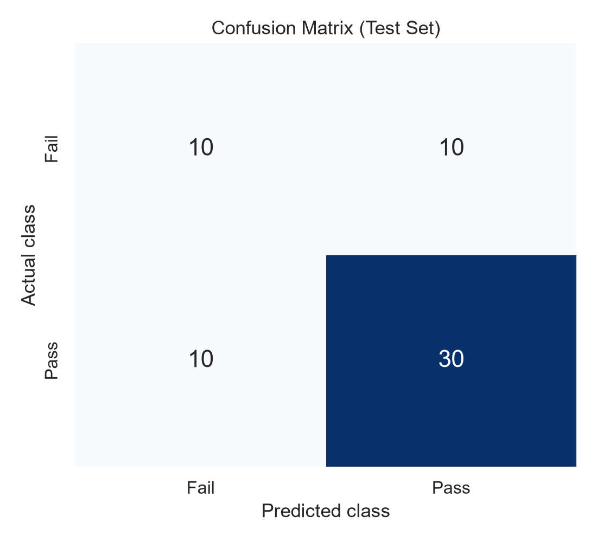
Figure 9: Confusion matrix on the test set
Out of 60 test students there were 10 false positives (failing students predicted to pass) and 10 false negatives (passing students predicted to fail). Missing a failing student is usually the costlier error in an early-support setting.
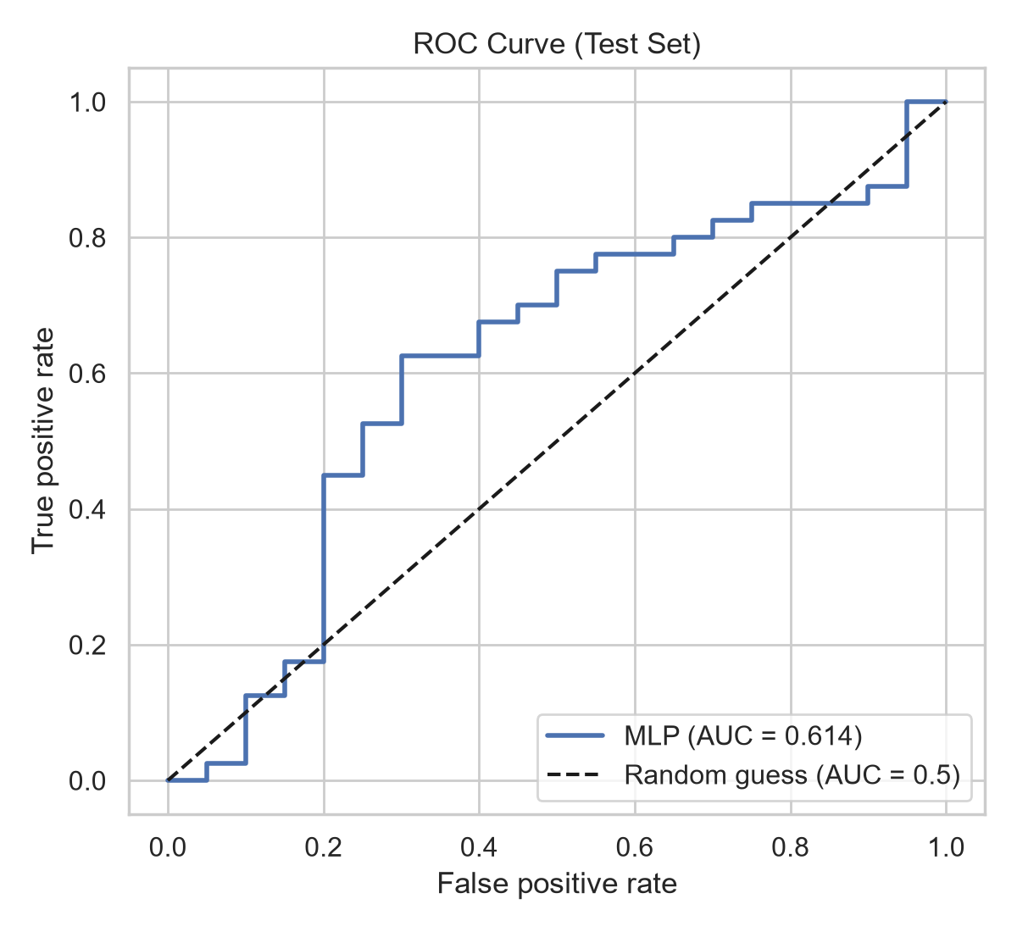
Figure 10: ROC curve on the test set
The test ROC-AUC is 0.614; 0.5 would be random guessing and 1.0 perfect separation. With only about 60 test students this estimate is noisy.
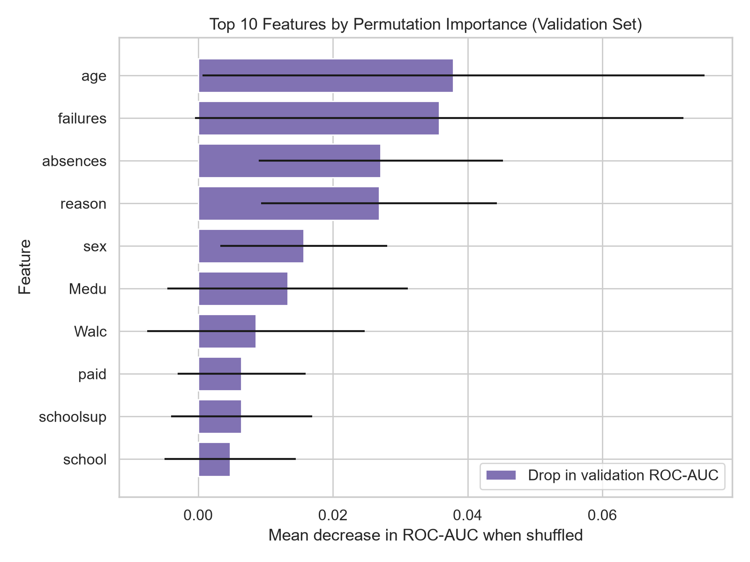
Figure 11: Permutation feature importance (validation set)
The features whose shuffling reduces validation ROC-AUC the most are age, failures, absences, reason, sex. Correlated features share importance, and this measure describes the model, not causes in real students.

8. Conclusion and Future Scope
EDA showed that G3 is spread across the 0 to 20 scale with a cluster of zero scores, and that 265 of 395 students passed. Absences had a Spearman correlation of 0.02 with G3. The Kruskal-Wallis test across study-time groups gave p = 0.0556. The MLP reached a test ROC-AUC of 0.614 and accuracy of 66.7% without using earlier grades.
Limitations: the data are observational, so all relationships are correlations and not causal effects. The data come from two Portuguese schools and may not generalize elsewhere. The test set is small, so metrics are uncertain. Several attributes are self-reported, and sensitive attributes such as sex and age are present, so a fairness analysis is needed before any real use.
Predictions from this model must not be used to make consequential decisions about students without further validation, fairness analysis and human oversight.
Future scope: k-fold cross-validation, comparison with other models (logistic regression, random forest, gradient boosting), more schools and years of data, additional features such as attendance over time, and calibration and fairness analysis.

References
Abadi, M., Barham, P., Chen, J., Chen, Z., Davis, A., Dean, J., ... Zheng, X. (2016). TensorFlow: A system for large-scale machine learning. Proceedings of the 12th USENIX Symposium on Operating Systems Design and Implementation (OSDI '16), 265-283.
Cortez, P. (2014). Student performance [Dataset]. UCI Machine Learning Repository. https://doi.org/10.24432/C5TG7T
Cortez, P., & Silva, A. (2008). Using data mining to predict secondary school student performance. In A. Brito & J. Teixeira (Eds.), Proceedings of 5th FUture BUsiness TEChnology Conference (FUBUTEC 2008) (pp. 5-12). EUROSIS.
Fry, B. (2007). Visualizing data: Exploring and explaining data with the Processing environment. O'Reilly Media.
Hunter, J. D. (2007). Matplotlib: A 2D graphics environment. Computing in Science & Engineering, 9(3), 90-95.
Pedregosa, F., Varoquaux, G., Gramfort, A., Michel, V., Thirion, B., Grisel, O., ... Duchesnay, E. (2011). Scikit-learn: Machine learning in Python. Journal of Machine Learning Research, 12, 2825-2830.

Appendix
Complete source code: [GitHub repository link]. The whole project is reproduced by running `python make_report.py`, which downloads the data, creates all figures, trains the model and regenerates this report. Key steps in code:
df = pd.read_csv('student-mat.csv', sep=';')
y = (df['G3'] >= 10).astype(int)
X = df.drop(columns=['G1', 'G2', 'G3'])
# stratified 70/15/15 split, preprocessor fitted on training data only
model = Sequential([Dense(64, 'relu'), Dropout(0.3), Dense(32, 'relu'),
Dropout(0.2), Dense(1, 'sigmoid')])
model.compile(optimizer='adam', loss='binary_crossentropy', metrics=['accuracy'])

