**SKIN LESION CLASSFICIATION**

**NEURAL COMPUTING AND DEEP LEARNING(MOD006568)**

**SID:2241387**

**TABLE OF CONTENTS**

**INTRODUCTION…………………………………………………………………………………………….**4

**EXPLORATORY DATA ANALYSIS……………………………………………………………….**4

**IMPLEMENTATION………………………………………………………………………………………**7

**RESULTS…………………………………………………………………………………………………………**7

**CONCLUSION……………………………………………………………………………………………….**9

**REFERENCES………………………………………………………………………………………………..**10

**INTRODUCTION**

A change or modification in the feel of the skin, colours, or structure is known to as a lesion. Numerous factors, such as diseases, scratches, genes, as well as surroundings like ultraviolet radiation may end up in wounds on the skin. Any unfamiliar  skin lesions should be examined by a specialist in dermatology to figure out whether it's benign along with need additional care. Frequent examinations of the skin may help in identifying signs if cancer of the complexion, even though it remains potentially treatable.

In order recognise skin lesions, Convolutional Neural Networks are frequently utilised while it is efficient at evaluating photos as finding patterns within data. Identification of the features of lesions in the skin, including extent, form, colours, or appearance, can be accomplished by examining pictures from them. To recognise similarities in photographs, CNNs use filters which examine a picture to identify characteristics at various degrees for complexity. When those characteristics combine, more advanced depiction of a picture are created  may be employed to projected what kind of skin damage which may be evident. In general, CNNs are a successful method for categorising lesions on the skin as these are capable of recognising pertinent characteristics with unprocessed pictures, hence improving precision while requiring less skilled techniques.

**EXPLORATORY DATA ANALYSIS**

The HAM10000 dataset is an extensive set of dermoscopic pictures from several sources of generally pigment lesions of the skin. It was composed of 10,015 digitally captured and saved as JPEG photos dermoscopic skin pigmented lesion images measuring 600 by 450 pixels. Each patient and photograph in this information gathering had seven properties, which were as follows:

The Patient's Sex , The Patient’s Age ,Image ID ,Lesion ID, Localization, A category of diagnostic skin lesion, DX type.

Each item had a distinct image id, however there was not separate lesion id. It was clear through this to indicate there were numerous additional pictures using identical ID, yet each one was distorting differently, such as by a position, strain, and magnification.

The functional verification field category referenced the real data in the set and offered details about when the proper diagnosis of the skin lesion was reached. Histopathology is where Dermatopathologists with specialisation have made evaluations of removed diseases.

Reflectance confocal microscopy has been used to make diagnoses of removed lesions. Following up is the  type is only available for nevi class individuals whose digital dermatoscopy did not detect any changes over the course of three follow-up visits or 1.5 years. Consensus is determined by the views of professionals. It is for usual benign instances without histology any monitoring, and in which the same unequivocal benign diagnosis has been made by two experts.

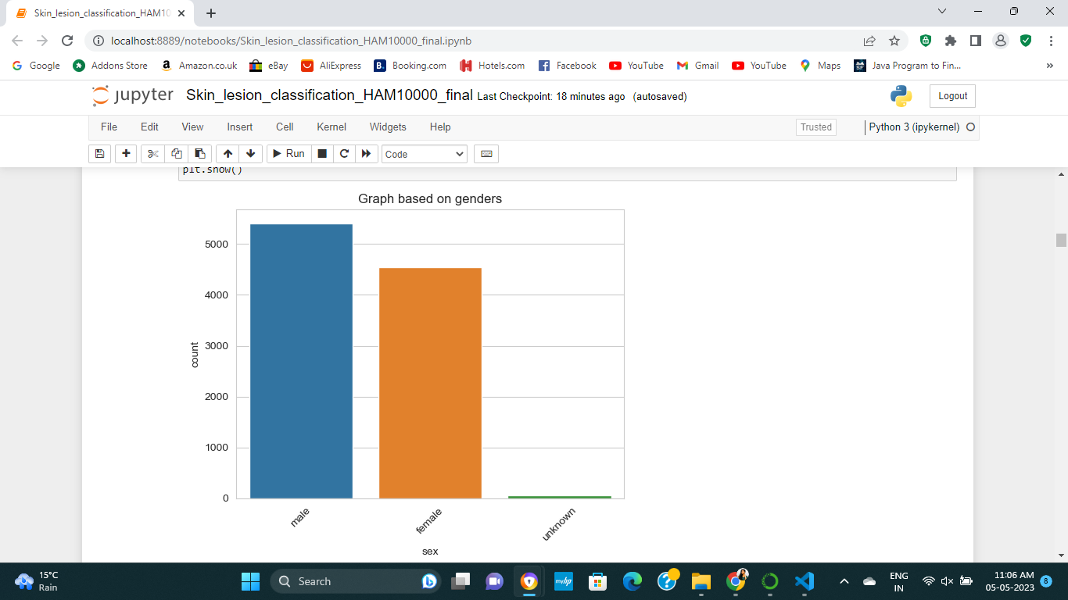

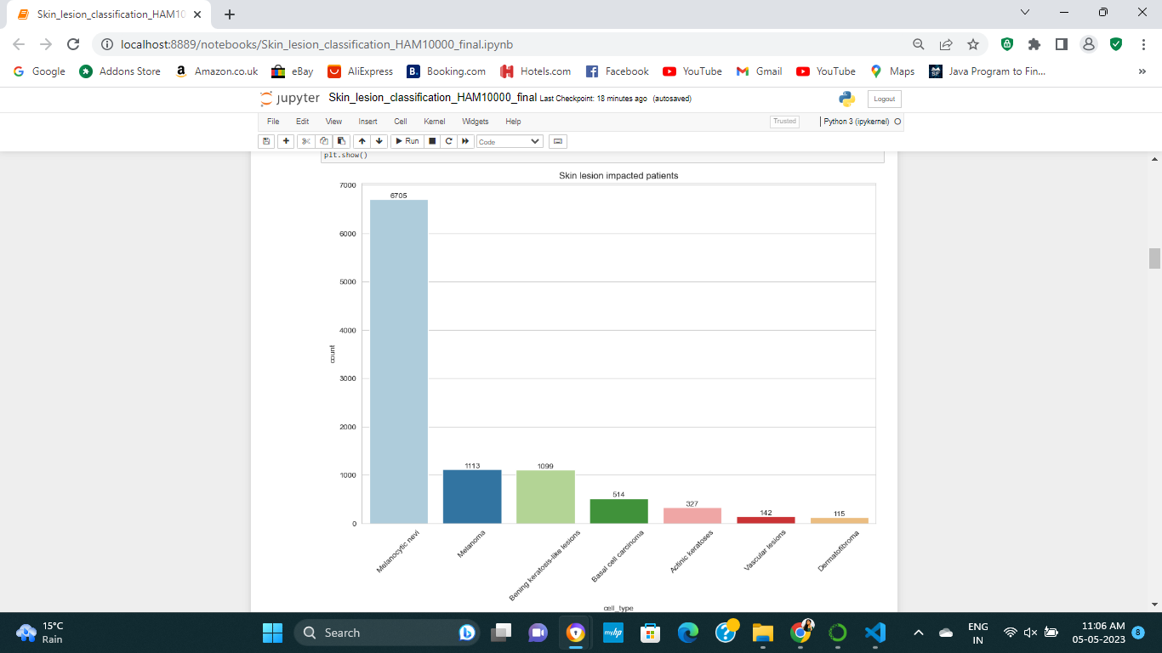

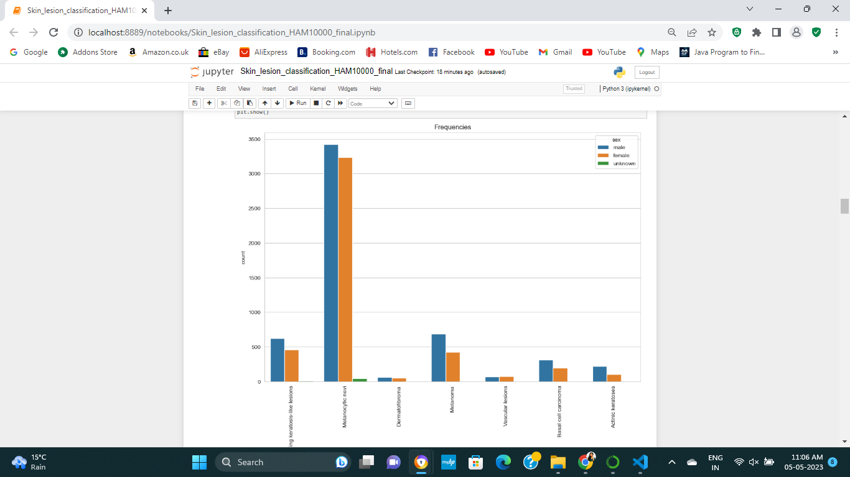

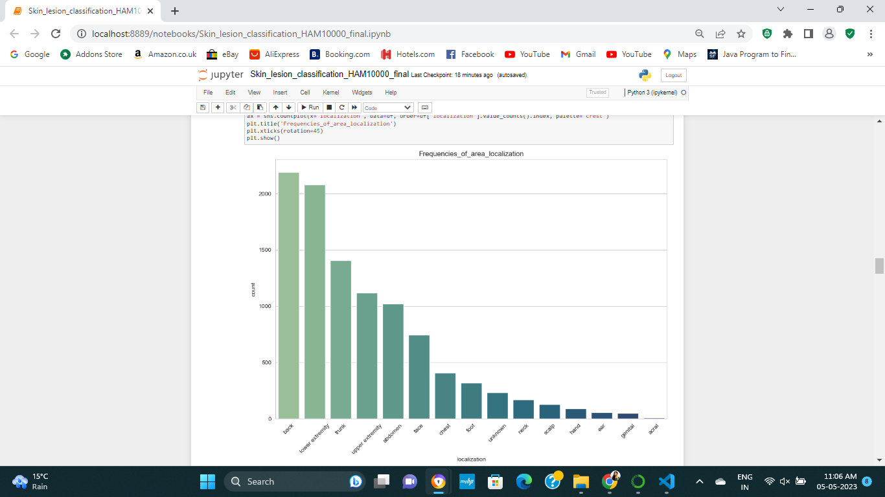

**IMPLEMENTATION**

Data entry then filtering: Depending on the CNN architecture that is being utilised, the initial phase is to upload a skin lesion information and process the pictures by scaling them to a standard dimension, normalising their pixel numbers, then converting them to monochrome or RGB colours.

Visualise the results of the analysis: A key component of EDA is representation of data, which may be used to spot trends and outliers in the collection of data. To do this, histograms, scatterplots, and various other visualisations can be created with programmes like matplotlib or seaborn.

This is necessary to organise facts in each stage of set creation and evaluation so as to assess the efficacy of the algorithm used by CNN. These collections should be created for education, evaluation, and validate. The set of validation values is used for adjusting the system's hyperparameters and prevent overloading when the algorithm is being trained. The tests were meant to gauge how well the model would ultimately function with unseen data.

Create along with build the CNN model: The next stage is to create and train the CNN model after preparing the data and dividing it into education, validation, and verification. In order to achieve this, a suitable CNN framework, like VGG16 or ResNet, must be chosen. The hyperparameters, including  rate at which it learns, numbers of batches, and the amount on periods, must also be modified.

Analyse the model's efficiency: After the model has been educated, it's crucial to assess it using measures like accuracy, precision, recall, and F1 score. Tools like sklearn.metrics or keras.metrics can be used for this.

**RESULTS**

In this study, various CNN architectures were examined for their potential for predicting skin lesion types using skin lesions imagery. preceding applying feature normalisation along with data augmenting, this information set underwent data editing and cleaning, was divided into the feature and target values, and finally underwent feature normalisation.

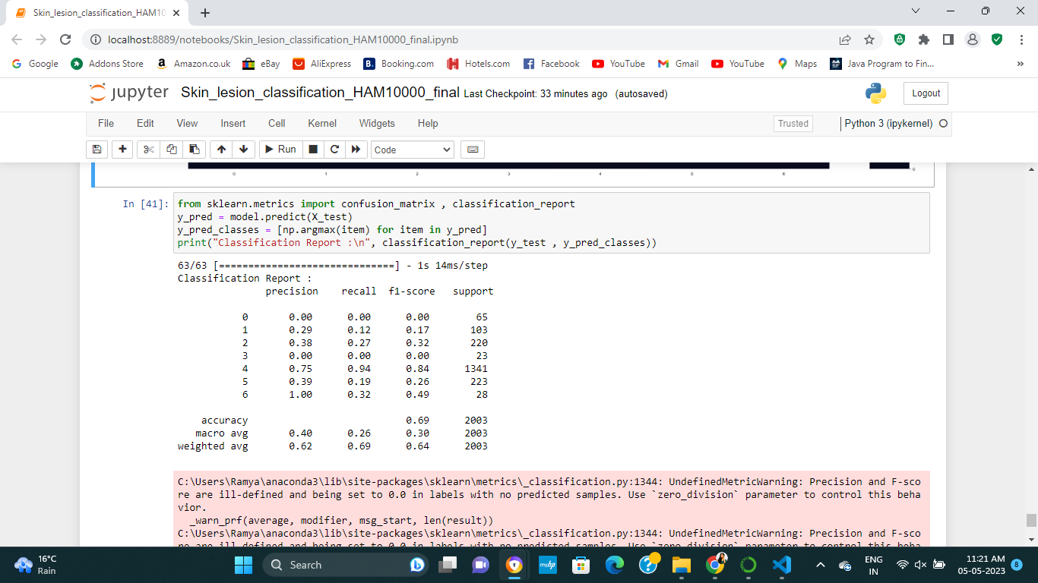

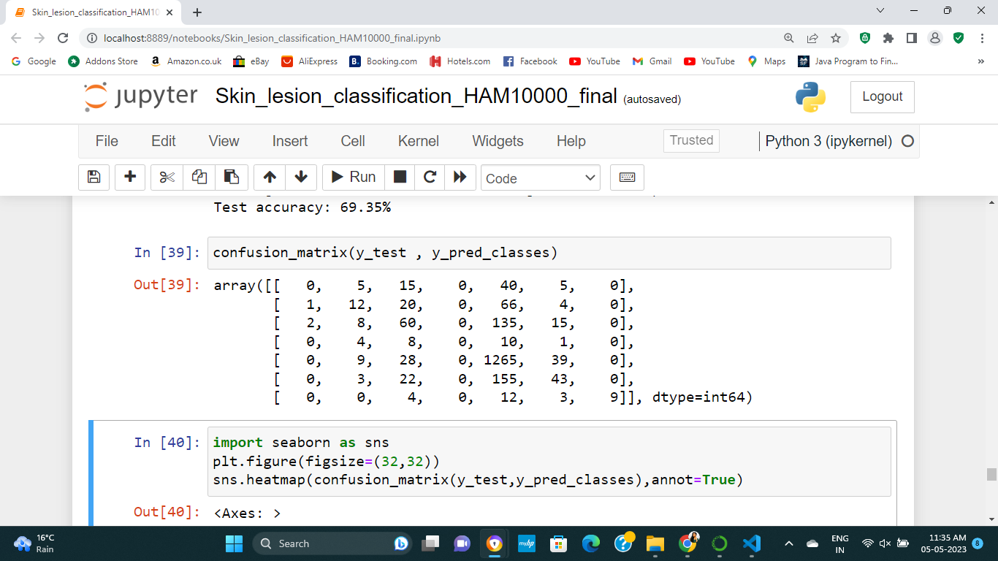

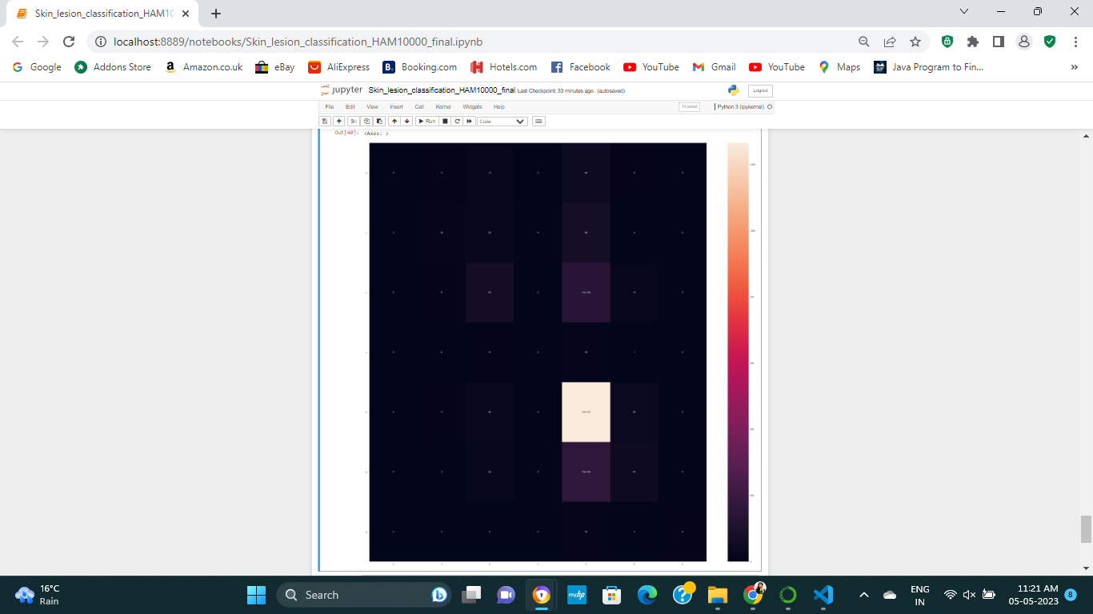

**CONCLUSION**

To improve skin lesion category classifications for groups that are underutilised, check at multiple class imbalance techniques. Use various algorithms which utilise everything  in this collection, including age and sex, to draw out relevant information. Investigate other skin lesion data sources to gather more instruction material on  designs, especially in the hazardous and underrepresented skin lesion classifications. Look into far more pre-trained CNN systems. By looking into these , accuracy and efficacy of the models will be improved.

**REFERENCES**

Albahar, M.A. (2019). Skin Lesion Classification Using Convolutional Neural Network With Novel Regularizer. *IEEE Access*, 7, pp.38306–38313. doi:https://doi.org/10.1109/access.2019.2906241.

Pham, T.-C., Luong, C.-M., Visani, M. and Hoang, V.-D. (2018). Deep CNN and Data Augmentation for Skin Lesion Classification. *Intelligent Information and Database Systems*, pp.573–582. doi:https://doi.org/10.1007/978-3-319-75420-8_54.

Zanddizari, H., Nguyen, N., Zeinali, B. and Chang, J.M. (2021). A new preprocessing approach to improve the performance of CNN-based skin lesion classification. *Medical & Biological Engineering & Computing*, 59(5), pp.1123–1131. doi:https://doi.org/10.1007/s11517-021-02355-5.

Ahmed, S.A.A., Yanikoğlu, B., Göksu, Ö. and Aptoula, E. (2020). *Skin Lesion Classification With Deep CNN Ensembles*. [online] IEEE Xplore. doi:https://doi.org/10.1109/SIU49456.2020.9302125.

Goceri, E. and Karakas, A. (n.d.). *COMPARATIVE EVALUATIONS OF CNN BASED NETWORKS FOR SKIN LESION CLASSIFICATION*. [online] Available at: https://www.cgv-conf.org/wp-content/uploads/2020/07/03_202011C031_S044.pdf [Accessed 5 May 2023].

Hasan, Md.K., Elahi, Md.T.E., Alam, Md.A., Jawad, Md.T. and Martí, R. (2022). DermoExpert: Skin lesion classification using a hybrid convolutional neural network through segmentation, transfer learning, and augmentation. *Informatics in Medicine Unlocked*, 28, p.100819. doi:https://doi.org/10.1016/j.imu.2021.100819.

Kassem, M.A., Hosny, K.M. and Fouad, M.M. (2020). Skin Lesions Classification into Eight Classes for ISIC 2019 Using Deep Convolutional Neural Network and Transfer learning. *IEEE Access*, pp.1–1. doi:https://doi.org/10.1109/access.2020.3003890.

Harangi, B. (2018). Skin lesion classification with ensembles of deep convolutional neural networks. *Journal of Biomedical Informatics*, 86, pp.25–32. doi:https://doi.org/10.1016/j.jbi.2018.08.006.

Benyahia, S., Meftah, B. and Lézoray, O. (2022). Multi-features extraction based on deep learning for skin lesion classification. *Tissue and Cell*, 74, p.101701. doi:https://doi.org/10.1016/j.tice.2021.101701.

Rehman, M. ur, Khan, S.H., Danish Rizvi, S.M., Abbas, Z. and Zafar, A. (2018). *Classification of Skin Lesion by Interference of Segmentation and Convolotion Neural Network*. [online] IEEE Xplore. doi:https://doi.org/10.1109/ICEI18.2018.8448814.