**Explanatory Analysis on Airbnb Data (Dublin)**

Airbnb is a most popular accommodation of connecting people and culture by providing a residential-space sharing platform and works parallel to the big hotel industry. Anyone with free space can become a host on Airbnb by renting it out. It is a best way to earn money with less efforts.

Being guests, we have specific needs -accommodations close to city attractions or premium apartments by the sea. Guests might be individuals or group , Local or foreign. For Each visit guests are provided with an opportunity to rate and provide feedback

We will try to explore what contributes to the listing property and predict whether listing has potential to make into top 100 reviewed accommodations

The dataset contains both current and historical listings we will measure their property based on the total number of reviews received.

This dataset contains statistics for a sample of 17,808 listings collected in 2019 for Dublin , Leinster ,Ireland. The data includes Entire Home, Shared Room, Private Room Listings (Property Type),Reviews, Host ID,Price, Number of reviews, ratings, comments. The dataset combines data from multiple sources : http://insideairbnb.com/get-the-data.html , <http://rpubs.com/jenny_meihwei/airbnb>

Publicly available Airbnb data will be used and is sourced from Airbnb website. The data covers all Dublin listing details, customer reviews and associated geolocation collected on feb 2019 and is published in the form of csv.

* listing_details.csv - Detailed Listings data for Dublin
* calendar_details.csv - Detailed Calendar Data for listings in Dublin
* review_details.csv - Detailed Review Data for listings in Dublin
* review_summary.csv - Summary Review data and Listing ID
* neighbourhoods.csv - Neighbourhood list for geo filter.
* neighbourhoods.geojson - GeoJSON file of neighbourhoods of the city

***Discoveries and Insight***

In order to answer these questions , we will be working with Airbnb dataset, Our Analysis starts with plot of individual variables to assess distributions and data quality. As we progress ,we build up multi-dimensional views for our analysis questions.

Analysis helps people efficiently constructing their travel experiences and encourages the participation into the sharing economy

*Initial Analysis Questions*

1. How much revenue do Airbnb hosts make?
2. What is the Ratio of the Entire Home Listings and Shared Room Listings ?
3. Most Popular Regions in Dublin
4. What are the best types of property to rent?
5. When is the best time to rent?
6. Which are the best areas to rent?
7. What should you write in a listing name to attract more attention?

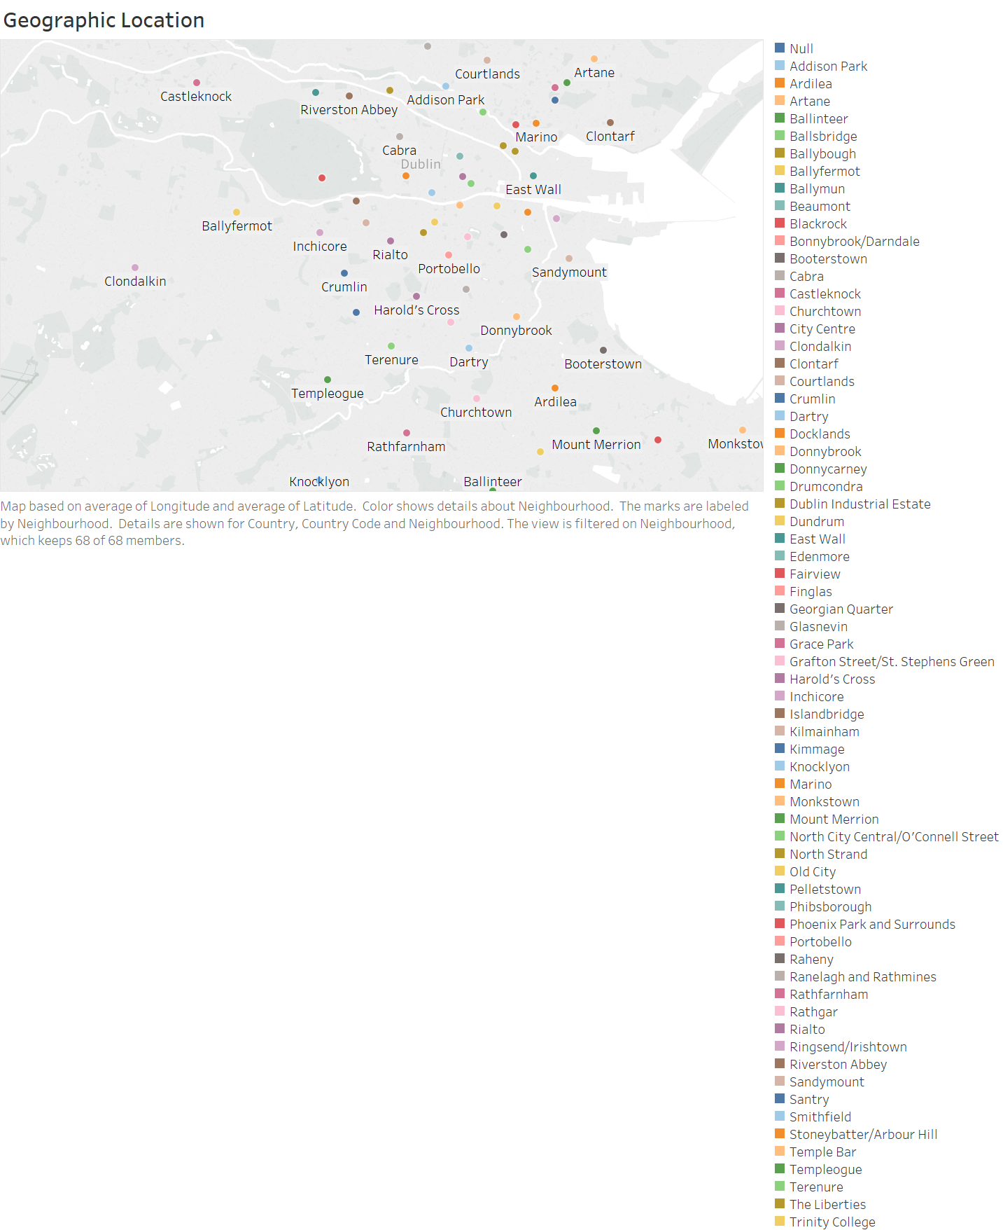

<https://public.tableau.com/profile/ramya1072#!/vizhome/geographicLocation/Sheet1?publish=yes>

The chart illustrates the geographic location of property listings and neighbourhood in the Dublin city .

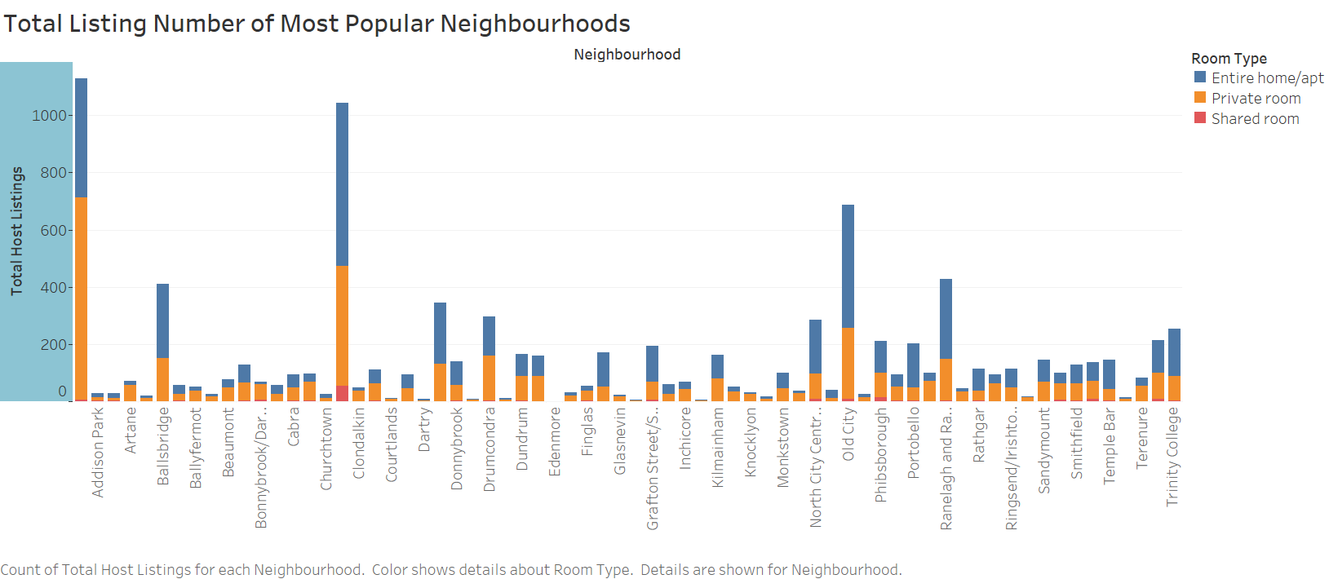

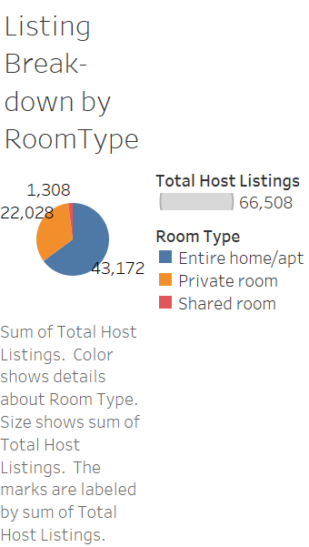

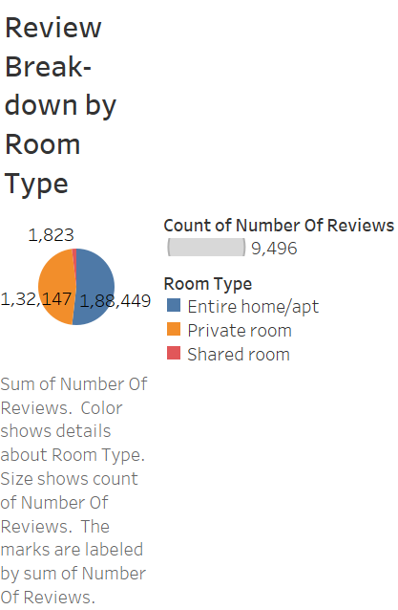

<https://public.tableau.com/profile/ramya1072#!/vizhome/Listing_15540659025570/Sheet12?publish=yes>

<https://public.tableau.com/profile/ramya1072#!/vizhome/ReviewBreakdown/Sheet12?publish=yes>

<https://public.tableau.com/profile/ramya1072#!/vizhome/ListingBreakdown/Sheet9?publish=yes>

The statistics demonstrated above gives an insight of all the properties hosted based on the room Type. This enables the business to understand the trending type of accommodation.

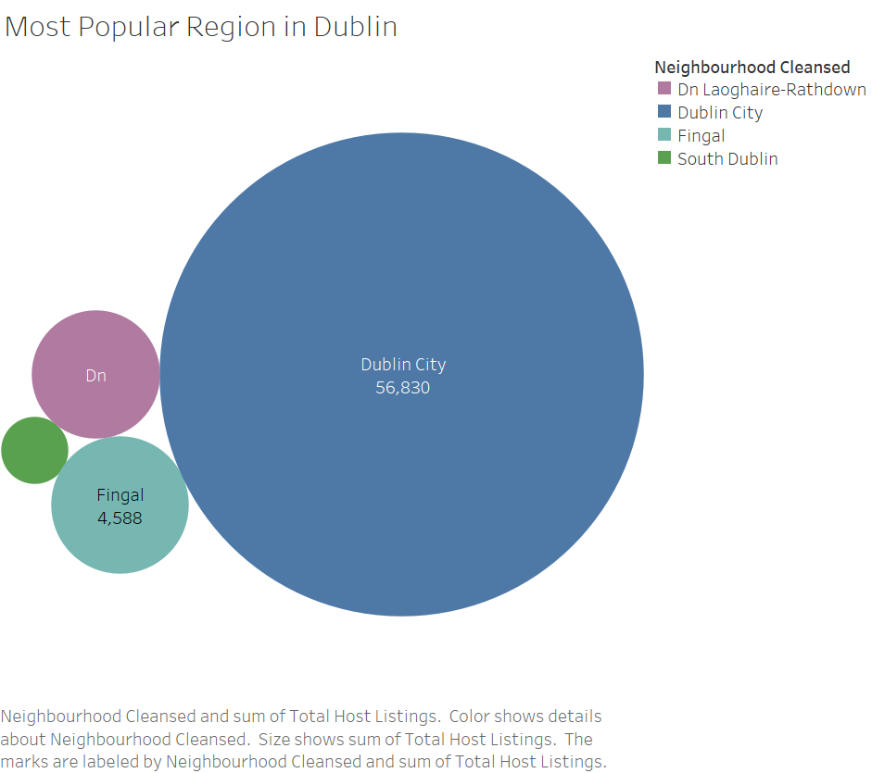

<https://public.tableau.com/profile/ramya1072#!/vizhome/Popularregion/Sheet10?publish=yes>

This plot shows the most popular region in Dublin .This will give insight to the business for approaching valuable market area. Investment in these areas could prove beneficial as these are the highly recommended areas in accordance with the data

We analyse the average revenue of the property with the formulae

*Number of Reviews* ***x*** *Price of Listing* ***x*** *Minimum Length of Stay*

This will serve as an estimate of the revenue since guests are likely to stay longer than the minimum number of nights required.

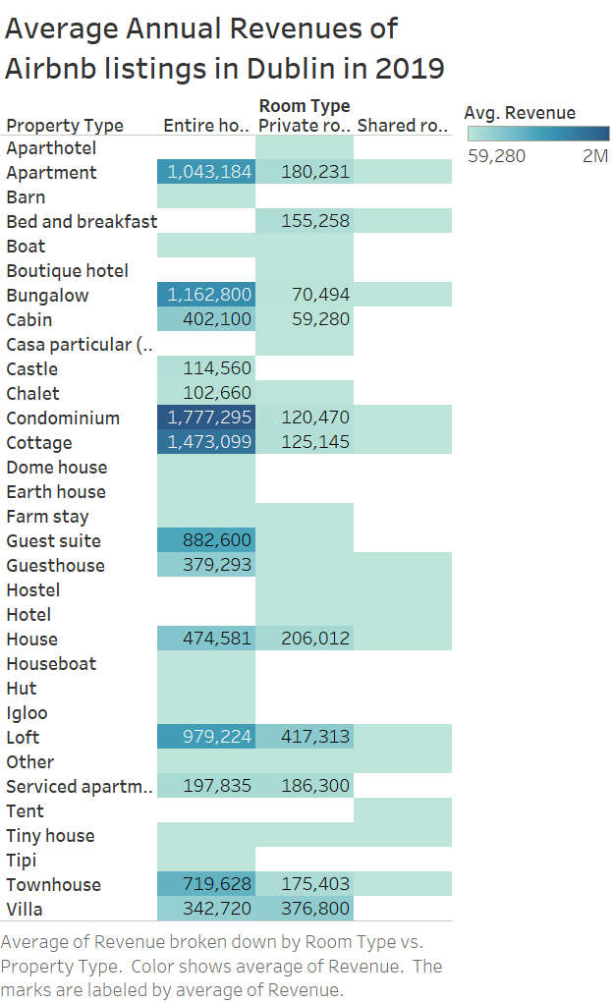

<https://public.tableau.com/profile/ramya1072#!/vizhome/AverageAnnualRevenue/AverageRevenue?publish=yes>

Based on the chart, we can infer that in **Dublin Renting out an entire apartment or house in Dublin is likely to result in good revenues** .Expect to receive annual revenues of 1,777,295 for condominium and 1043,184 for an entire apartment. While there might be other property types (Loft,BB etc) that generate higher revenues ,they compromised a smaller proportion of Dublin’s listing and thus of more likely to serve smaller niche market.

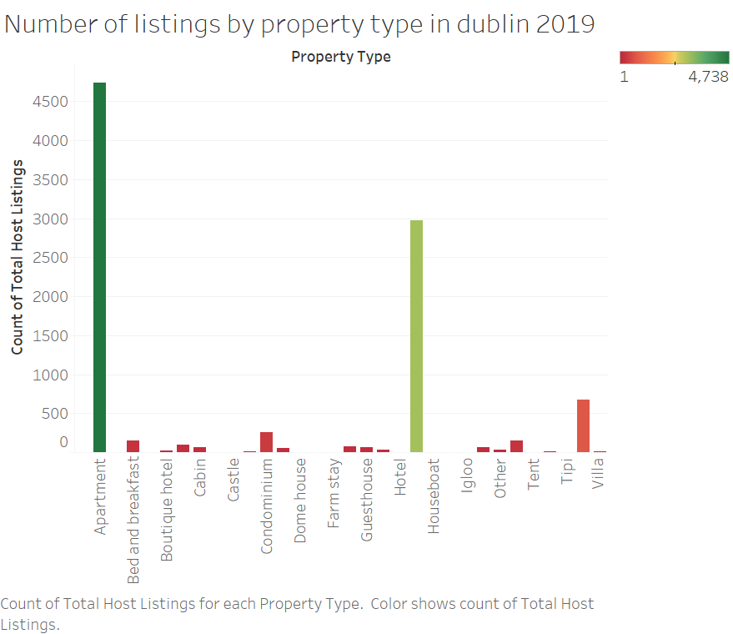

<https://public.tableau.com/profile/ramya1072#!/vizhome/NumberOfListings/Numberoflistingsbypropertytypeindublin2019?publish=yes>

Chart provides an insight of total listing of each property type. It is known that properties which accommodates more guest are also more likely to generate higher revenue in Dublin. The average revenue for accommodating 4 guest was almost double the revenue for properties accommodating 2 guest

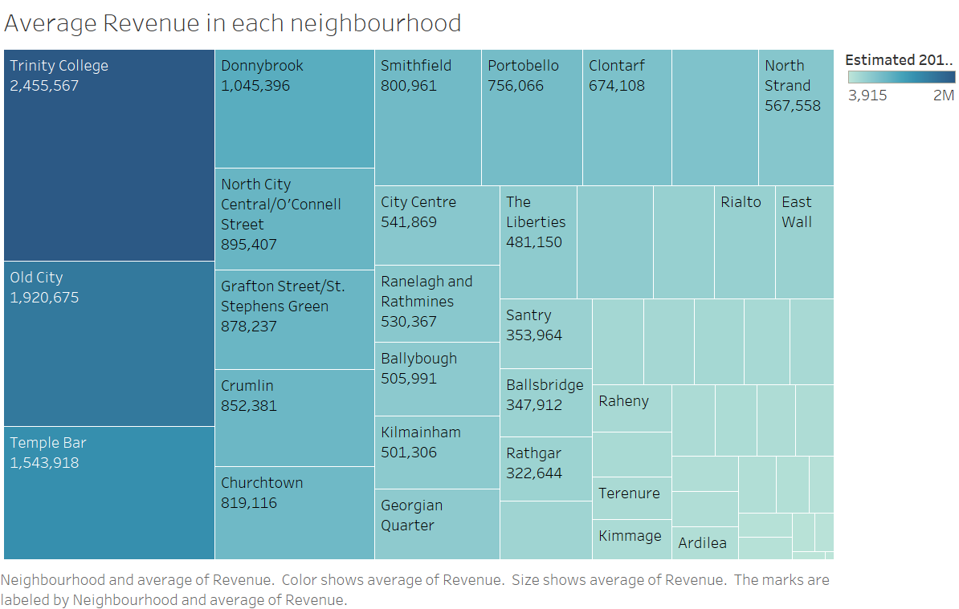

<https://public.tableau.com/profile/ramya1072#!/vizhome/RevenueinNeigbourhood/AverageRevenueineachneighbourhood?publish=yes>

**Trinity College and Old City are the best performing neighbourhoods in Dublin**

In Dublin, Trinity College generated the highest revenue among all neighbourhood in 2019 and old city being the next .Both neighbourhood also ranked among the top 5 neighbourhood with regard to the total number of listings available.

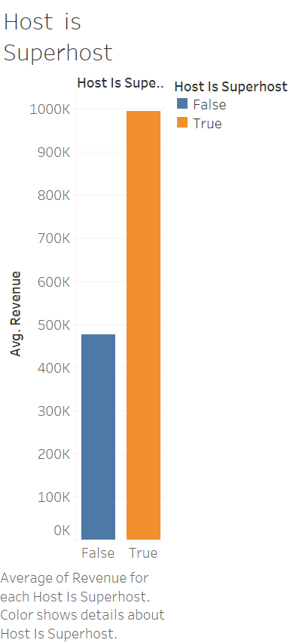

<https://public.tableau.com/profile/ramya1072#!/vizhome/Superhost/Sheet6?publish=yes>

**Airbnb Super Hosts earn more in Dublin.** In Dublin, being recognized as an Airbnb super host is more likely to result in higher revenues. The requirement of super host are as follows :

4.8+ overall rating, Respond to at least 90% booking request within 24 hours, host at least 10 stays a year and honor every reservations

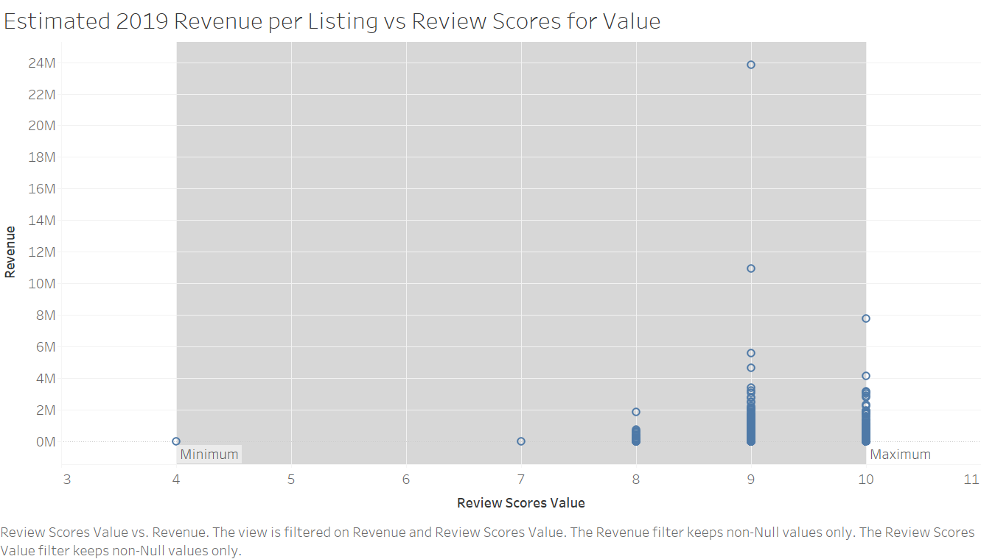

<https://public.tableau.com/profile/ramya1072#!/vizhome/ReviewScores_15540401398190/Sheet7?publish=yes>

Customer prefers properties that provide good value for the price. Airbnb Customers in Dublin are primarily concerned with getting their money worth. Hence properties with higher review scores for value tend to perform better in Dublin

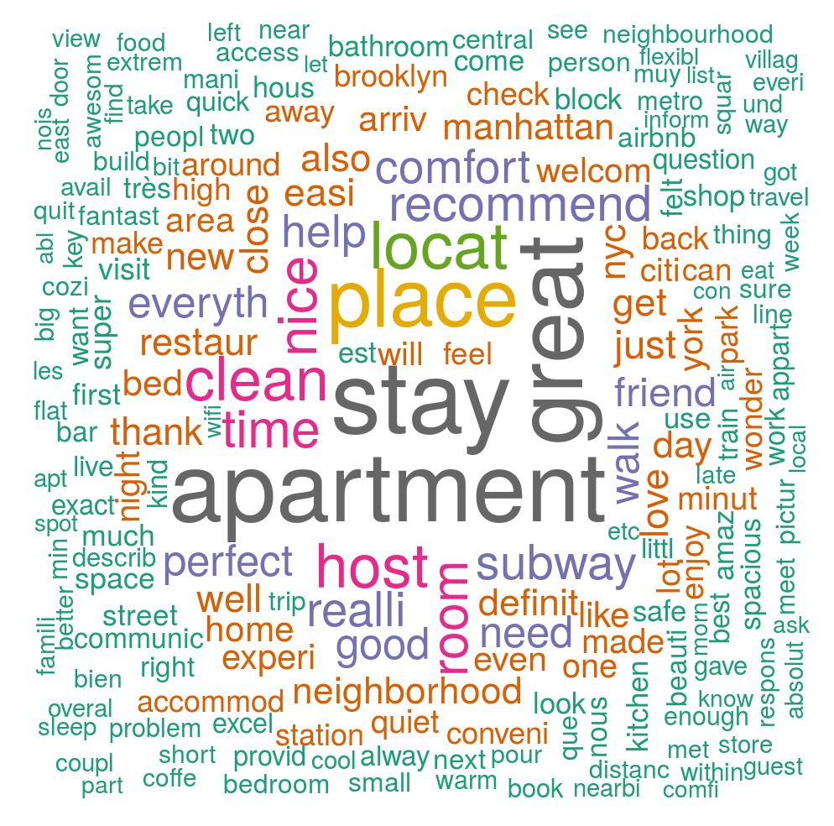

Analysing Customer Reviews :The data provides tons of data ,customer reviews/feedback are important insight to understand ,An analysis of the word cloud shows interesting trends .Since the keywords are highlighted .Word Vector provides an effective way to figure out the closest words to particular search terms

Based on the above visualisation we have seen numerous strategies that will help in set up the Airbnb listing. We will now recap of the key findings

* Trending Type of accommodation
* Most Popular region in Dublin
* Renting an entire apartment is likely to bring in a good and stable revenue
* Properties Accommodating 4 guests seems to be best choice
* Trinity and City Centre are generally the best neighbourhood to establish an Airbnb
* Airbnb Super host will earn more money
* Customer prefer properties that provide good value for the price