**Assignment – 3**

* **Use the Employee Details dataset and perform the following activities: -**

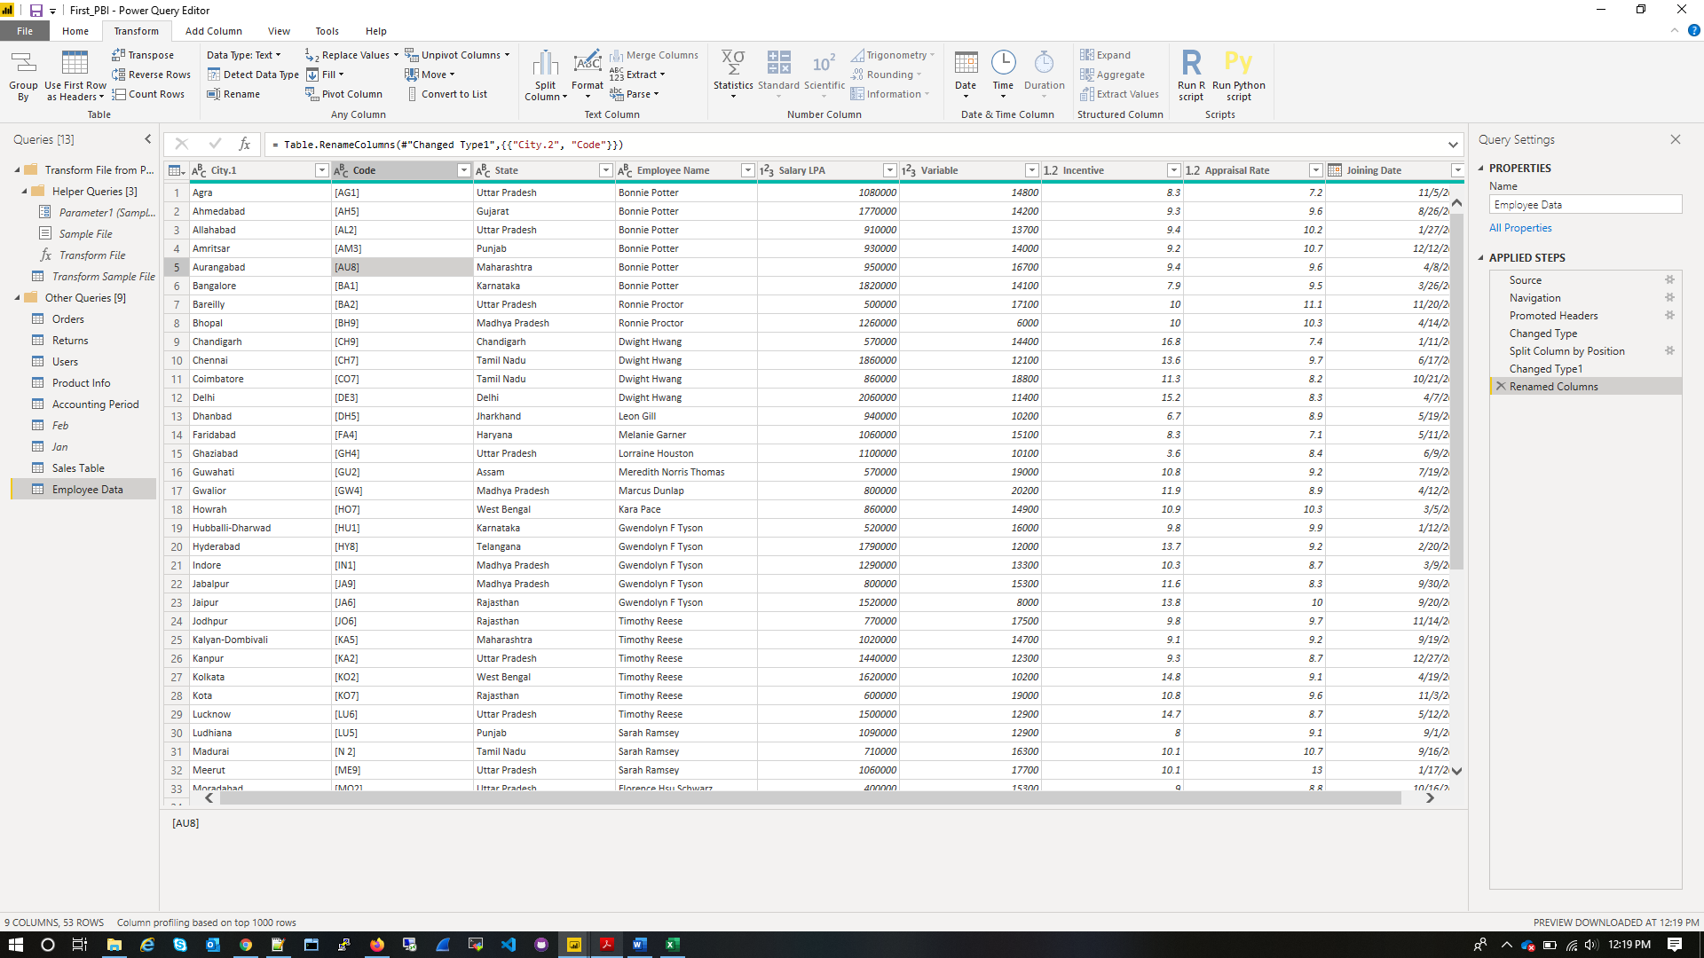

Extract the first name from EMPLOYEE NAME column and transform the column

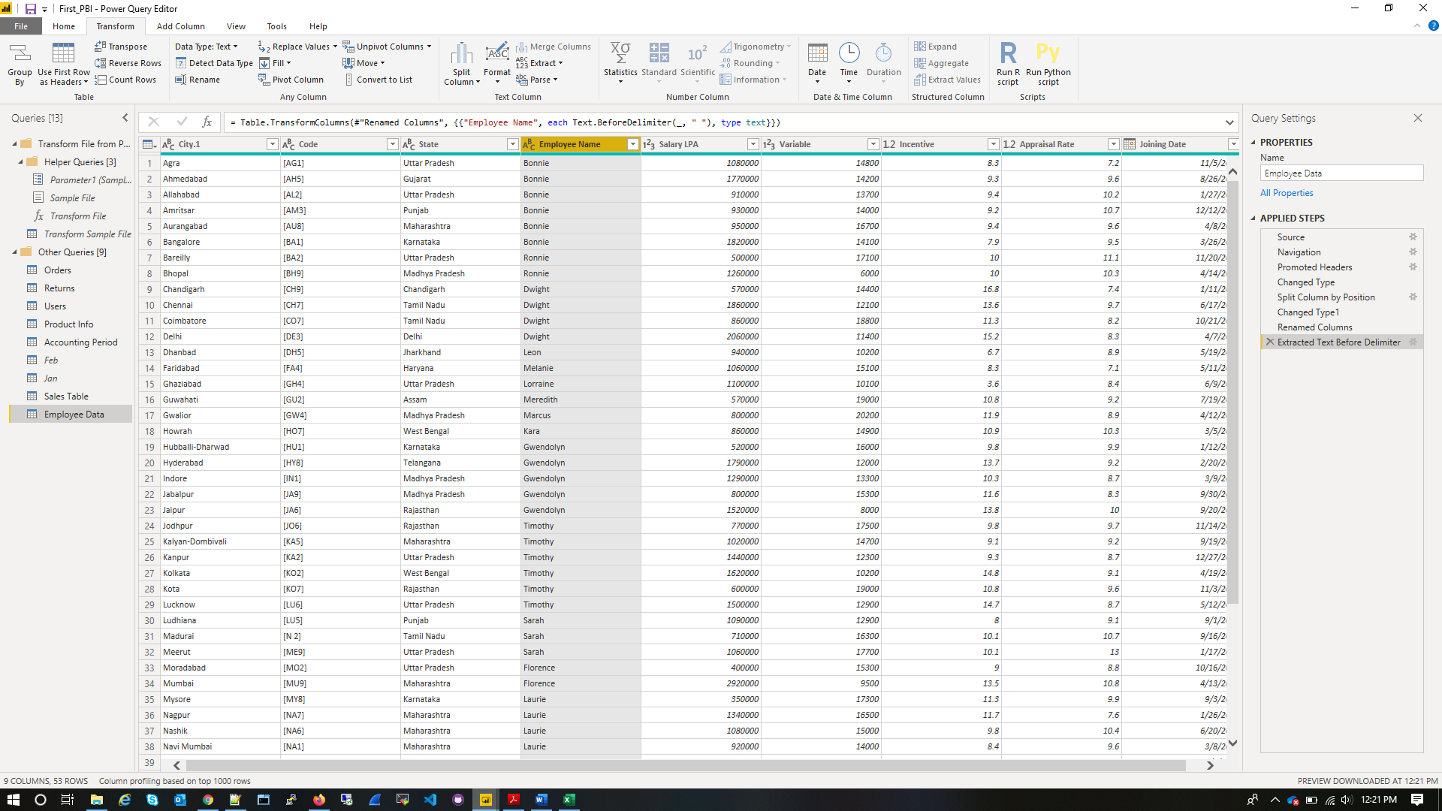

*Using the JOINING DATE column extract the Year and no. of days for that month*

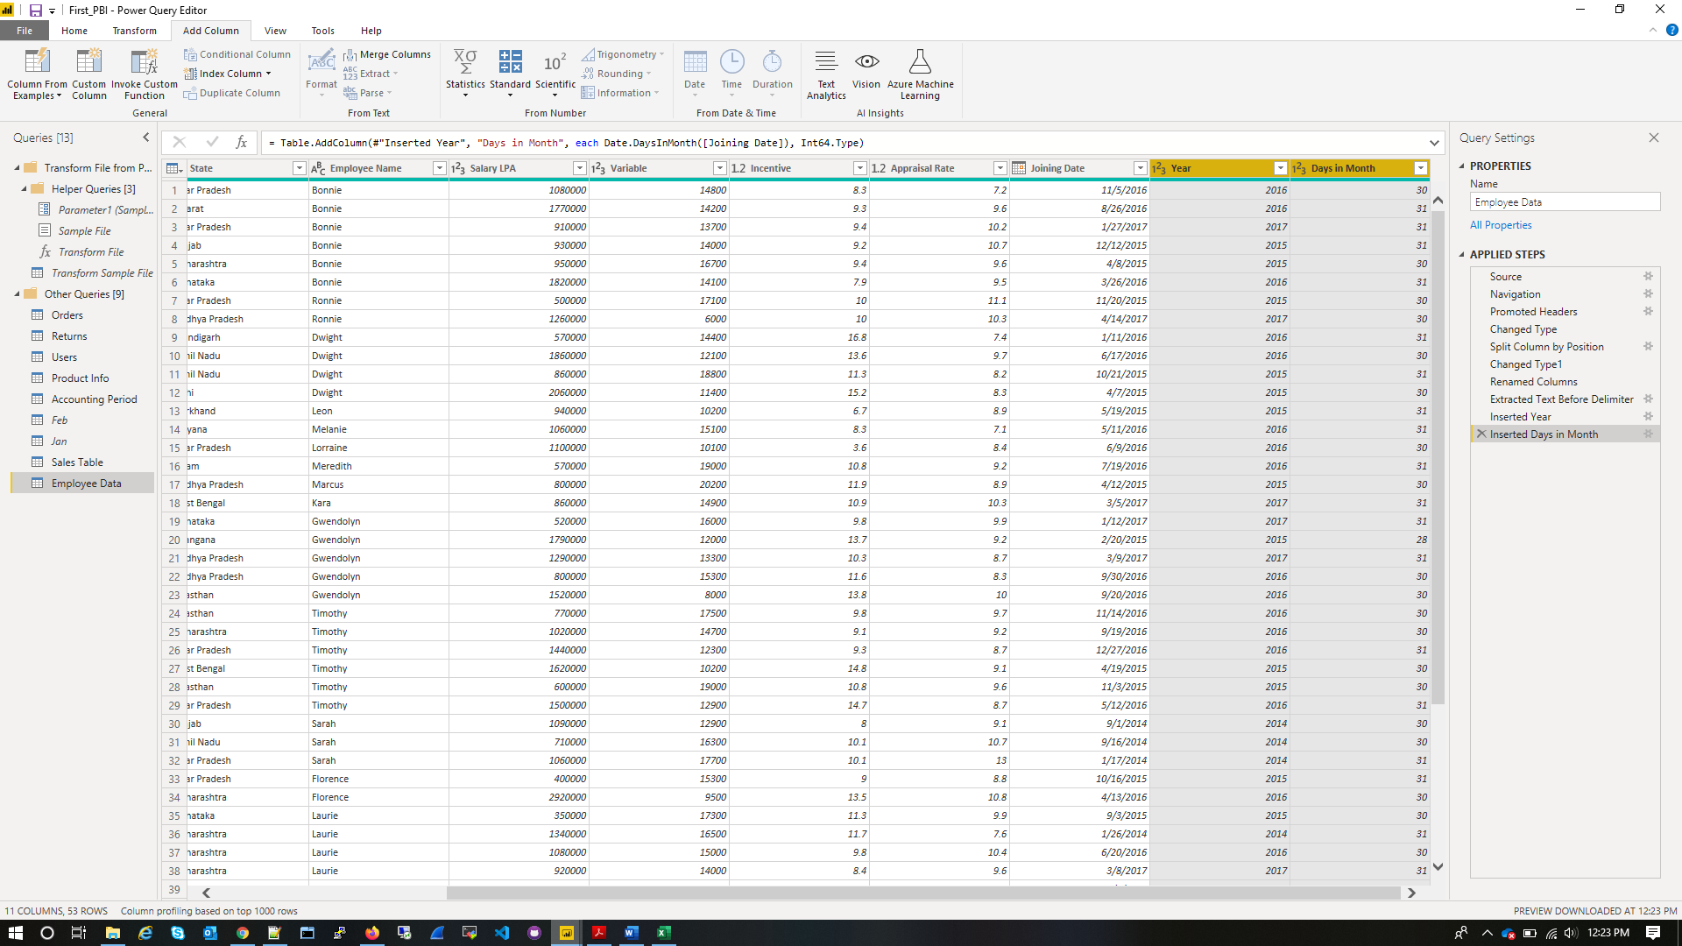

*Create a visual of your choice and show the how much salary has been paid to each state and which state has lowest payout*

