**Assignment – 1**

* **Install Power BI Desktop and share the final screenshot of the report view page which appears when power desktop starts**

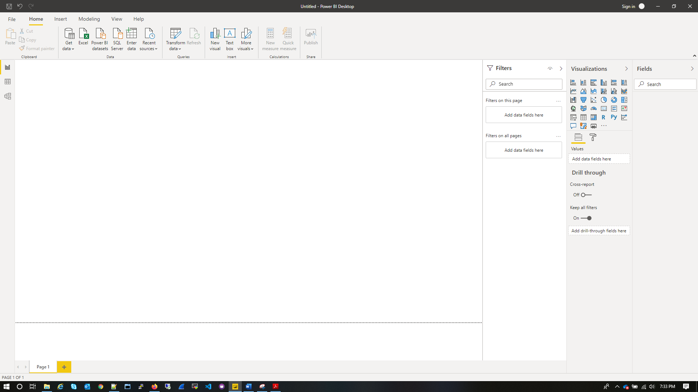

* **Prepare a document and with the following screenshot**
* **Report View**

Power BI Desktop includes a Report view, where you can create any number of report pages with visualizations. Report view in Power BI Desktop provides a similar design experience to the report's editing view in the Power BI service. You can move visualizations around, copy and paste, merge, and so on.



* **Data View**

Data view helps you inspect, explore, and understand data in your Power BI Desktop model. It's different from how you view tables, columns, and data in Power Query Editor. With Data view, you're looking at your data after it has been loaded into the model.

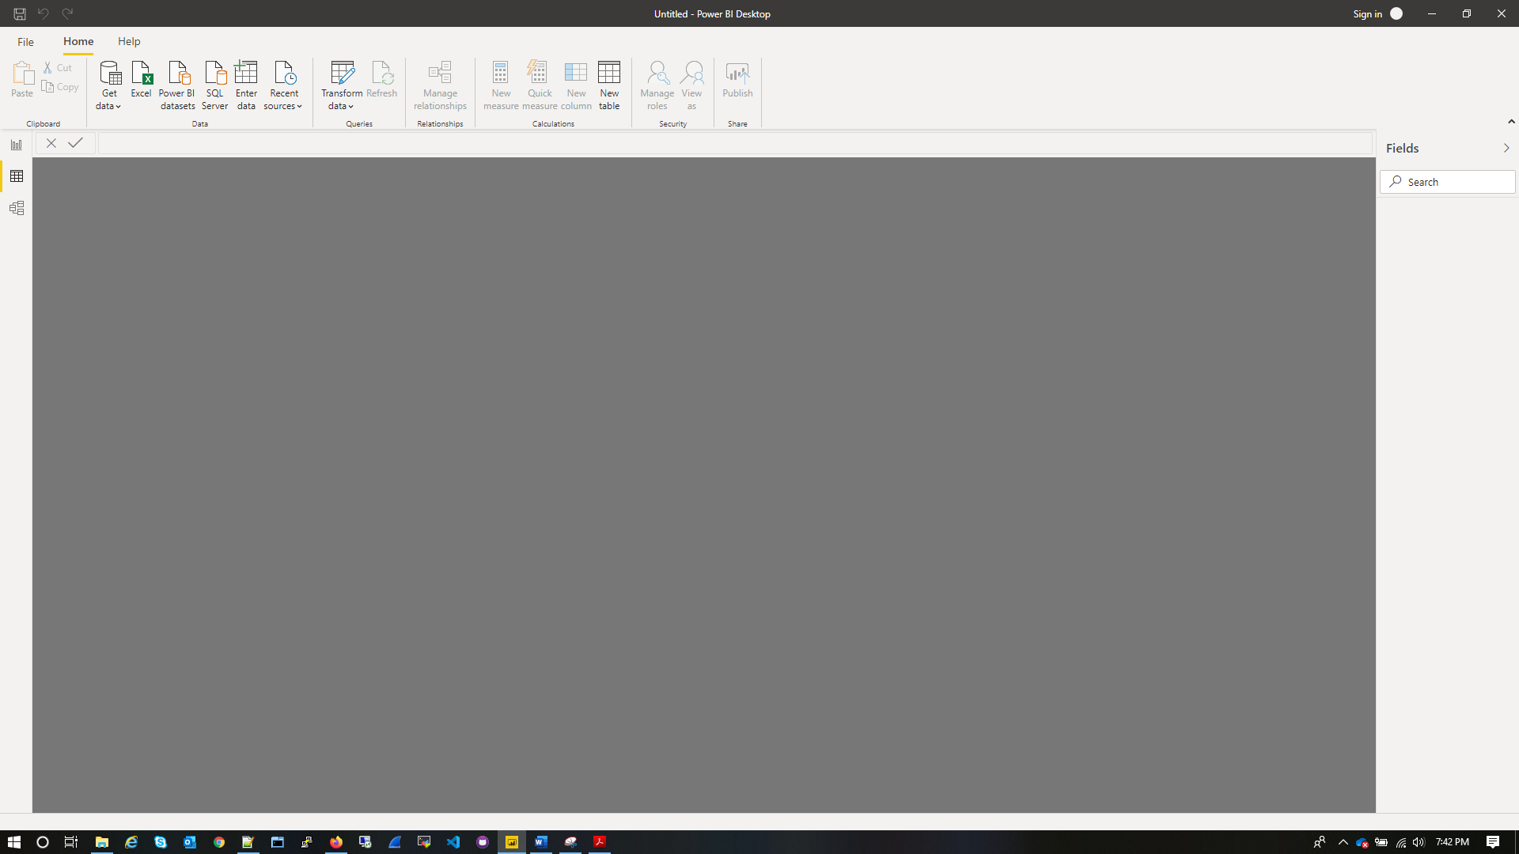

* **Model View**

Model view shows all of the tables, columns, and relationships in your model. This view can be especially helpful when your model has complex relationships between many tables.

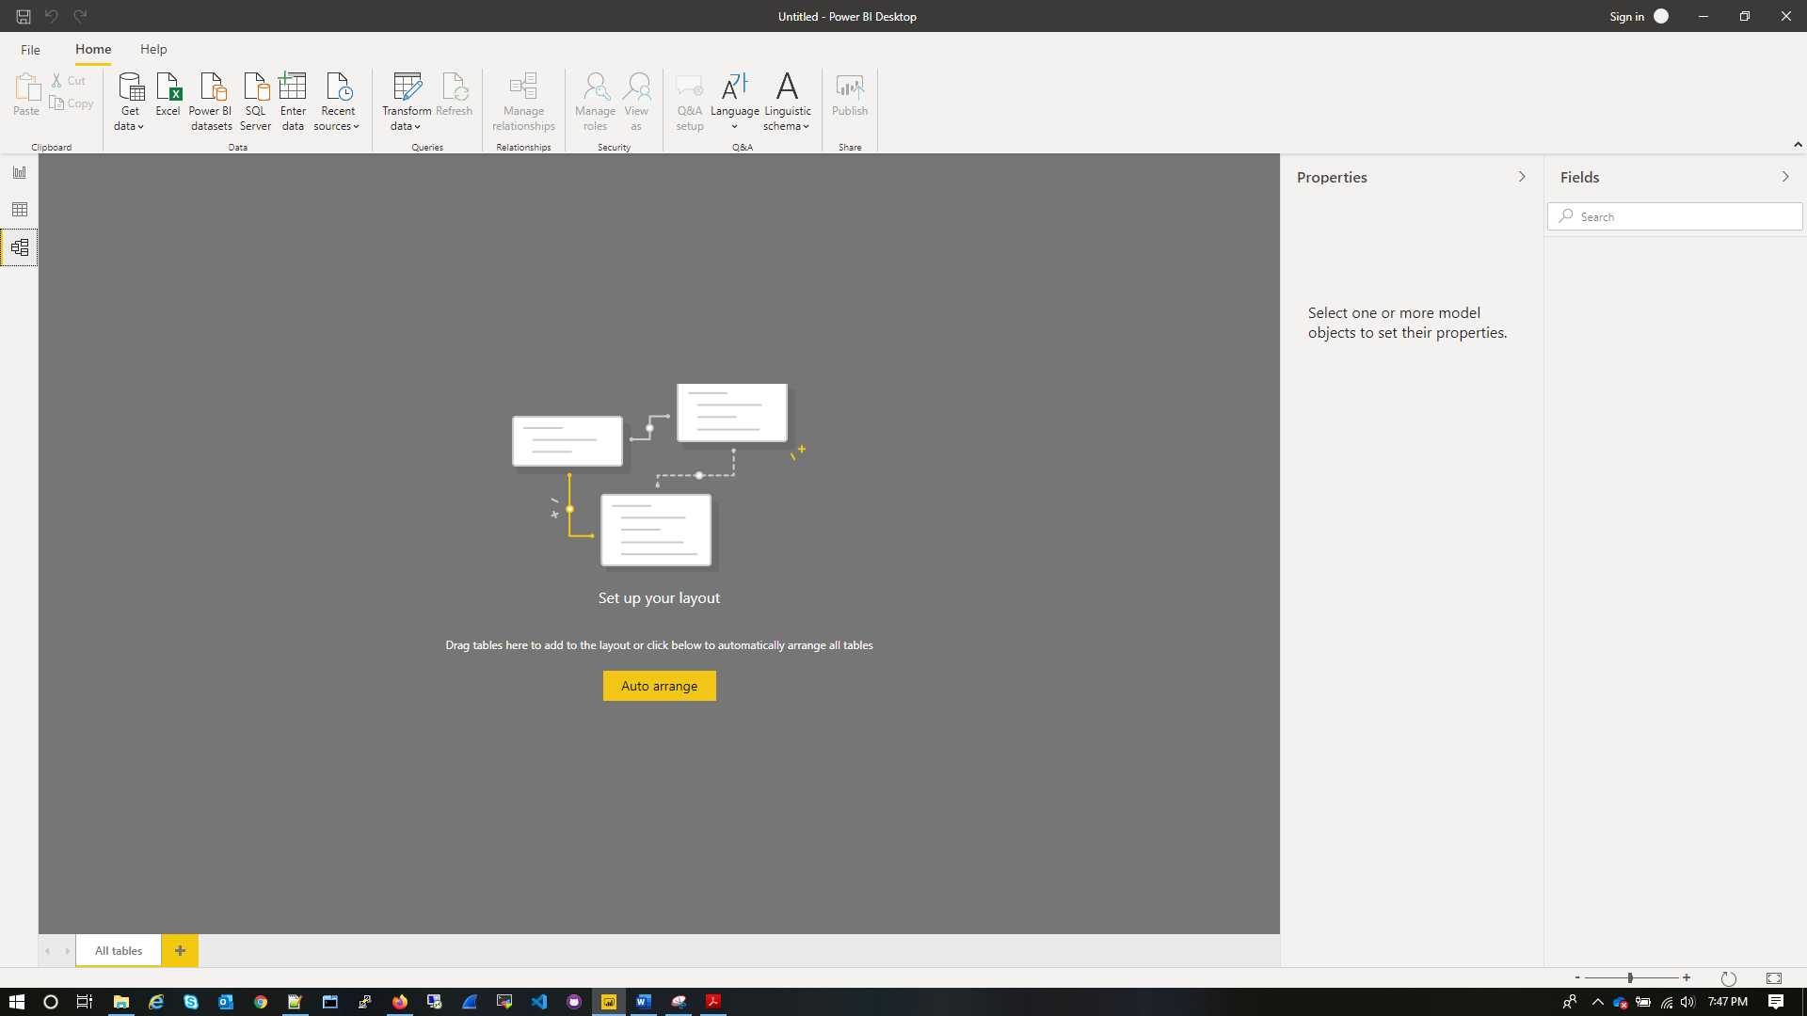

* **Power Query Editor**

With **Power Query** in **Power BI** you can connect to many different data sources, transform the data into the shape you want, and quickly be ready to create reports and insights. When using Power BI Desktop, **Power Query** functionality is provided in the **Power Query Editor**.

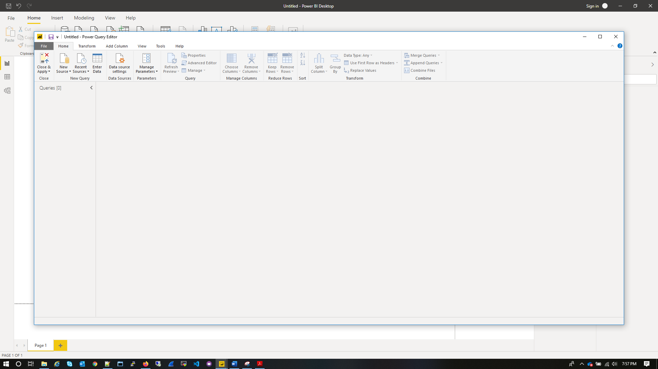

* **Advance Editor**

With Advanced Editor you can see the code for all the applied steps which you are doing against your raw data using power query editor.

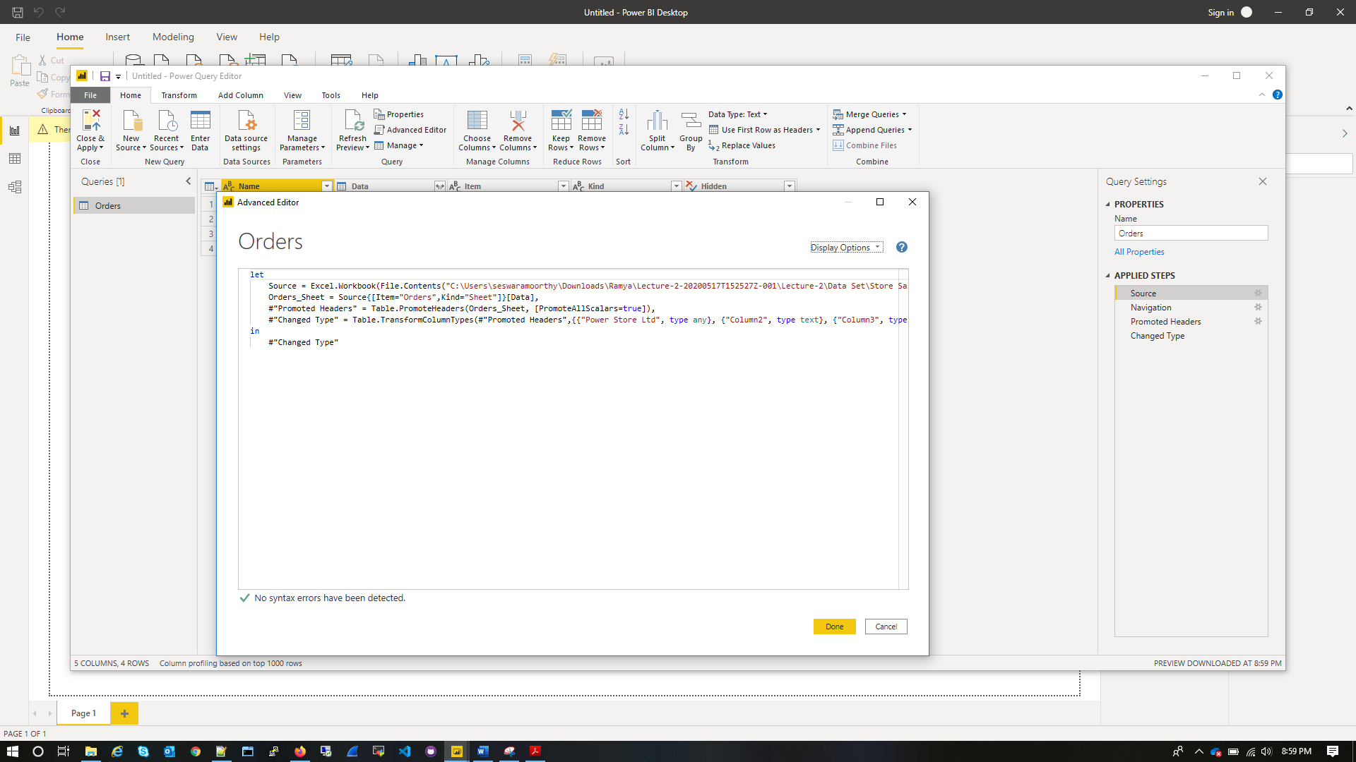

* **Prepare a document with details of the following along with their price**

**Power BI Desktop**

Power BI Desktop is the free version of Power BI that you can install on your local computer as a program, and acts as a companion desktop application to the full version of Power BI. Power BI Free enables you to connect to 70+ data sources, analyze data, publish to the web, export to excel and much more.

**Power BI Pro**

Power BI Pro is the full version of Power BI, which means it comes complete with the ability to use Power BI for both building dashboards, reports and unlimited viewing, sharing and consumption of your created reports (and reports shared by others) which is not possible with Power BI Desktop

The biggest difference of Power BI Pro vs. Free is the fact that with Pro you have the option and the ability to share the data, reports, and dashboards with a large number of other users that also have a Power BI Pro license while also being able to create an app based workspace. Furthermore, in Power BI Pro vs. Free you have a 10 GB per Pro user data storage limit

The Pro plan costs **$9.99/user/month**. It includes data collaboration, data governance, building dashboards with a 360-degree real-time view and the ability to publish reports anywhere

**Power BI Premium**

Power BI Premium is for use in large organizations with a great number of users that need to collaborate in real time. The application is geared towards addressing the challenges of large enterprise deployments and workloads.

Mainly, the advantage garnered through using Power BI Premium is the dedicated capacity and the ease of access for those that need to consume the data / reports.

The Premium plan starts at **$4,995** **a month per dedicated cloud compute and storage resource**. This does not include the cost of licensing for individual Pro and Free licenses required for each user in your organization