**Assignment -2:**

* Remove all the blank rows
* Update the column header if they are not updated

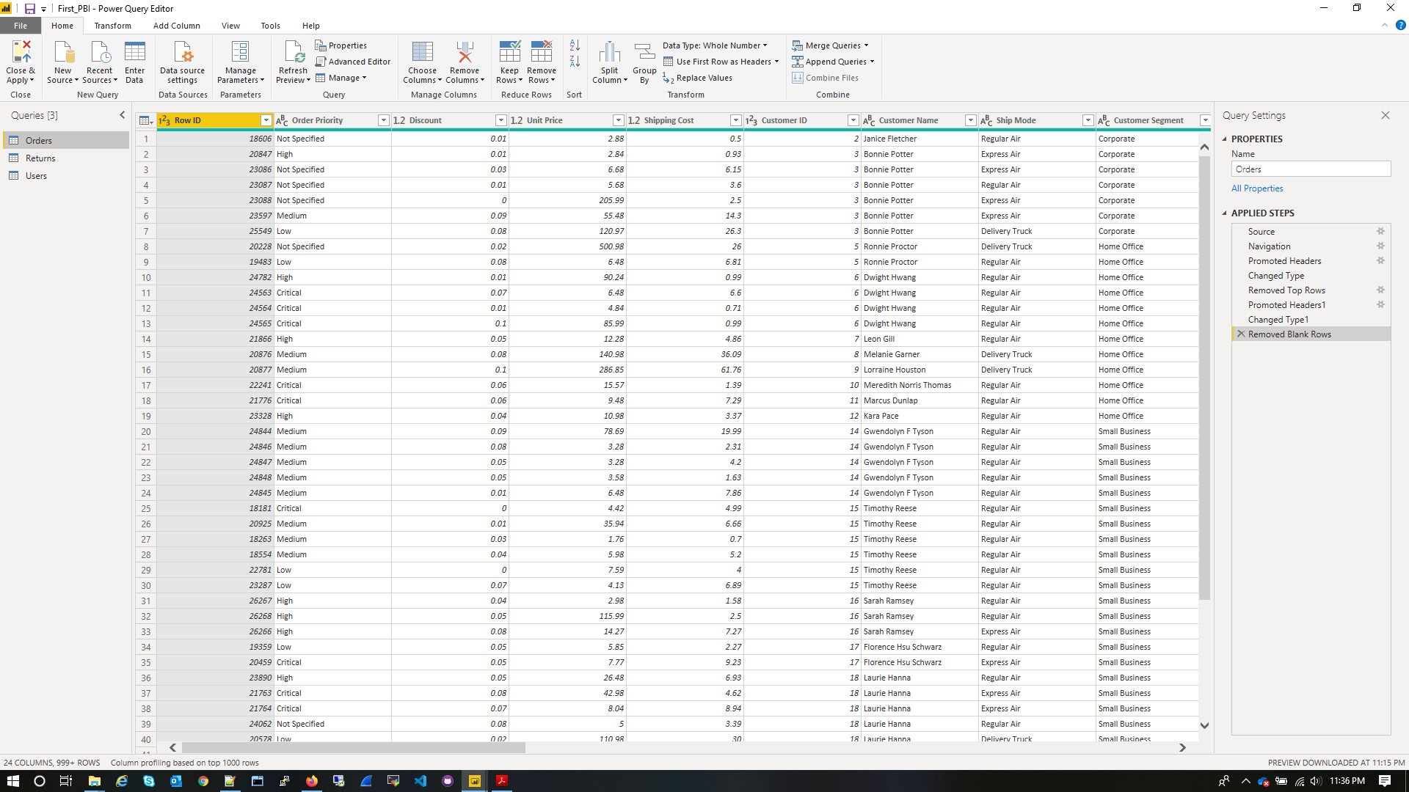

* Create a text table and show the sales in terms of

Customers

Product Category

Regions

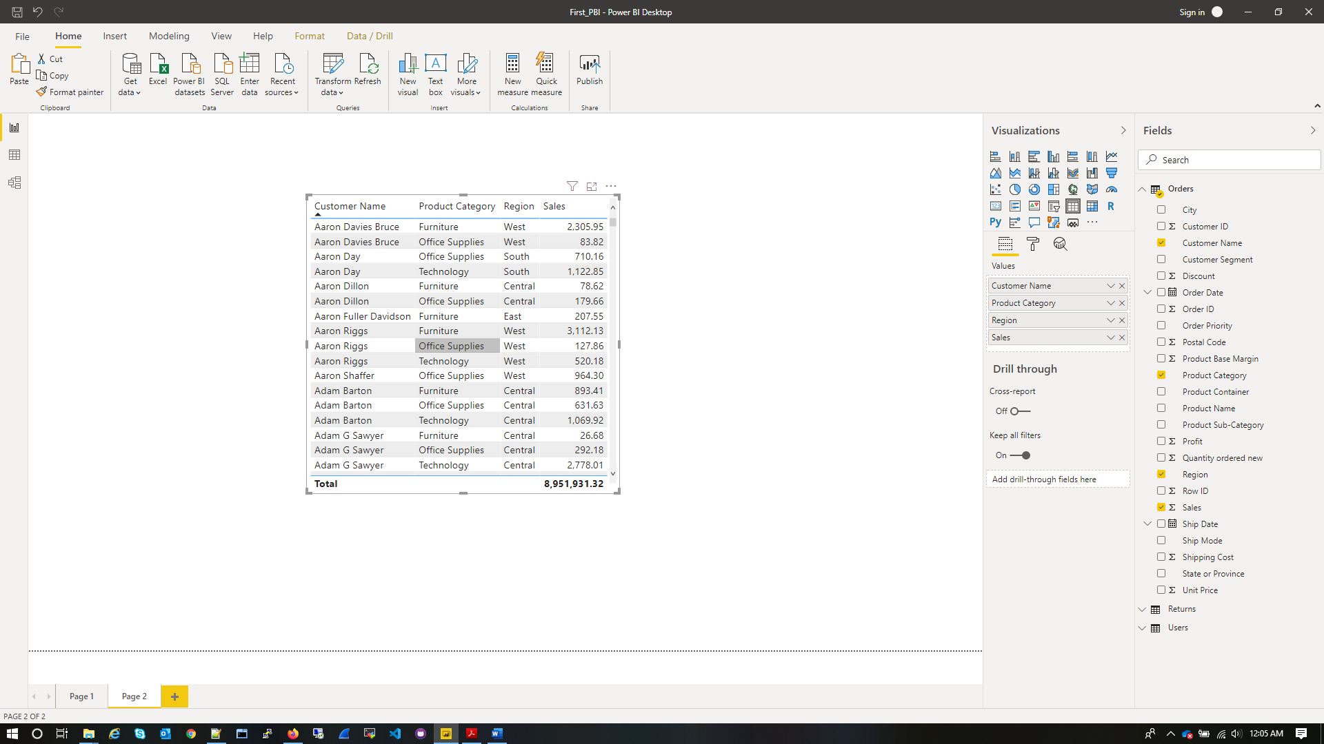

**Create a line and Clustered Column Chart showing the Sales and Discount as per**

**the State or Province**

* Format the bars and line with different colors

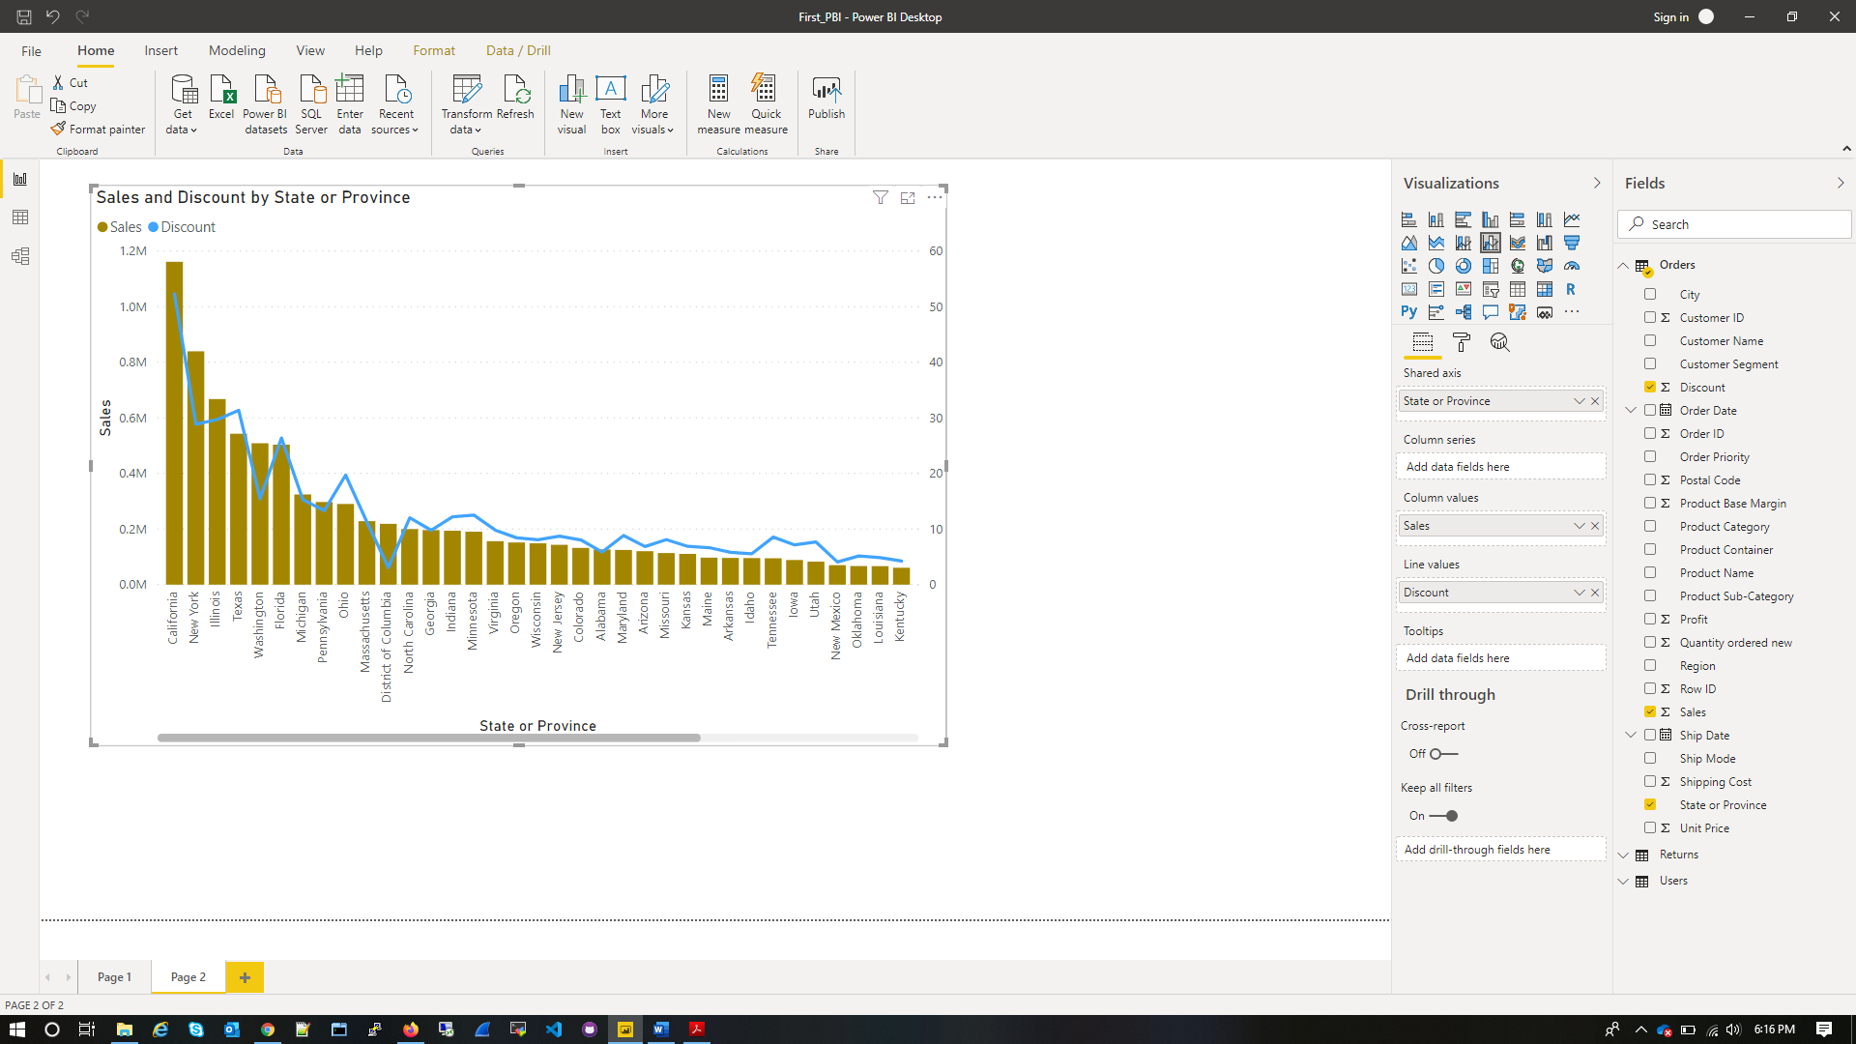

* Which state has the highest sales in terms Technology

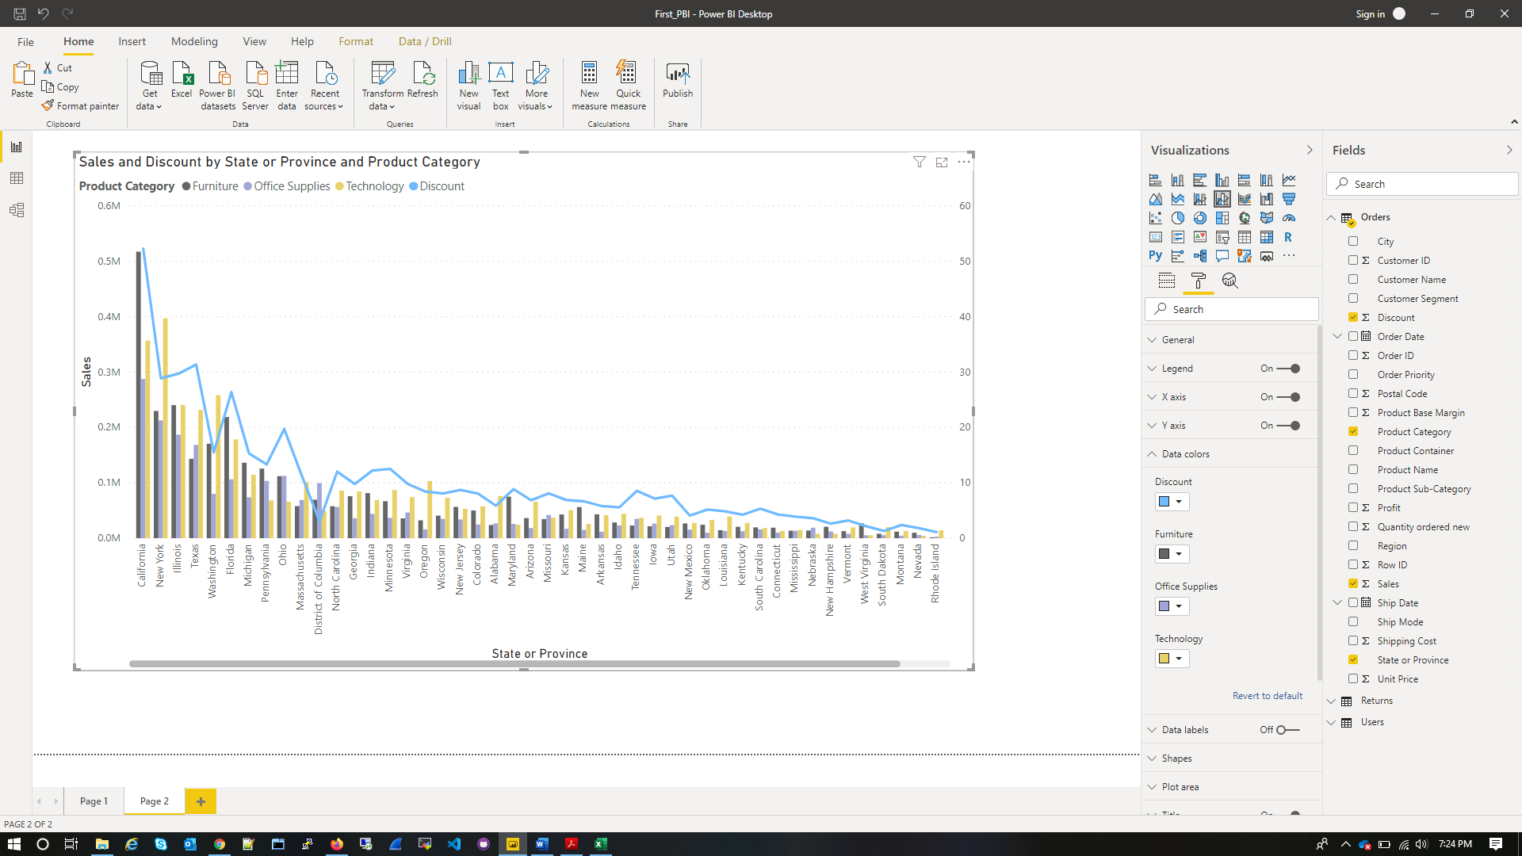

* **Create a** *Donut Chart* **showing sales in terms of Product category**

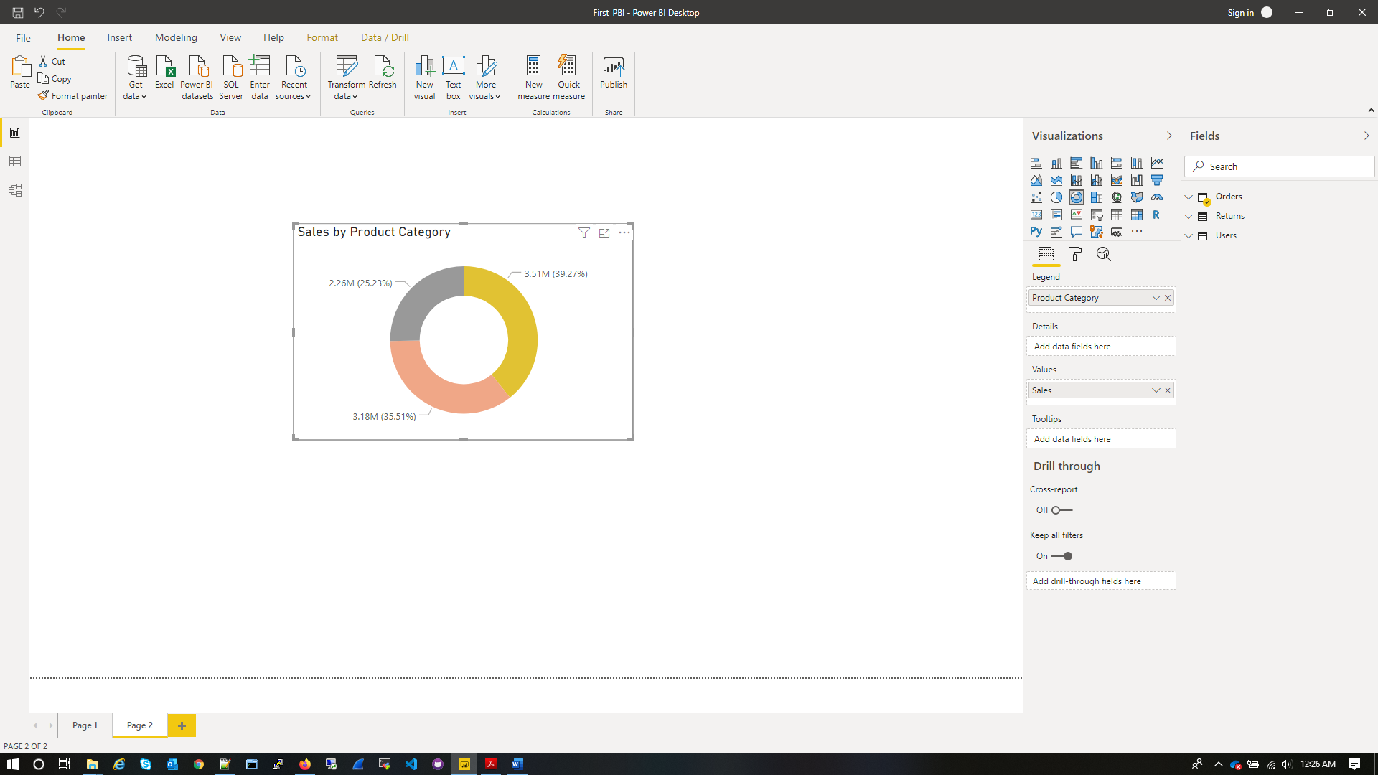

* Create a *Slicer* and show the regions in dropdown. See how all the visuals mentioned above behaving when a region is selected

