**STUDY KID**

**CONTENTS**

1. **Introduction**
2. **Team members**
3. **Abstract**
4. **Developer Requirements**
   1. **Software Requirements**
   2. **Hardware Requirements**
5. **Phone Requirements**
   1. **Software Requirements**
   2. **Hardware Requirements**
6. **Module Packages**
   1. **Pre-defined**
   2. **User defined**
   3. **Clean diagram**
7. **Screenshots**

**Team members**

**DURGAPRASAD KANCHUSTAMBAM (B.tech)**

**MADUNAPANTHULA SAI RAMYA (B.tech)**

**SURESH GOLLA (B.tech)**

**ABSTRACT**

The main idea for developing the project is to provide primary education to the physically challenged children (Blind, Deaf, Dumb and others). Since these children finds difficulty in learning basics of education at home, so we come up with this idea. It helps to build confidence in the children.

**Introduction:**

This documentation provides the clear and detailed explanation of our project STUDY KID. The main idea of our project is to provide primary education to the physically challenged children (blind, deaf, dumb and others).Our app consists of three modules. They are Blind, Deaf and Dumb.

Children can be able to learn alphabets and numbers by using this app. This app is designed in such a way that it can also be accessed by the blind children as it is linked with cortana. It builds more confidence in them.

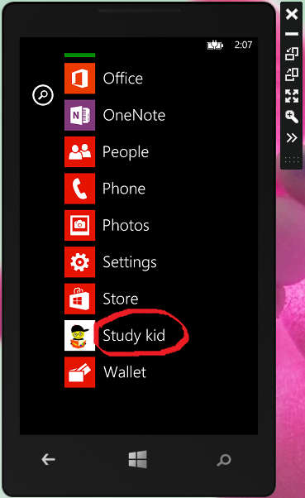

* This picture shows installation of our app in windows phone 8.0.
* You can open the app by clicking on it.

**Developer Requirements**

To develop this app the requirements are

**Software Requirements:**

* + - Visual studio 2013 with windows phone 8.0 sdk installation.
    - Blend

**Hardware Requirements:**

Processor: Intel(R) Core(TM) i3-3240 CPU @ 3.40GHz 3.39GHz

Installed Memory (RAM): 8.00 GB

System type: 64 bit Operating system, x64-based processor

**Phone Requirements**

The requirements are

**Software Requirements:**

* + - This app can beinstalled in windows phone with 8.0 operating system.

**Hardware Requirements:**

The hardware requirements are

* + - The phone should contain 512mb RAM.
    - It requires minimum 200mb internal storage to install this app.
* Usage of Head phones are optional.

**Module Packages**

The installed packages can be shown in the below figure

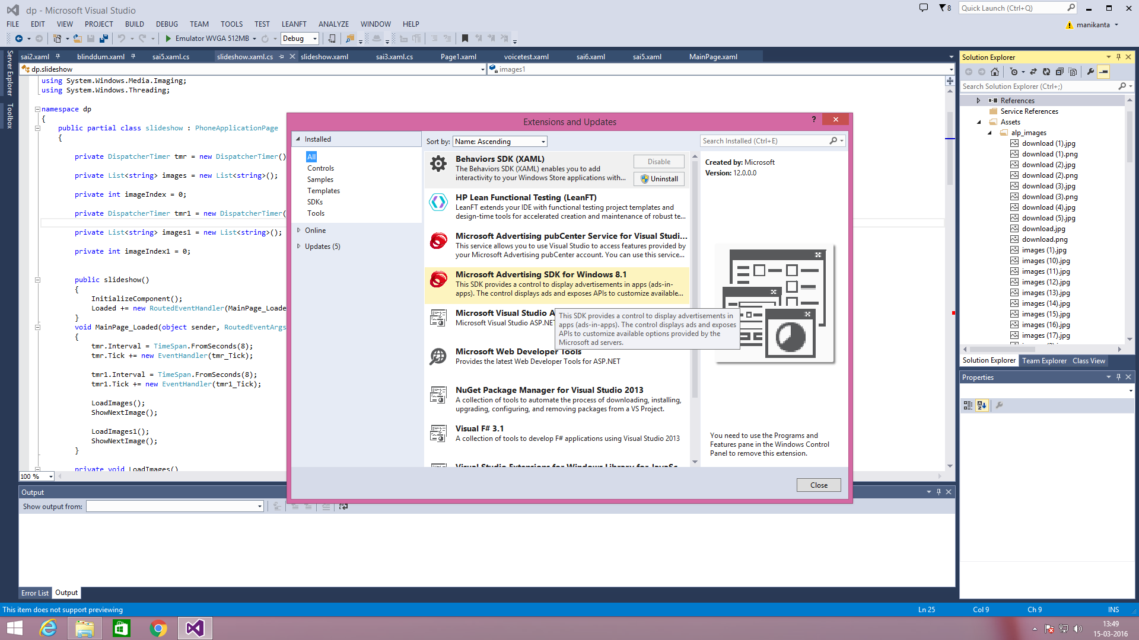

The sdk’s installed can be shown in this picture

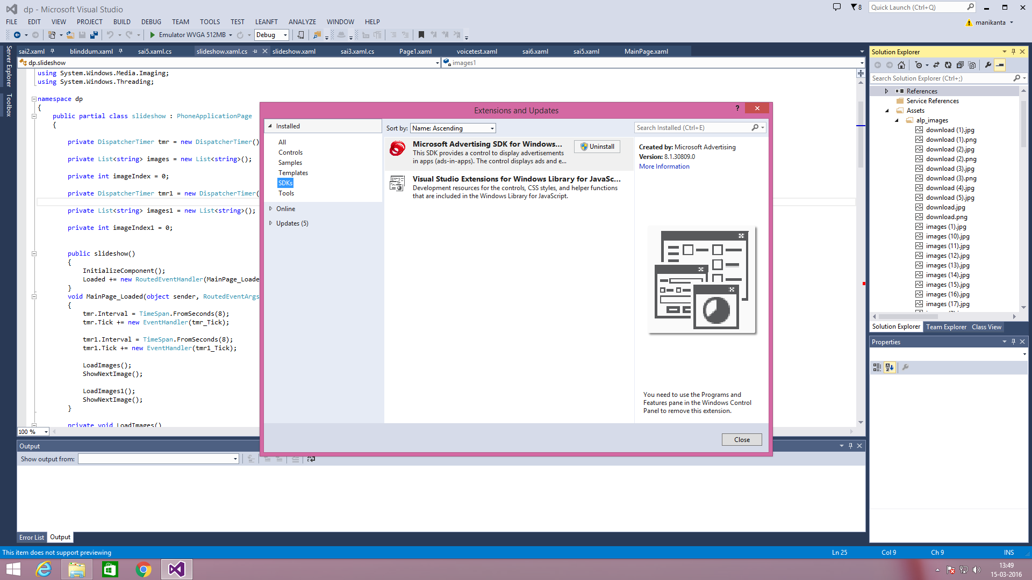

The tools used are

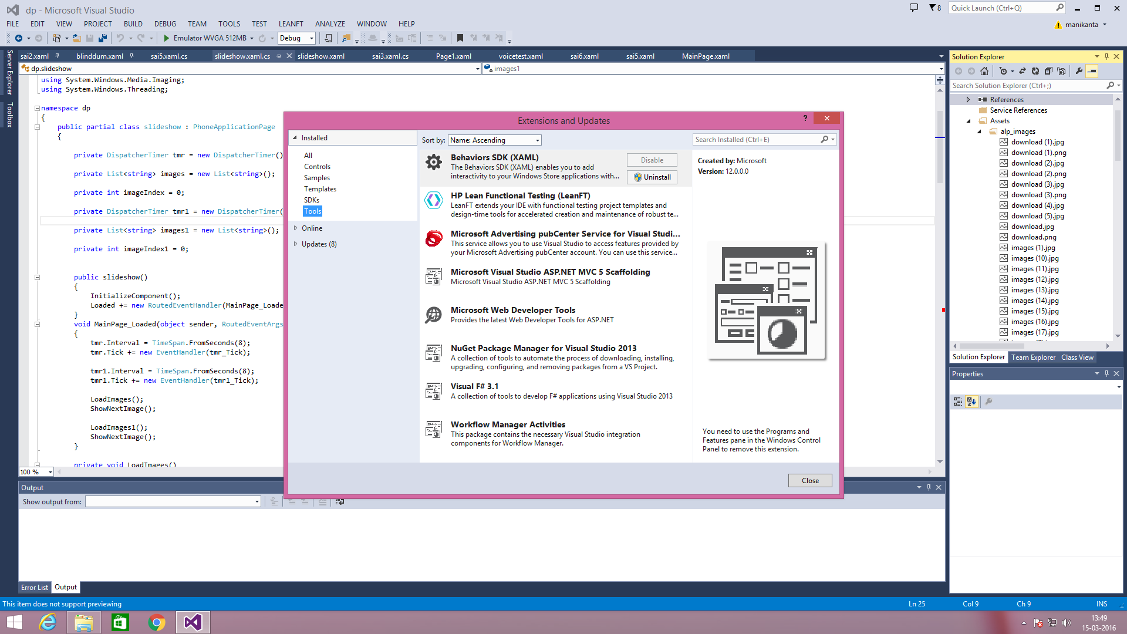

Running of emulator can be shown in this figure

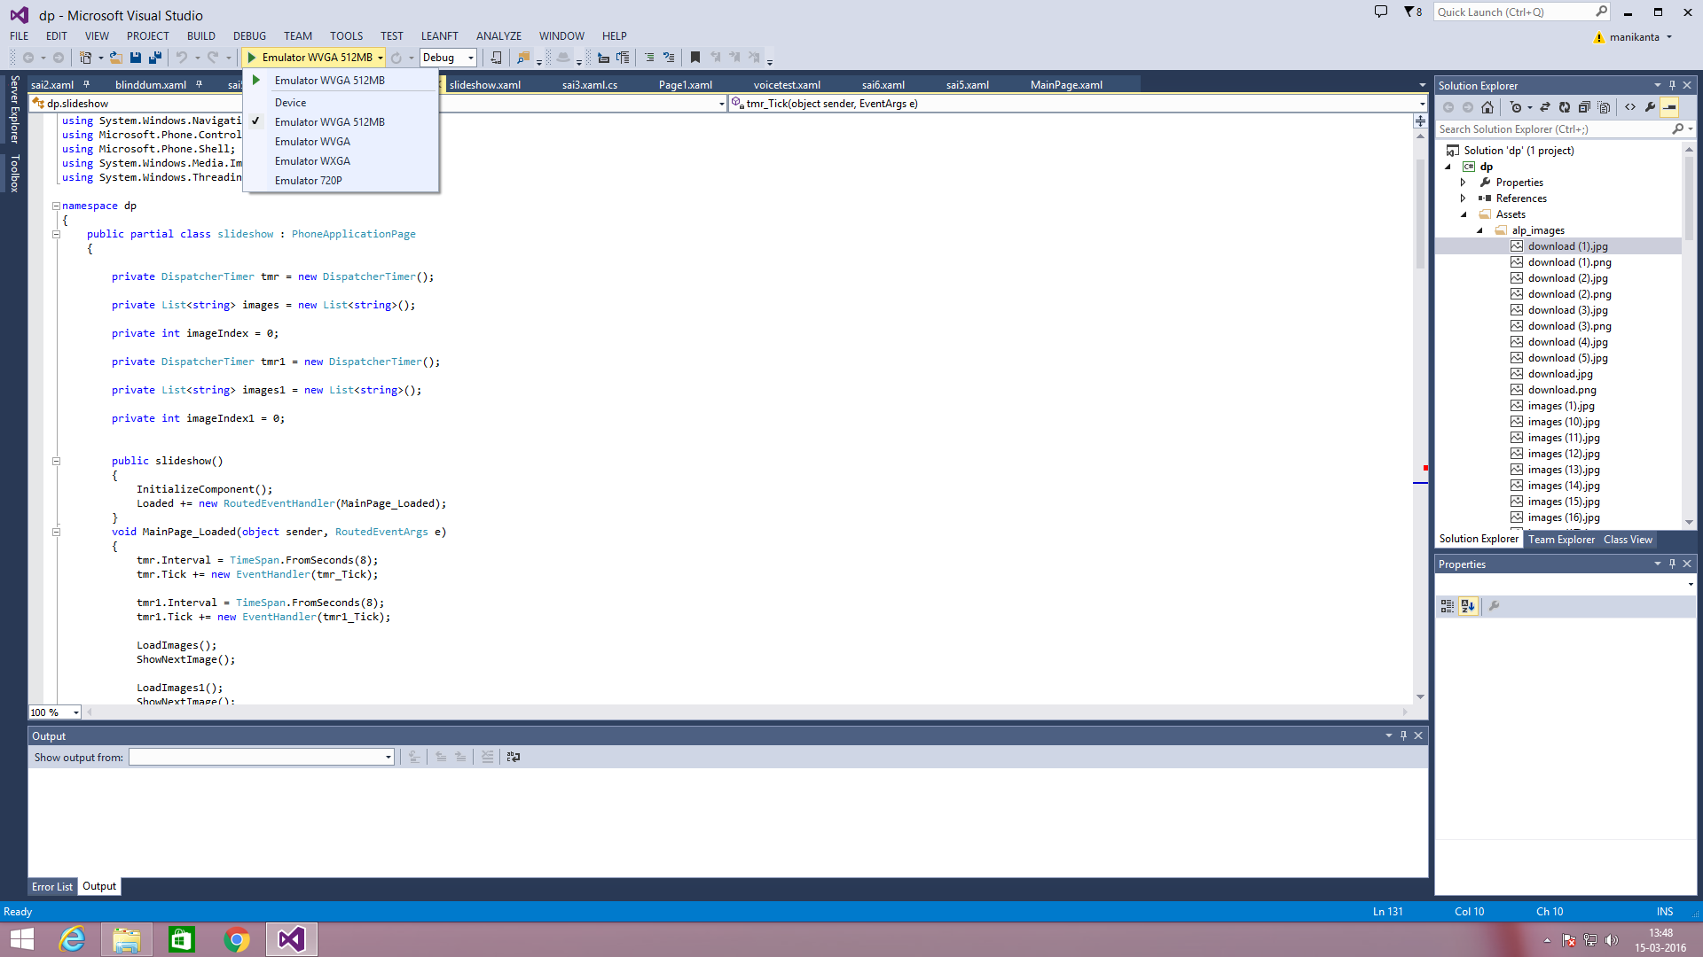

The extensions used are can be shown below

