Difference of Lazy Prompt And Engineering Prompt :
1.Lazy Prompt:
Prompt: Create an image explaining Prompt Engineering and explain there benefits
Output:
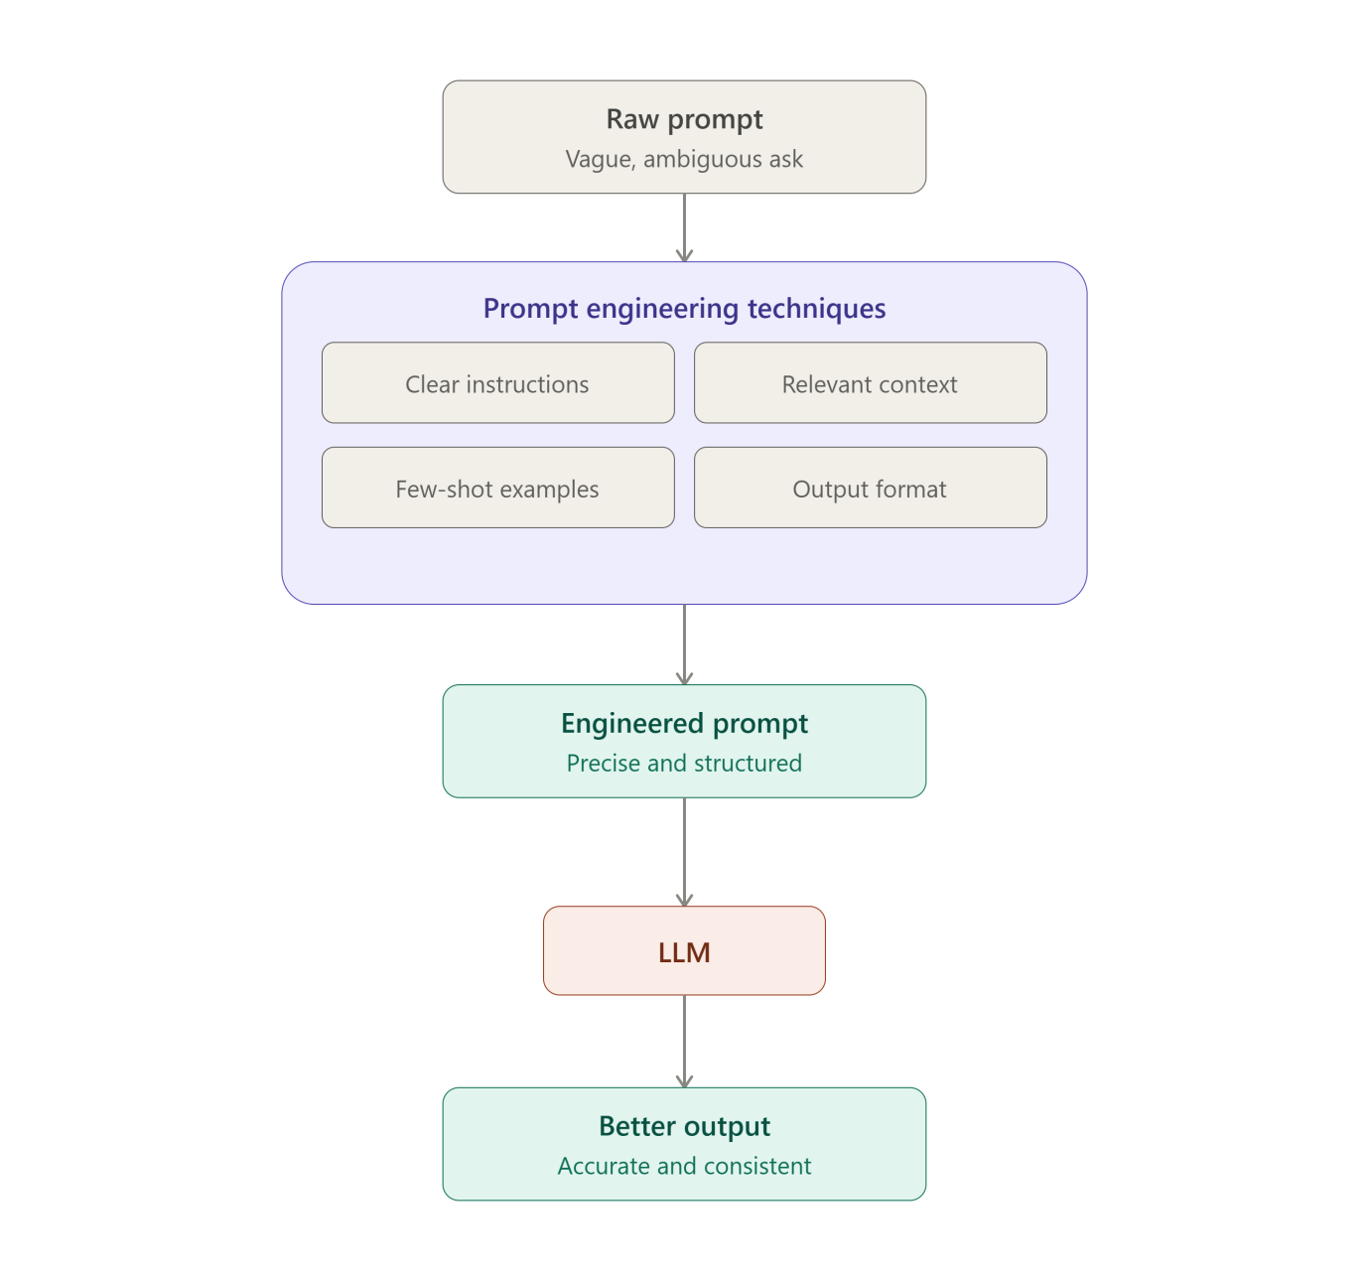

Prompt engineering is the practice of crafting your input to an AI model so it reliably produces the output you actually want. Instead of typing the first thing that comes to mind, you refine the instructions, add context, give examples, and specify format — turning a vague ask into a precise one.
Key techniques (shown above):
- Clear instructions — state exactly what you want, avoiding ambiguity
- Relevant context — give the model background it needs to answer well
- Few-shot examples — show a couple of sample input/output pairs to set the pattern
- Output format — specify structure (JSON, bullet points, word count, tone)
Benefits of prompt engineering:
- Accuracy — well-specified prompts reduce misunderstandings and wrong answers
- Consistency — the same style of prompt produces predictable, repeatable results
- Efficiency — fewer back-and-forth corrections, less wasted time and tokens
- Control — you can shape tone, length, format, and depth to fit your exact use case
- Unlocks capability — techniques like examples and step-by-step reasoning can significantly improve output quality on complex tasks, even with the same underlying model
- Cost savings — at scale (e.g. via API), better prompts mean fewer retries and lower token usage
If you want, I can also put together a short guide with concrete before/after prompt examples.

2.Prompt Engineering:
Prompt:”You are an AI educator teaching complete beginners.
Explain Prompt Engineering in simple language.
Include:
* What Prompt Engineering is
* Why it matters when using AI tools like Claude
* One example of a weak prompt
* One example of an improved prompt
* Three practical benefits of writing better prompts
Also create a LinkedIn-ready image concept.
Image Requirements:
* Square LinkedIn post (1080×1080)
* Claude-inspired brown, beige and cream colors
* Professional and minimal design
* Main title: "Prompt Engineering"
* Show a visual comparison:
* Weak Prompt → Basic Output
* Engineered Prompt → Better Output
* Modern AI and productivity-themed visuals
add abtalks 60 days claude challenge in the heading
Output Format:
Section 1: Explanation
Section 2: Weak vs Improved Prompt Example
Section 3: Detailed Image Generation Prompt”
Output:

Section 1: Explanation
What is Prompt Engineering? Prompt engineering is the skill of writing clear, specific instructions to get better results from an AI tool like Claude. Think of it like giving directions to a very capable but literal-minded assistant — the more precise and thoughtful your instructions, the better the outcome.
Why it matters when using AI tools like Claude AI tools don't read your mind — they respond based on exactly what you tell them. A vague request leads to a vague, generic answer. A well-crafted prompt (with context, format, and clear goals) helps Claude understand what you want, why you want it, and how you want it delivered — saving you time and reducing back-and-forth edits.

Section 2: Weak vs Improved Prompt Example
❌ Weak Prompt:
"Write about marketing."
Result: A generic, unfocused overview that could apply to anyone, anywhere — not useful for a specific goal.
✅ Improved Prompt:
"Act as a marketing strategist. Write a 200-word LinkedIn post explaining 3 low-budget digital marketing strategies for small local bakeries. Use a friendly, practical tone and end with a call-to-action."
Result: A focused, ready-to-use post tailored to a specific audience, format, and purpose.
Three practical benefits of writing better prompts:
- Saves time — fewer follow-up corrections and re-explanations.
- Improves accuracy — outputs match your actual intent and context.
- Unlocks better creativity — specific prompts often lead to more original, useful ideas than generic ones.

Section 3: Detailed Image Generation Prompt
Here's a ready-to-use prompt you can paste into an image generator (like Midjourney, DALL·E, or Canva's AI tool):
Create a professional, minimal LinkedIn square post (1080x1080px) for an educational carousel/post.

HEADER: Small badge/label at the top reading "AbTalks – 60 Days Claude Challenge" in a clean sans-serif font, subtle rounded pill/badge shape.

MAIN TITLE: Large, bold text "Prompt Engineering" centered near the top, in a warm dark brown (#3E2723 or similar).

COLOR PALETTE: Claude-inspired tones only — warm beige background (#F5F0E8 or #EDE4D3), soft cream accents (#FAF7F2), deep brown text and icons (#4A342A), muted terracotta/clay accent (#C17B5C) for highlights.

LAYOUT: Two-column comparison panel below the title, divided by a thin vertical line or arrow:

LEFT SIDE (labeled "Weak Prompt"):
- Small icon of a plain speech bubble or blank text box
- Text: "Weak Prompt → Basic Output"
- Simple, dull, flat visual (grayscale-ish icon of a plain document or lightbulb dimmed)

RIGHT SIDE (labeled "Engineered Prompt"):
- Icon of a structured/detailed document, checklist, or glowing lightbulb
- Text: "Engineered Prompt → Better Output"
- Vibrant, polished visual elements (upward arrow, sparkles, or a bar chart trending up) in terracotta accent color

CENTER: A bold arrow (→) or "VS" divider connecting both sides, in cream/brown tones.

BOTTOM: Thin footer line with small AI/productivity icons (gear, spark, chat bubble) in muted brown, evenly spaced.

STYLE: Flat minimal vector illustration, generous white/cream space, professional corporate-educational aesthetic, no clutter, high contrast for LinkedIn feed visibility, consistent rounded-corner design language throughout.

FONT STYLE: Modern clean sans-serif (like Inter or Poppins), bold for headings, regular weight for supporting text.
If you'd like, I can also turn this into an actual inline visual mockup right now so you can preview the layout before generating the final image — just say the word.
