Day 3- Role Based Prompting
A. Without Specify The Role:
1. Explain Role Based Prompting along with image explainaing role based prompting about 100 -200 words.
Ouput :
Role-based prompting is a technique where you assign the AI a specific persona or identity before giving it a task — for example, "You are an experienced lawyer" or "You are a friendly kindergarten teacher." Instead of answering as a generic assistant, the model adopts the tone, vocabulary, priorities, and depth of expertise associated with that role.
This works because the role acts as context that narrows the space of possible responses. A "lawyer" persona will flag contract risks and use precise legal terms; a "kindergarten teacher" persona will simplify the same explanation with simple words and analogies. The underlying knowledge is the same, but the framing, style, and focus shift dramatically.
It's especially useful for:
- Consistency — keeping tone uniform across a long interaction
- Expertise framing — nudging the model to prioritize domain-relevant details
- Audience matching — tailoring complexity to the reader (child vs. expert)
As shown above, the same task can produce a vague, generic answer without a role, or a sharp, purpose-fit answer once a role is specified.
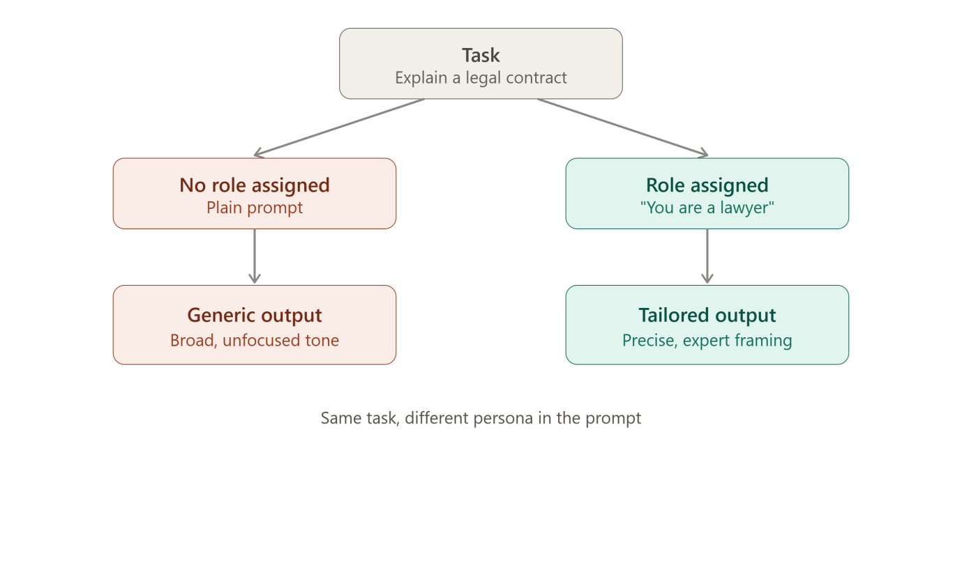

B. With Specify the Role:
Role Assigned Prompt: You are an AI educator teaching complete beginners. Explain Role-Based Prompting in simple language. Include:
- What Role-Based Prompting is
- Why it matters when using AI tools like Claude
- How assigning a role changes the quality of AI responses
- One example without a role prompt
- One example with a role prompt
- Three practical benefits of Role-Based Prompting Also create a LinkedIn-ready image concept. Image Requirements:
- Square LinkedIn post (1080×1080)
- Claude-inspired brown, beige and cream colors
- Professional and minimal design
- Main title: 'Role-Based Prompting'
- Add subheading 'ABTalks 60-Day Claude AI Mastery Challenge'
- Subtitle: 'Turn Claude into Any Expert You Need'
- Show a visual comparison: Without Role Prompt → Generic Answer With Role Prompt → Expert-Level Answer
- Include persona cards: Developer Product Manager HR Manager Founder Marketer
Output:
Good, rsvg-convert is available via ImageMagick delegate. Let me build the SVG design.Rendering works. Let me view the test output to check font quality before building the full design.## What is Role-Based Prompting?
Role-Based Prompting means telling the AI who to be before asking your question. Instead of just typing your request, you first give it an identity — like "You are a career coach" or "You are a Python teacher." The AI then answers from that perspective instead of giving a generic, one-size-fits-all reply.

Why it matters when using Claude
Claude doesn't know your intent just from the words you type — it has to guess how deep, how technical, or how formal to be. Giving it a role removes the guesswork. It's like walking into a room and saying "I need a lawyer" instead of "I need someone" — you instantly get the right kind of help.

How a role changes the quality of the response
Without a role, Claude tries to cover many possible angles at once, so answers stay broad and safe. With a role, it narrows its focus, uses the vocabulary of that profession, and prioritizes the details an expert in that field would care about. Same question, sharper answer.
Example without a role prompt:
"Explain how to price a product." → A general, textbook-style answer covering costs, competitors, and demand — useful, but shallow.
Example with a role prompt:
"You are a pricing strategist at a SaaS startup. Explain how to price a new product." → A focused answer using SaaS-specific concepts like tiered pricing, freemium models, and customer lifetime value.

Three practical benefits
- Sharper, more relevant answers — the response matches the expertise you actually need.
- Consistent tone — great for long chats where you want the same "voice" throughout.
- Easy audience-matching — ask for a "kindergarten teacher" for simple explanations, or a "senior engineer" for technical depth.

I built the LinkedIn image concept per your specs — brown/beige/cream Claude-inspired palette, the persona cards, and the before/after comparison.Let me know if you'd like any tweaks — different persona names, a darker/lighter palette, or a version sized for other platforms (e.g. Instagram carousel).

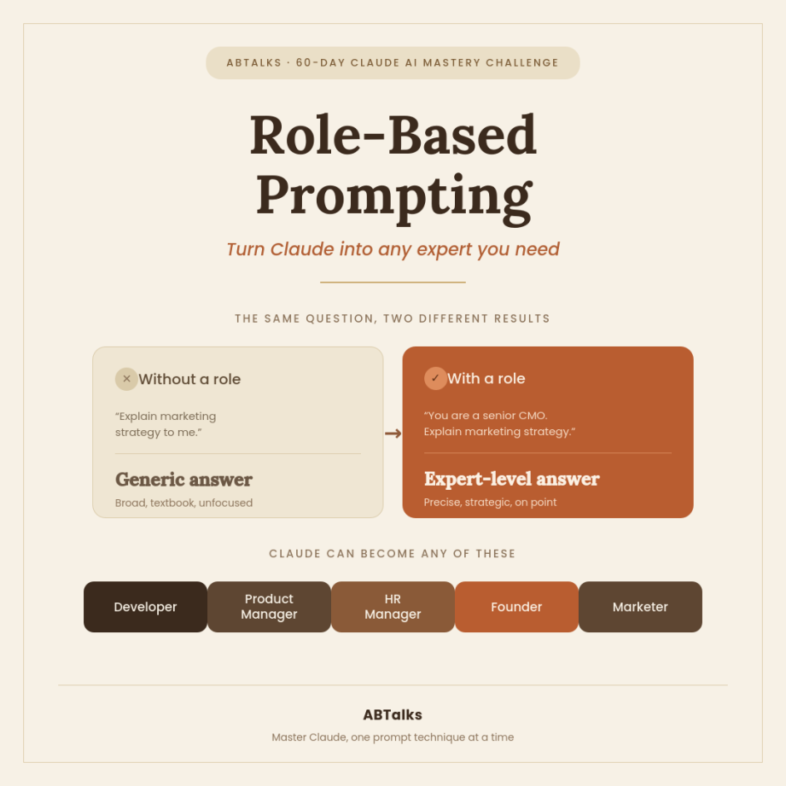
C. Founder Persona
Prompt: You are the founder of a successful AI startup. I want to build an AI-powered student study app. Explain how I should build it. Focus on:
- Problem validation
- Target users
- Market opportunity
- Business model
- MVP features
- Go-to-market strategy
- Growth plan Keep the explanation beginner-friendly.
Output:
Happy to walk through this like I would with a first-time founder pitching me this idea. Let's go section by section.

1. Problem Validation (do this before writing any code)
The biggest mistake early founders make is building first, validating later. Before you touch a line of code:
- Talk to 20-30 students directly. Not surveys — conversations. Ask: "How do you study right now? What's frustrating about it? What have you tried and abandoned?" You're listening for repeated pain, not polite feedback.
- Look for a specific moment of pain, not a vague "studying is hard." Good signals: "I spend 3 hours making flashcards and never get to actually study," or "I read the textbook but forget everything by the exam."
- Check if they're already hacking together a solution — using ChatGPT, Quizlet, and Notion together. That's a strong signal there's a real job to be done, and an opening for something that does it better in one place.
- Validate willingness to pay, not just willingness to use. Free tools get praised; paid tools get used. Ask "would you pay $10/month for this" and be suspicious of enthusiastic yeses — look for people who've paid for similar things before.
Rule of thumb: if you can't name the exact sentence a student would use to describe their frustration, you're not ready to build yet.

2. Target Users
Don't target "students" — that's too broad to design for or market to. Pick a beachhead:
- By academic stage: high schoolers (parents often pay), college students (price-sensitive, high volume), grad/professional students (MCAT, bar exam, nursing boards — narrow but high willingness to pay)
- By subject: STEM-heavy courses have very different study patterns (problem sets, formulas) than humanities (reading, essays, memorization)
- By use case: exam crammers vs. long-term learners vs. people re-learning material they missed in class
My advice: start with high-stakes, high-stress exam prep (nursing boards, MCAT, bar exam, or even a specific hard college course like organic chemistry). These users have money, urgency, and a clear definition of "success" — which makes both product design and marketing much easier than "general student."

3. Market Opportunity
EdTech and AI tutoring is a large and growing space, but "large market" isn't your edge — a large market with slow-moving incumbents and an underserved segment is. Questions to answer for yourself:
- Who are the incumbents (Quizlet, Chegg, Khan Academy, Anki) and what do they not do well? Usually: they're generic, not personalized to your actual course material, or clunky about turning your own notes into something usable.
- Is there a wedge — a specific student population or workflow — the big players are ignoring because it's too niche for them but big enough for you?
- Is the market growing for a real reason (more people going back to school, licensing exam volume increasing, AI making tutoring feel viable for the first time) or is it just "AI hype market"?
You don't need a huge market on day one. You need a market that's big enough to get to $1M+ ARR with your beachhead, with room to expand into adjacent user groups after.

4. Business Model
Common options, ranked by how well they usually fit this space:
- Freemium subscription (most common, proven model — Quizlet, Duolingo). Free tier: limited uploads/questions per month. Paid tier ($8-15/month): unlimited generation, advanced features. Works well because students churn seasonally (exam periods), so a low-friction free tier keeps them in the funnel year-round.
- One-time purchase per exam/course — e.g., "$29 for a complete MCAT prep pack." Works well for high-stakes, one-shot exams where the value is obvious and time-boxed.
- B2B2C via schools/institutions — sell to universities or tutoring centers, distribute to students free. Longer sales cycles, but higher ACV and stickier.
- Usage-based/API pass-through pricing — risky as a primary model early on since AI costs scale with heavy usage; better as a component of #1.
For most first-time founders, freemium subscription is the right starting point because it's simplest to build, test, and iterate pricing on.

5. MVP Features
Resist the urge to build the "everything app." Your MVP should prove one core loop works and that people come back for it.
Absolute minimum:
- Upload notes/PDF/slides
- AI generates flashcards and a short quiz from that content
- Spaced repetition scheduling so review timing is smart (this is the retention engine — don't skip it even though it's "boring" compared to AI features)
- Basic progress view (what's mastered, what needs work)
Explicitly leave out of v1: chat-based tutoring, social/collaborative features, gamification, multi-subject dashboards, mobile app (start web if it gets you to users faster). Add these once you've proven the core loop retains people.
Success metric for MVP: do users come back within a week to review, not "did they upload once and generate content." Retention on the core loop is the whole ballgame.

6. Go-to-Market Strategy
For a beachhead like exam prep, you don't need paid ads on day one — you need to go where the anxiety already lives:
- Reddit/Discord communities for your target exam (r/step1, r/LSAT, nursing school Discords) — answer questions genuinely, mention your tool when relevant, don't spam
- TikTok/Instagram content from students who use it — study creators are a huge, low-cost distribution channel in this space right now
- Campus ambassadors — a handful of engaged students per campus who get free premium access in exchange for word-of-mouth
- SEO on exam-specific long-tail terms ("best MCAT flashcard app," "how to study for step 1") — slow burn but compounds
- Direct outreach to study groups, tutoring centers, prep course instructors — they influence many students at once
Don't try all five at once. Pick one or two channels, get them working, then expand.

7. Growth Plan
- Phase 1 (0-1,000 users): manual, high-touch — talk to every early user, iterate fast on the core loop, focus entirely on retention over acquisition
- Phase 2 (1,000-10,000 users): double down on the one acquisition channel that's working, start layering in referral loops (e.g., "invite a study buddy, both get a free month")
- Phase 3 (10,000+): expand horizontally — new subjects, new exam types, or new user segments (once your first beachhead is a strong, retained base) — and start testing paid acquisition now that you know your unit economics
- Throughout: watch cost per AI-generated study session closely — this is the metric that can quietly kill margins if you scale usage before optimizing your prompt/caching strategy

If I had to compress this into one piece of advice: pick one painful, high-stakes studying moment for one specific type of student, build the smallest thing that fixes it well, and get 100 people using it every week before you think about anything else. Everything else — funding, growth, expansion — gets dramatically easier once you have that.
Want me to help you pick a specific beachhead niche based on what you're most excited about, or start sketching the actual MVP build?
D. Developer
Prompt: You are a Senior Full Stack AI Developer. I want to build an AI-powered student study app. Explain how I should build it. Focus on:
- Tech stack
- System architecture
- AI models
- Database
- APIs
- Frontend
- Backend
- Deployment
- Security
- Testing Keep the explanation beginner-friendly.
Output:
Let's go through this like I'm scoping the technical build with you before we write code. I'll keep each section practical and beginner-friendly, with reasoning for the choices so you're not just copying a stack blindly.

1. Tech Stack (recommended for a solo/small team)
Frontend: React (web) or React Native/Flutter if mobile-first Backend: Node.js (Express/NestJS) or Python (FastAPI) Database: PostgreSQL + pgvector extension AI: Claude API (Anthropic) for generation/chat, plus an embeddings model for search Hosting: Vercel (frontend) + Railway/Render/Fly.io (backend) to start — move to AWS/GCP once you have real scale
Why this combo: Python (FastAPI) is a strong choice if your team leans toward AI/data work since most AI tooling is Python-native; Node is a good choice if you want one language across frontend and backend. Either is fine — pick based on what you or your team knows best. Don't overthink this decision; it's reversible later.

2. System Architecture
Think of the system in four layers:
[Frontend] → [API/Backend] → [AI Layer] → [Database]
↓
[Vector DB for retrieval]
Flow for the core feature (generate flashcards from notes):
- User uploads a PDF/notes → frontend sends file to backend
- Backend extracts text, splits into chunks
- Chunks get embedded (converted to vectors) and stored in a vector database
- Backend sends chunks to Claude API with a prompt like "generate flashcards from this content, return as JSON"
- Structured flashcards come back → stored in Postgres → sent to frontend to render
Flow for Q&A/chat about their material (RAG pattern):
- User asks a question
- Backend embeds the question, searches the vector DB for the most relevant chunks of their uploaded material
- Those chunks + the question get sent to Claude
- Claude answers grounded in their actual notes, not generic knowledge
This RAG pattern (retrieval-augmented generation) is the single most important architectural concept for this kind of app — it's what makes answers accurate to their textbook instead of hallucinated or too generic.

3. AI Models
- Main reasoning/generation model: Claude API — use it for flashcard generation, quiz generation, chat/Q&A, and summarization. For structured outputs (flashcards, quiz JSON), prompt it explicitly to return only valid JSON in a defined schema, and validate/parse that on the backend.
- Embeddings model: needed to convert text chunks into vectors for retrieval. You'll pick a dedicated embeddings API/model for this (this is a separate model from the generation model — check current embedding model options when you get to this step, since this space changes often).
- Model cost management: cache generated content aggressively (don't regenerate flashcards from the same PDF twice), and set reasonable input length limits per request early on so costs don't spiral before you have paying users.

4. Database
PostgreSQL is the right default. Structure roughly:
- users — auth, plan tier
- documents — uploaded files, metadata
- chunks — text chunks + vector embeddings (using the pgvector extension so you don't need a separate vector database initially)
- flashcards — question/answer pairs, linked to a document/deck
- reviews — spaced repetition state per card per user (ease factor, interval, next review date — this is your SM-2 algorithm data)
- quizzes / quiz_attempts — generated questions and user performance
Starting with pgvector inside Postgres (instead of a separate vector DB like Pinecone) is a good beginner move — one database to manage, and it scales fine until you have a genuinely large amount of content.

5. APIs
- Your own REST API (or GraphQL if you prefer) for frontend↔backend: /documents, /flashcards, /reviews, /chat
- Claude API for all AI generation and chat, called server-side (never from the frontend — you don't want your API key exposed in client code)
- File parsing: you'll need a library/service to extract clean text from PDFs and slides — this is often the messiest part in practice, so budget real time here, especially for scanned documents or slide decks with lots of images
- Auth API: use a managed service (Clerk, Auth0, or Supabase Auth) rather than building auth yourself — this saves weeks and avoids security mistakes

6. Frontend
- React (or React Native for mobile) with a component library (Tailwind + shadcn/ui, or similar) so you're not designing every button from scratch
- Key screens: upload/library, flashcard review (the core loop — make this fast and satisfying), chat/Q&A interface, progress dashboard
- State management: React Query (or similar) for server state is usually enough early on — don't reach for heavy state libraries prematurely
- Loading states matter a lot here — AI generation takes a few seconds, so show clear progress indicators rather than a frozen screen

7. Backend
- Structure around clear services: AuthService, DocumentService (upload/parsing), AIService (all Claude API calls, prompt templates), ReviewService (spaced repetition logic)
- Keep prompt templates in one place (not scattered across the codebase) — you'll be iterating on these constantly as you improve output quality
- Implement the spaced repetition scheduling as deterministic backend logic (SM-2 algorithm) — this isn't an AI task, it's just math based on user performance history
- Queue long-running AI jobs (large document processing) with a background job system (BullMQ, Celery) rather than making the user wait on a blocking request

8. Deployment
Start simple, scale later:
- Frontend: Vercel or Netlify (near-zero config, free tier is generous)
- Backend: Railway, Render, or Fly.io — much less operational overhead than raw AWS when you're starting out
- Database: managed Postgres (Supabase, Neon, or Railway's built-in Postgres) — don't self-host a database as a beginner
- Move to AWS/GCP/Azure only once you have real scale and specific needs (compliance, custom infra) that justify the added complexity

9. Security
- Never expose API keys client-side — all Claude API calls go through your backend
- Encrypt sensitive data at rest (especially if students upload personal academic records)
- Rate limit your API endpoints, especially anything that triggers an AI call, to prevent cost abuse
- Validate and sanitize all file uploads — check file types/sizes server-side, scan for malicious content
- Use a managed auth provider rather than rolling your own password handling
- If you ever handle payment info, never touch raw card data — use Stripe/similar and let them handle PCI compliance
- If targeting K-12 users, look into COPPA/FERPA compliance requirements early — this affects data handling significantly and is easier to build in from the start than retrofit

10. Testing
- Unit tests for your deterministic logic (spaced repetition scheduling, especially — this needs to be correct)
- Integration tests for your API endpoints (does upload → parse → generate → store actually work end to end)
- AI output validation: since Claude's output feeds into structured UI (flashcards, quizzes), always validate the JSON structure on the backend before storing it — don't trust the model's output blindly, even with good prompting
- Manual QA on AI quality: build a small internal review process where you spot-check generated flashcards for accuracy — this is qualitative and won't be caught by automated tests, but it directly affects whether users trust your product
- Load testing before any big launch/marketing push, since AI API calls are your slowest and most expensive operations

Suggested build order if you're doing this solo: auth + file upload → text extraction/chunking → flashcard generation with Claude → spaced repetition logic → review UI → chat/Q&A with RAG → progress dashboard. Get the first four working end-to-end before touching anything else — that's your provable core loop.
Want me to sketch out the actual database schema in more detail, or write starter code for the RAG pipeline (chunking → embedding → retrieval → generation)?

E. Founder vs Developer Comparison
Founder Perspective | Developer Perspective
- Focuses on users and business | - Focuses on implementation
- Validates the problem | - Designs the architecture
- Plans the MVP | - Chooses the tech stack
- Thinks about growth | - Thinks about performance
- Discusses revenue | - Discusses APIs and databases

F. Key Learning
The same question can produce very different answers depending on the role assigned to the AI. Role-Based Prompting helps generate responses that are more relevant, specialized, and aligned with the expertise of the chosen persona.

