AI-POWERED INVENTORY ANALYTICS
& DEMAND PREDICTION
IBM SkillsBuild Data Analytics with AI Internship 2026
BharatCares
Project Report
Prepared by
Ramya N
B.E. Computer Science and Engineering
Vidya Vikas Institute of Engineering and Technology (VVIET), Mysuru
2026

1. Project Overview
This project analyzes historical retail inventory and sales data to identify demand patterns, potential inventory risks, important demand drivers, and business actions that can support better inventory planning. A Random Forest regression model is also used to predict demand and provide an AI/ML component for decision support.

2. Problem Statement
Retail businesses need to maintain sufficient inventory to meet customer demand while avoiding unnecessary excess stock. The project addresses this problem by analyzing demand, sales, inventory levels, promotions, pricing, seasonality, weather, regions, categories, and product-level behavior. The goal is to convert the historical data into actionable insights for inventory planning.

3. Objectives
- Understand the structure and quality of the retail dataset.
- Measure important business KPIs such as demand, units sold, inventory, and units ordered.
- Analyze demand across product categories and regions.
- Identify records where demand is greater than available inventory as a potential inventory-risk indicator.
- Study demand associations with promotion, discount, seasonality, weather, and competitor pricing.
- Analyze monthly, seasonal, and product-level demand patterns.
- Build a Random Forest regression model for demand prediction.
- Translate analytical findings into practical business recommendations.

4. Dataset Description
The project uses a retail sales and inventory dataset containing 76,000 records and 16 original columns. The dataset covers observations from 1 January 2022 to 30 January 2024.
Item | Details
Records | 76,000
Original columns | 16
Date range | 2022-01-01 to 2024-01-30
Categories | Electronics, Clothing, Groceries, Toys, Furniture
Regions | North, South, East, West
Weather | Sunny, Cloudy, Rainy, Snowy
Seasonality | Winter, Spring, Summer, Autumn
Original variables include Date, Store ID, Product ID, Category, Region, Inventory Level, Units Sold, Units Ordered, Price, Discount, Weather Condition, Promotion, Competitor Pricing, Seasonality, Epidemic, and Demand.

5. Data Quality and Preparation
- The Date column was converted to datetime format for time-based analysis.
- The dataset contained 0 missing values.
- The dataset contained 0 duplicate records.
- Additional time features were created for machine learning: Year, Month, Day, and DayOfWeek.
- Categorical variables were encoded using OneHotEncoder inside a scikit-learn preprocessing pipeline.
- The data was split chronologically rather than randomly: records before 1 October 2023 were used for training and records from 1 October 2023 onward were used for testing.

6. Key Performance Indicators
KPI | Value
Total records | 76,000
Total units sold | 6,750,876
Total demand | 7,928,104
Average demand | 104.32
Average inventory level | 301.06
Total units ordered | 6,770,889
Minimum demand | 4
Maximum demand | 430
Potential inventory-risk records | 10,394 (13.68%)

7. Category Analysis
Groceries has the largest total demand and units sold among the analyzed categories. Clothing has the highest potential inventory-risk rate, while Furniture has the lowest.
Category | Total Demand | Avg Demand | Avg Inventory | Potential Risk Rate
Groceries | 3,677,684 | 120.98 | 360.31 | 13.49%
Clothing | 1,369,456 | 112.62 | 282.10 | 19.42%
Furniture | 1,006,590 | 73.58 | 250.07 | 7.84%
Toys | 985,338 | 92.61 | 229.11 | 14.97%
Electronics | 889,036 | 97.48 | 289.26 | 13.87%

8. Region Analysis
Region | Total Demand | Avg Demand | Avg Inventory | Potential Risk Rate
North | 3,154,658 | 103.77 | 279.03 | 14.60%
South | 1,625,471 | 106.94 | 332.01 | 12.93%
East | 1,618,324 | 106.47 | 321.99 | 13.26%
West | 1,529,651 | 100.63 | 293.24 | 12.99%

9. Inventory Risk Analysis
A derived indicator was created using Demand - Inventory Level. A record was marked as a potential inventory-risk record when Demand was greater than Inventory Level. This is an analytical warning indicator and should not be interpreted as proof that a stock-out actually occurred.
- 10,394 of 76,000 records were potential-risk records, representing 13.68%.
- Clothing had the highest potential-risk rate at 19.42%.
- North had the highest regional potential-risk rate at 14.60%.
- Product P0008 had the highest observed potential-risk rate among the analyzed products at 28.39%.

10. Demand Driver Analysis
Factor | Observed result
Promotion | Average demand was 123.27 with promotion vs 95.03 without promotion.
Seasonality | Summer had the highest average demand at 112.86.
Discount | 15–25% discount groups showed higher average demand than 0–10% groups.
Weather | Sunny observations had the highest average demand at 115.17.
Monthly pattern | August had the highest calendar-month average demand at 119.80; May had the lowest at 86.52.
These are observed associations in the dataset. They do not establish that a factor caused the change in demand.

11. Product Analysis
Product | Average Demand | Total Demand | Avg Inventory | Potential Risk Rate
P0009 | 118.51 | 450,324 | 272.30 | 18.58%
P0013 | 116.03 | 440,895 | 382.65 | —
P0004 | 115.40 | 438,505 | 320.35 | 12.13%
P0007 | 115.02 | 437,089 | 466.86 | —
P0002 | 112.07 | 425,853 | 285.83 | 14.16%
P0009 had the highest average demand among the products highlighted in the analysis. P0008 had the highest potential inventory-risk rate at 28.39%, showing that high demand and high inventory risk are not identical measures.

12. Machine Learning: Demand Prediction
A Random Forest Regressor was selected to predict Demand. Numeric variables included Inventory Level, Price, Discount, Promotion, Competitor Pricing, Epidemic, Year, Month, Day, and DayOfWeek. Categorical variables included Category, Region, Weather Condition, and Seasonality.
Training records: 63,800. Testing records: 12,200. The chronological split was used to evaluate the model on later observations.

13. Model Evaluation
Model | MAE | RMSE | R²
Baseline Random Forest | 20.10 | 27.89 | 0.6146
Tuned Random Forest | 20.14 | 27.81 | 0.6168
The tuned model produced a slightly lower RMSE and slightly higher R², while MAE was marginally higher. The improvement was modest, so the model should be treated as a decision-support tool rather than a guaranteed forecast.

14. Feature Importance
Feature | Importance
Price | 0.1891
Epidemic | 0.1276
Category: Groceries | 0.1102
Competitor Pricing | 0.0876
Promotion | 0.0855
Inventory Level | 0.0815
Day | 0.0455
Category: Furniture | 0.0345
Category: Clothing | 0.0324
Discount | 0.0288
Feature importance represents predictive importance within the trained Random Forest model. It should not be interpreted as causal importance.

15. Business Insights and Recommendations
- Prioritize inventory monitoring for products with higher potential-risk rates, especially P0008.
- Review inventory planning for Clothing because it has the highest category-level potential-risk rate.
- Give additional attention to the North region because it has the highest regional potential-risk rate.
- Consider promotion and seasonal patterns when planning inventory because higher observed demand is associated with promotional and summer periods.
- Monitor high-demand products such as P0009 closely so that demand is supported by sufficient inventory.
- Use the demand-prediction model as a supporting analytical tool and combine its output with operational knowledge before making inventory decisions.

16. Limitations
- The dataset represents historical observations and may not represent every retail environment.
- Demand greater than inventory is a potential risk indicator, not confirmation of an actual stock-out.
- Observed relationships between promotions, discounts, weather, pricing, and demand do not prove causation.
- The prediction model has measurable error and should not be treated as a guaranteed forecast.
- The year 2024 contains only January observations and should not be directly compared with complete 2022 and 2023 annual totals.

17. Conclusion
This project analyzed 76,000 retail inventory and sales records to identify demand patterns, inventory-risk areas, product and regional differences, and important demand-related factors. The analysis identified a 13.68% potential-risk rate using the Demand > Inventory Level indicator and highlighted Clothing, North region, and product P0008 for closer monitoring. A tuned Random Forest model achieved an R² of 0.6168 on the chronological test set. Overall, the project demonstrates how data analytics and machine learning can support inventory planning through measurable KPIs, visual analysis, predictive modeling, and actionable recommendations.

18. Project Files
File | Purpose
RamyaN_InventoryAnalytics.ipynb | Complete Python analysis, visualizations, and ML model
requirements.txt | Python libraries required to run the project
README.md | Project overview, dataset information, setup, and usage
RamyaN_InventoryAnalytics_ProjectReport.docx | Project documentation and findings

Note: The dataset source URL should be added to the README once the original dataset source is confirmed. No source URL has been invented in this report.

Average Demand by Category
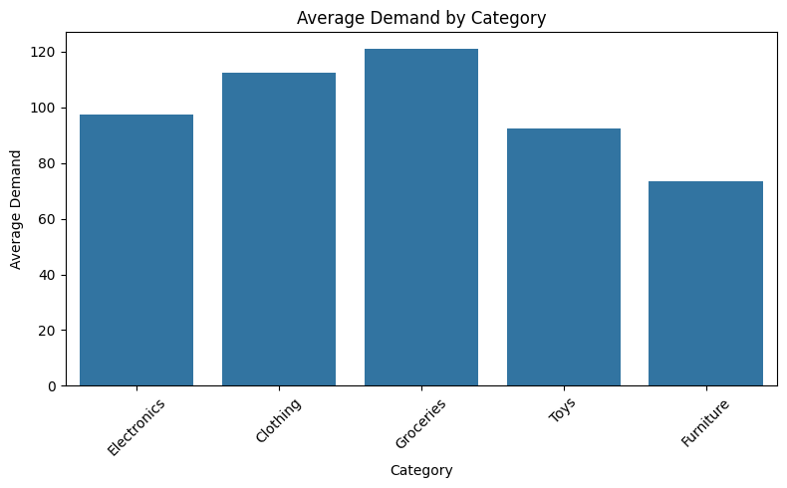

Promotion vs No Promotion
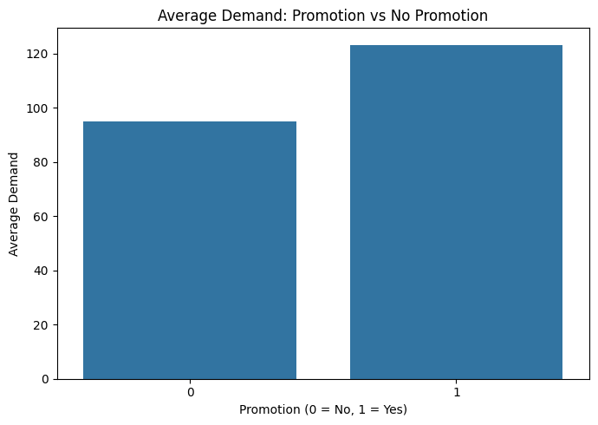

Potential Inventory Risk by Category
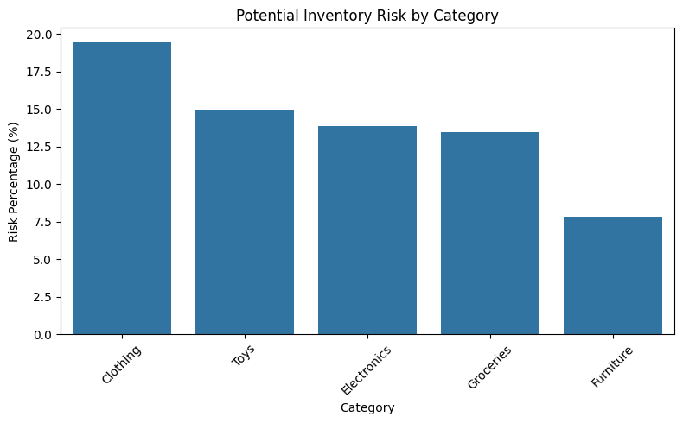

Potential Inventory Risk by Region
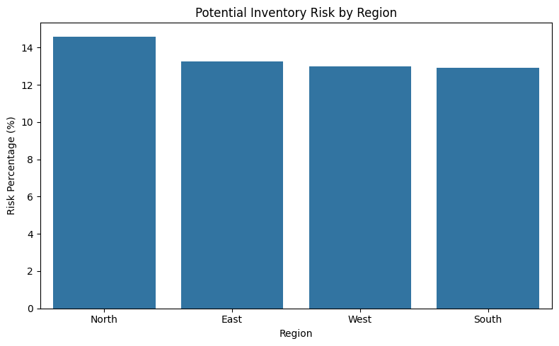

Monthly Total Demand Trend
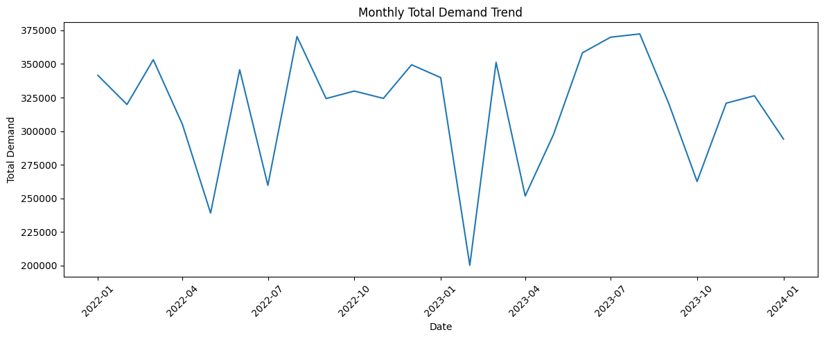

Actual vs Predicted Demand
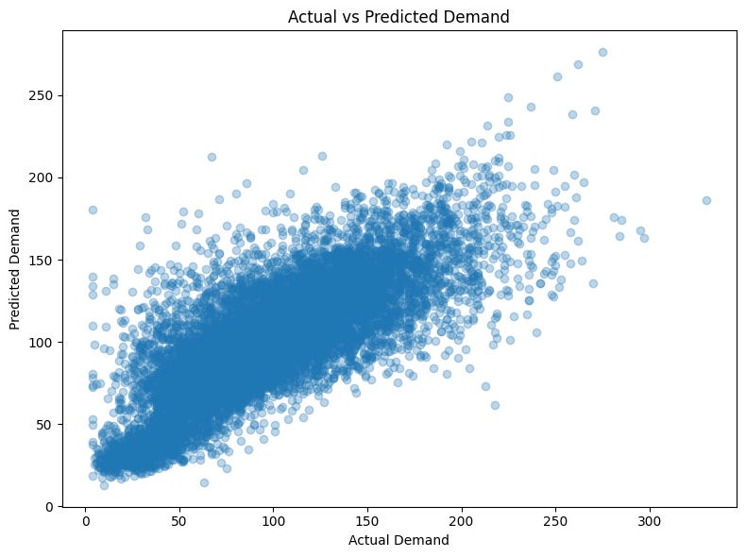

Feature Importance
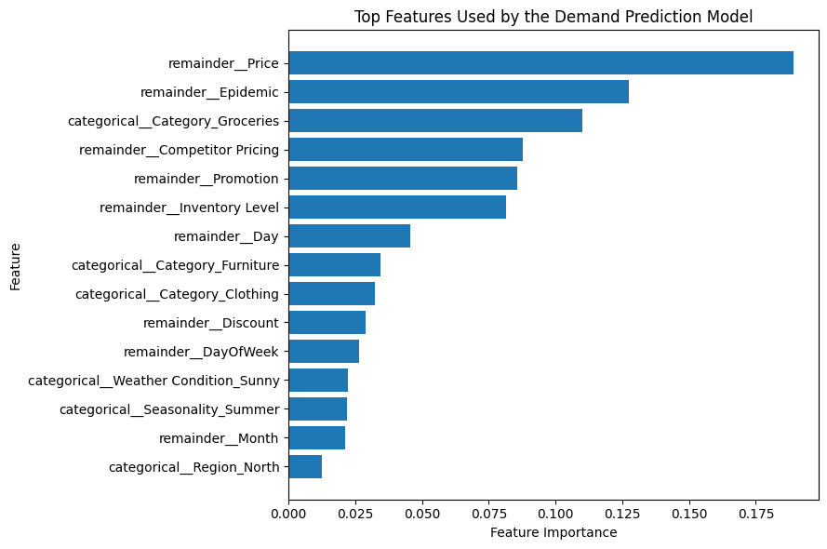

Top 10 Products by Average Demand
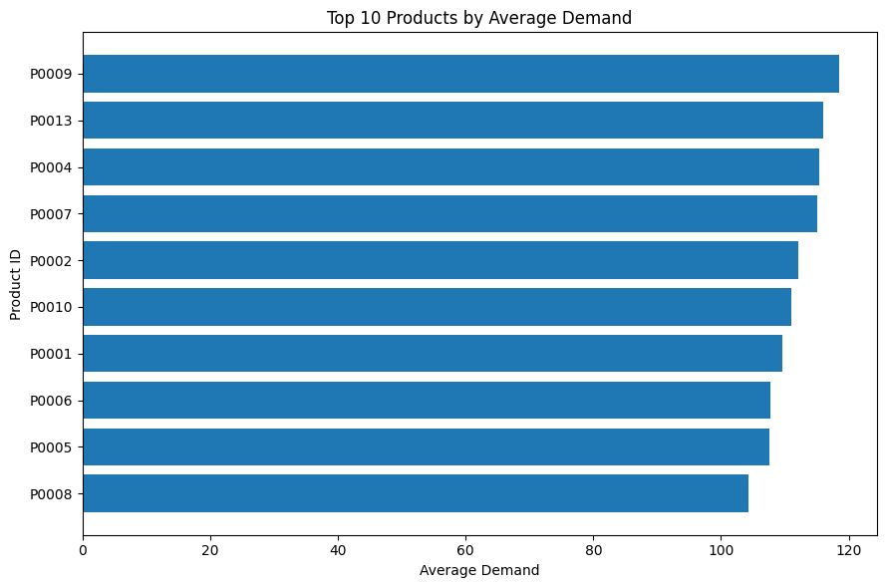

Top 10 Products by Potential Inventory Risk
