IS 733 Lab-1

1. 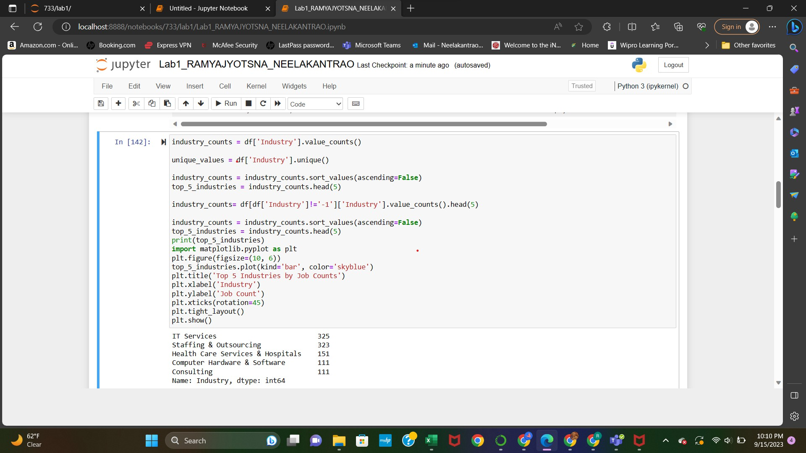Learning Notes: a.

From the above code it helps to learn the concepts like sorting,and while I came across a condition like -1 in the industry I learned how to exclude the desired conditions. And finally the plotting condition tigh_ layout() used for automatically adjusting the plot parameter.

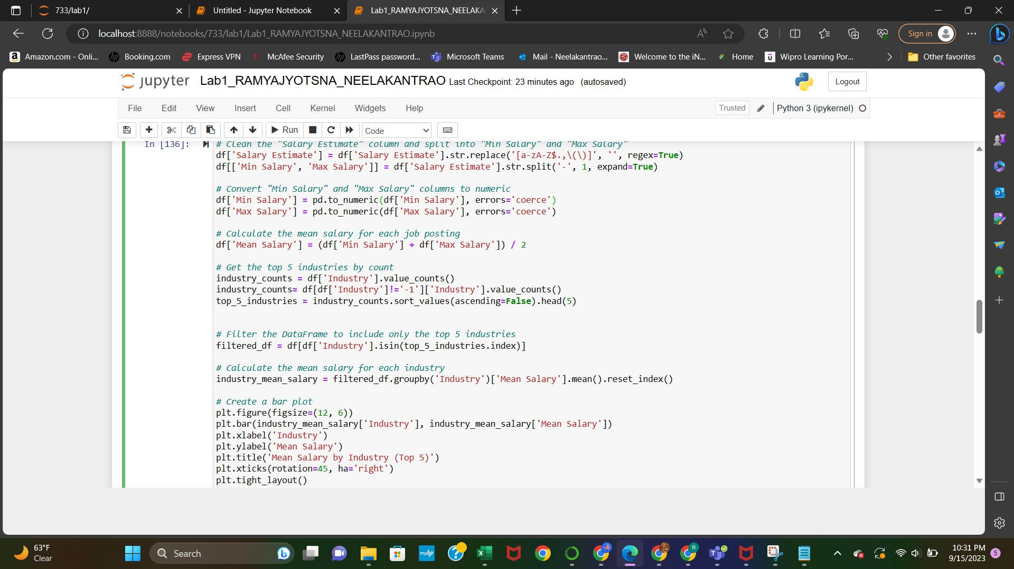

From the above, it helps me learn the following things like cleaning the data, and splitting the data as well as I came across the pd.to_numeric() with errors='coerce': When you use pd.to_numeric() to convert a Series to a numeric data type (e.g., int or float), setting errors='coerce' means that if a value in the Series cannot be converted to a numeric type, it will be replaced with NaN (Not a Number). This is useful when you have a Series with mixed data types, and you want to convert as much as possible to numeric values while handling non-convertible values gracefully.

Reflection:

* 1. Previously used for learning concepts or morley in question and answer cases.
  2. Yes, it is useful to complete the tasks successfully.
  3. Yes, as it is interactive and similar to asking the concepts from the person so, it helped in understanding and saved a lot of time when compared to watching the lectures and googling. And mainly I learned how to train the machine.
  4. Firstly, I Would say it is resourceful, productive. But at some point of time find it frustrating as it takes multiple times to retrieve and I agree that there is mistake on my side I should train it properly