Northwind_Assignment3( Modifying Data, Join Tables)

1. Update the categoryName From “Beverages” to "Drinks" in the categories table.

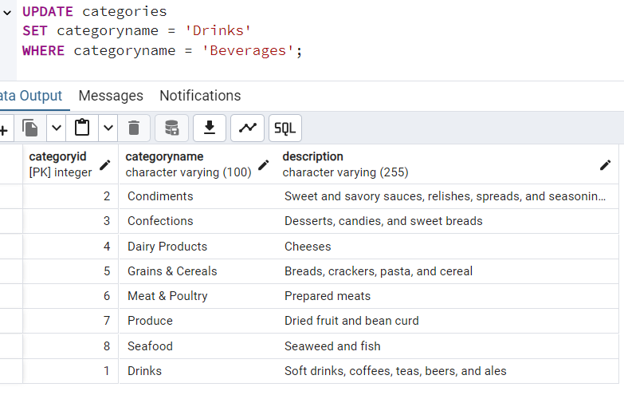

1. Insert into shipper new record (give any values) Delete that new record from shippers table.

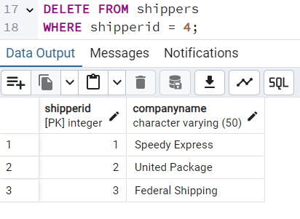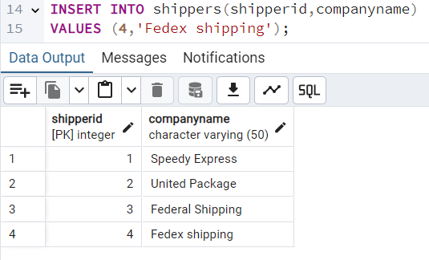

1. Update categoryID=1 to categoryID=1001. Make sure related products update their categoryID too. Display the both category and products table to show the cascade.

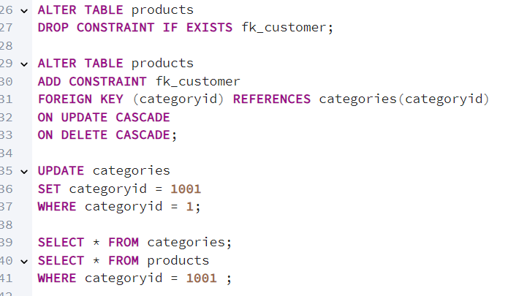

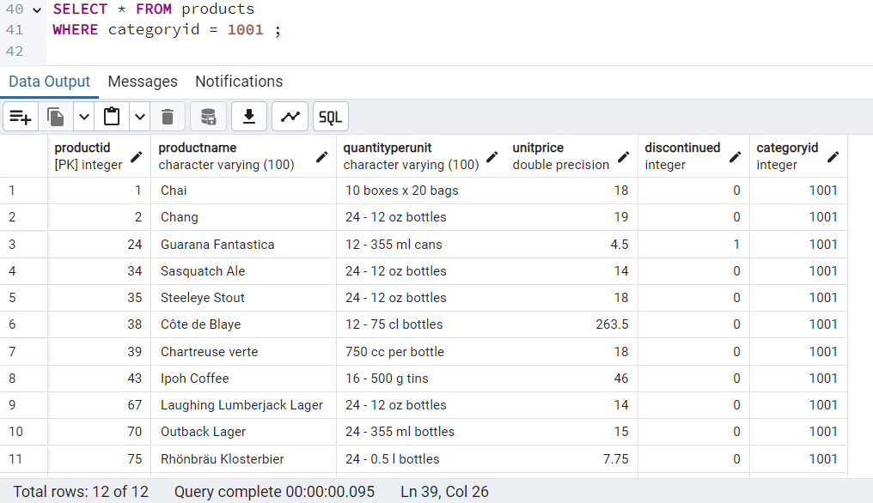

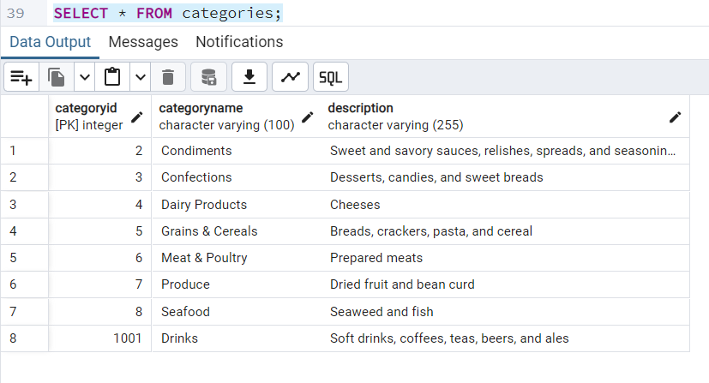

1. Delete the customer = “VINET”  from customers. Corresponding customers in orders table should be set to null (HINT: Alter the foreign key on orders(customerID) to use ON DELETE SET NULL)

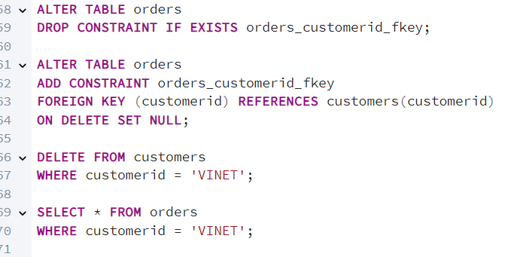

1. Insert the following data to Products using UPSERT:

product_id = 100, product_name = Wheat bread, quantityperunit=1,unitprice = 13, discontinued = 0, categoryID=5

product_id = 101, product_name = White bread, quantityperunit=5 boxes,unitprice = 13, discontinued = 0, categoryID=5

product_id = 100, product_name = Wheat bread, quantityperunit=10 boxes,unitprice = 13, discontinued = 0, categoryID=5

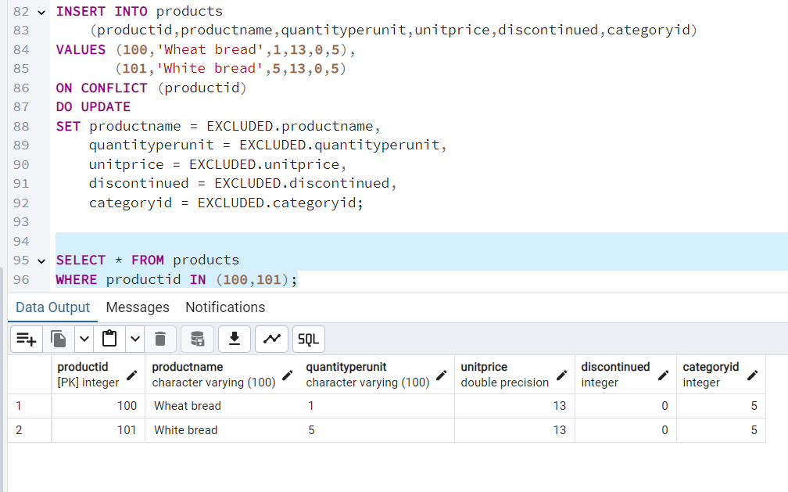

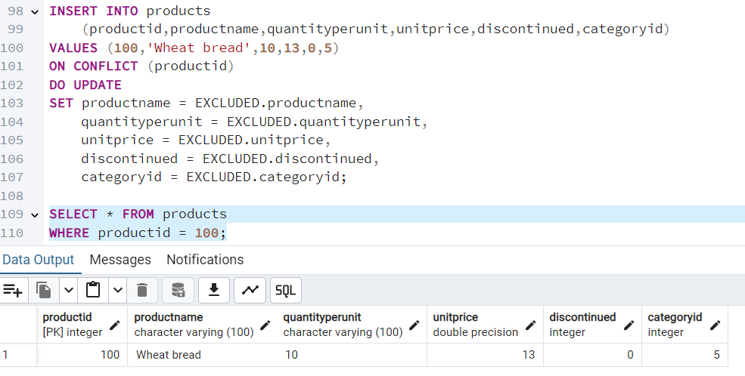

1. Write a **MERGE query**:

Create **temp table with name:**  ‘updated_products’ and insert values as below:

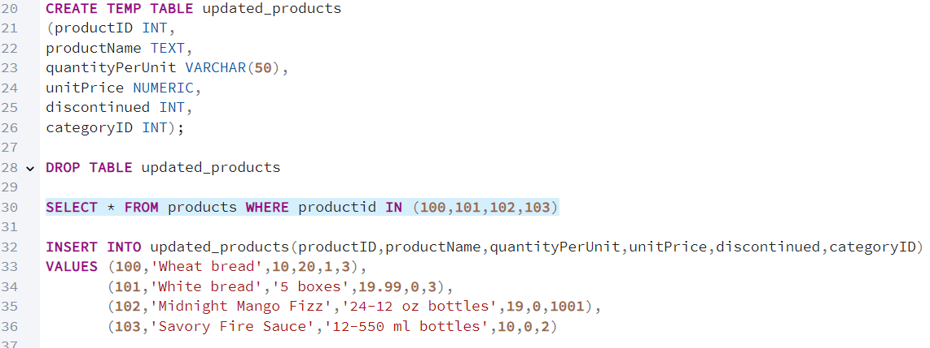

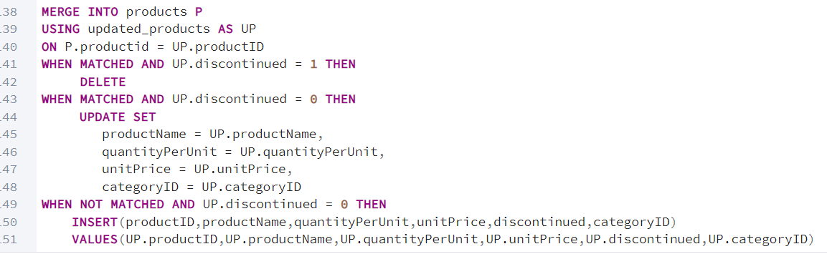

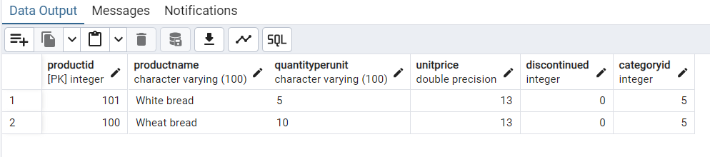

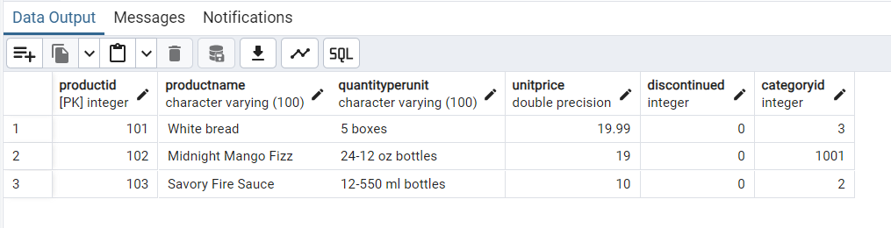

1. 7)      List all orders with employee full names. (Inner join)
2. 