**DAY 4**

1. List all customers and the products they ordered with the order date. (Inner join)

**Tables used:** customers, orders, order_details, products

**Output should have below columns:**companyname AS customer, orderid, productname, quantity, orderdate

SELECT CUSTOMERS.COMPANYNAME AS CUSTOMER_NAME, ORDERS.orderid,PRODUCTS.productname,ORDER_DETAILS.quantity,ORDERS.orderdate

FROM CUSTOMERS,ORDERS,PRODUCTS,ORDER_DETAILS

WHERE CUSTOMERS.CUSTOMERID= ORDERS.CUSTOMERID

AND ORDERS.ORDERID=ORDER_DETAILS.orderid

AND ORDER_DETAILS.PRODUCTID=PRODUCTS.PRODUCTID;

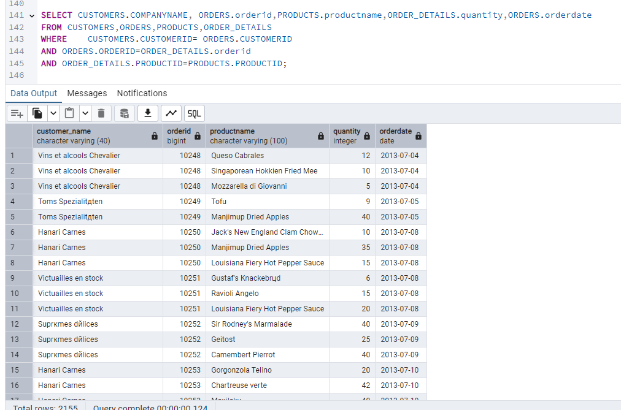

2. Show each order with customer, employee, shipper, and product info — even if some parts are missing. (Left Join)

**Tables used: orders, customers, employees, shippers, order_details, products**

SELECT

CUSTOMERS.COMPANY NAME AS CUSTOMER,

EMPLOYEES.EMPLOYEENAME,

SHIPPERS.COMPANY NAME AS SHIPPER,

ORDERS.ORDERID,

PRODUCTS.*,

ORDER_DETAILS.QUANTITY,

ORDERS.ORDERDATE

FROM ORDERS

LEFT JOIN CUSTOMERS ON CUSTOMERS.CUSTOMERID = ORDERS.CUSTOMERID

LEFT JOIN EMPLOYEES ON ORDERS.EMPLOYEEID = EMPLOYEES.EMPLOYEEID

LEFT JOIN SHIPPERS ON ORDERS.SHIPPERID = SHIPPERS.SHIPPER ID

LEFT JOIN ORDER_DETAILS ON ORDERS.ORDERID = ORDER_DETAILS.ORDERID

LEFT JOIN PRODUCTS ON ORDER_DETAILS.PRODUCTID = PRODUCTS.PRODUCTID;

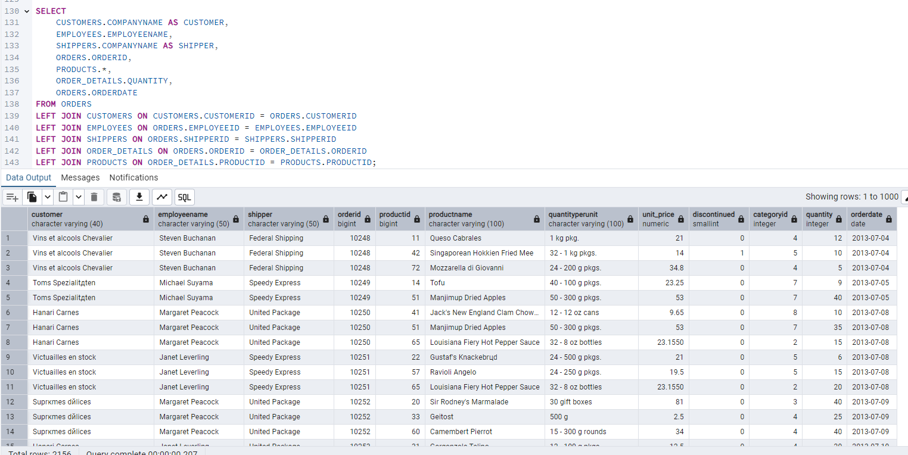

3. Show all order details and products (include all products even if they were never ordered). (Right Join)

**Tables used: order_details, products**

**Output should have below columns:** orderid, productid, quantity, productname

SELECT ORDER_DETAILS.orderid,PRODUCTS.productid,ORDER_DETAILS.quantity,PRODUCTS.productname

FROM order_details

RIGHT JOIN

products ON ORDER_DETAILS.productid = products.productid

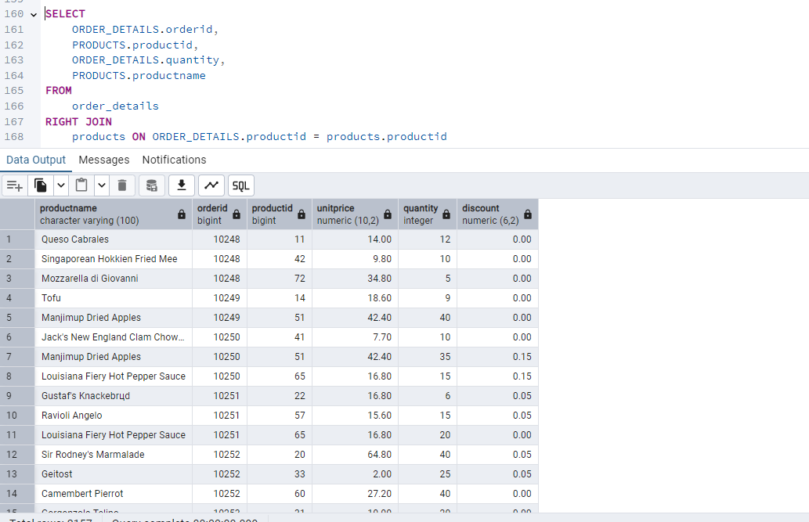

4. List all product categories and their products — including categories that have no products, and products that are not assigned to any category.(Outer Join)

**Tables used: categories, products**

SELECT CATEGORY.categoryid,CATEGORY.categoryname,PRODUCTS.productid,PRODUCTS.productname

FROM

categories CATGORY

FULL OUTER JOIN

products.PRODUCTS ON CATEGORY.categoryid = PRODUCTS.categoryid;

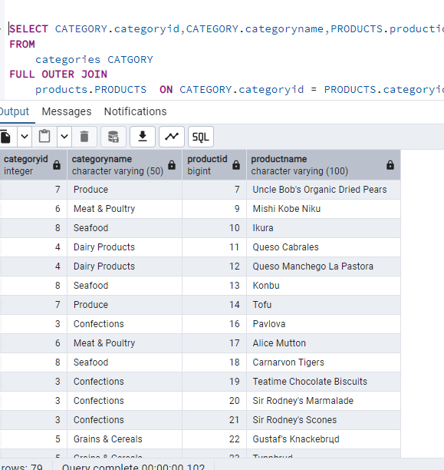

5. Show all possible product and category combinations (Cross join).

select * from Categories;

select * from products;

SELECT *

FROM categories

CROSS JOIN products;

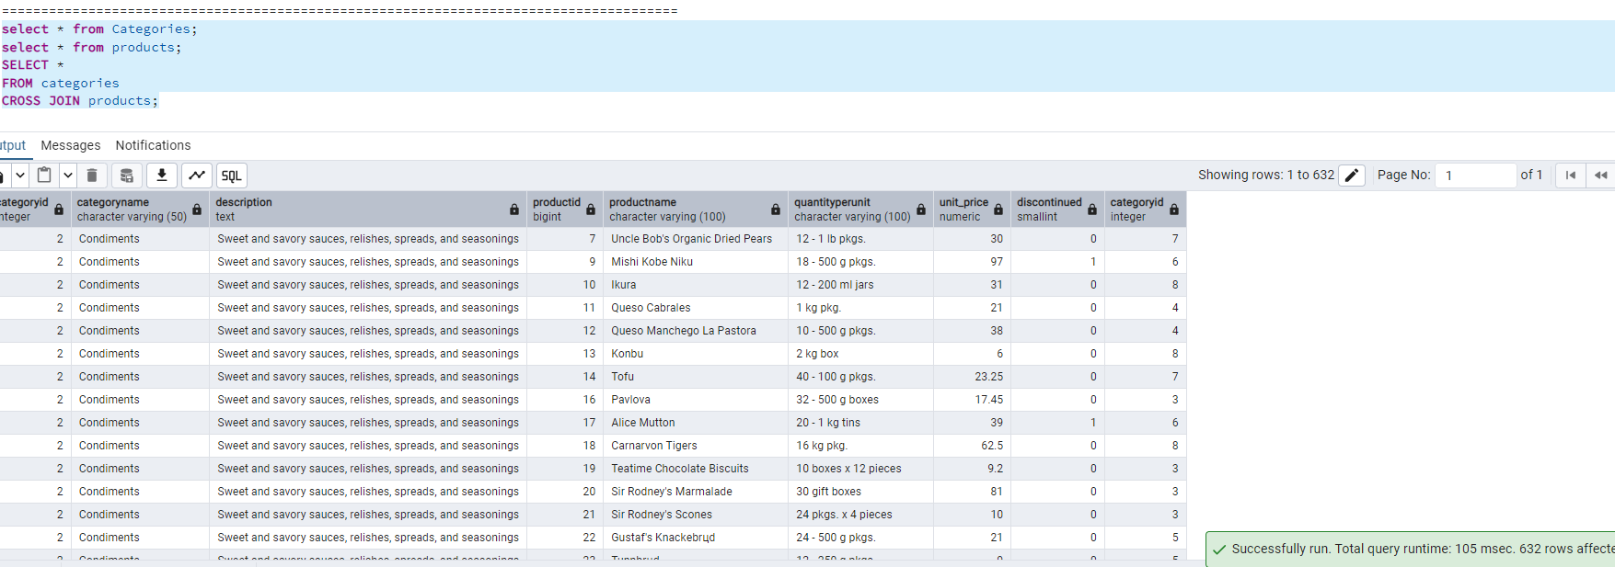

6. Show all employees and their manager(Self join(left join))

SELECT EMP.EMPLOYEENAME EMPLOYEENAME,EMP.REPORTSTO REPORTING_MANAGER_ID, MGR.EMPLOYEEID MANAGER_EMP_id, MGR.EMPLOYEENAME MANAGERNAME from EMPLOYEES EMP,EMPLOYEES MGR where EMP.REPORTSTO=MGR.EMPLOYEEID;

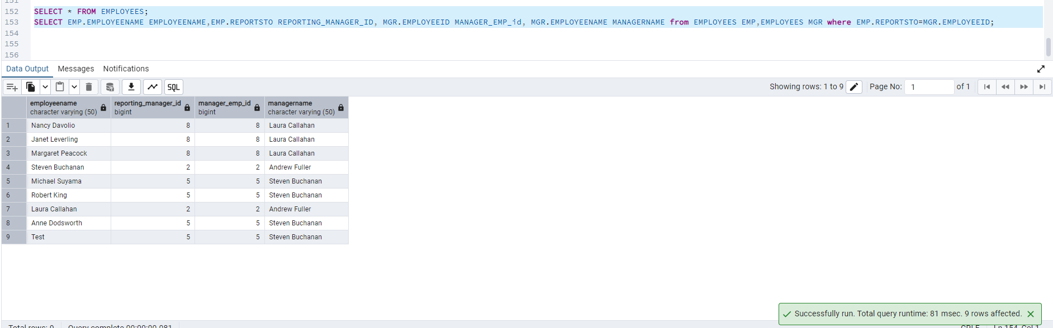

7. List all customers who have not selected a shipping method.

**Tables used:** customers, orders

**(Left Join, WHERE o.shipvia IS NULL)**

SELECT CUSTOMERS.customerid,CUSTOMERS.companyname

FROM CUSTOMERS

LEFT JOIN

orders orders ON CUSTOMERS.customerid = orders.customerid

WHERE

orders.shipvia IS NULL;

