**Elamathi_Assignment 5_ Day 5**

**Question1:**

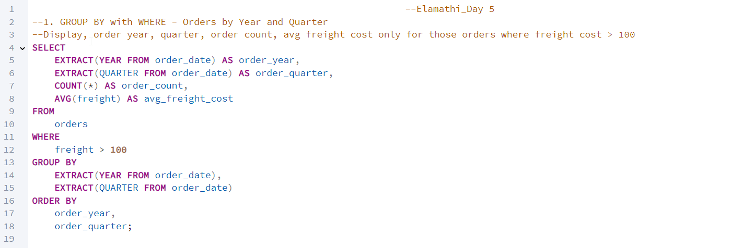

**OUTPUT:**

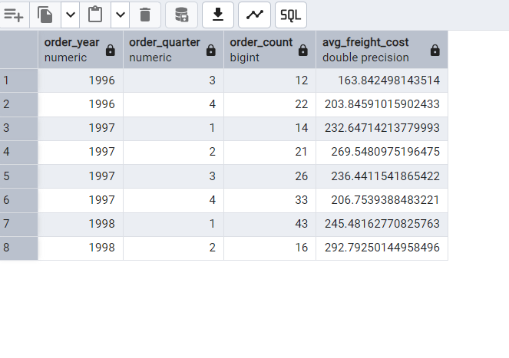

------------------------------------------------------------------------------------------------------------------------------------------

**Question2:**

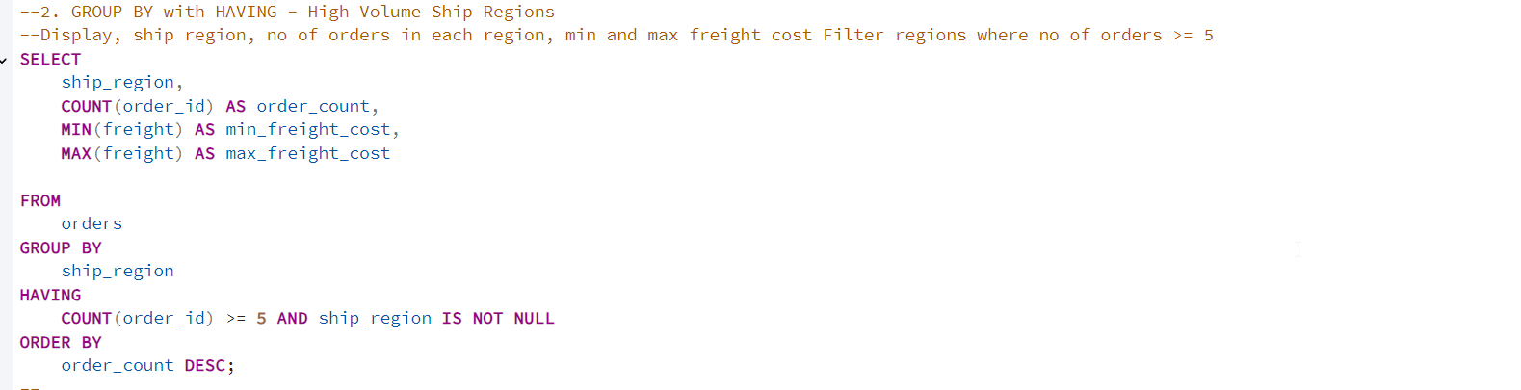

**OUTPUT:**

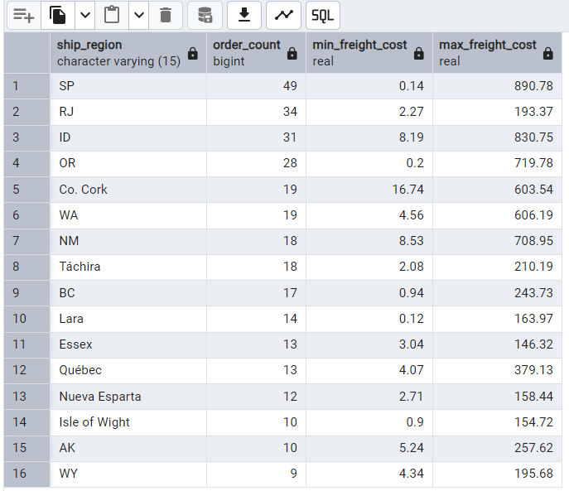

------------------------------------------------------------------------------------------------------------------------------------------

**Question 3:**

**3.1 With UNION**

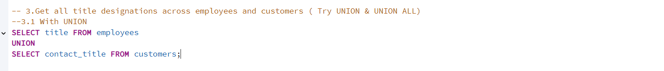

**OUTPUT:**

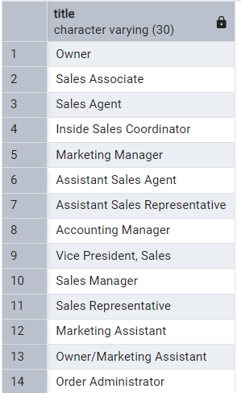

**3.2 With UNION ALL**

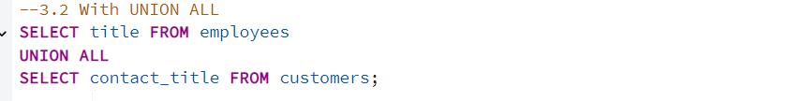

**OUTPUT:**

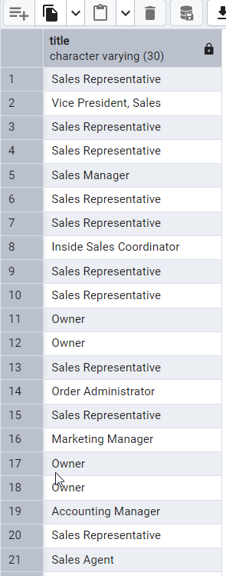

------------------------------------------------------------------------------------------------------------------------------------------

**Question 4:**

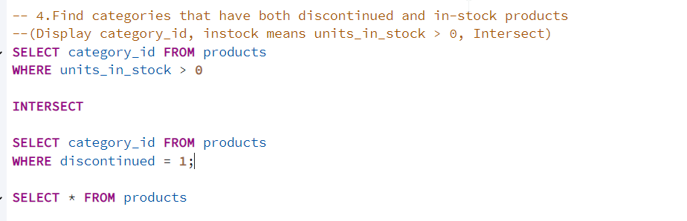

**OUTPUT:**

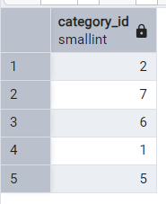

------------------------------------------------------------------------------------------------------------------------------------------

**Question 5:**

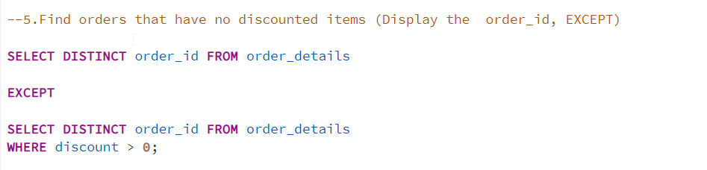

**OUTPUT:**

