Elamathi_Assignment6_Day6

Question1:

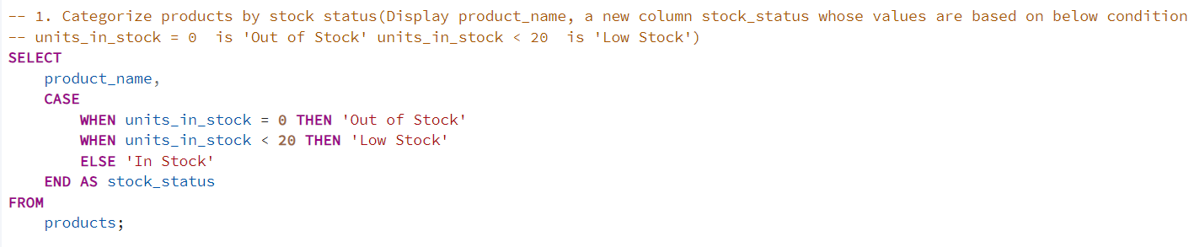

**OUTPUT:**

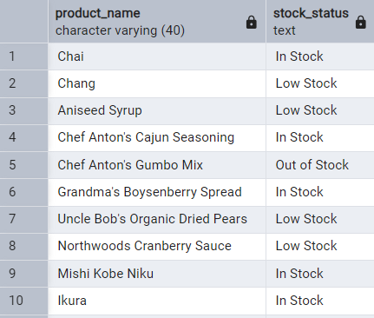

**----------------------------------------------------------**--------------------------------------------------------------------------------

**Question2:**

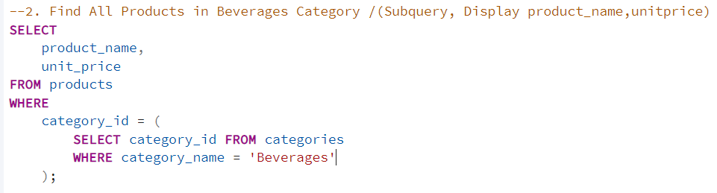

**OUTPUT:**

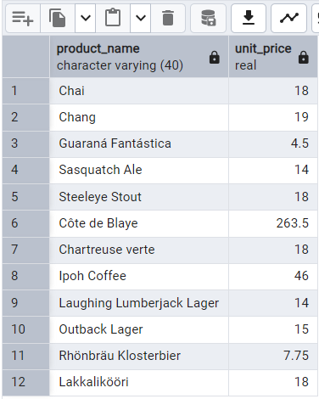

**----------------------------------------------------------**--------------------------------------------------------------------------------

**Question3:**

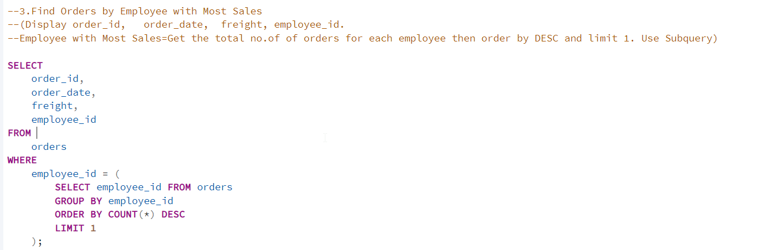

**OUTPUT:**

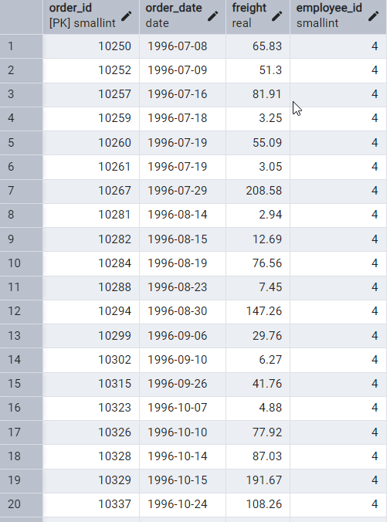

**----------------------------------------------------------**--------------------------------------------------------------------------------

**Question4:**

**4.4 With ANY**

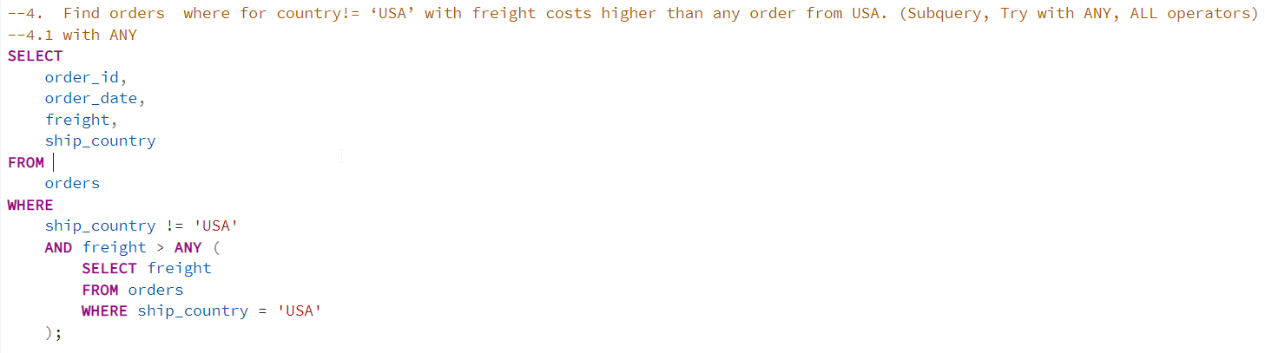

**OUTPUT:**

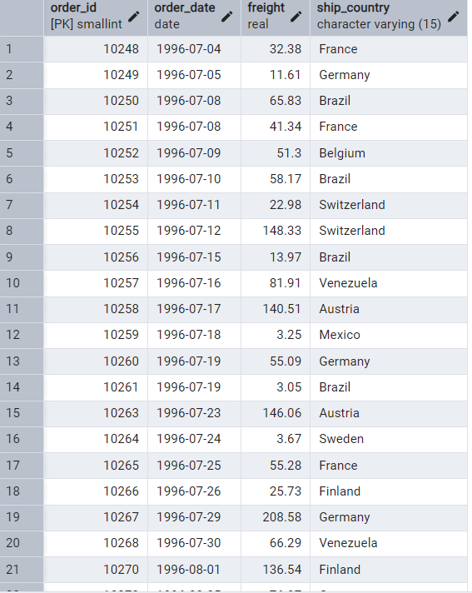

**4.2 With ALL**

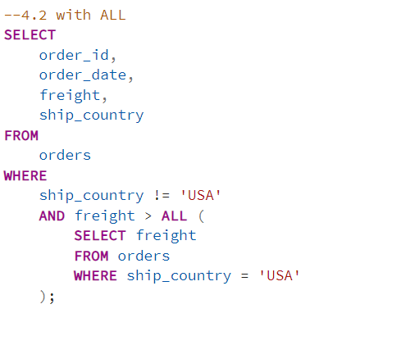

**OUTPUT:**

