**Day 6**

1. Categorize products by stock status

(Display product_name, a new column stock_status whose values are based on below condition

units_in_stock = 0 is 'Out of Stock'

units_in_stock < 20 is 'Low Stock')

SELECT PRODUCT_NAME,

CASE

WHEN UNITS_IN_STOCK = 0 THEN 'Out of Stock'

WHEN UNITS_IN_STOCK < 20 THEN 'Low Stock'

ELSE 'In Stock'

END AS STOCK_STATUS

FROM PRODUCTS;

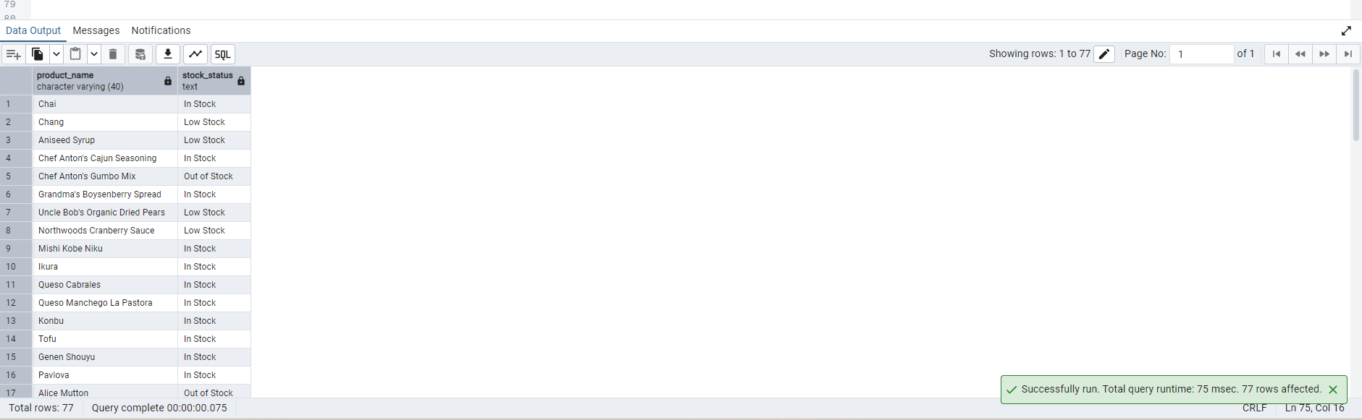

2. Find All Products in Beverages Category

(Subquery, Display product_name,unitprice)

SELECT PRODUCT_NAME,UNIT_PRICE FROM PRODUCTS

WHERE CATEGORY_ID = (

SELECT CATEGORY_ID

FROM CATEGORIES

WHERE CATEGORY_NAME = 'BEVERAGES'

);

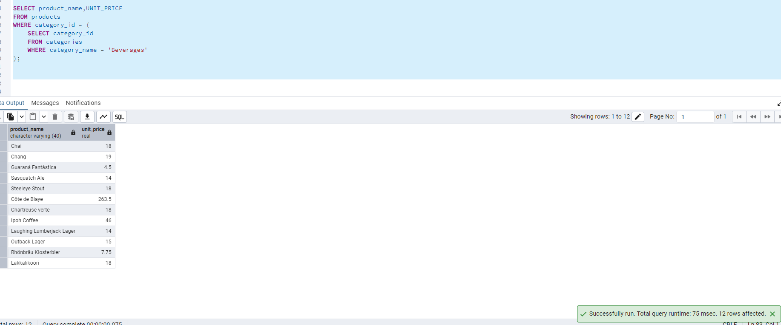

3. Find Orders by Employee with Most Sales

(Display order_id, order_date, freight, employee_id.

Employee with Most Sales=Get the total no.of of orders for each employee then order by DESC and limit 1. Use Subquery)

SELECT ORDER_ID, ORDER_DATE, FREIGHT, EMPLOYEE_ID

FROM ORDERS

WHERE EMPLOYEE_ID = (

SELECT EMPLOYEE_ID

FROM ORDERS

GROUP BY EMPLOYEE_ID

ORDER BY COUNT(*) DESC

LIMIT 1

);

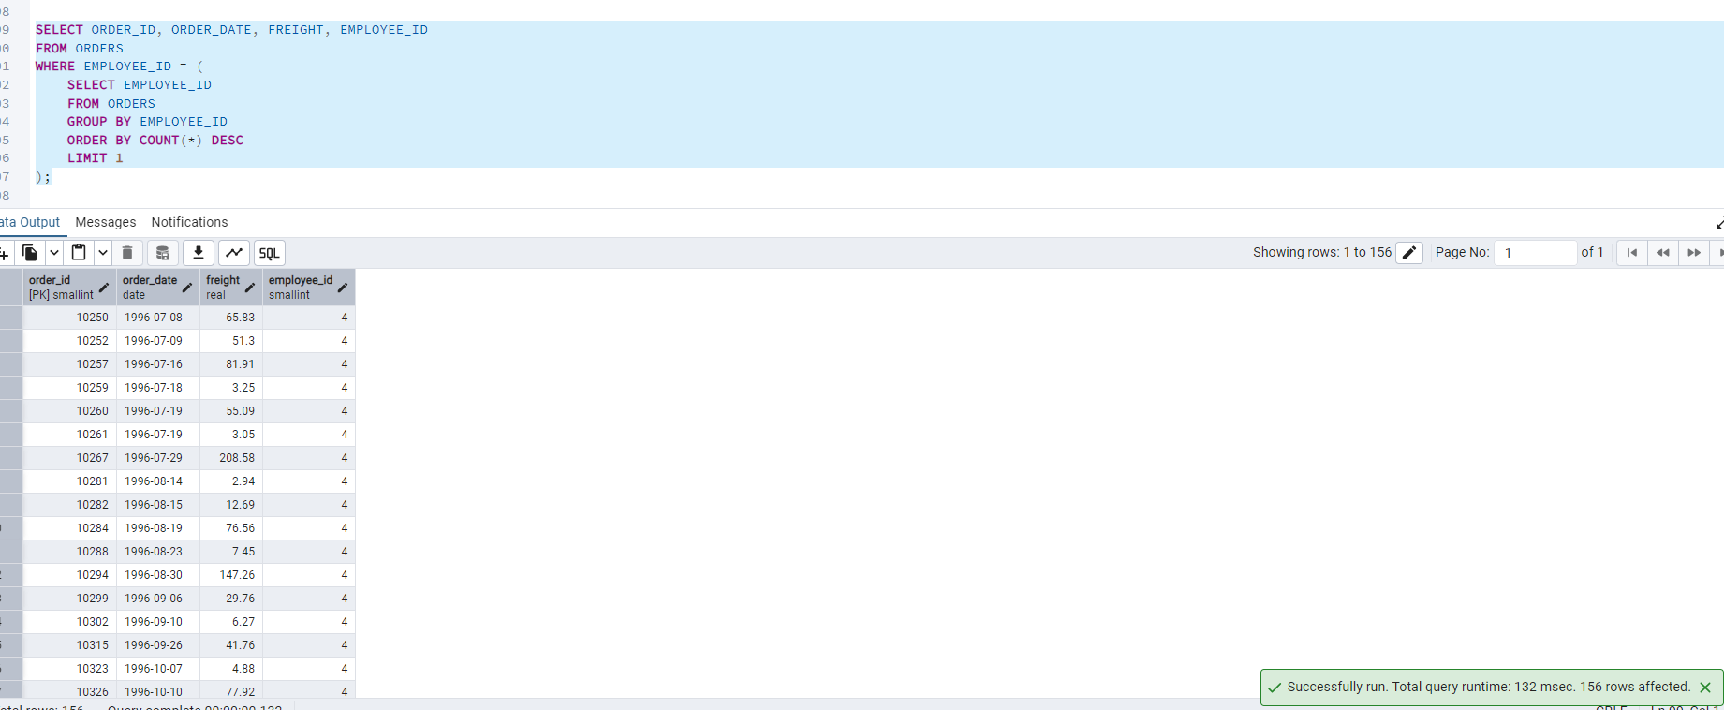

4. Find orders where for country!= ‘USA’ with freight costs higher than any order from USA. (Subquery, Try with ANY, ALL operators)

**SELECT ORDER_ID, ORDER_DATE, FREIGHT, SHIP_COUNTRY**

**FROM OREDRS**

**WHERE SHIP_COUNTRY != 'USA'**

**AND FREIGHT > ANY (**

**SELECT FREIGHT**

**FROM OREDRS**

**WHERE SHIP_COUNTRY = 'USA'**

