**Day 7**

1. Rank employees by their total sales

(Total sales = Total no of orders handled, JOIN employees and orders table)

SELECT employee_id, COUNT(*) AS total_sales

FROM orders

GROUP BY employee_id

ORDER BY

total_sales DESC;

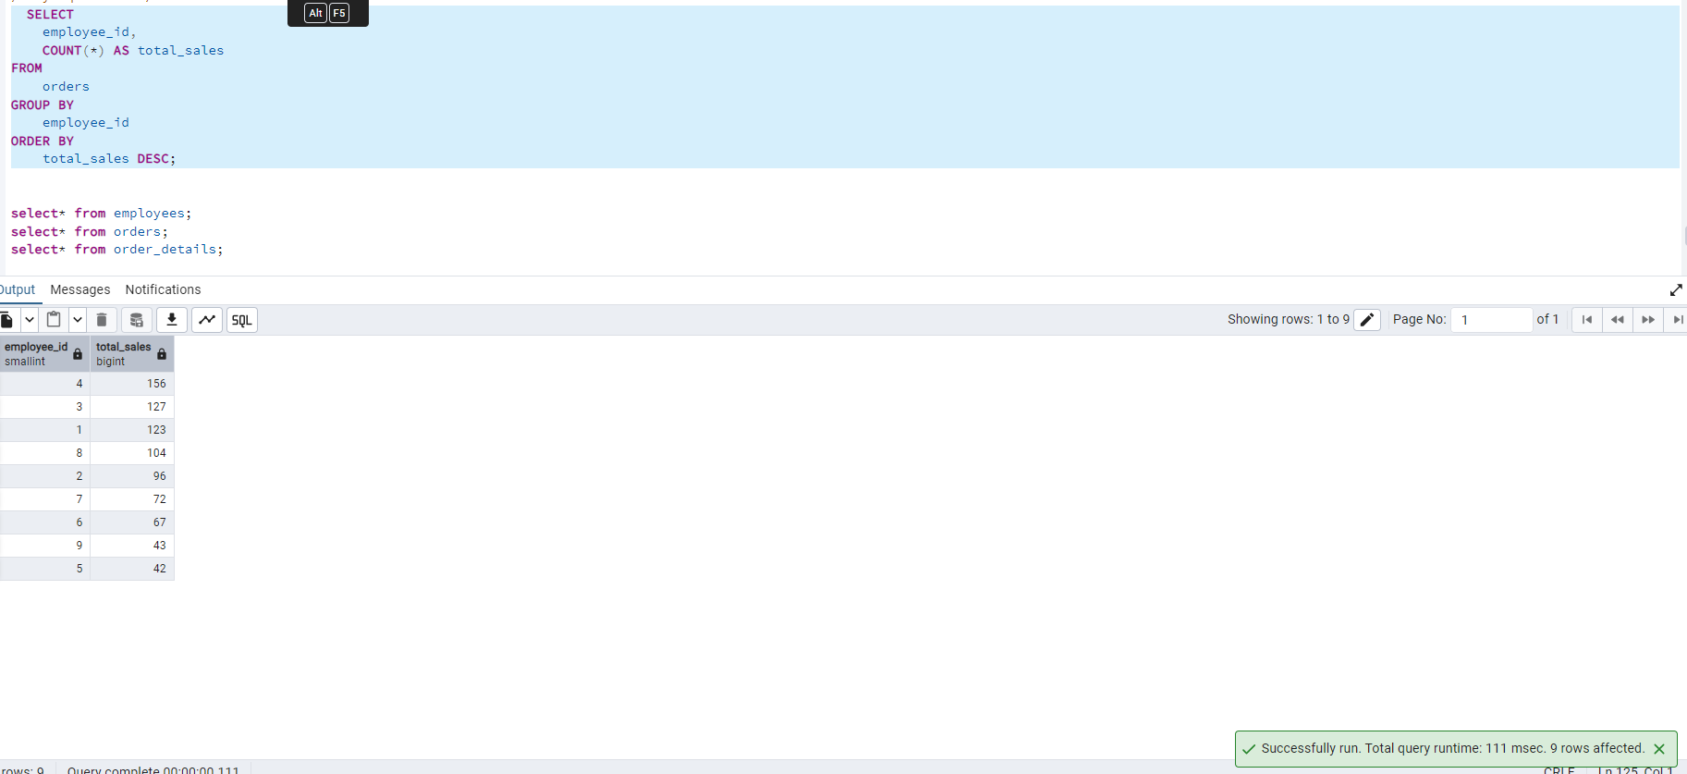

2. Compare current order's freight with previous and next order for each customer.

(Display order_id, customer_id, order_date, freight,

Use lead(freight) and lag(freight).

lag(freight)

select order_id,customer_id,order_date,freight,

LAG(freight, 1) OVER (

ORDER BY order_id)

from orders;

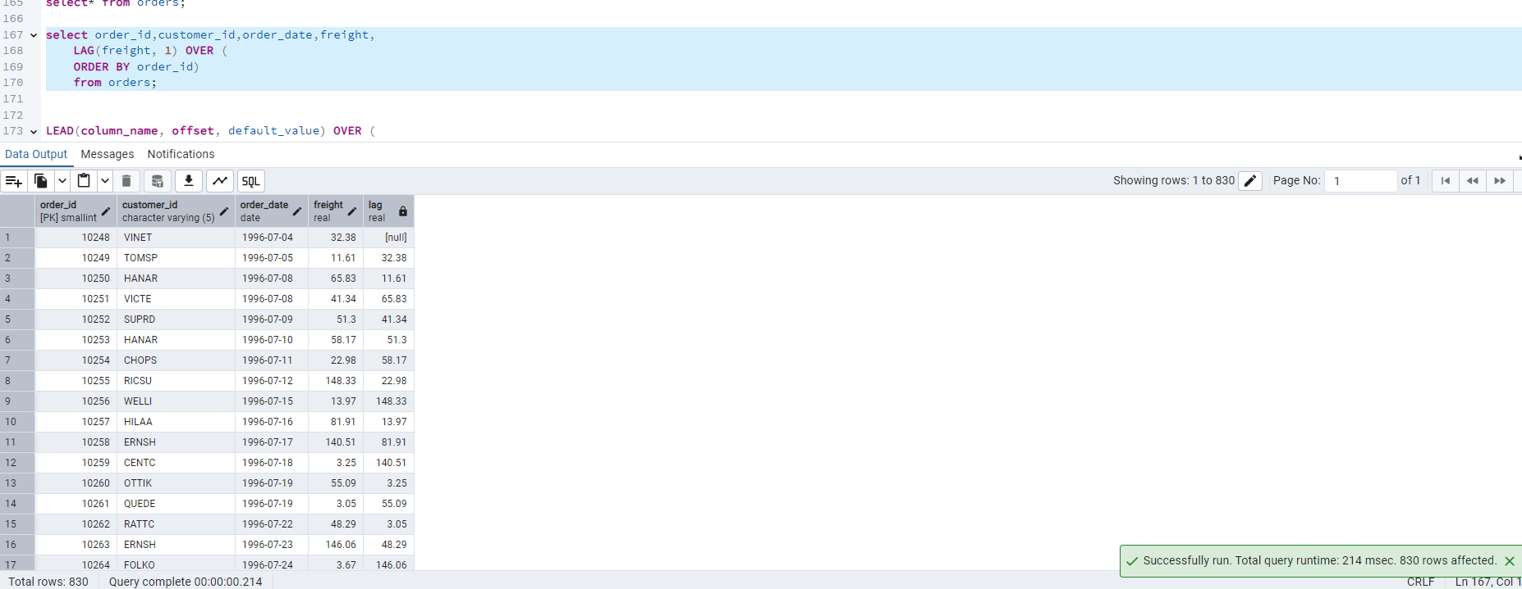

Use lead(freight)

select order_id,customer_id,order_date,freight,

lead(freight, 1) OVER (

ORDER BY order_id)

from orders;

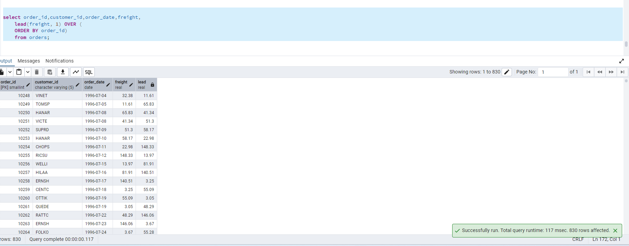

3. Show products and their price categories, product count in each category, avg price:

(HINT:

· Create a CTE which should have price_category definition:

WHEN unit_price < 20 THEN 'Low Price'

WHEN unit_price < 50 THEN 'Medium Price'

ELSE 'High Price'

· In the main query display: price_category, product_count in each price_category, ROUND(AVG(unit_price)::numeric, 2) as avg_price)

WITH price_cte AS (

SELECT

product_name,

unit_price,

CASE

WHEN unit_price < 20 THEN 'Low Price'

WHEN unit_price < 50 THEN 'Medium Price'

ELSE 'High Price'

END AS price_category

FROM products

)

SELECT

price_category,

COUNT(*) AS product_count,

ROUND(AVG(unit_price)::numeric, 2) AS avg_price

FROM price_cte

GROUP BY price_category;

