**Elamathi_Assignment8_Day8**

**Question 1:**

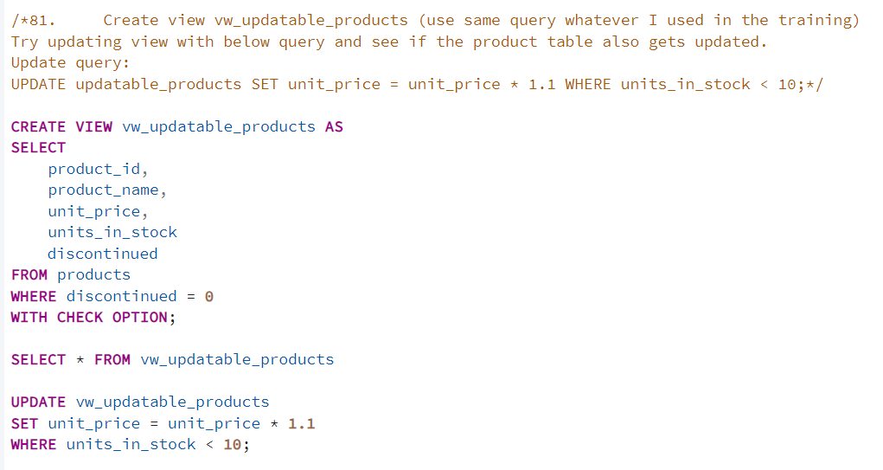

**OUTPUT:**

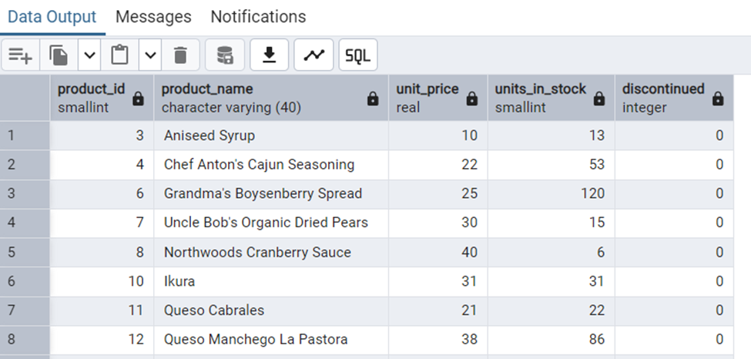

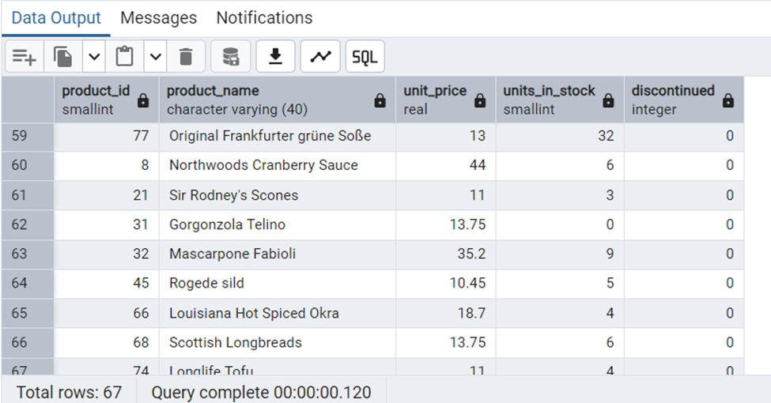

---------------------------------------------------------------------------------------------------------------------

**Question2:**

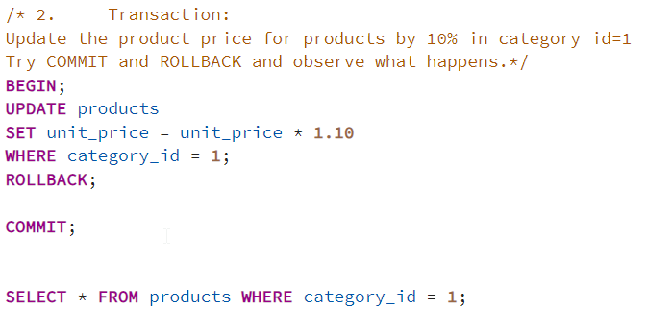

**OUTPUT:**

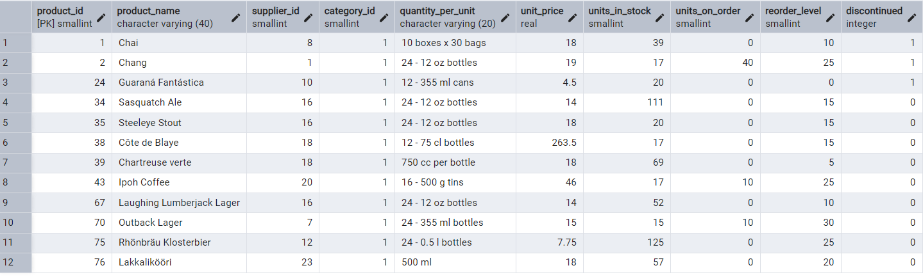

After commit:

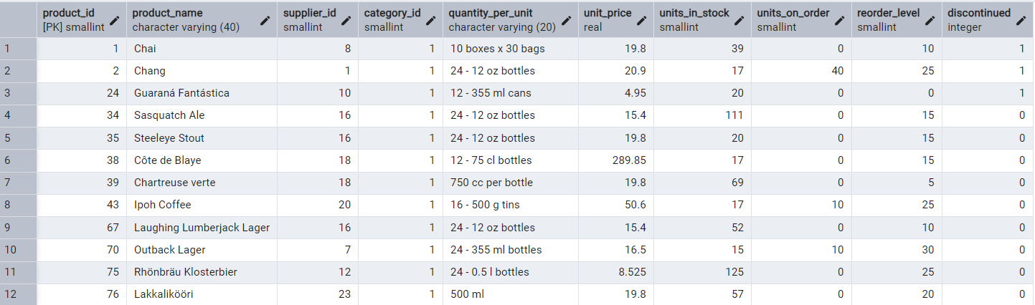

After Rollback:



---------------------------------------------------------------------------------------------------------------------

**Question 3:**

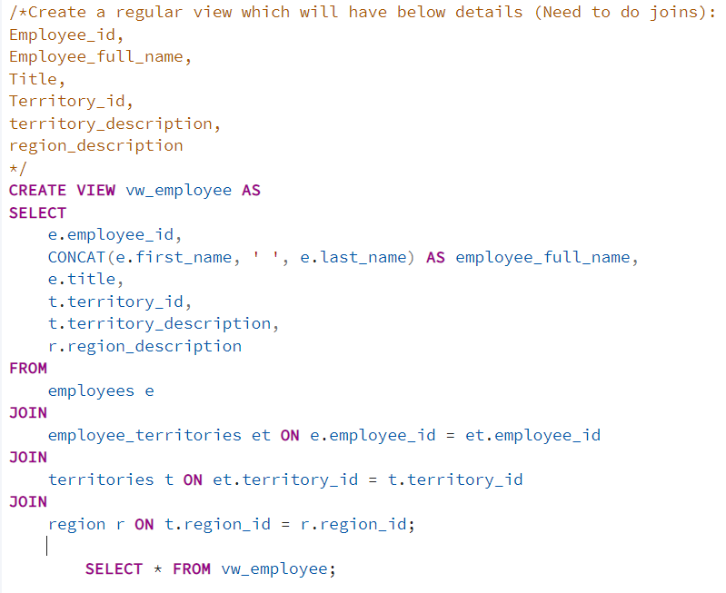

**OUTPUT**

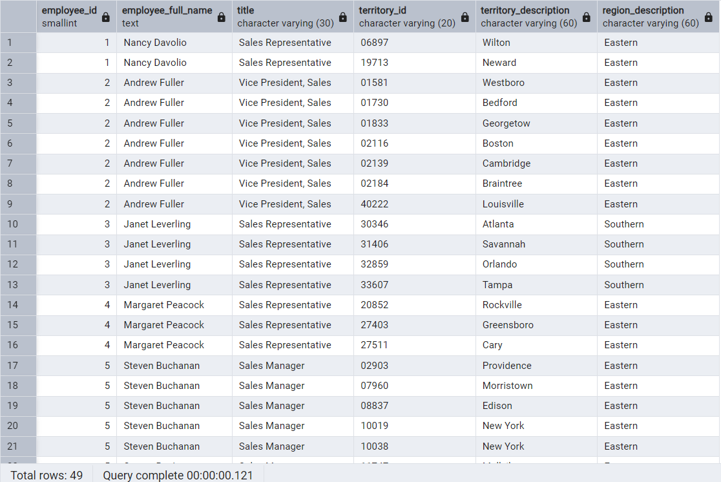

---------------------------------------------------------------------------------------------------------------------

**Question 4:**

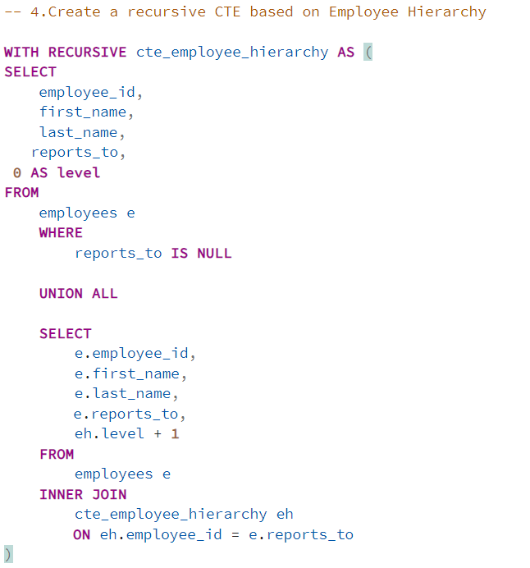

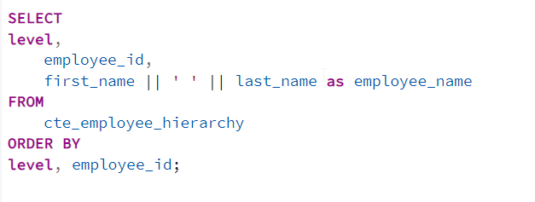

OUTPUT:

