**Day 8**

1. Create view vw_updatable_products (use same query whatever I used in the training)

Try updating view with below query and see if the product table also gets updated.

Update query:

UPDATE updatable_products SET unit_price = unit_price * 1.1 WHERE units_in_stock < 10;

CREATE VIEW vw_updatable_products AS

SELECT product_id,product_name,unit_price,units_in_stock,discontinued

FROM products

WHERE discontinued = 0

WITH CHECK OPTION;

SELECT * FROM vw_updatable_products;

UPDATE vw_updatable_products

SET unit_price = unit_price * 1.1

WHERE units_in_stock < 10

2. Transaction:

Update the product price for products by 10% in category id=1

Try COMMIT and ROLLBACK and observe what happens.

select * from products;

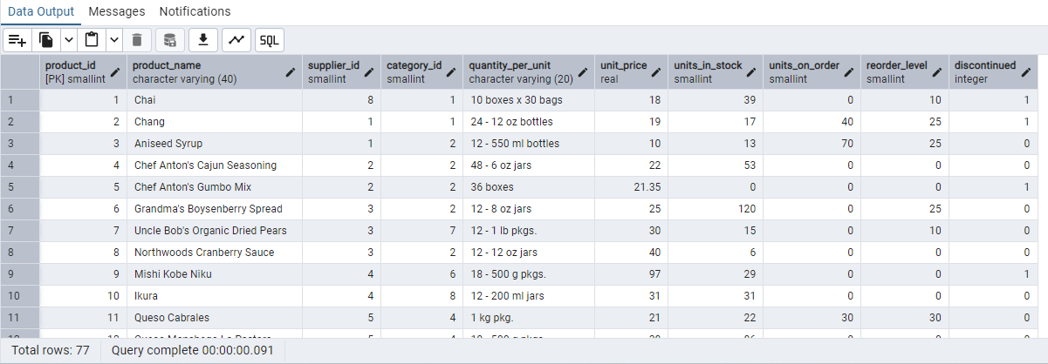

UPDATE products

SET unit_price = unit_price * 1.10

WHERE category_id = 1;

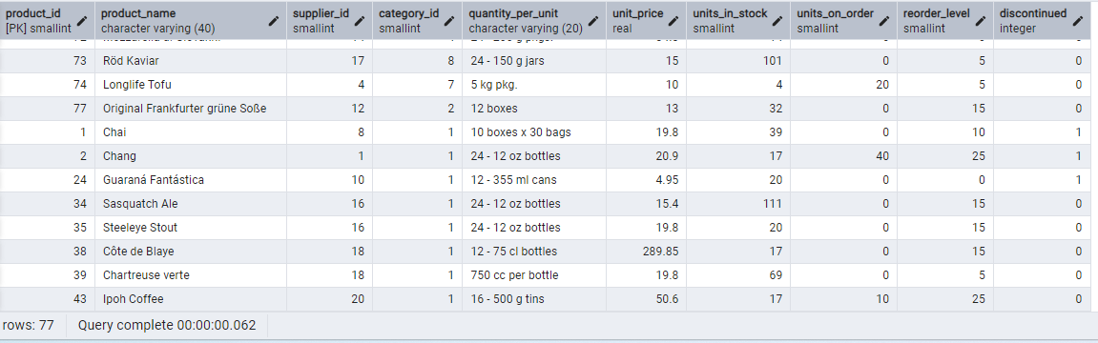

With commit-

UPDATE products

SET unit_price = unit_price * 1.10

WHERE category_id = 1;

Commit;

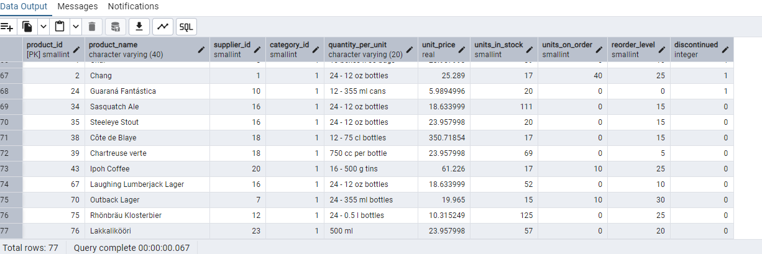

With rollback;

UPDATE products

SET unit_price = unit_price * 1.10

WHERE category_id = 1;

Rollback;

3. Create a regular view which will have below details (Need to do joins):

Employee_id,

Employee_full_name,

Title,

Territory_id,

territory_description,

Region_description

CREATE VIEW vw_employee AS

select e.employee_id,CONCAT(e.first_name, ' ', e.last_name) AS employee_full_name,e.title,t.territory_id,

t.territory_description,r.region_description

from employees e

join employee_territories et ON e.employee_id = et.employee_id

join territories t ON et.territory_id = t.territory_id

join region r ON t.region_id = r.region_id;

SELECT * FROM vw_employee;

4. Create a recursive CTE based on Employee Hierarchy

WITH RECURSIVE cte_employeehierarchy AS (

SELECT

employee_id,

first_name,

last_name,

reports_to,

0 AS level

FROM employees

WHERE reports_to IS NULL

UNION ALL

SELECT

e.employee_id,

e.first_name,

e.last_name,

e.reports_to,

eh.level + 1

FROM employees e

JOIN cte_employeehierarchy eh

ON e.reports_to = eh.employee_id

)

SELECT * FROM cte_employeehierarchy;

