**Day 9**

1. Create AFTER UPDATE trigger to track product price changes

· Create product_price_audit table with below columns:

audit_id SERIAL PRIMARY KEY,

product_id INT,

product_name VARCHAR(40),

old_price DECIMAL(10,2),

new_price DECIMAL(10,2),

change_date TIMESTAMP DEFAULT CURRENT_TIMESTAMP,

user_name VARCHAR(50) DEFAULT CURRENT_USER

· Create a trigger function with the below logic:

INSERT INTO product_price_audit (

product_id,

product_name,

old_price,

new_price

)

VALUES (

OLD.product_id,

OLD.product_name,

OLD.unit_price,

NEW.unit_price

);

· Create a row level trigger for below event:

AFTER UPDATE OF unit_price ON products

· Test the trigger by updating the product price by 10% to any one product_id.

Here , creating a Product_Price table —

CREATE TABLE product_price_audit table

audit_id SERIAL PRIMARY KEY,

product_id INT,

product_name VARCHAR(40),

old_price DECIMAL(10,2),

new_price DECIMAL(10,2),

change_date TIMESTAMP DEFAULT CURRENT_TIMESTAMP,

user_name VARCHAR(50) DEFAULT CURRENT_USER

);

In the second step we are creating Trigger-

CREATE OR REPLACE Trigger track_price_change()

RETURNS TRIGGER AS $$

BEGIN

-- Only log if price actually changed

IF OLD.unit_price IS DISTINCT FROM NEW.unit_price THEN

INSERT INTO product_price_audit (

product_id,

product_name,

old_price,

new_price

)

VALUES (

OLD.product_id,

OLD.product_name,

OLD.unit_price,

NEW.unit_price

);

END IF;

RETURN NEW;

END;

$$ LANGUAGE plpgsql;

Updating Trigger here

CREATE TRIGGER trg_track_price_change

AFTER UPDATE OF unit_price ON products

FOR EACH ROW

EXECUTE FUNCTION track_price_change();

Checking updating value via this query

SELECT product_id, product_name, unit_price FROM products WHERE product_id = 3;

-- Update price by 10%

UPDATE products

SET unit_price = unit_price * 1.10

WHERE product_id = 3;

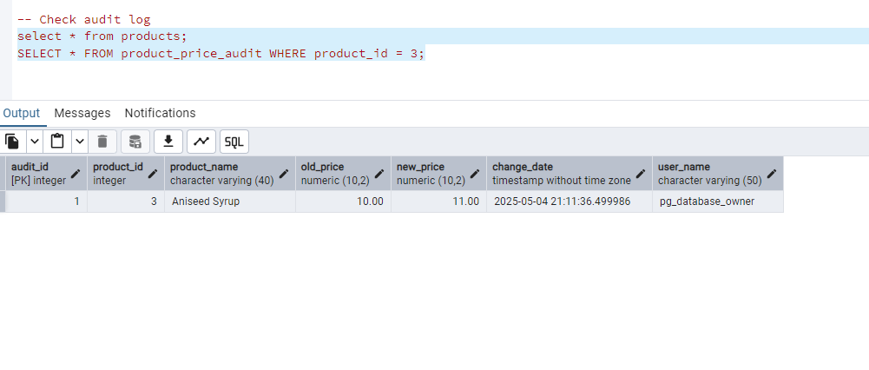2. Create stored procedure using IN and INOUT parameters to assign tasks to employees

· Parameters:

IN p_employee_id INT,

IN p_task_name VARCHAR(50),

INOUT p_task_count INT DEFAULT 0

· Inside Logic: Create table employee_tasks:

CREATE TABLE IF NOT EXISTS employee_tasks (

task_id SERIAL PRIMARY KEY,

employee_id INT,

task_name VARCHAR(50),

assigned_date DATE DEFAULT CURRENT_DATE

);

· Insert employee_id, task_name into employee_tasks

· Count total tasks for employee and put the total count into p_task_count .

· Raise NOTICE message:  
 RAISE NOTICE 'Task "%" assigned to employee %. Total tasks: %',

p_task_name, p_employee_id, p_task_count;

After creating stored procedure test by calling it:

CALL assign_task(1, 'Review Reports');

You should see the entry in employee_tasks table.

**Create assign tasks to employees Table**

CREATE TABLE IF NOT EXISTS employee_tasks (

task_id SERIAL PRIMARY KEY,

employee_id INT,

task_name VARCHAR(50),

assigned_date DATE DEFAULT CURRENT_DATE

);

**Create Procedure here-**

CREATE OR REPLACE PROCEDURE assign_task(

IN p_employee_id INT,

IN p_task_name VARCHAR(50),

INOUT p_task_count INT DEFAULT 0

)

LANGUAGE plpgsql

AS $$

BEGIN

**-- Insert the task**

INSERT INTO employee_tasks (employee_id, task_name)

VALUES (p_employee_id, p_task_name);

**-Count total tasks assigned to the employee**

SELECT COUNT(*) INTO p_task_count

FROM employee_tasks

WHERE employee_id = p_employee_id;

DO $$

DECLARE

v_task_count INT := 0;

BEGIN

CALL assign_task(1, 'Review Reports', v_task_count);

-- Optionally display the final count

RAISE NOTICE 'Returned task count: %', v_task_count;

END;

$$;

**Verify the employee table -**

SELECT * FROM employee_tasks WHERE employee_id = 1;

**Output Verified -**