**Day 5**

1. GROUP BY with WHERE - Orders by Year and Quarter

Display, order year, quarter, order count, avg freight cost only for those orders where freight cost > 100

select * from orders;

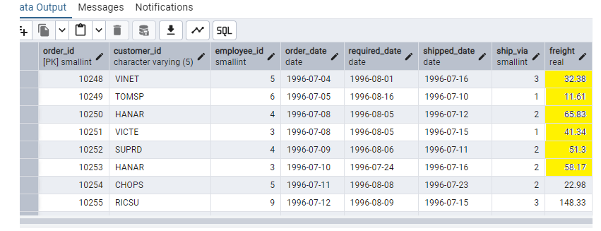

select * from orders;

SELECT EXTRACT(YEAR FROM order_date) AS order_year,EXTRACT(QUARTER FROM order_date) AS order_quarter,COUNT(*) AS order_count,AVG(freight) AS avg_freight_cost FROM orders

WHERE freight > 100

GROUP BY EXTRACT(YEAR FROM order_date),EXTRACT(QUARTER FROM order_date)ORDER BY order_year,order_quarter;

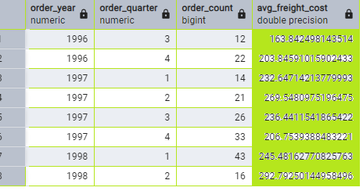

2. GROUP BY with HAVING - High Volume Ship Regions

Display, ship region, no of orders in each region, min and max freight cost  
 Filter regions where no of orders >= 5

select ship_region,count(*) as no_of_orders,min(freight) as minimum_freight_cost,max(freight) as maximum_freight_cost

from orders

group by ship_region

having count(*)>=5

order by count(*) ;

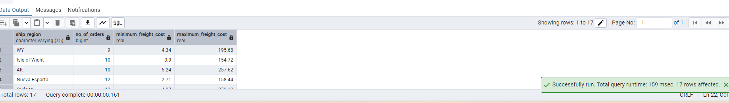

3. Get all title designations across employees and customers ( Try UNION & UNION ALL)

SELECT title FROM employees

UNION

SELECT contact_title FROM customers;

SELECT title FROM employees

UNION ALL

SELECT contact_title FROM customers;

4. Find categories that have both discontinued and in-stock products

(Display category_id, instock means units_in_stock > 0, Intersect)

SELECT CATEGORY_ID FROM CATEGORIES

INTERSECT

SELECT CATEGORY_ID FROM PRODUCTS WHERE DISCONTINUED=1 AND UNITS_IN_STOCK>0;

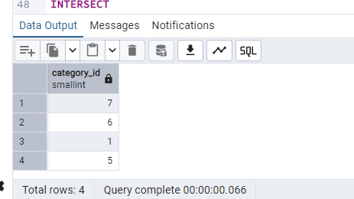

5. Find orders that have no discounted items (Display the order_id, EXCEPT)

SELECT * FROM PRODUCTS;

SELECT DISTINCT(category_id) FROM products

WHERE units_in_stock > 0

INTERSECT

SELECT DISTINCT(category_id) FROM products

WHERE discontinued = 1

ORDER BY category_id;

SELECT DISTINCT(order_id) FROM order_details

EXCEPT

SELECT DISTINCT(order_id) FROM order_details

WHERE discount > 0;

