Agile in Jira (Scrum/Kanban Workflows)
Scrum Workflow in Jira: Sprints, Planning, and Execution
- Sprint Planning
The team selects prioritized stories from the backlog, estimates effort, and commits work to a sprint.
- Sprint Execution
Work is performed during the sprint, with issues moving across the board (To Do → In Progress → Done). Daily stand-ups help track progress and blockers.
- Sprint Completion
At the end of the sprint, completed work is reviewed, and the sprint is closed. Jira reports (burndown, velocity) are used to assess performance.
Estimating with Story Points and Time in Agile Projects
Estimation helps teams plan work, manage capacity, and set realistic delivery expectations. Agile teams commonly use story points and time-based estimates, each serving a different purpose.
- Story Points
Story points estimate the relative effort of a user story by considering complexity, amount of work, risk, and uncertainty. They are assigned during backlog refinement or sprint planning and are used to calculate team velocity, which helps forecast future work.
- Time-Based Estimates
Time estimates (hours or days) represent the expected effort required to complete tasks or subtasks. These are useful for day-to-day execution, workload balancing, and tracking remaining work during a sprint.
- How They Work Together
Story points support high-level planning and predictability, while time estimates provide detailed visibility into execution. Using both allows teams to plan effectively without over-committing.
Running Daily Standups with Jira: Best Practices
Daily standups help teams align, identify blockers, and keep work moving. Jira supports effective standups by providing real-time visibility into work status.
- Use the Board as the Standup Focus
Review issues directly from the Scrum or Kanban board, moving left to right across columns to discuss progress.
- Follow the Three Standup Questions
What was completed since the last standup?
What will be worked on next?
Are there any blockers?
- Update Jira in Real Time
Team members should update issue status, comments, and remaining work during or immediately after the standup.
- Highlight Blockers Clearly
Use flags, comments, or blocked statuses in Jira to make impediments visible.
- Keep It Time-Boxed
Limit the standup to 15 minutes. Deeper discussions should be taken offline.
- Use Jira Reports for Support
Burndown and control charts help identify trends and risks but should not replace daily conversations.
Working with Kanban: Managing Flow Over Time in Jira
Kanban focuses on managing the continuous flow of work rather than working in fixed iterations. Jira’s Kanban boards help teams visualize work, limit overload, and improve delivery over time.
- Visualize the Workflow
Use a Kanban board to represent each step of the workflow (e.g., To Do, In Progress, Review, Done). This makes work status and bottlenecks visible.
- Limit Work in Progress (WIP)
Set WIP limits on columns to prevent too many items being worked on at once, encouraging focus and faster completion.
- Pull Work Based on Capacity
Team members pull new work only when capacity is available, instead of pushing tasks into progress.
- Manage and Resolve Blockers
Flag blocked issues in Jira and address them quickly to keep work flowing smoothly.
- Track Flow Metrics
Use Jira reports such as Cumulative Flow Diagram, Control Chart, and Throughput to analyze cycle time and identify process improvements.
- Continuously Improve
Regularly review metrics and adjust workflows, WIP limits, and policies to improve efficiency and predictability.
Visualizing Work with WIP Limits and Swimlanes in Jira
Jira helps teams manage work efficiently by visualizing tasks and controlling workflow.
- Work in Progress (WIP) Limits
Set maximum limits for tasks in each column to prevent overloading the team and maintain focus. WIP limits improve flow and help identify bottlenecks early.
- Swimlanes
Organize issues on the board into horizontal lanes based on criteria like assignee, priority, or epic. Swimlanes make it easier to see related work, group tasks, and track progress.
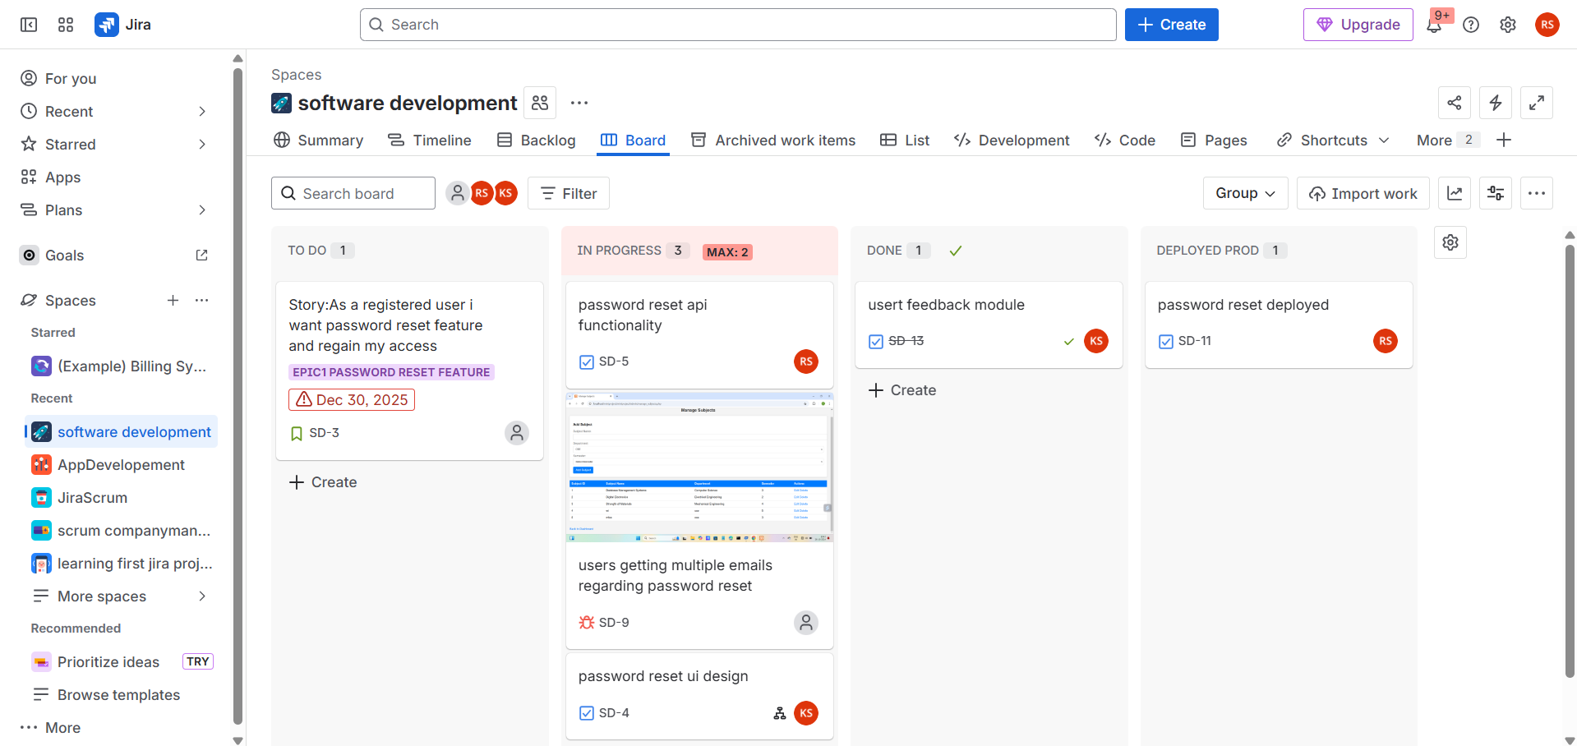
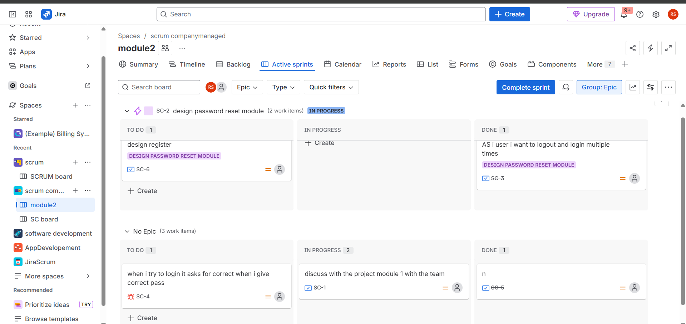

Understanding the Cumulative Flow Diagram (CFD) in Jira
- Shows the number of issues in each workflow stage over time.
- Helps identify bottlenecks and monitor Work in Progress (WIP).
- Reveals flow stability to track delivery efficiency.
- Supports continuous improvement for Kanban teams.

Bugs, Lifecycle, and Status Updates in Jira
Bugs are issues that represent defects, errors, or problems in software or processes. Managing their lifecycle ensures timely resolution and quality control.
Bug Lifecycle in Jira
- Open / New – Bug is reported and logged in Jira.
- In Progress – Assigned team member starts working on fixing the bug.
- In Review / Testing – Fix is implemented and submitted for code review or QA testing.
- Resolved / Fixed – Bug has been fixed; awaiting verification.
- Closed – QA verifies the fix; the bug is confirmed as resolved.
- Reopened – If the issue persists after verification, it is reopened for further work.
Status Updates
- Each status reflects the current stage of the bug in its lifecycle.
- Jira allows team members to update status, add comments, attach screenshots, and log work.
- Automated notifications can alert stakeholders about critical bug updates.

