Organizing your work: Labels, Components, Versions and Templates
Using Issue Labels and Priorities to Organize Work in Jira
Jira provides labels and priority fields to categorize, filter, and manage work effectively.
Issue Labels
- Custom tags that categorize issues (e.g., frontend, bug, urgent).
- Enable filtering, searching, and grouping issues in boards and list views.
- Help teams quickly identify related work across projects.
Issue Priorities
- Indicate the importance or urgency of an issue (e.g., Highest, High, Medium, Low, Lowest).
- Guide teams on what to address first.
- Can be used in reports and dashboards to focus on critical tasks.
List Views
- Jira allows viewing issues in list or table format, showing labels, priorities, assignees, and statuses.
- Useful for bulk updates, sorting, and filtering issues.

1. Creating and Assigning Labels to an Issue
- Open the issue you want to tag.
- Locate the Labels field (usually on the right panel or under details).
- Click the Labels field, type a new label name or select an existing one.
- Press Enter to save the label.

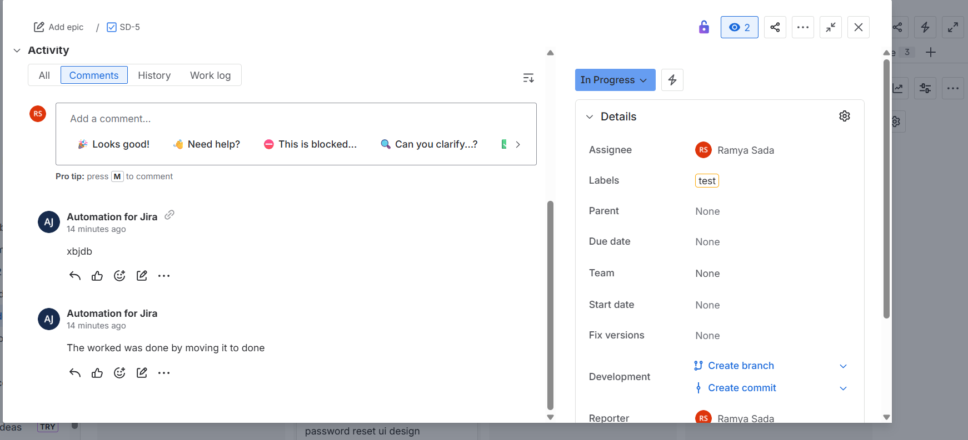
2. Setting the Priority of an Issue
- Open the issue you want to prioritize.
- Locate the Priority field.
- Click the dropdown and select a priority (e.g., Highest, High, Medium, Low, Lowest).
- Changes are saved automatically.

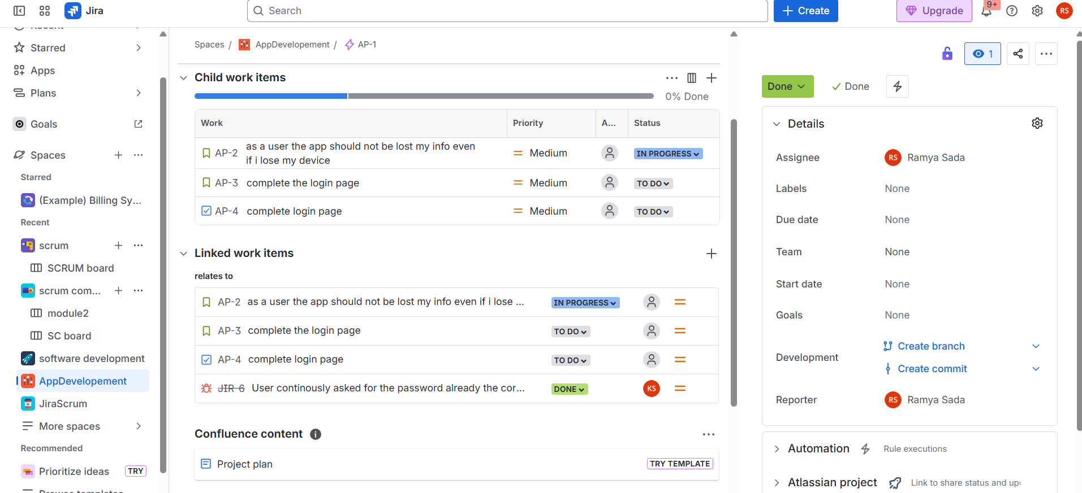
3. Viewing Issues in List View
- Go to your Jira project.
- Click Issues or Filters → View All Issues.
- Select List view (table layout) from the top-right corner of the board or search results.
- Use columns to display important fields such as Labels, Priority, Assignee, Status.
- Apply filters or sorting to focus on specific labels, priorities, or issue types.
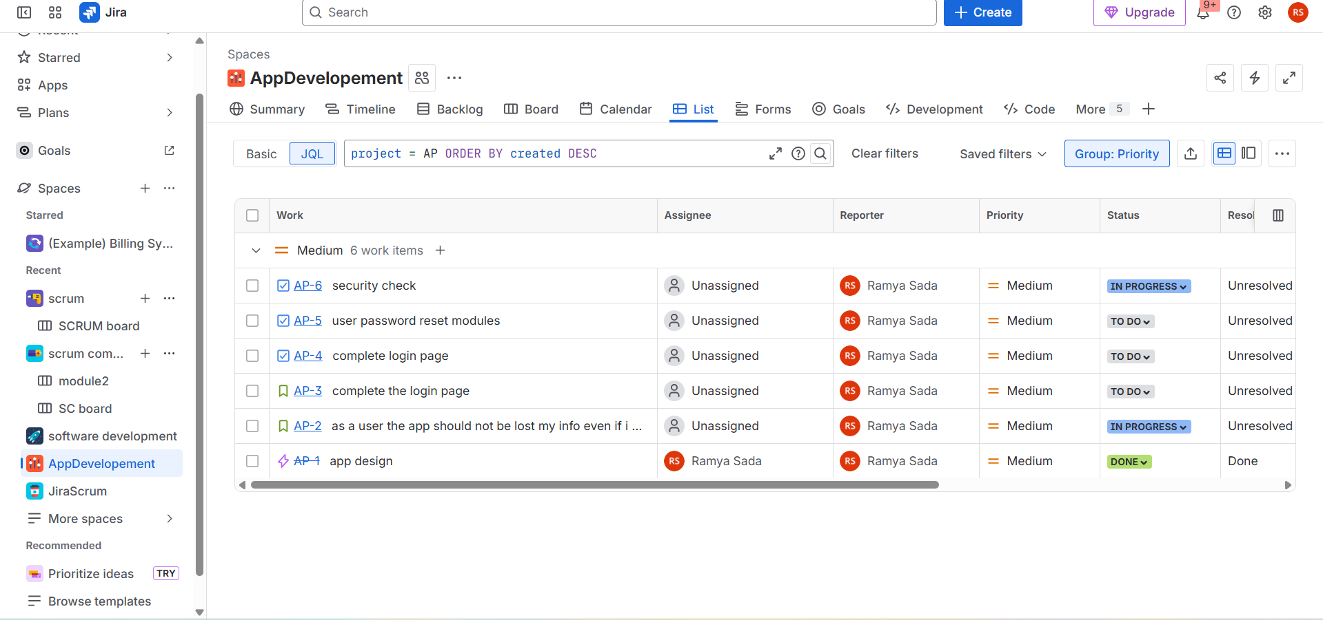
Structuring Work with Components in Jira Projects
Components in Jira are a way to divide a project into smaller, manageable parts based on functionality, team, module, or feature area.
Key Features of Components
- Represent sub-sections of a project (e.g., Frontend, Backend, API, UI/UX).
- Can be assigned default leads who are responsible for issues in that component.
- Help categorize issues for reporting, filtering, and tracking.
- Support automation (e.g., automatically assign issues to component leads).
How Components Help Teams
- Organize large projects into logical areas.
- Track work progress per component.
- Generate component-specific reports and dashboards.
- Improve accountability by assigning leads to components.
1. Creating a Component in a Jira Project
- Go to your Jira project.
- Click Project Settings (usually in the left sidebar).
- Select Components from the menu.
- Click Create Component.
- Fill in the fields:
  - Name – e.g., Frontend, Backend, Payments
  - Description – optional, explain the purpose of the component
  - Component Lead – assign a team member responsible for this component
  - Default Assignee – choose who issues will be automatically assigned to (optional)
- Click Add to save the component.
2. Assigning Issues to a Component
- Open the issue you want to categorize.
- Locate the Components field (on the issue detail view).
- Click the field and select one or more components from the dropdown.
- Save your changes.
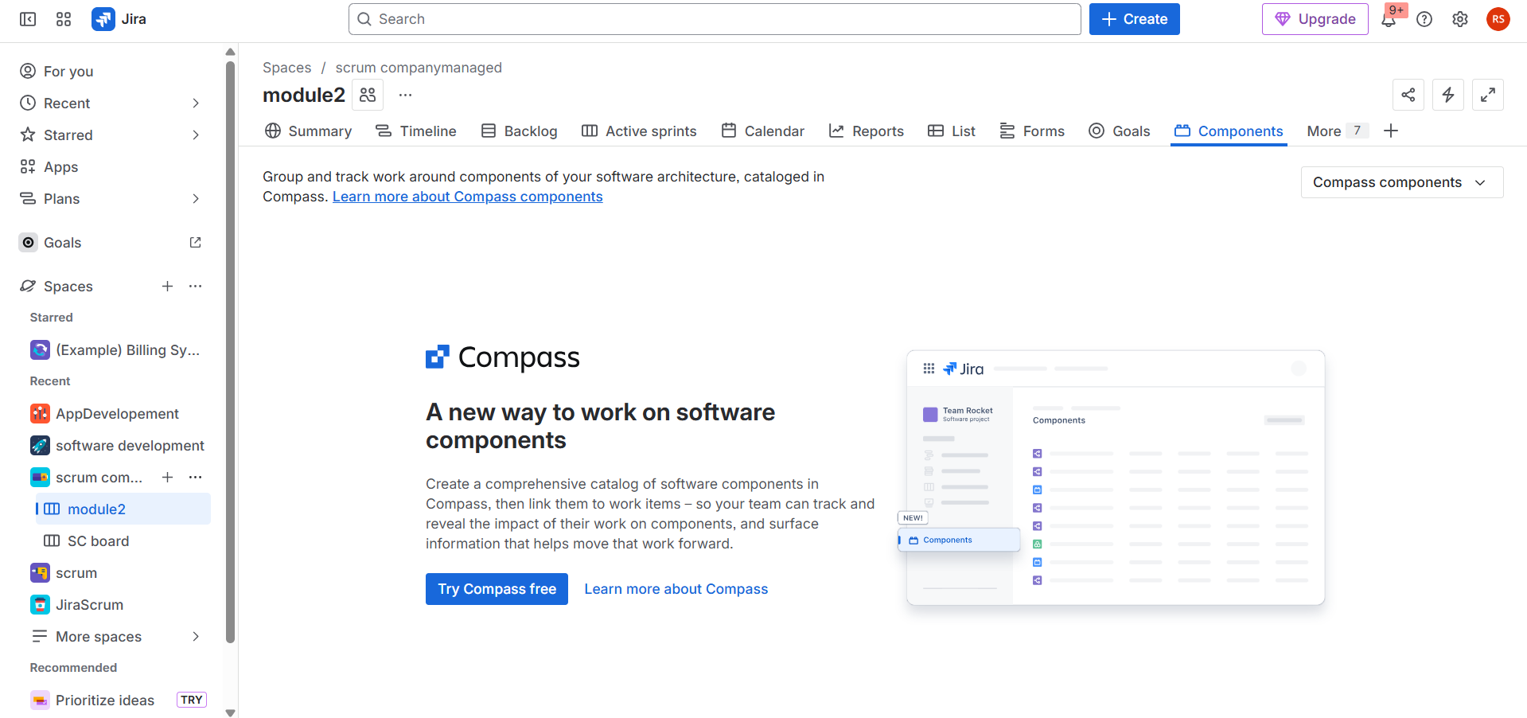
Planning and Releasing with Versions in Jira
Versions (also called Releases) in Jira are used to plan, track, and deliver work tied to a specific release or milestone. They help teams organize issues, manage timelines, and communicate release progress.
Key Concepts
- Version / Release – Represents a target product release, e.g., v1.0, Sprint 5 Release.
- Fix Version – The field used on issues to indicate which version they belong to.
- Released Version – Once work is complete, the version can be marked as released.
Steps to Plan and Release with Versions in Jira
1. Create a Version
- Go to your Jira project.
- Click Project Settings → Versions.
- Click Create Version.
- Enter:
  - Name – e.g., v1.0
  - Description – optional details about the release
  - Start Date / Release Date – optional planning dates
- Click Add to save.
2. Assign Issues to a Version
- Open an issue.
- Locate the Fix Version / Release field.
- Select the version to associate the issue with.
- Save the issue.
3. Track Progress
- Use the Releases / Versions panel in Jira to view which issues are completed, in progress, or pending for each version.
- Generate release reports or burndown charts to monitor readiness.
4. Release a Version
- Once all issues are complete, go to Project Settings → Versions.
- Click Release next to the version.
- Optionally update release notes or mark the release as complete.
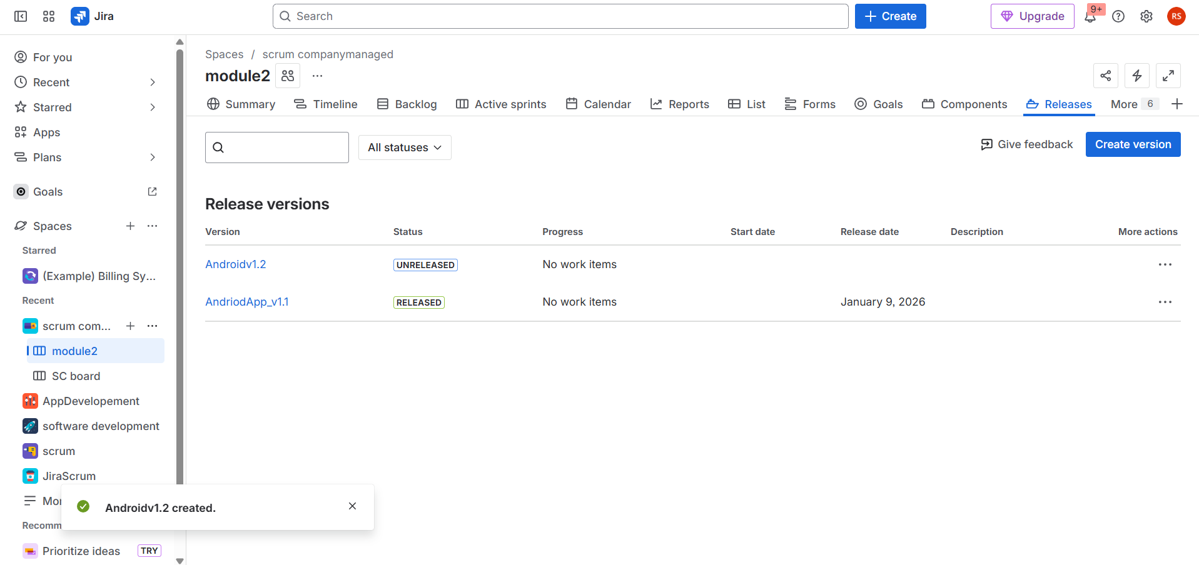
Creating Templates and Reusable Tasks for Efficiency in Jira
Jira allows teams to save time and standardize work by using templates and reusable tasks for recurring processes.
Using Issue Templates (Reusable Tasks)
- Pre-fill fields like summary, description, components, labels, assignee, and priority.
- Ideal for recurring tasks or standard processes (e.g., onboarding, bug triage).
Creating a Template
- Open the issue you want as a template.
- Fill in all necessary fields.
- Save as a template (if using a plugin) or keep as a master issue.
- Copy or clone the template for new work.
Cloning Issues
- Open an issue, select More → Clone.
- Include subtasks, attachments, and links if needed.
- Modify the cloned issue and save.
