Filters and JQL: Advanced Search for Better
Using Basic Search and Quick Filters in Jira
Jira provides powerful search capabilities that help users quickly find, track, and manage issues. Two commonly used features are Basic Search and Quick Filters. These tools allow users to locate issues efficiently without requiring advanced query knowledge.
1. Basic Search in Jira
What is Basic Search?
Basic Search is a user-friendly search option in Jira that allows users to find issues using simple dropdown selections instead of complex queries.
How to Access Basic Search
- Open Jira.
- Click on Issues in the top navigation bar.
- Select Search for issues.
- Ensure Basic Search mode is selected (not JQL).
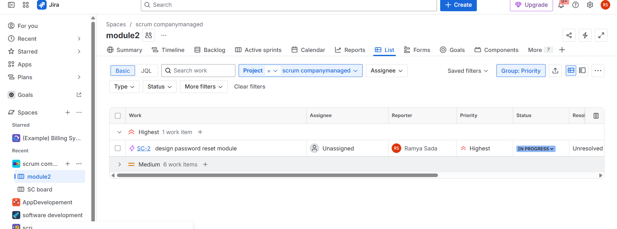

2. Quick Filters in Jira
What are Quick Filters?
Quick Filters are predefined filters available on Jira boards (Scrum or Kanban) that allow users to instantly narrow down issues displayed on the board.
Where to Find Quick Filters
- Open a Jira board.
- Locate Quick Filters at the top of the board.
- Click a filter to apply it instantly.
Common Quick Filters
- Only My Issues – Shows issues assigned to the logged-in user
- Recently Updated – Displays recently modified issues
- High Priority – Shows critical or high-priority issues
- Bugs Only – Displays only bug-type issues
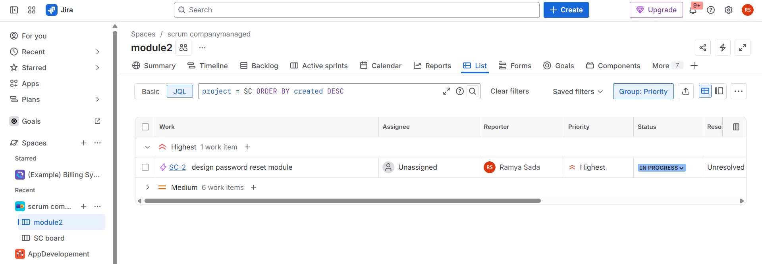

Creating and Saving Filters in Jira for Quick Access
Jira filters allow users to search for issues based on specific criteria and save those searches for future use. Saved filters provide quick access to frequently used issue lists, improving productivity and workflow efficiency.
What are Filters in Jira?
A filter in Jira is a saved search query that displays issues matching defined conditions. Filters can be reused, shared, and applied to dashboards, boards, and reports.
Steps to Create and Save Filters in Jira
- Log in to Jira.
- Click Search for issues.
- Apply search criteria using Basic Search or JQL.
- Verify the search results.
- Click Save As.
- Enter a filter name (and description if needed).
- Click Save.

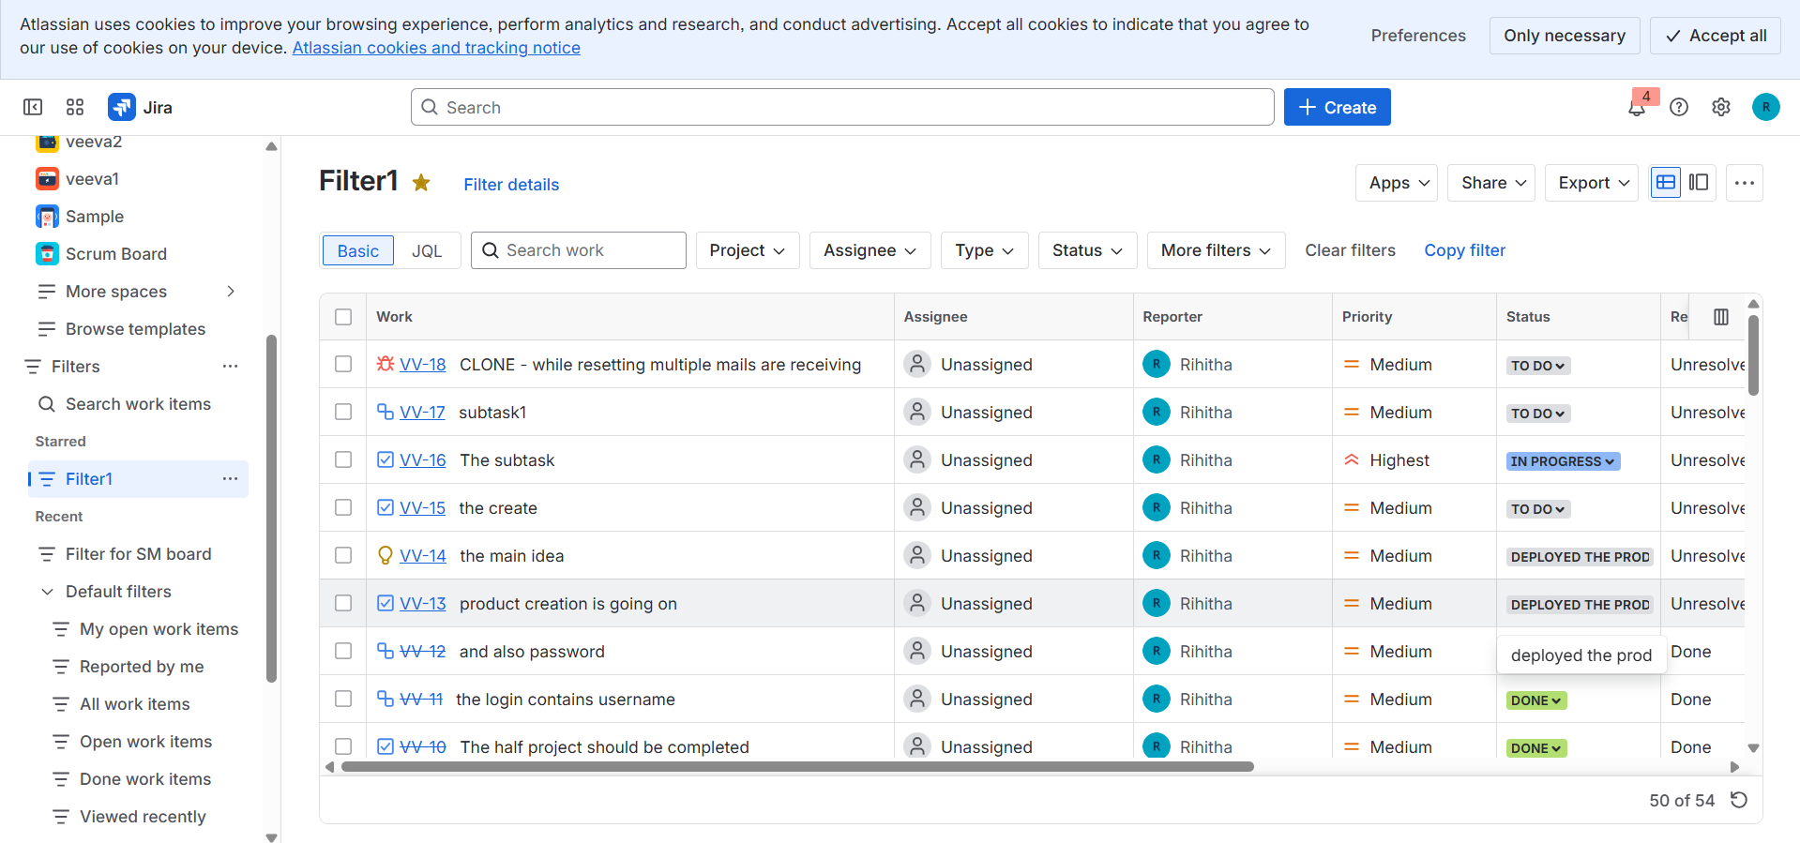
JQL Basics: What is Jira Query Language and Why It Matters
Jira Query Language (JQL) is a powerful query language used in Jira to search, filter, and retrieve issues based on specific conditions. Unlike Basic Search, JQL allows more precise and advanced searches.
JQL matters because it helps users quickly find exact issues, create advanced filters, build dashboards, and manage large projects efficiently. It improves accuracy, saves time, and gives better control over issue tracking in Jira.
Time-Based JQL Queries: Finding Issues by Date and Time
Time-based JQL queries are used in Jira to find issues based on dates and time, such as when an issue was created, updated, or resolved. These queries help track progress, monitor activity, and analyze work over a specific period.
Common date fields include created, updated, resolved, and due. JQL supports operators like =, >, <, >=, <=, and keywords such as startOfDay(), endOfDay(), startOfWeek(), and endOfMonth().
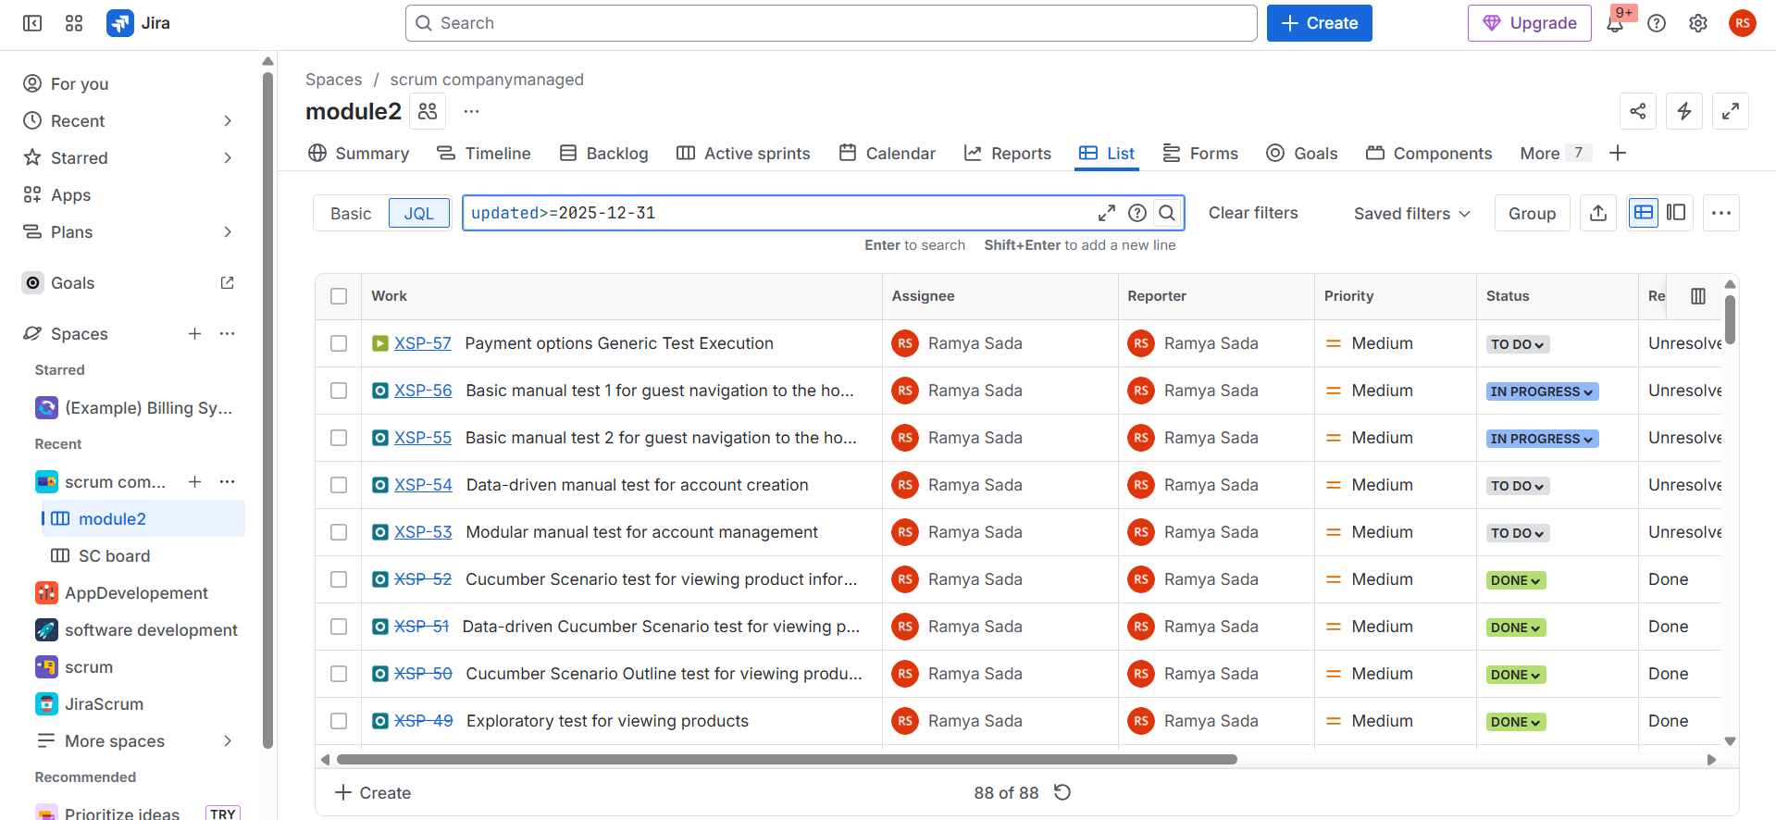
Link-Based and Hierarchy JQL Queries for Advanced Filtering
Link-based and hierarchy JQL queries help users filter Jira issues based on relationships and dependencies between issues, which is especially useful in large or complex projects.
Link-Based JQL Queries
Link-based queries are used to find issues that are connected to other issues through issue links such as blocks, is blocked by, relates to, or duplicates. These queries help track dependencies and identify issues that may affect progress. For example, you can find all issues that block a specific task or all tasks related to a bug.
Hierarchy JQL Queries
Hierarchy queries focus on parent–child relationships in Jira. They are used to track work across Epics, Stories, Tasks, and Sub-tasks. Common use cases include finding all stories under an Epic or identifying sub-tasks linked to a parent issue.
