Test Set
Steps to Create a Test Set in Xray (Jira Cloud – Company-Managed Project)
- Open Your Jira Project
  - Go to Jira → Projects
  - Select your Company-Managed project where Xray is enabled
- Click Create
  - Click the Create button on the top navigation bar
- Select Issue Type
  - Choose Test Set as the Issue Type
  - Click Next / continue
- Enter Test Set Details
  - Summary: Name of the Test Set
    - Example: Regression Tests – Sports Module
  - Description (optional): Purpose of this Test Set
- Create the Test Set
  - Click Create
  - The Test Set issue is now created
- Add Tests to the Test Set
  - Open the created Test Set
  - Go to the Tests section
  - Click Add Tests
  - Search and select existing Tests
  - Click Add
Created the test set and imported the tests
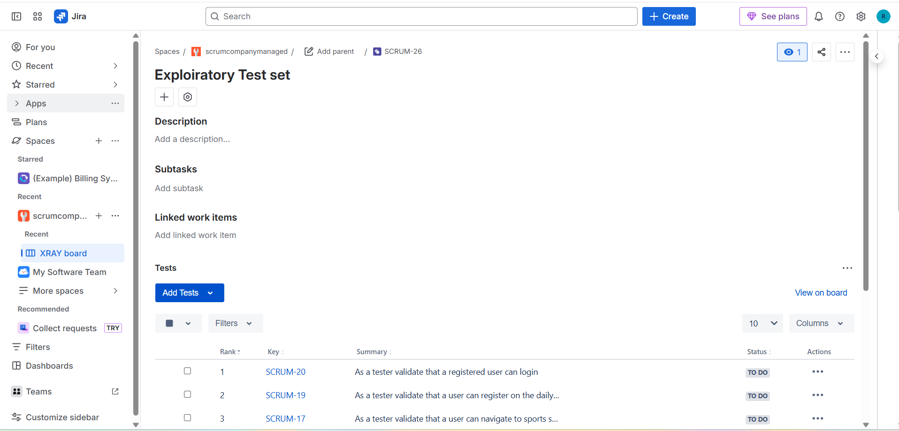
Importing the test set in the test execution
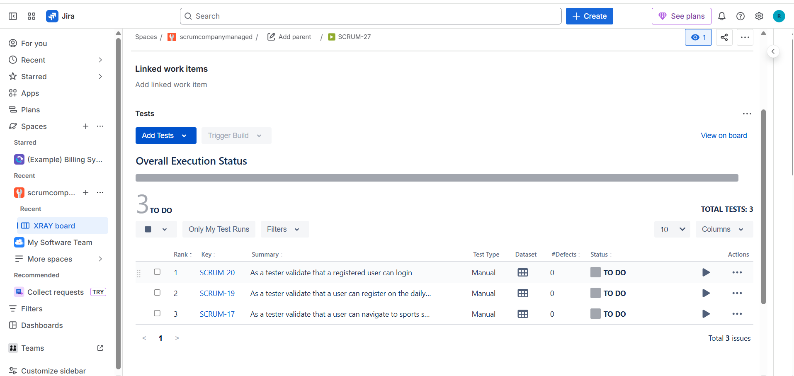

Creating the test plans
Steps to Create a Test Plan in Xray (Jira Cloud – Company-Managed Project)
- Open Your Jira Project
  - Go to Jira → Projects
  - Select the Company-Managed project where Xray is enabled
- Click Create
  - Click the Create button in the top navigation bar
- Select Issue Type
  - Choose Test Plan as the Issue Type
  - Click Next / Create
- Enter Test Plan Details
  - Summary: Name of the Test Plan
    - Example: Sprint 4 – Sports Module Test Plan
  - Description (optional): Scope, objectives, or release details
- Create the Test Plan
  - Click Create
  - The Test Plan issue is now created
- Add Tests to the Test Plan
  - Open the created Test Plan
  - Go to the Tests section
  - Click Add Tests
  - Select Tests directly or
    - Add entire Test Sets
  - Click Add
- (Optional) Add Test Executions
  - In the Test Executions section
  - Click Add Test Execution
  - Create or link executions related to this plan
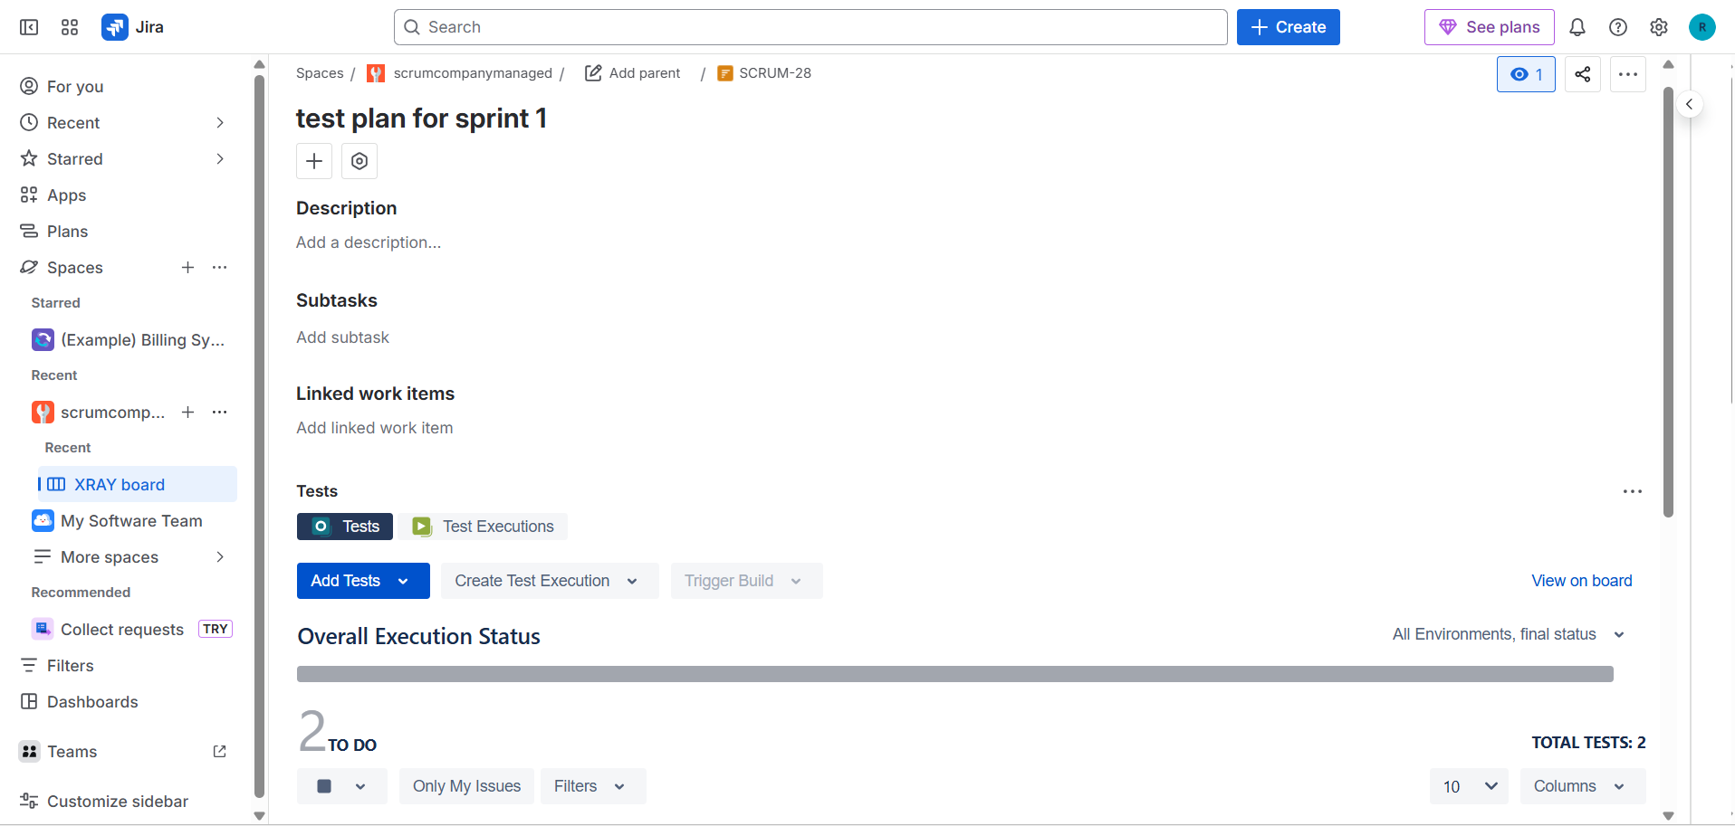
Adding test executions
