Testrail account setup
Go to search gurock.com
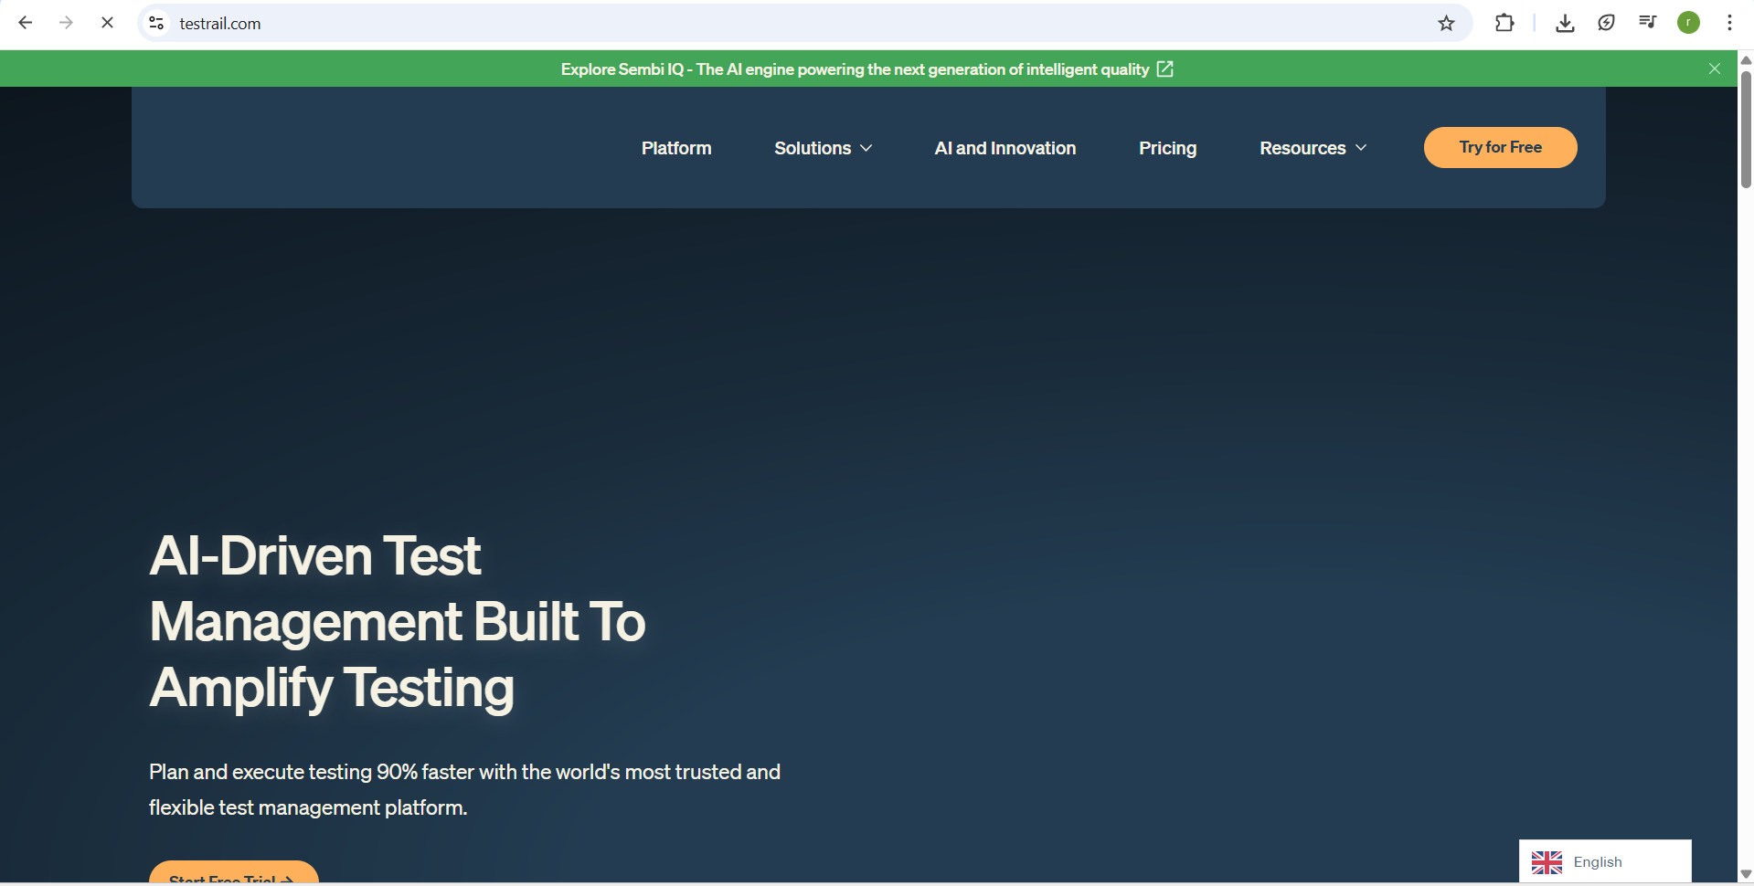
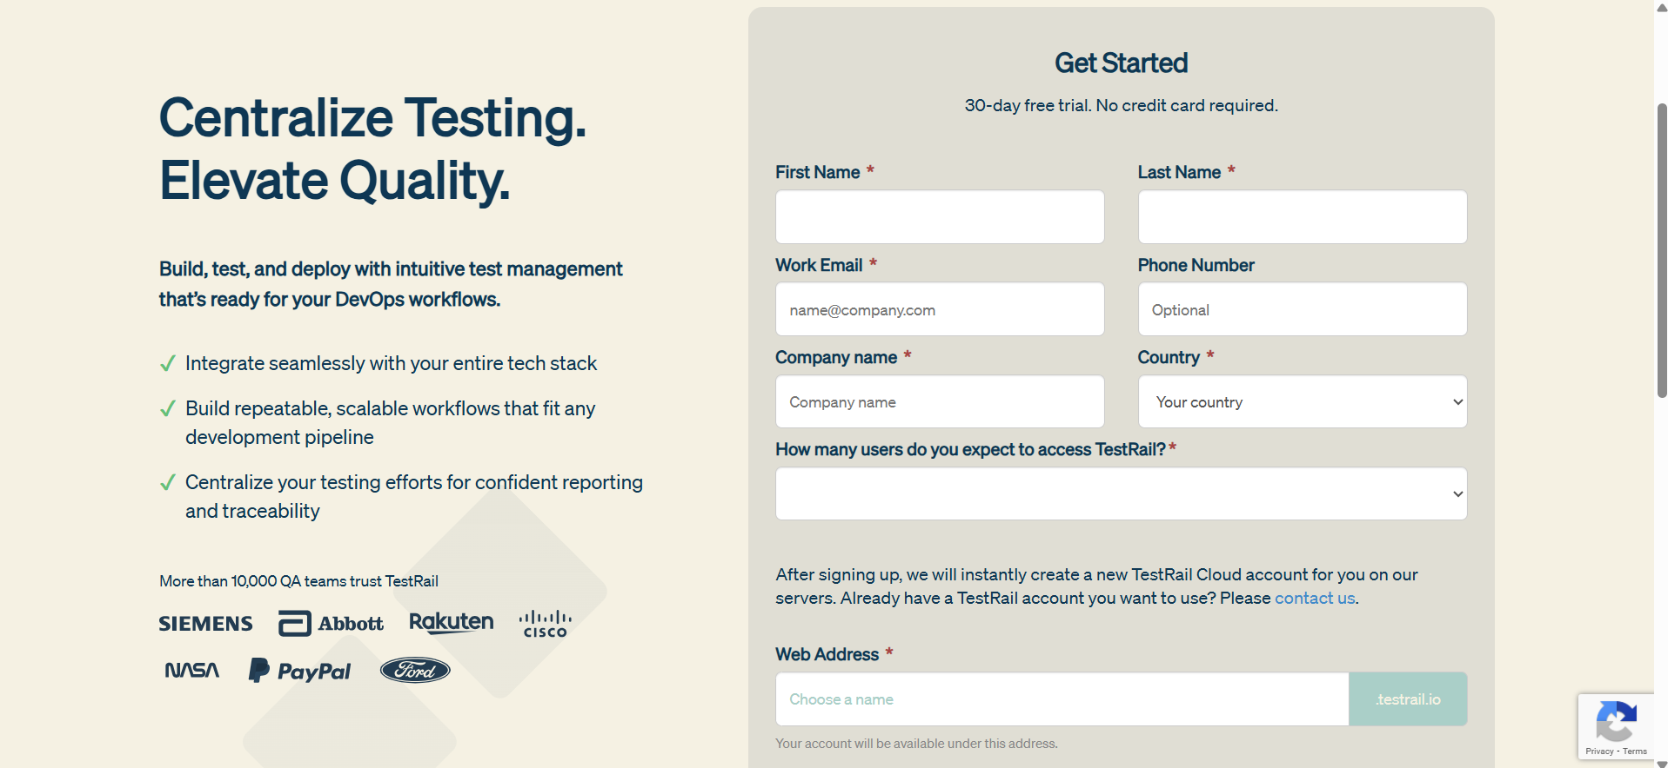
After login it visible like this
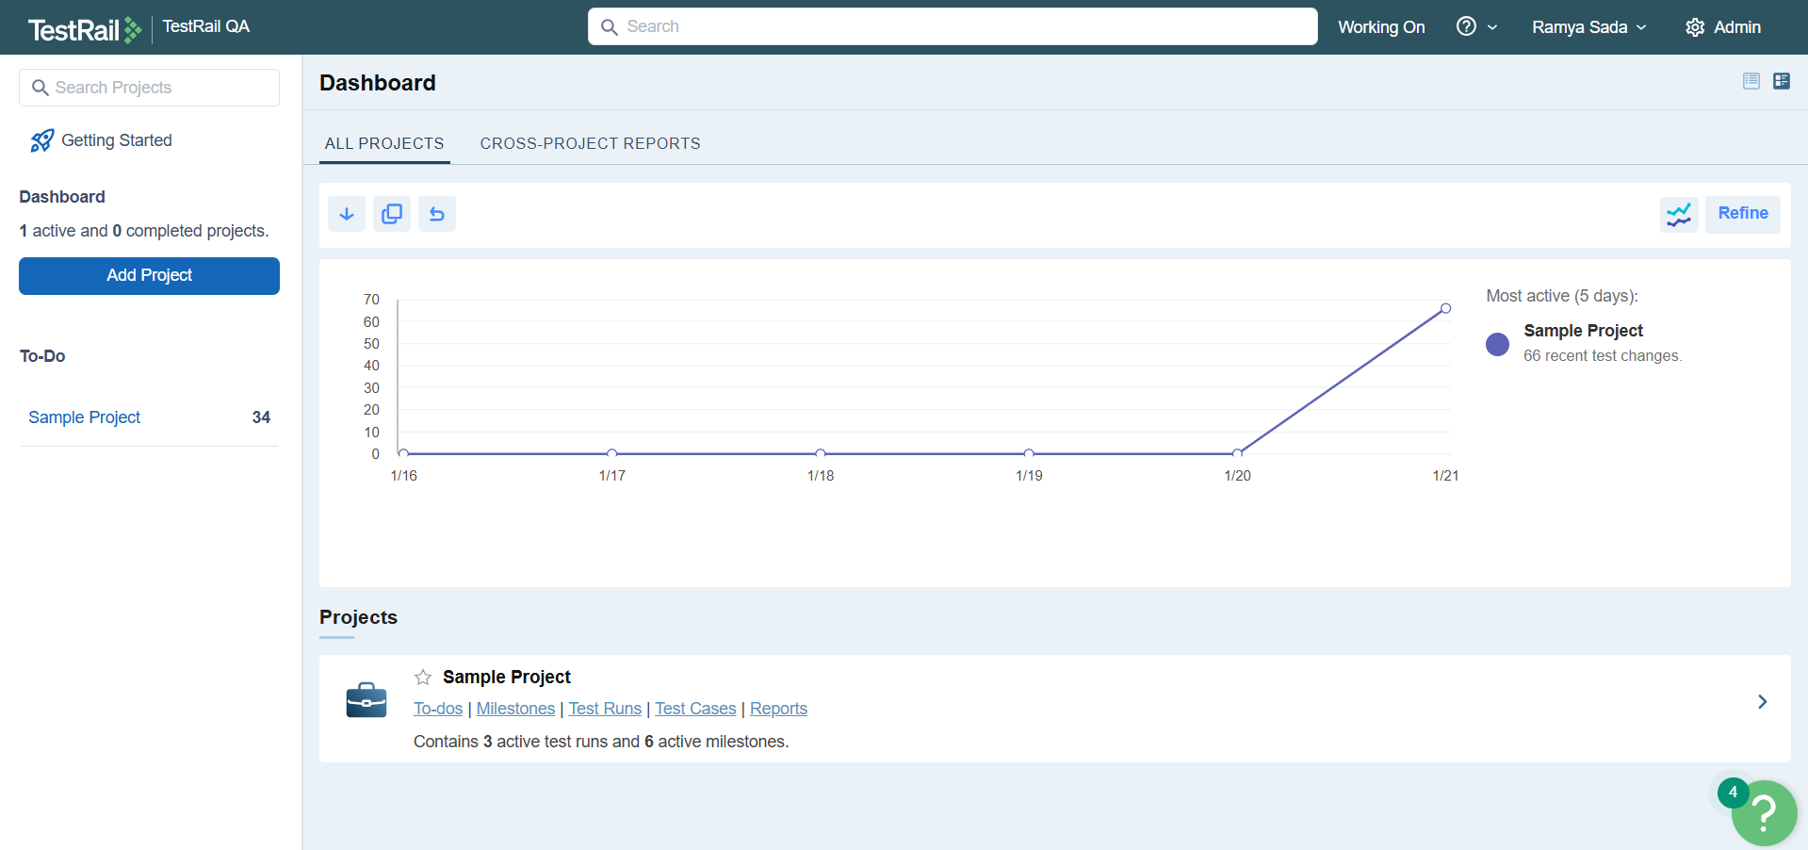
Adding project to the testrail
Click on the add project
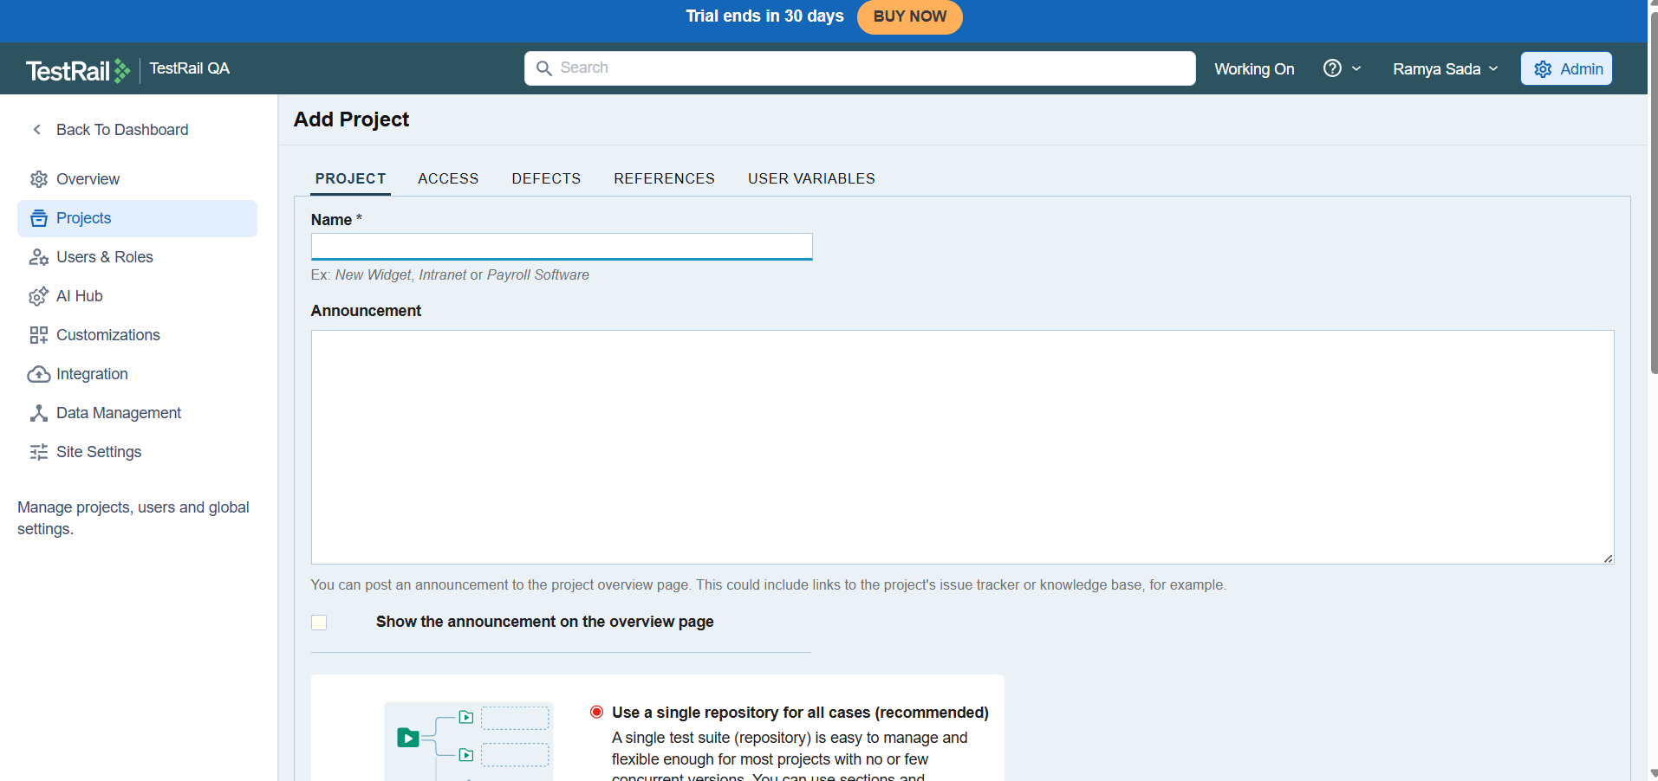

To add project there are multiple ways
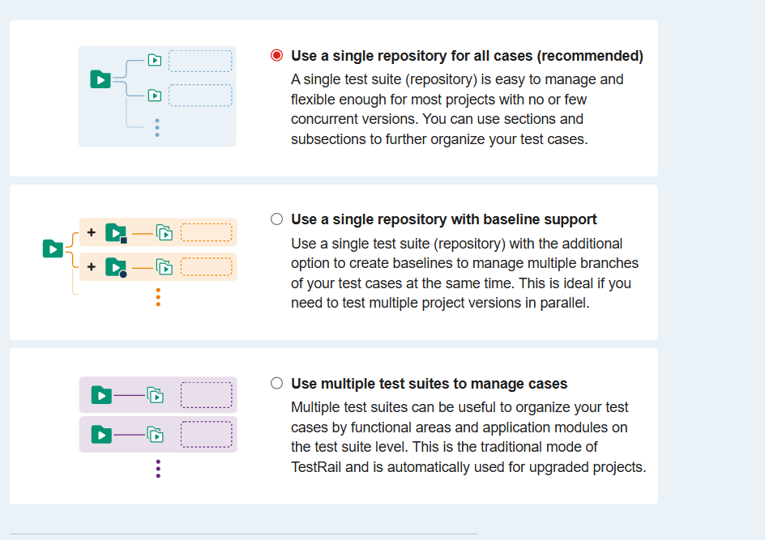

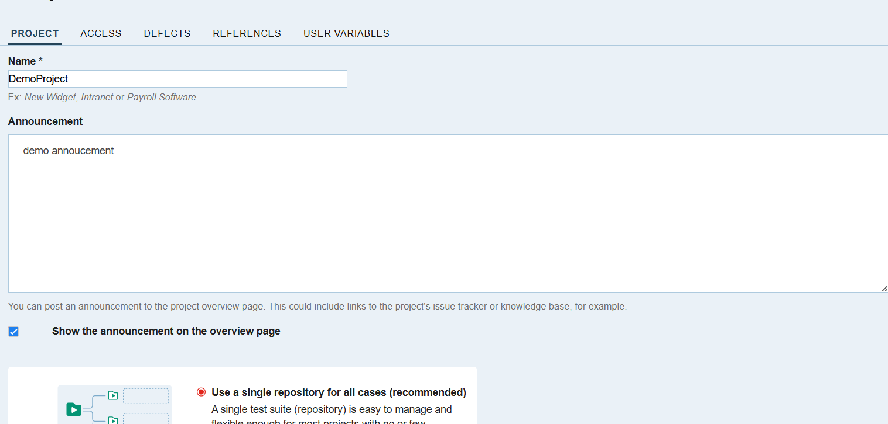
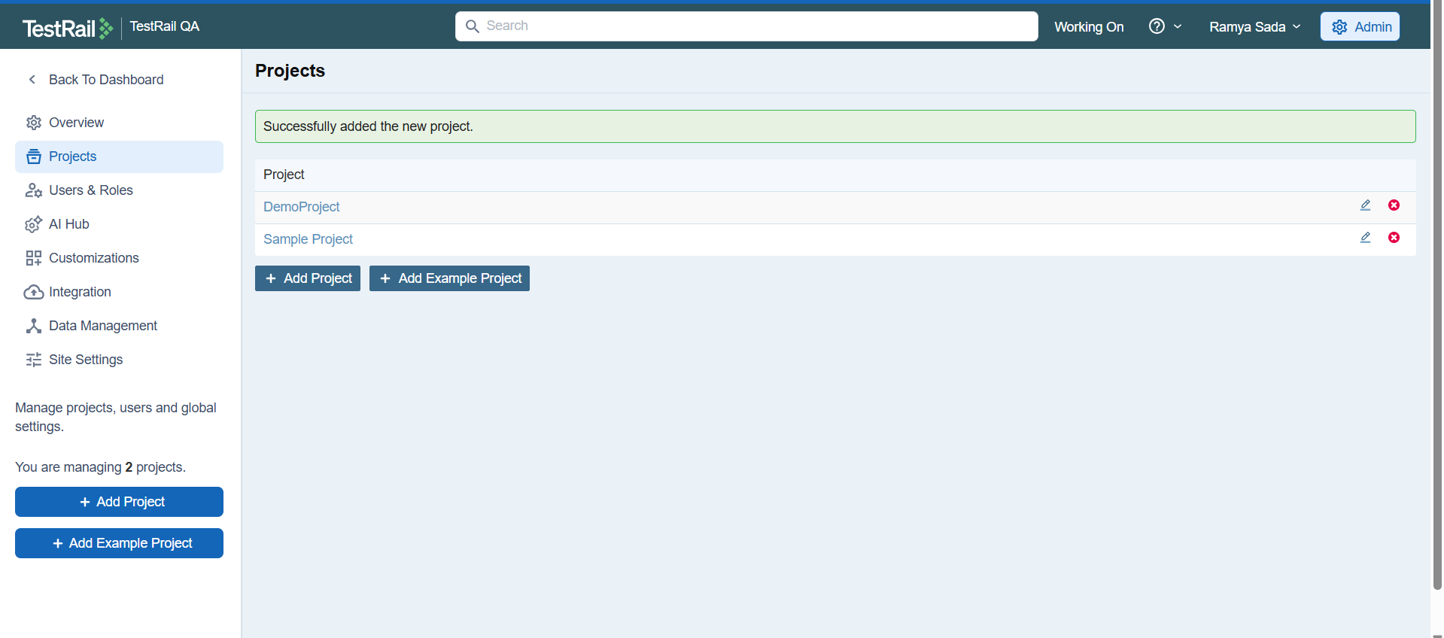
It shows like this
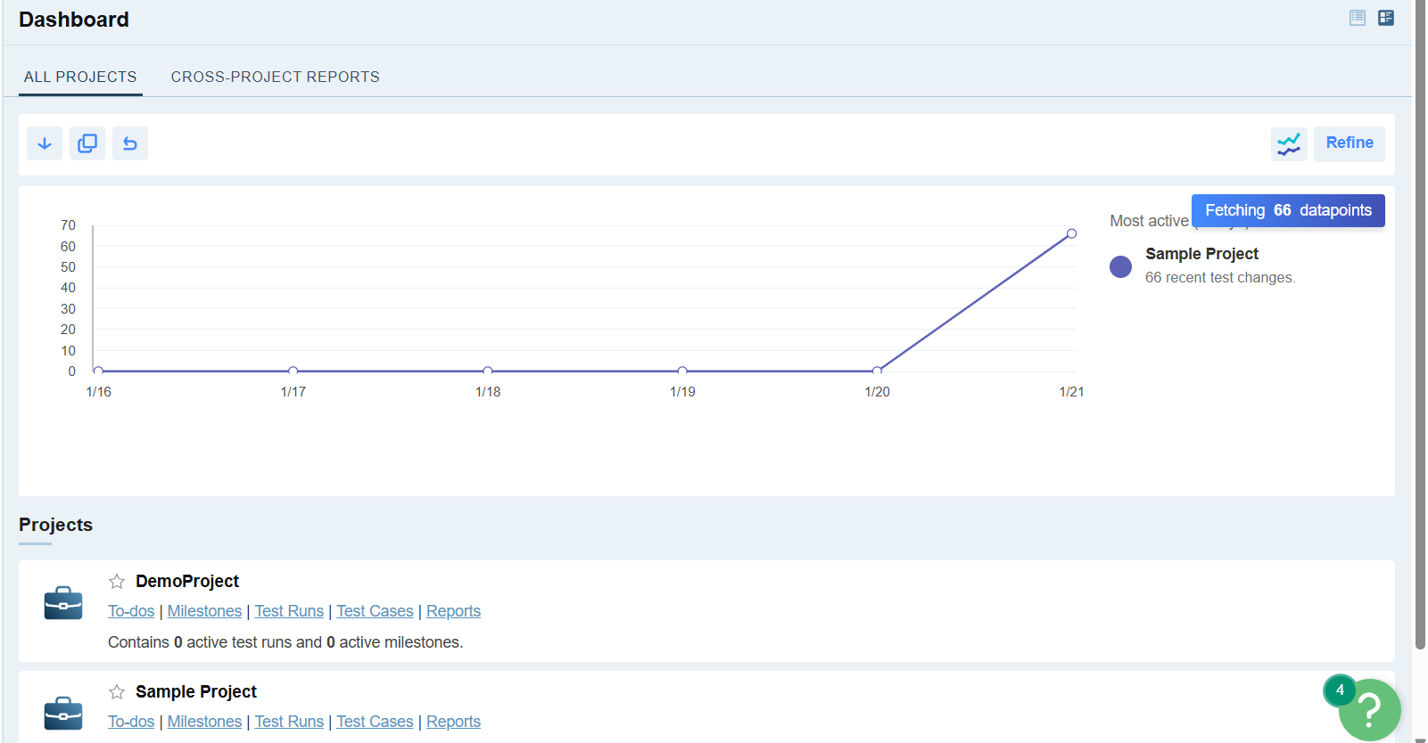
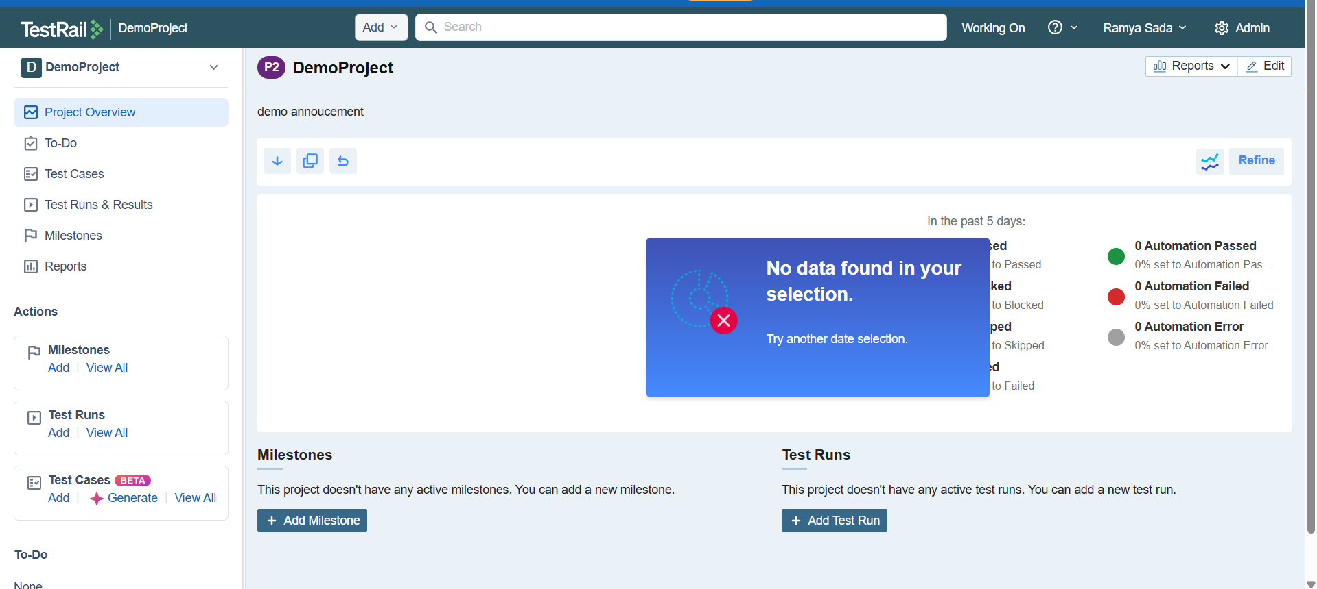
Main Project Options in TestRail
1️⃣ Single Repository (Single Test Suite)
What it means:
- All test cases are kept in one place.
- You organize test cases using sections and sub-sections (like folders).
Example:
Login Tests
└── Valid Login
└── Invalid Login
Payment Tests
└── Card Payment
└── UPI Payment
When to use:
- Small or medium projects
- One application with simple modules
Simple line:
One project → one test case collection

2️⃣ Single Repository with Baseline Support
What it means:
- Same as Single Repository
- PLUS you can create baselines (versions) of test cases
What is a baseline?
- A snapshot of test cases for a specific release
Example:
- Baseline 1: Version 1.0 test cases
- Baseline 2: Version 2.0 test cases
When to use:
- When your application has multiple releases
- When old and new versions are tested in parallel
Simple line:
One test suite, but different versions of test cases

3️⃣ Multiple Test Suites
What it means:
- Test cases are divided into multiple separate suites
- Each suite can represent a module or feature
Example:
Login Suite
Payment Suite
Admin Suite
Reports Suite
When to use:
- Large applications
- Many modules and many testers
- Need clear separation of test areas
Simple line:
One project → many test suites

Adding test cases
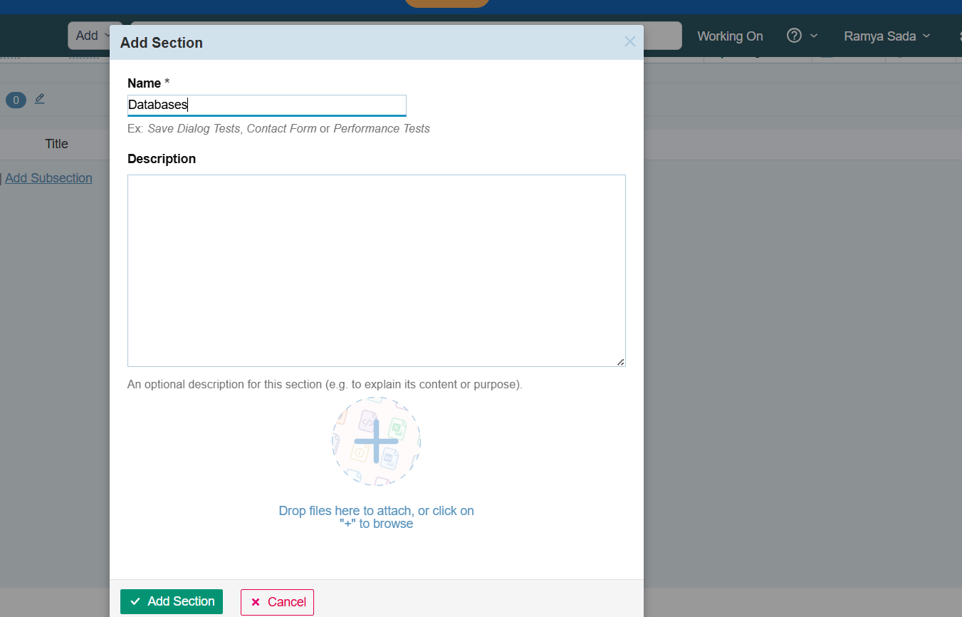

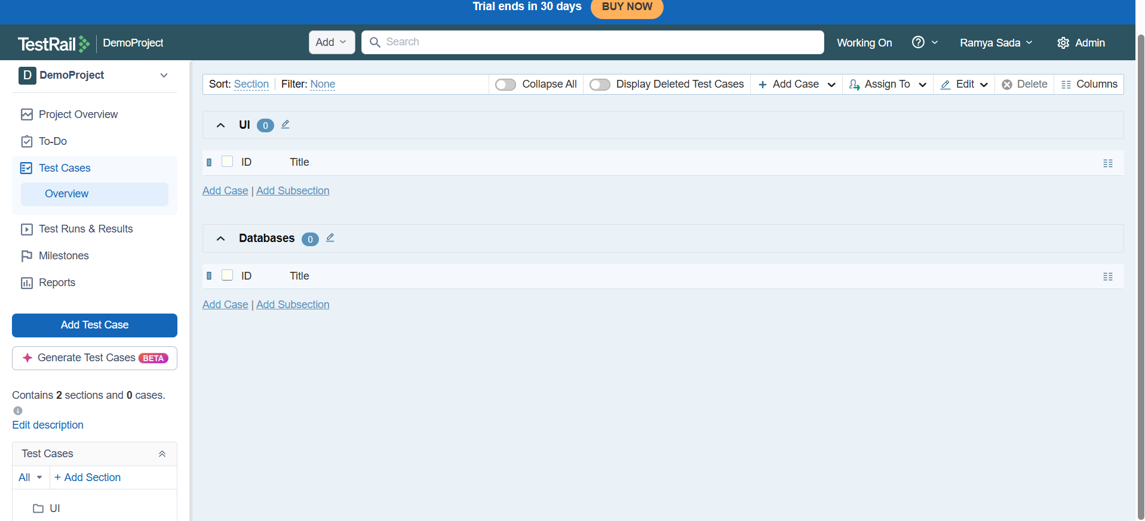
Adding testcases to the section
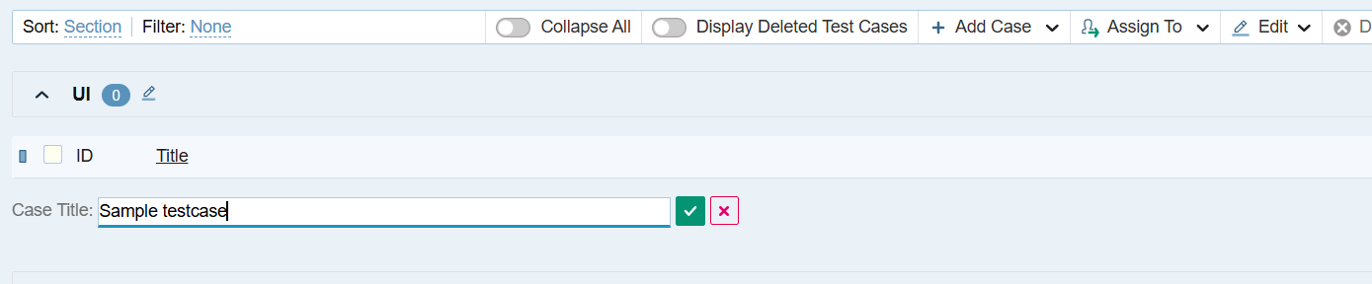
By clicking on the edit testcase it will show like this
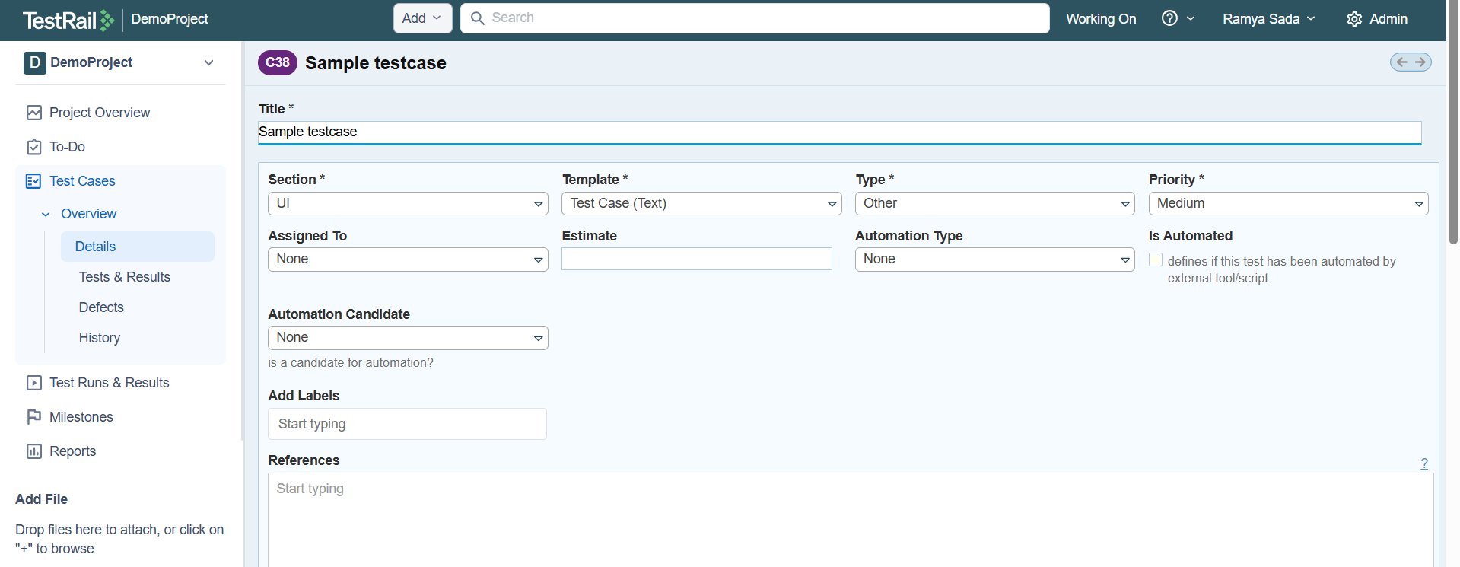
Switching to the required templates
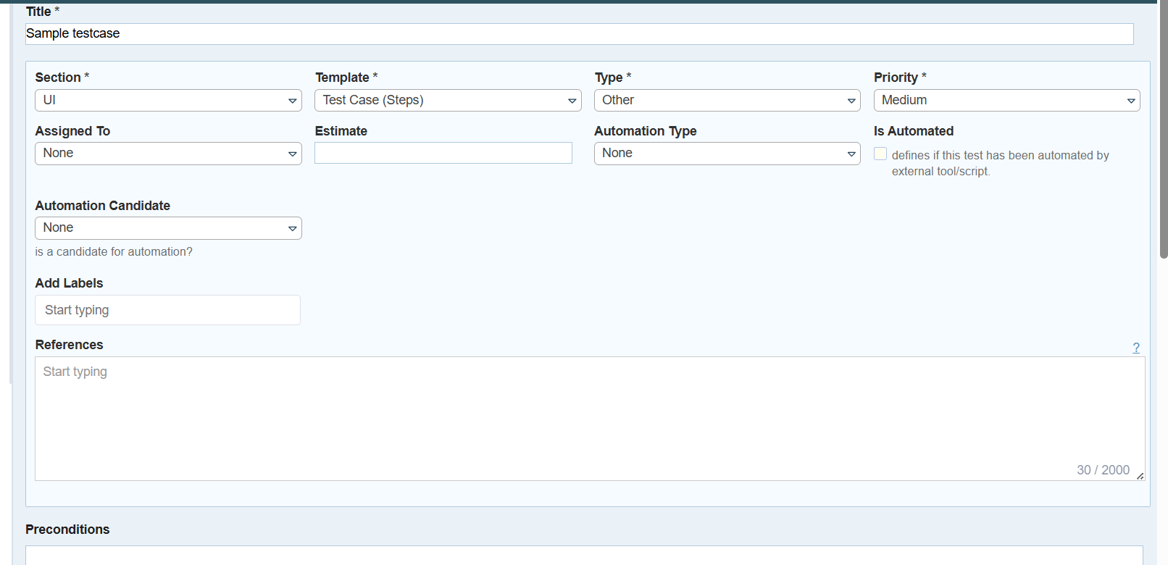
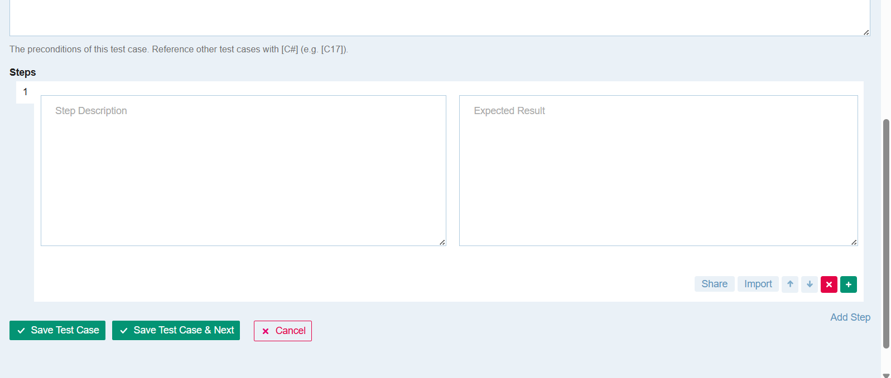
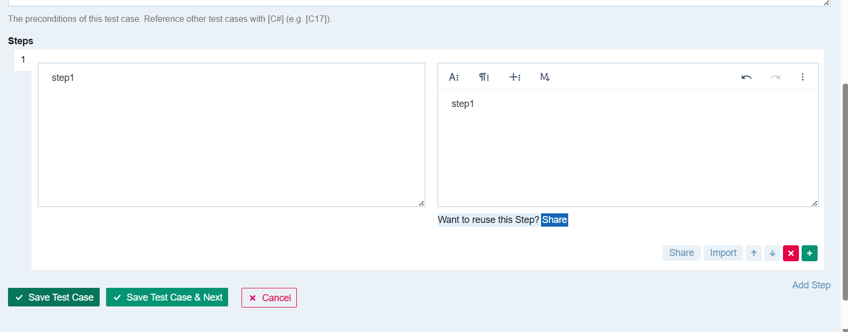
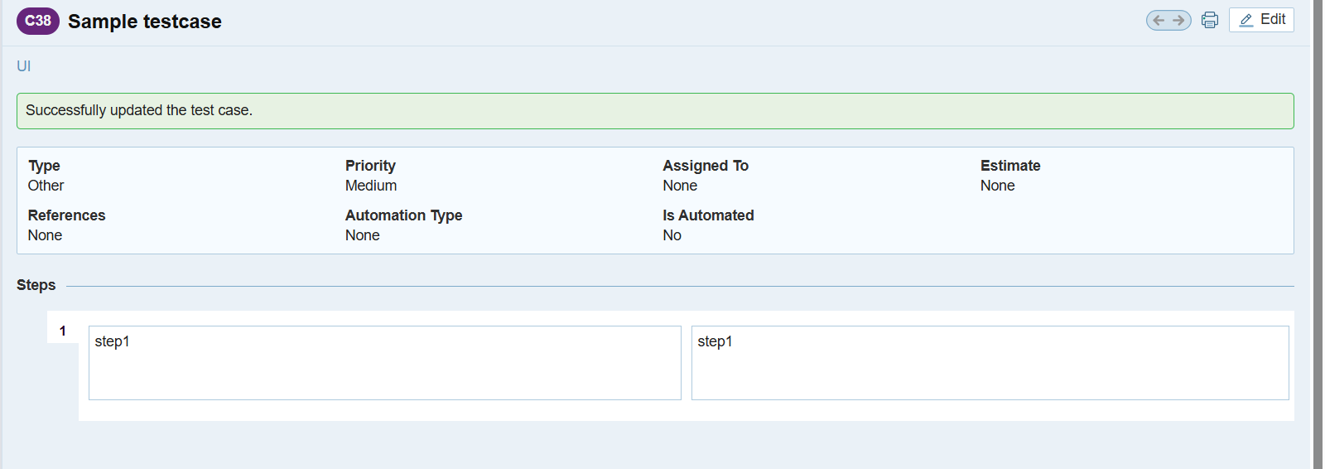

Exploratory testcases in the template
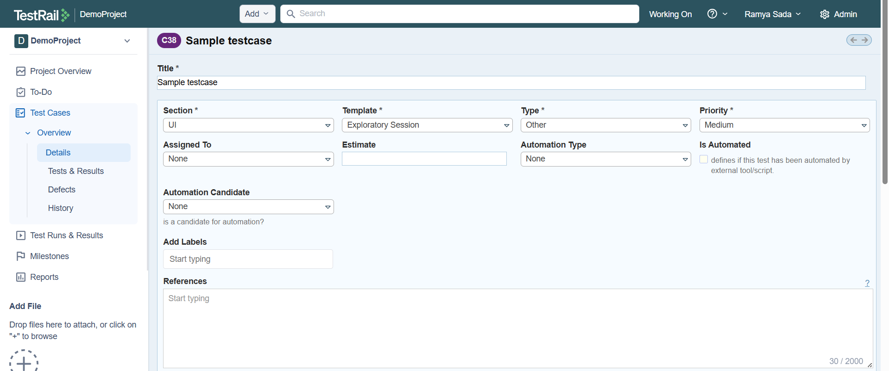

Bulk editing the test cases

