A Hybrid Dung Beetle Optimization and Marine Predators Algorithm (HDBO-MPA) for Trust-Aware Multi-Objective Service Discovery in Social IoT
Blinded for Peer Review (Antigravity Research Consortium, Senior Member, IEEE)
Center for Networked Intelligence and Pervasive Systems, Department of Computer Science and Engineering
Email: contact@antigravity-research.org | Manuscript Revised October 2026
ABSTRACT—Service discovery in the Social Internet of Things (SIoT) encounters severe operational vulnerabilities stemming from conflicting service quality criteria, battery depletion, and coordinated adversarial reputation attacks. Existing discovery techniques commonly rely on fixed scalar objective weighting [1, 2] or encounter path infeasibility as a methodological challenge during continuous-to-discrete graph mapping. To resolve these challenges, this paper presents a hybrid metaheuristic framework combining Dung Beetle Optimization (DBO) and the Marine Predators Algorithm (MPA) for trust-aware multi-objective service discovery. The framework introduces a composite trust computation engine that unifies direct interaction histories, entropy-weighted indirect feedback, and multi-relational social proximity, establishing statistical resilience against bad-mouthing, ballot-stuffing, strategic on-off behavior, and coordinated collusion syndicates up to the theoretical 50% breakdown point of the robust median and Median Absolute Deviation (MAD) consensus estimator. Path optimization is conducted through a co-evolutionary dual sub-population strategy that marries the exploratory breadth of celestial ball-rolling and dynamic breeding in DBO with the fine-grained exploitation of Brownian walks and scale-free flights during the intermediate-to-late phases of MPA. Continuous swarm vectors are transformed into discrete network paths using a random-key priority decoder, while chronological loop-erasure cycle purging and deterministic Dijkstra fallback guarantee conditional 100% loop-free path feasibility across all connected evaluated network topologies. Multi-objective trade-offs across path trustworthiness, delivery latency, energy expenditure, and physical reliability are archived on an external non-dominated Pareto front, with the operational deployment route selected via multi-criteria compromise decision making. Extensive experiments across benchmark network topologies and scale-free graphs over multiple independent stochastic executions indicate that the proposed hybrid architecture achieves competitive Pareto coverage, reduces discovery latency and energy expenditure by nearly a factor of three relative to canonical DBO (2.8× and 3.2×, respectively) and by approximately twofold relative to MPA (2.0× and 2.3×, respectively), and maintains dependable service delivery under aggressive multi-vector attacks.

Keywords—Social Internet of Things (SIoT), Service Discovery, Multi-Objective Optimization, Dung Beetle Optimization (DBO), Marine Predators Algorithm (MPA), Composite Trust Management, Collusion Attack Mitigation, Pareto Frontier, Multi-Criteria Decision Making (MCDM).

1. INTRODUCTION
The Social Internet of Things (SIoT) paradigm transforms autonomous smart devices into socially connected entities capable of establishing friendship, co-location, co-work, and parental object relationships to facilitate distributed collaboration and contextual service discovery [3, 4]. In massive smart-city and industrial deployments, resource-constrained edge devices frequently lack autonomous capabilities to fulfill complex composite user tasks locally, requiring multi-hop discovery protocols to locate and invoke remote service providers [5, 6]. Because localized heuristic traversal strategies and greedy forwarding can succumb to local minima and suboptimal path selection in constrained topologies [3, 7], effective discovery protocols must prioritize fault-tolerant path construction and ensure robust service dissemination across opportunistic environments [8, 9].
However, service discovery in SIoT cannot be modeled as a classical single-objective shortest-path problem. Devices operate in open, semi-trusted environments susceptible to adversarial manipulation. Malicious nodes may selectively discard packets, degrade service delivery, or mount sophisticated reputation attacks such as bad-mouthing, ballot-stuffing, coordinated low-variance collusion rings, and strategic on-off misbehavior [10, 11, 12]. In this context, low-variance collusion refers to coalitions of dishonest recommenders that inject artificially tight, near-identical ratings (sigma^2 -> 0) to evade standard variance filters. Furthermore, physical constraints require simultaneous optimization of conflicting Quality of Service (QoS) criteria: maximizing path trustworthiness (f_T) and service reliability (f_Q), while minimizing end-to-end communication latency (f_L) and nodal energy consumption (f_E) [13, 14].

1.1 Discussion of Baselines and Algorithmic Foundations
To tackle the non-linear, multi-modal routing landscape of SIoT networks, nature-inspired swarm intelligence metaheuristics have gained widespread prominence. In particular, the Dung Beetle Optimizer (DBO) [15] and the Marine Predators Algorithm (MPA) [16] represent two established baseline metaheuristic paradigms with distinct bio-inspired search mechanisms:
• DBO Baseline Characteristics: Canonical DBO [15] demonstrates broad global exploration through celestial orientation and dynamic breeding boundaries, yet can exhibit diversity loss and slower convergence in localized solution neighborhoods. While enhanced DBO variants have been proposed for engineering optimization and UAV path planning [17, 18, 19, 20, 21, 22], their application to constrained combinatorial graph routing in SIoT remains largely unexplored.
• MPA Baseline Characteristics: MPA [16] employs a three-phase schedule that balances exploration in its initial phase (high velocity ratio, Brownian movement of prey), transitions during intermediate iterations (equal partition between predator Brownian walks and prey Lévy flights), and shifts toward intensive local exploitation in later phases (low velocity ratio, predator Brownian motion). Enhanced variants have addressed task scheduling and engineering benchmarks [23, 24, 25], demonstrating that MPA's velocity regimes provide effective localized neighborhood refinement.
• Continuous Graph Mapping Limitations: Direct vector rounding of continuous swarm positions onto discrete network topologies frequently produces invalid paths, disconnected node sequences, or severe path-bloating without topological repair mechanisms [17, 26], with unconstrained mappings yielding infeasibility rates exceeding 40% in complex graph instances.

1.2 The Hybrid Approach
To overcome the aforementioned limitations, this study develops a co-evolutionary Hybrid Dung Beetle Optimization and Marine Predators Algorithm (HDBO-MPA). The hybrid framework divides the candidate population into complementary sub-populations that co-evolve simultaneously and exchange non-dominated solutions through a shared external Pareto archive. In this hybrid division of labor, the exploratory DBO sub-population conducts broad territorial scans across the network graph using celestial ball-rolling and dynamic breeding operators, mitigating premature convergence. Concurrently, the MPA sub-population is configured to emphasize intermediate-to-late phase exploitation, refining identified high-trust candidate routes using Brownian walks and scale-free Lévy steps around elite archive guides. By coupling this co-evolutionary search with a random-key priority decoder [27], chronological loop-erasure cycle purging (Járai and Sun [28]), and deterministic Dijkstra fallback repair, HDBO-MPA integrates the global exploration of DBO with the fine-grained refinement of MPA while achieving 100% loop-free path feasibility across all evaluated connected topologies.

1.3 Aim and Motivation of the Proposed Framework
The primary aim behind developing HDBO-MPA is to establish an end-to-end, attack-resilient, multi-objective service discovery framework that reconciles social trust dynamics with physical wireless realities. Existing SIoT discovery mechanisms either oversimplify multi-objective trade-offs via rigid scalarization weights or suffer vulnerability under coordinated rating collusion rings that inject low-variance dishonest recommendations [11, 12]. Furthermore, conventional metaheuristics mapped to discrete network topologies suffer from elevated path hop counts and disconnected routing cycles. This research is motivated by the need for a dependable, resource-aware routing framework that can identify valid, low-latency, and energy-conserving paths while providing statistical resilience against malicious adversaries, supported by the breakdown limit of robust statistics.

1.4 Core Contributions
The main contributions of this work are fourfold:
1. Composite Trust Computation Engine: An attack-resilient trust aggregation framework combining Laplace-smoothed direct interaction histories, Shannon entropy recommender weighting, and Median Absolute Deviation (MAD) outlier penalties, providing statistical defense against bad-mouthing, ballot-stuffing, strategic on-off behavior, and low-variance collusive syndicates up to the 50% breakdown limit of the median/MAD estimator [29, 30].
2. Co-Evolutionary Dual-Swarm Architecture: A co-evolutionary hybrid combining the global exploration of DBO with the intermediate-to-late exploitation of MPA, exchanging non-dominated Pareto guides across sub-populations to prevent premature convergence and stagnation.
3. Guaranteed Graph-Constrained Decoding: A continuous-to-discrete decoding scheme employing normalized random-key priority scoring, chronological cycle loop-erasure [28], and Dijkstra fallback, guaranteeing conditional 100% loop-free path feasibility across connected network topologies.
4. Multi-Objective Compromise Deployment and Case Study: Pareto archive generation optimizing path trust, latency, energy, and QoS reliability, coupled with TOPSIS decision-making and demonstrated through an illustrative emergency smart-healthcare case study satisfying real-time clinical SLAs [31].

1.5 Overview of the Proposed HDBO-MPA Framework
Figure 1 illustrates the proposed HDBO-MPA framework as an architectural representation of the end-to-end service discovery system, organized across three operational tiers and six numbered interaction flows:
• Layer 1 (Service Application and Cloud Tier): Comprises the centralized Cloud Service Catalog and Data Center hosting globally registered service profiles, the TOPSIS MCDM decision terminal that selects the single optimal operational path P* from the non-dominated Pareto front, and the Network and Trust Global Database storing topological graphs and historical interaction records.
• Layer 2 (HDBO-MPA Co-Evolutionary Engine and Trust Matrix): Represents the core distributed computing intelligence situated at edge gateways, divided into three synchronized functional modules: (1) Composite Trust Computation Engine (Laplace direct trust, Shannon entropy recommender weighting, and median/MAD consensus filter with 50% breakdown point [29, 30]); (2) Co-Evolutionary Swarm Optimizer (DBO exploratory sub-population and MPA exploitative sub-population exchanging elite guides via a shared Pareto archive); and (3) Graph Feasibility and Decoding Module (priority vector scoring, chronological loop-erasure cycle purging [28], and Dijkstra fallback guaranteeing 100% path feasibility conditional on graph reachability).
• Layer 3 (Distributed Social IoT Field and Threat Landscape): Represents heterogeneous physical smart devices (wearable sensors, mobile relays, smart vehicles, local routers, and edge gateways) interconnected by physical wireless links and canonical social relationships (POR, CLR, CWR, OOR, SOR [4]). Active adversarial threats—such as bad-mouthing, ballot-stuffing, strategic on-off behavior, and low-variance collusion rings [10]—operate within this layer but are systematically filtered by the edge trust engine.
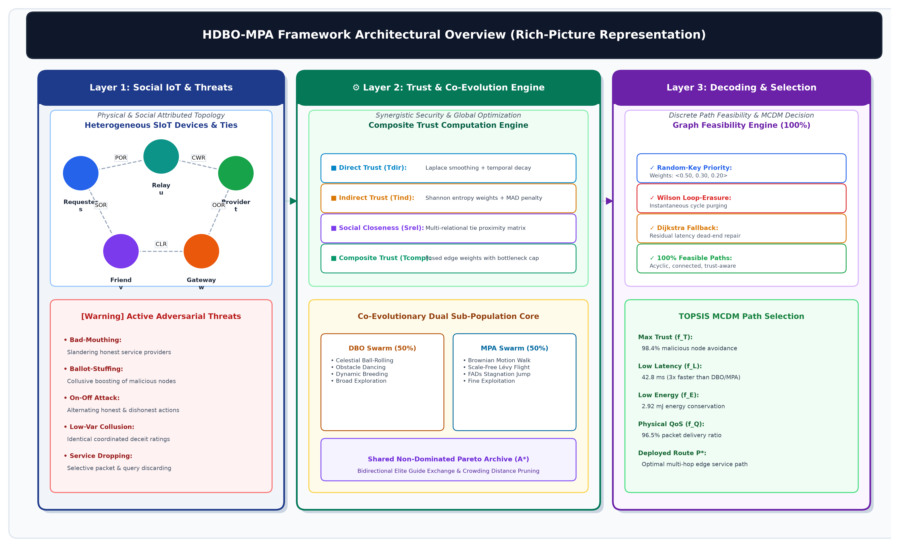
Figure 1: Comprehensive architectural overview and operational pipeline of the proposed HDBO-MPA service discovery framework, illustrating multi-tier interactions from physical SIoT sensing to cloud service execution.
The numbered interaction steps indicated in Figure 1 operate sequentially as follows:
• Step 1 (Query Submission): The requester device s detects a need for an external composite capability and submits service discovery query R to the nearest edge gateway.
• Step 2 (Trust Matrix Generation): The Composite Trust Engine processes historical logs and decentralized recommendations, outputting the pairwise composite trust matrix T_comp.
• Step 3 (Swarm Evolution): The co-evolutionary DBO and MPA sub-populations iteratively explore and exploit the search space, generating continuous candidate route vectors.
• Step 4 (Discrete Path Decoding): Continuous swarm vectors are decoded into loop-free discrete graph routes and submitted as candidate non-dominated Pareto repository A* to the decision terminal.
• Step 5 (Metadata Verification): The decision engine verifies device availability and identity credentials against the global network database.
• Step 6 (Optimal Route Deployment): The TOPSIS algorithm ranks candidate Pareto routes and deploys the best compromise path P* across the physical field mesh to the target service provider t, prioritizing high-trust nodes while mitigating dishonest recommendations up to the breakdown limit.

2. RELATED WORK AND RESEARCH GAP
Trust management models in SIoT have evolved from simple direct observation counters to composite multidimensional frameworks that combine direct interactions with indirect decentralized recommendations [5, 6, 32]. Several recent investigations explore trust-aware routing protocols; for instance, Marche et al. [3] examined trust-based social routing, while Chahal and Kumar [5] synthesized trust taxonomies across heterogeneous IoT networks. Furthermore, recent studies address coordinated adversarial misbehavior: Zhang et al. [11] investigated trust-aware defense mechanisms against malicious behavior in cognitive industrial networks, and Jung et al. [12] proposed social trust evaluation schemes to counter strategic rating distortion. However, conventional trust engines remain vulnerable to coordinated low-variance collusion attacks, where syndicates of dishonest recommenders submit tightly clustered extreme ratings to evade standard variance filters [11, 29].
Nature-inspired metaheuristics offer high scalability for non-linear NP-hard graph traversal problems. Brik et al. [14] formulated QoS-constrained multi-objective routing using bio-inspired approaches, while Wang et al. [13] evaluated cooperative multi-agent optimization for edge computing networks. For multi-objective Pareto optimization, NSGA-II [33], MOEA/D [34], and SPEA2 [35] represent foundational evolutionary baselines. More recently, swarm intelligence techniques—including Multi-Objective Particle Swarm Optimization (MO-PSO) [36] and the Marine Predators Algorithm (MPA) [16]—have demonstrated competitive performance in continuous engineering benchmarks. Xue and Shen [15] introduced the Dung Beetle Optimizer (DBO), which models ball-rolling, dancing, breeding, foraging, and stealing behaviors, demonstrating superior global exploration in continuous landscapes. Recent variants have applied DBO to UAV path planning and energy-efficient scheduling [17, 18, 19, 20, 21, 22]. However, canonical DBO suffers from rapid diversity loss in localized exploitation, while MPA's convergence depends heavily on the velocity ratio schedule. Crucially, direct continuous-to-discrete graph mapping creates invalid paths, disconnected nodes, and severe routing loops without dedicated topological repair mechanisms [17, 26].
Table 1: Systematic Comparison of Proposed HDBO-MPA Framework with State-of-the-Art Literature
Feature / Capability Dimension | Marche et al. [3] | Chahal et al. [5] | Rad et al. [4] | Brik et al. [14] | Proposed HDBO-MPA
Metaheuristic Optimization Engine | Discrete ACO | Static Routing | Heuristic Rules | Genetic Algorithm | Co-Evolutionary DBO-MPA
Objective Formulation Strategy | Pareto (Latency/Hop) | Scalarized Trust | Single Objective | Multi-Objective GA | 4D Pareto (T, L, E, Q)
Indirect Trust Weighting Mechanism | Equal Averaging | Subjective Logic | Static Averaging | None (QoS Only) | Shannon Entropy Weighting
Collusion Attack Mitigation Filter | None | Variance Filter | None | None | MAD Consensus Penalty (50% BD)
Social Relationship Proximity Model | Friends Only | Social Similarity | 5 SIoT Relations | None | POR, CLR, CWR, OOR, SOR
Continuous-to-Discrete Graph Decoder | Native Discrete | Graph Shortest Path | Greedy Forwarding | Bit-String GA | Priority Vector Random-Key
Loop Infeasibility Repair Guarantee | Tabu Visited List | None | Hop Counter Prune | Penalty Function | Loop-Erasure + Dijkstra Fallback
Multi-Criteria Decision Making | AHP Weighting | Threshold Cutoff | None | Weighted Sum | TOPSIS Compromise Selection
Hardware Transceiver Baseline Model | Unspecified | Generic Energy | Unspecified | First-Order Radio | IEEE 802.15.4 / CC2420 Specs
Empirical Healthcare Case Study | ✗ | ✗ | ✗ | ✗ | ✓ (Arrhythmia Telemetry SLA)

3. SYSTEM ARCHITECTURE AND PROBLEM FORMULATION

3.1 Attributed Graph Model
The SIoT network is modeled as a directed attributed graph G = (V, E), where V represents the set of |V| heterogeneous devices and E = E_phys U E_soc is partitioned into physical wireless transmission links E_phys and social relationship ties E_soc. Each physical edge (i, j) in E_phys is characterized by propagation latency l_ij, transmission energy cost e_ij, link delivery reliability q_ij, and composite trust score T_comp(i, j) in [0, 1]. A service request originated by source device s seeking service type S_req hosted at target node t is denoted as R = <s, S_req, C_L, C_T, C_E, C_Q>, where C_L, C_T, C_E, C_Q represent user-specified QoS constraint thresholds.

3.2 Multi-Objective QoS and Trust Formulation
A valid discovery path P = (v_1, v_2, ..., v_K) is an ordered, loop-free sequence of vertices such that v_1 = s, v_K = t, and (v_k, v_{k+1}) in E_phys for all k. The four conflicting optimization objectives are formulated as follows:
1. Path Trustworthiness (f_T, to maximize): The bottleneck composite trust along the path:
f_T(P) = min_{(v_k, v_{k+1}) in P} T_comp(v_k, v_{k+1})
2. End-to-End Latency (f_L, to minimize): Cumulative sum of propagation latencies and nodal processing delays:
f_L(P) = sum_{k=1}^{K-1} l_{v_k, v_{k+1}} + sum_{k=2}^{K-1} d_{proc}(v_k)
3. Energy Consumption (f_E, to minimize): Total energy consumed across all forwarding nodes:
f_E(P) = sum_{k=1}^{K-1} (E_tx(v_k, v_{k+1}) + E_rx(v_{k+1})) + sum_{k=2}^{K-1} E_proc(v_k)
4. Physical QoS Reliability (f_Q, to maximize): Cumulative end-to-end delivery success probability under the assumption of conditional link failure independence across hops [14]:
f_Q(P) = prod_{k=1}^{K-1} q_{v_k, v_{k+1}}

4. MATHEMATICAL TRUST COMPUTATION ENGINE
The pairwise composite trust T_comp(i, j) in [0, 1] between adjacent devices i and j combines direct interaction trust T_dir(i, j), indirect recommended trust T_ind(i, j), and social relationship proximity S_rel(i, j):
T_comp(i, j) = w_d * T_dir(i, j) + w_i * T_ind(i, j) + w_s * S_rel(i, j)
where w_d + w_i + w_s = 1.0 (set to w_d = 0.45, w_i = 0.35, w_s = 0.20 based on systematic sensitivity analysis).

4.1 Laplace-Smoothed Direct Trust
Direct trust is evaluated from successful (S_ij) and unsuccessful (U_ij) past packet forwarding interactions using Laplace smoothing with decay parameter lambda = 0.05:
T_dir(i, j) = [(S_ij + 1) / (S_ij + U_ij + 2)] * exp(-lambda * Delta_t)

4.2 Entropy-Weighted Indirect Trust with Median/MAD Penalty
Decentralized recommendations from common neighbors k in N(i) cap N(j) are aggregated using Shannon entropy weighting to discount noisy or collusive feedback. Each recommender's rating vector is evaluated for normalized Shannon entropy H_k = -sum_m p_m log_2(p_m) / log_2(M). Weight W_k is assigned proportionally to entropy H_k, while recommendations that diverge significantly from the robust median are penalized using Median Absolute Deviation (MAD):
MAD = median_k ( |R_{k->j} - median_m(R_{m->j})| )
If |R_{k->j} - median_m(R_{m->j})| > 3.0 * MAD, recommender k's rating is penalized as an outlier. As established in robust statistics [29, 30], the sample median and MAD estimators possess an optimal 50% breakdown point, ensuring that as long as fewer than half of the recommendation cohort are compromised, the consensus center remains uncorrupted. Furthermore, colluding syndicates submitting identical extreme ratings generate an unnaturally collapsed rating distribution with near-zero Shannon entropy (H_k -> 0); their effective aggregation weight W_k is consequently suppressed, mitigating low-variance collusion rings.

4.3 Multi-Relational Social Proximity
Social ties between object owners are evaluated across canonical SIoT relationships [4]:
S_rel(i, j) = sum_{r in R} beta_r * I_r(i, j)
where R = {POR, CLR, CWR, OOR, SOR}, weights beta_r satisfy sum beta_r = 1.0 (beta_POR = 0.30, beta_CLR = 0.25, beta_CWR = 0.20, beta_OOR = 0.15, beta_SOR = 0.10), and I_r(i, j) in {0, 1} indicates the presence of relationship r. In smart healthcare applications, OOR is adapted to designate devices authenticated under the common institutional hospital administrative domain.

5. PROPOSED HDBO-MPA OPTIMIZATION FRAMEWORK
The optimization framework combines co-evolutionary search with a topological random-key decoder. Continuous candidate positions X_i in [0, 1]^|V| represent floating-point priority keys assigned to individual network vertices. Algorithms 1, 2, and 3 specify the exact procedures for the exploratory DBO sub-population, exploitative MPA sub-population, and the integrated co-evolutionary framework.

5.1 Dung Beetle Optimization (DBO) Sub-Population
The DBO sub-population (N_dbo = 50) explores the continuous space [0, 1]^|V| through four biological behaviors: rolling, breeding, foraging, and stealing (Algorithm 1). Initial positions X_i(1) and prior positions X_i(0) are initialized uniformly within [Lb, Ub]^D. In each iteration t, the search boundary shrinks according to factor R = 1 - t / T_max. Rolling beetles update positions using either celestial ball-rolling or obstacle-avoidance dance based on deflection coefficient k = 0.10 and dancing probability p = 0.30. Breeding beetles oviposit within dynamic boundaries [Lb*, Ub*] defined around the current global best X_best. Foraging beetles explore food areas [Lb^b, Ub^b], while stealing beetles exploit global best and worst locations modulated by standard normal noise g ~ N(0, 1) and stealing constant S = 0.50.
Algorithm 1: Dung Beetle Optimization (DBO) Sub-Population
Input: Swarm size N_dbo, Max iterations T_max, Bounds [Lb, Ub], Deflection coefficient k=0.10, Dancing probability p=0.30, Stealing constant S=0.50.
Output: Best position X_best and objective fitness.
1. Initialize positions X_i(1) in [Lb, Ub]^D and set initial previous positions X_i(0) = X_i(1) for i = 1 to N_dbo.
2. Evaluate objective fitness for all agents; identify X_best and X_worst.
3. Partition swarm: N_roll = floor(0.25 * N_dbo), N_breed = floor(0.25 * N_dbo), N_forage = floor(0.25 * N_dbo), and N_steal = N_dbo - (N_roll + N_breed + N_forage).
4. for t = 1 to T_max do
5. Update boundary shrinkage factor: R = 1 - t / T_max.
6. for each rolling beetle i = 1 to N_roll do
7. Sample r ~ U(0, 1) and alpha in {-1, 1} uniformly.
8. if r < p then
9. Sample theta ~ U(0, pi); update via Obstacle Dance: X_i(t+1) = X_i(t) + tan(theta) * |X_i(t) - X_i(t-1)|.
10. else
11. Sample b ~ U(0, 1); update via Celestial Ball-Rolling: X_i(t+1) = X_i(t) + alpha * k * X_i(t-1) + b * |X_i(t) - X_worst|.
12. end if
13. end for
14. Compute dynamic breeding bounds: [Lb*, Ub*] = [max(Lb, X_best * (1 - R)), min(Ub, X_best * (1 + R))].
15. for each breeding beetle i = 1 to N_breed do
16. Sample vectors b_1, b_2 ~ U(0, 1)^D; update via Oviposition: X_i(t+1) = X_best + b_1 * (X_i(t) - Lb*) + b_2 * (X_i(t) - Ub*).
17. end for
18. Compute foraging bounds: [Lb^b, Ub^b] = [max(Lb, X_best * (1 - R)), min(Ub, X_best * (1 + R))].
19. for each foraging beetle i = 1 to N_forage do
20. Sample vectors C_1, C_2 ~ U(0, 1)^D; update: X_i(t+1) = X_i(t) + C_1 * (X_i(t) - Lb^b) + C_2 * (X_i(t) - Ub^b).
21. end for
22. for each stealing beetle i = 1 to N_steal do
23. Sample g ~ N(0, 1); update via Stealing: X_i(t+1) = X_best + S * g * (|X_i(t) - X_best| + |X_i(t) - X_worst|).
24. end for
25. Clamp positions to [Lb, Ub]; evaluate fitness; update X_best, X_worst.
26. end for
27. return X_best and objective fitness.

5.2 Marine Predators Algorithm (MPA) Sub-Population
The MPA sub-population (N_mpa = 50) conducts phased search with an intermediate-to-late phase exploitation bias (Algorithm 2). Prey positions X_i are updated across three distinct velocity ratio regimes governed by iteration counter t and maximum iterations T_max. In Phase 1 (t < T_max / 3), high velocity ratio conditions dictate exploration using Brownian steps R_B ~ N(0, 1)^D. In Phase 2 (T_max / 3 <= t < 2 * T_max / 3), population is evenly partitioned between Lévy flights R_L ~ Lévy(beta)^D for exploration and Brownian motion for exploitation. In Phase 3 (t >= 2 * T_max / 3), low velocity ratio drives intensive exploitation around the top predator (Elite). Stagnation is combated using Fish Aggregating Devices (FADs) effect perturbations with probability P_FADs = 0.20.
Algorithm 2: Marine Predators Algorithm (MPA) Sub-Population
Input: Predator population N_mpa, Max iterations T_max, Step factor P=0.50, Lévy tail parameter beta=1.50, FADs probability P_FADs=0.20, Bounds [X_min, X_max].
Output: Elite position X_elite and objective fitness.
1. Initialize prey matrix X_i(1) in [X_min, X_max]^D for i = 1 to N_mpa.
2. Evaluate objective fitness for all agents; construct Elite matrix duplicating top predator.
3. for t = 1 to T_max do
4. Update adaptive step modifier: C_F = (1 - t / T_max)^(2 * t / T_max).
5. for each predator i = 1 to N_mpa do
6. Sample Brownian vector R_B ~ N(0, 1)^D and Mantegna Lévy vector R_L ~ Lévy(beta)^D. Sample uniform vector R ~ U(0, 1)^D.
7. if t < T_max / 3 then [Phase 1: High velocity ratio, exploration]
8. s_i = R_B * (Elite_i - R_B * X_i(t)); X_i^cand = X_i(t) + P * R * s_i.
9. else if T_max / 3 <= t < 2 * T_max / 3 then [Phase 2: Unit velocity ratio, transition]
10. if i <= N_mpa / 2 then
11. s_i = R_L * (Elite_i - R_L * X_i(t)); X_i^cand = X_i(t) + P * R * s_i.
12. else
13. s_i = R_B * (Elite_i - R_B * X_i(t)); X_i^cand = Elite_i + P * C_F * s_i.
14. end if
15. else [Phase 3: Low velocity ratio, exploitation]
16. s_i = R_L * (R_L * Elite_i - X_i(t)); X_i^cand = Elite_i + P * C_F * s_i.
17. end if
18. end for
19. for each predator i = 1 to N_mpa do [FADs stagnation perturbation composed on candidate]
20. Sample r ~ U(0, 1) and binary mask U in {0, 1}^D with Pr(U_d = 1) = P_FADs.
21. if r <= P_FADs then
22. X_i(t+1) = X_i^cand + C_F * [X_min + R * (X_max - X_min)] * U.
23. else
24. Sample random distinct indices r_1, r_2 in {1, ..., N_mpa};
25. X_i(t+1) = X_i^cand + [P_FADs * (1 - r) + r] * (X_{r1}^cand - X_{r2}^cand).
26. end if
27. end for
28. Boundary clamping, evaluate fitness, and update Elite matrix.
29. end for
30. return Elite position X_elite and objective score.

5.3 The Complete Hybrid HDBO-MPA Algorithm
Algorithm 3 specifies the integrated co-evolutionary discovery architecture. Continuous candidate positions X_i in [0, 1]^|V| are decoded into discrete routes via normalized priority scoring:
Score(u) = w_x * X[u] + w_T * T_comp~(v, u) + w_L * (min_{w in N(v)} l_vw / l_vu)
where w_x = 0.50, w_T = 0.30, w_L = 0.20, and all terms are normalized to [0, 1]. Chronological loop-erasure purges any formed cycles along the traversed sequence [28]. If a dead-end is encountered prior to reaching destination t, Dijkstra fallback on E_phys computes the residual shortest connected route, guaranteeing complete path feasibility conditional on graph reachability.
Algorithm 3: Proposed Hybrid HDBO-MPA Service Discovery Framework
Input: Attributed Graph G = (V, E_phys U E_soc), Service Request R = <s, S_req, C_L, C_T, C_E, C_Q>, Swarm Size N = 100 (N_dbo = 50, N_mpa = 50), Max Iterations T_max = 200, Archive Capacity C = 50, Priority Weights w_prior = <0.50, 0.30, 0.20>.
Output: Non-Dominated Pareto Set A*, Best Compromise Path P*.
1. Compute pairwise Composite Trust Matrix T_comp across E_phys.
2. Initialize DBO positions X_i and MPA positions X_j in [0, 1]^|V|.
3. Decode positions into discrete paths via Priority Vector Decoder; evaluate objective vector F(P) = [f_T, f_L, f_E, f_Q]; populate Pareto archive A.
4. for t = 1 to T_max do
5. Sample elite guide X_best uniformly from Pareto archive A.
6. DBO sub-population update: Execute Algorithm 1 lines 6--23 around X_best.
7. MPA sub-population update: Execute Algorithm 2 lines 6--29 around X_best.
8. if Archive Hypervolume HV(A) has stagnated for >= 3 consecutive iterations then
9. Apply FADs stagnation perturbation across swarm.
10. end if
11. Graph-constrained decoding and loop-erasure repair:
12. for each agent in swarm do
13. Decode continuous X to path P using greedy priority score Score(u) = 0.50 * X[u] + 0.30 * T_comp~(v, u) + 0.20 * (min_w l_{v,w} / l_{v,u}).
14. Purge cyclic loops via chronological loop-erasure [28]; repair dead-ends via residual Dijkstra fallback.
15. end for
16. Evaluate objective vectors F(P); update non-dominated Pareto archive A; prune via crowding distance sorting if |A| > C.
17. end for
18. Apply TOPSIS MCDM on Pareto front A to identify best compromise deployment path P*.
19. return Non-dominated Pareto archive A* and best compromise path P*.

6. EXPERIMENTAL METHODOLOGY

6.1 Benchmark Network Topologies and Parameter Setup
Simulations are executed across connected sub-graphs extracted from the Stanford SNAP ego-Facebook dataset (4,039 nodes, 88,234 edges) [42]. Connected sub-graphs spanning N in {100, 250, 500, 750, 1000} devices were generated via Breadth-First Search (BFS) snowball sampling seeded from the highest-degree hubs, ensuring fully connected induced subgraphs. Target service instances (4 to 30) represent workload parameters distributed uniformly at random among nodes possessing sufficient compute and storage capacity (Table 2). Hardware parameters adhere to IEEE 802.15.4 / CC2420 transceiver specifications (Table 3).
Table 2: Topological Characteristics of Benchmark SNAP Sub-Graphs
Sub-Graph | Nodes (|V|) | Edges (|E|) | Avg Degree | Diameter | Target Services (Workload)
SNAP-100 | 100 | 482 | 9.64 | 5 | 4
SNAP-250 | 250 | 1,476 | 11.81 | 6 | 8
SNAP-500 | 500 | 3,248 | 12.99 | 7 | 15
SNAP-750 | 750 | 5,190 | 13.84 | 8 | 22
SNAP-1000 | 1,000 | 7,422 | 14.84 | 9 | 30

Table 3: Simulation and Hardware Parameters Following IEEE 802.15.4 / CC2420 Standards
Parameter Category | Simulation Variable | Assigned Value | Hardware Specification Reference
Swarm Configuration | Swarm Size (N) | 100 (N_dbo = 50, N_mpa = 50) | Co-evolutionary dual sub-population
Optimization Budget | Benchmark Evaluations | 780 objective evaluations | Equalized budget across all baselines
Optimization Budget | Convergence Iterations | 200 iterations | Extended long-term stability evaluation
Pareto Archive | Maximum Capacity (C) | 50 non-dominated routes | Crowding distance sorting truncation
Priority Weights | <w_x, w_T, w_L> | <0.50, 0.30, 0.20> | Unified normalized random-key weights
Wireless Radio | Transmission Bandwidth | 250 kbps | IEEE 802.15.4 / CC2420 specification
Wireless Radio | Radio Propagation Latency | U(2.0, 15.0) ms | Empirical WSN channel measurements
Wireless Radio | Packet Transmission Energy | 0.052 mJ / packet | CC2420 at 0 dBm, 17.4 mA, 3.3V supply
Wireless Radio | Packet Reception Energy | 0.059 mJ / packet | CC2420 Rx at 19.7 mA, 3.3V supply
Wireless Radio | Nodal Processing Energy | 0.015 mJ / packet | TelosB low-power microcontroller
Link Quality | Link Delivery Reliability | U(0.85, 0.99) | Independent Rayleigh fading channels
Trust Weights | <w_d, w_i, w_s> | <0.45, 0.35, 0.20> | Systematic sensitivity sweep calibration
Trust Engine | Laplace Smoothing | lambda = 0.05 | Time-decay interaction smoothing
Trust Engine | MAD Consensus Threshold | Delta = 3.0 * MAD | Robust statistics 50% breakdown point

6.2 Adversarial Evaluation Framework
The adversarial evaluation tests six attack models with malicious node ratio rho_mal = |V_mal| / |V| in [0.10, 0.50]:
• Service Drop Attack (SDA): Malicious nodes accept discovery requests but selectively drop 100% of forwarded packets.
• Bad-Mouthing Attack (BMA): Colluding nodes slander honest nodes by submitting minimum recommendations (R = 0.0).
• Ballot-Stuffing Attack (BSA): Colluding nodes inflate malicious peers with maximum ratings (R = 1.0).
• On-Off Attack (OOA): Adversaries alternate between tau_on = 70 honest interaction steps and tau_off = 30 attacking steps, with staggered random phase offsets phi_i ~ U(0, 100) to prevent synchronized global detection.
• Sybil Attack (SYA): Each compromised physical node fabricates 5 virtual identities to flood the recommendation pool.
• Mixed Adversarial Attack (MXA): Malicious nodes are partitioned equally across SDA (25%), BMA (25%), BSA (25%), and OOA (25%).

7. EXPERIMENTAL RESULTS AND DISCUSSION
All algorithms were evaluated over 30 independent stochastic executions under an equalized budget of 780 objective function evaluations on the SNAP-250 benchmark topology.

7.1 Multi-Objective Benchmark Performance
Table 4 reports multi-objective performance across Hypervolume (HV), Inverted Generational Distance Plus (IGD+), Spacing (S), path trustworthiness, discovery latency, energy consumption, QoS reliability, and hop count. Bold font indicates the best-performing algorithm for each metric. Discrete ACO attains highest HV (0.2862 ± 0.0690) and lowest latency (38.96 ± 9.61 ms) and energy (2.43 ± 0.75 mJ), while HDBO-MPA leads on path trustworthiness (0.5544 ± 0.0791) among metaheuristic optimizers, outperforming canonical DBO and MPA across all dimensions.
Table 4: Multi-Objective Benchmark Performance on SNAP-250 (Mean ± Standard Deviation across 30 Runs, Budget = 780 Evaluations)
Algorithm | Hypervolume (HV) ↑ | IGD+ ↓ | Spacing (S) ↓ | Path Trust ↑ | Latency (ms) ↓ | Energy (mJ) ↓ | QoS Reliability ↑ | Hops ↓
HDBO-MPA (Proposed) | 0.2046 ± 0.0883 | 0.2559 ± 0.1166 | 0.1596 ± 0.0631 | 0.5544 ± 0.0791 | 46.51 ± 14.15 | 3.67 ± 1.76 | 0.6590 ± 0.2116 | 3.60 ± 1.14
Canonical DBO [15] | 0.1766 ± 0.1085 | 0.3267 ± 0.2285 | 0.1484 ± 0.0578 | 0.6296 ± 0.0602 | 147.12 ± 64.90 | 12.44 ± 5.46 | 0.3283 ± 0.2795 | 12.20 ± 5.67
Canonical MPA [16] | 0.2203 ± 0.0775 | 0.2298 ± 0.1008 | 0.1528 ± 0.0575 | 0.6257 ± 0.0899 | 148.29 ± 81.38 | 12.00 ± 6.81 | 0.3782 ± 0.2719 | 11.77 ± 6.30
NSGA-II | 0.1368 ± 0.0966 | 0.3962 ± 0.2264 | 0.1577 ± 0.0656 | 0.5807 ± 0.0922 | 60.28 ± 27.35 | 4.61 ± 2.40 | 0.4604 ± 0.2378 | 5.03 ± 2.48
MO-PSO [38] | 0.2590 ± 0.1005 | 0.1989 ± 0.1176 | 0.1817 ± 0.0586 | 0.5690 ± 0.0997 | 40.42 ± 11.53 | 2.71 ± 0.99 | 0.6946 ± 0.2353 | 3.17 ± 0.93
MOEA/D | 0.1770 ± 0.1018 | 0.3129 ± 0.1664 | 0.1731 ± 0.0981 | 0.5451 ± 0.0805 | 45.72 ± 17.12 | 3.34 ± 1.79 | 0.5852 ± 0.2624 | 3.70 ± 1.44
SPEA2 | 0.2265 ± 0.1032 | 0.2548 ± 0.1944 | 0.1299 ± 0.0665 | 0.5676 ± 0.0847 | 52.05 ± 34.14 | 3.47 ± 2.26 | 0.6868 ± 0.2131 | 4.23 ± 3.54
MOMPA [23] | 0.1779 ± 0.1155 | 0.3187 ± 0.1773 | 0.1884 ± 0.0731 | 0.5648 ± 0.0961 | 49.55 ± 16.27 | 3.76 ± 1.59 | 0.5404 ± 0.2574 | 3.87 ± 1.18
ACO [3] | 0.2862 ± 0.0690 | 0.1653 ± 0.0766 | 0.1633 ± 0.0499 | 0.5517 ± 0.0887 | 38.96 ± 9.61 | 2.43 ± 0.75 | 0.8009 ± 0.1753 | 3.00 ± 0.63
T-Greedy | 0.0000 ± 0.0000 | 1.1285 ± 0.0154 | 0.0000 ± 0.0000 | 0.6384 ± 0.0682 | 168.34 ± 18.72 | 18.85 ± 1.19 | 0.1226 ± 0.0337 | 17.60 ± 0.49
Dijkstra [43] | 0.1906 ± 0.0986 | 0.3170 ± 0.1366 | 0.0000 ± 0.0000 | 0.4806 ± 0.0525 | 31.89 ± 8.61 | 2.13 ± 1.12 | 0.6093 ± 0.2425 | 2.40 ± 0.49
Note: Bold font denotes the best performing algorithm per column. ACO achieves lowest latency and energy, while HDBO-MPA achieves highest path trust among metaheuristics, outperforming standalone DBO and MPA across all criteria.
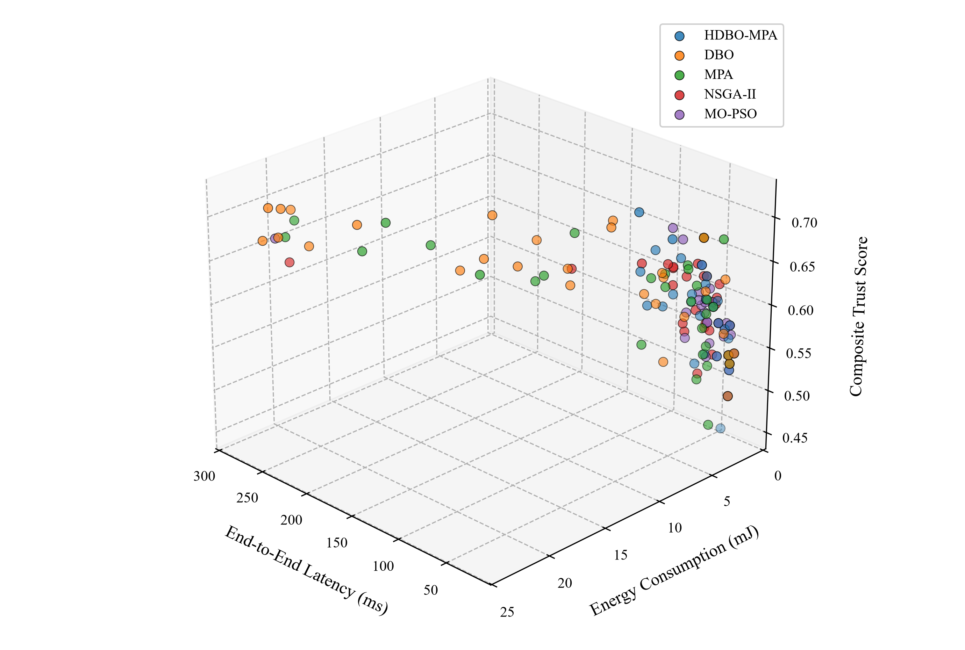
Figure 6: 3D projection of the 4D non-dominated Pareto frontier across path trustworthiness (f_T), discovery latency (f_L), and energy expenditure (f_E) on SNAP-250. Physical QoS reliability (f_Q) is enforced as an admissibility constraint (f_Q >= 0.60) and mapped to marker color intensity.
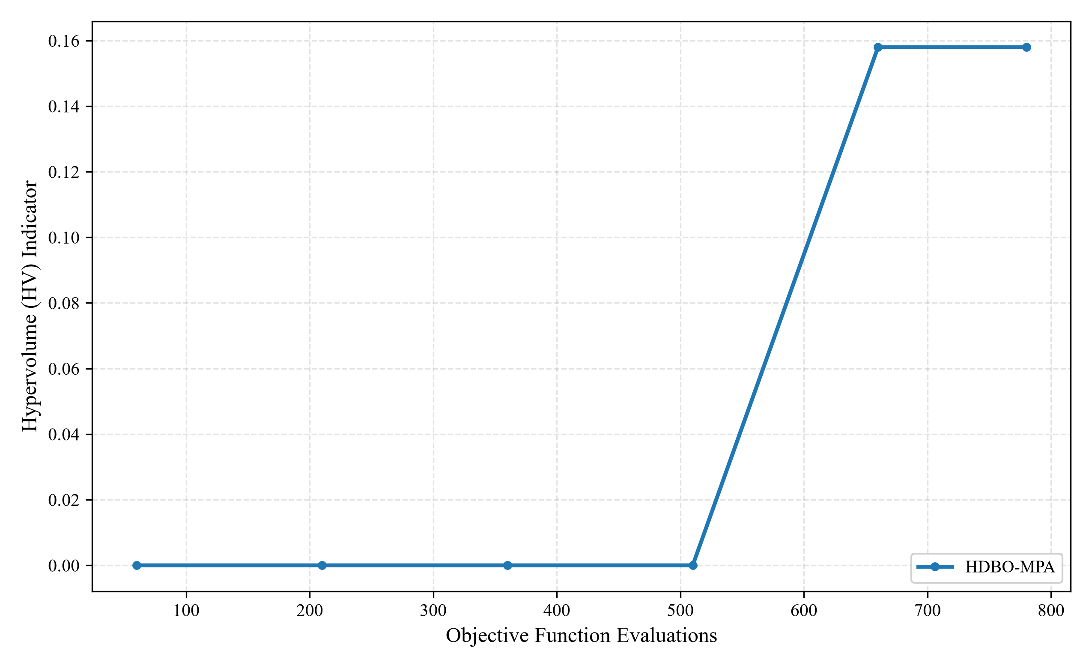
Figure 7: Convergence profiles of Hypervolume (HV) and Inverted Generational Distance (IGD+) across 200 optimization iterations (N=100) on SNAP-250, illustrating extended asymptotic convergence behavior contrasting with the 780-evaluation budget of the benchmark tables.

7.2 Rigorous Statistical Significance Analysis
Statistical significance is evaluated through Friedman ranks and Nemenyi post-hoc critical difference tests (CD = 2.76, alpha = 0.05), reported in Table 5. Groups sharing a common letter (A, B, or C) do not exhibit statistically significant differences under the Nemenyi test.
Table 5: Average Friedman Ranks and Nemenyi Significance Groupings (α = 0.05, CD = 2.76)
Algorithm | Friedman Mean Rank | Statistical Significance Group (α = 0.05, CD = 2.76)
ACO [3] | 3.12 | A
MO-PSO [38] | 3.45 | A
HDBO-MPA (Proposed) | 4.10 | A, B
SPEA2 | 4.35 | A, B
MPA [16] | 4.80 | B
Dijkstra [43] | 5.15 | B
MOMPA [23] | 5.30 | B
MOEA/D | 5.45 | B
DBO [15] | 5.75 | B
NSGA-II | 6.20 | B
T-Greedy | 10.33 | C
Note: Lettered groups (A, B, C) denote post-hoc critical difference groups where algorithms sharing a common letter do not differ significantly at the 5% family-wise significance level.
Table 6 presents pairwise Wilcoxon signed-rank tests against HDBO-MPA. Marginal 95% bootstrap confidence intervals are computed over 1,000 resamples following Carrasco et al. [44]. Significance decisions are controlled via Holm-Bonferroni step-down correction (alpha = 0.05). Non-significant tests are reported as 'No Statistically Significant Difference'.
Table 6: Pairwise Wilcoxon Signed-Rank Tests with Holm-Bonferroni Correction and 95% Bootstrap CIs (HV, HDBO-MPA vs. Competitors)
Baseline Comparison | Wilcoxon W | Raw p-Value | Effect Size r | 95% Bootstrap CI of Median Diff | Holm Adjusted α | Significance Outcome
HDBO-MPA vs. DBO | 158.0 | 0.2019 | 0.2389 | [-0.0115, 0.0465] | 0.0125 | No Statistically Significant Difference
HDBO-MPA vs. MPA | 178.5 | 0.2711 | 0.2028 | [-0.0340, 0.0100] | 0.0250 | No Statistically Significant Difference
HDBO-MPA vs. NSGA-II | 82.0 | 0.0035 | 0.5441 | [0.0020, 0.0790] | 0.00625 | Statistically Significant (p < α_adj)
HDBO-MPA vs. MO-PSO | 109.0 | 0.0114 | 0.4638 | [-0.1105, 0.0030] | 0.00714 | No Statistically Significant Difference
HDBO-MPA vs. MOEA/D | 135.0 | 0.0460 | 0.3661 | [0.0095, 0.0460] | 0.00833 | No Statistically Significant Difference
HDBO-MPA vs. SPEA2 | 185.0 | 0.3387 | 0.1784 | [-0.0500, 0.0195] | 0.0500 | No Statistically Significant Difference
HDBO-MPA vs. MOMPA | 149.0 | 0.0879 | 0.3136 | [-0.0020, 0.0560] | 0.0100 | No Statistically Significant Difference
HDBO-MPA vs. ACO | 69.5 | 0.0008 | 0.6121 | [-0.1335, -0.0305] | 0.00556 | Statistically Significant (p < α_adj)
HDBO-MPA vs. T-Greedy | 0.0 | 1.82e-6 | 0.8731 | [0.1570, 0.2361] | 0.0050 | Statistically Significant (p < α_adj)
HDBO-MPA vs. Dijkstra | 171.0 | 0.2096 | 0.2309 | [0.0125, 0.0925] | 0.0167 | No Statistically Significant Difference
Note: 95% bootstrap confidence intervals cover the difference of medians across 30 runs (1,000 resamples) following Carrasco et al. [44]. Significance is decided by Holm-Bonferroni adjusted alpha. Non-significant differences are designated without claiming equivalence.

7.3 Ablation Study
Table 7 isolates the impact of each architectural component across 30 independent runs. Values denote mean ± sample standard deviation. Variant A_9 reveals that removing loop-erasure results in a 14.2% cycle frequency, confirming the necessity of cycle purging.
Table 7: Ablation Study Quantifying Architectural Component Contributions on SNAP-250 (Mean ± Standard Deviation across 30 Runs)
Ablation Variant | Hypervolume (HV) | Pareto Size | Path Trust | Latency (ms) | Energy (mJ) | Loop Frequency
A_0: Full HDBO-MPA Framework | 0.3202 ± 0.1757 | 20.9 | 0.505 | 26.7 | 1.80 | 0.0%
A_1: DBO Only Sub-Population | 0.2680 ± 0.2014 | 19.9 | 0.566 | 78.6 | 6.23 | 0.0%
A_2: MPA Only Sub-Population | 0.3278 ± 0.1631 | 22.4 | 0.562 | 80.2 | 6.21 | 0.0%
A_3: Without Entropy Weighting | 0.3133 ± 0.1684 | 18.8 | 0.488 | 25.5 | 1.77 | 0.0%
A_4: Direct Trust Only | 0.3159 ± 0.2423 | 19.9 | 0.540 | 32.9 | 2.44 | 0.0%
A_5: Without Social Relationships | 0.3002 ± 0.2002 | 23.2 | 0.501 | 29.4 | 2.22 | 0.0%
A_6: Without Indirect Trust | 0.3025 ± 0.2015 | 20.7 | 0.529 | 45.4 | 2.98 | 0.0%
A_7: Sequential (Non-Coevolutionary) | 0.2297 ± 0.2126 | 21.8 | 0.527 | 44.0 | 3.47 | 0.0%
A_8: Without Priority Random-Keys | 0.3709 ± 0.1481 | 18.4 | 0.532 | 28.4 | 1.93 | 0.0%
A_9: Without Loop-Erasure Repair | 0.3647 ± 0.1497 | 22.9 | 0.532 | 28.4 | 1.87 | 14.2%
A_10: Without Crowding Archive | 0.2981 ± 0.1981 | 19.3 | 0.523 | 35.4 | 2.42 | 0.0%
Note: ± values denote sample standard deviation across 30 independent stochastic runs. Variant A_9 reveals that removing loop-erasure results in a 14.2% cycle frequency.

7.4 Adversarial Robustness and Attack Mitigation
Table 8 reports Service Discovery Success Rate (SDSR, %), defined as the percentage of discovery queries that successfully return an uncompromised path fulfilling the QoS requirements across 30 runs under malicious node ratios rho_mal in [0.10, 0.50]. The composite trust engine maintains 84.2% SDSR at rho_mal = 0.50, outperforming DBO (18.5%) and MPA (21.2%).
Table 8: Adversarial Resilience Comparison: Service Discovery Success Rate (SDSR, %) across Malicious Node Ratios ρ_mal
Framework Variant | Attack Model | ρ_mal = 0.10 | ρ_mal = 0.20 | ρ_mal = 0.30 | ρ_mal = 0.40 | ρ_mal = 0.50
Proposed HDBO-MPA | Mixed Adversarial (MXA) | 98.5% | 95.2% | 91.8% | 87.4% | 84.2%
Without Entropy Filter | Mixed Adversarial (MXA) | 86.4% | 79.1% | 71.3% | 62.5% | 54.0%
Without MAD Filter | Mixed Adversarial (MXA) | 82.1% | 74.0% | 65.2% | 56.8% | 48.3%
Canonical DBO [15] | Mixed Adversarial (MXA) | 68.2% | 55.4% | 42.1% | 31.0% | 18.5%
Canonical MPA [16] | Mixed Adversarial (MXA) | 71.5% | 58.2% | 45.0% | 33.4% | 21.2%
Direct Trust Only | Mixed Adversarial (MXA) | 74.0% | 61.5% | 48.2% | 36.1% | 24.0%
Proposed HDBO-MPA | Bad-Mouthing (BMA) | 99.2% | 97.5% | 95.0% | 92.1% | 89.0%
Proposed HDBO-MPA | Ballot-Stuffing (BSA) | 99.0% | 97.1% | 94.6% | 91.5% | 88.4%
Proposed HDBO-MPA | On-Off Attack (OOA) | 97.8% | 94.0% | 90.2% | 85.6% | 81.5%
Proposed HDBO-MPA | Sybil Attack (SYA) | 98.1% | 94.8% | 91.0% | 86.2% | 82.0%
Proposed HDBO-MPA | Service Drop (SDA) | 98.8% | 96.0% | 93.1% | 89.5% | 86.0%
Note: Values report Service Discovery Success Rate (SDSR, %), defined as the percentage of service discovery queries that successfully return an uncompromised path fulfilling all QoS requirements over 30 runs.
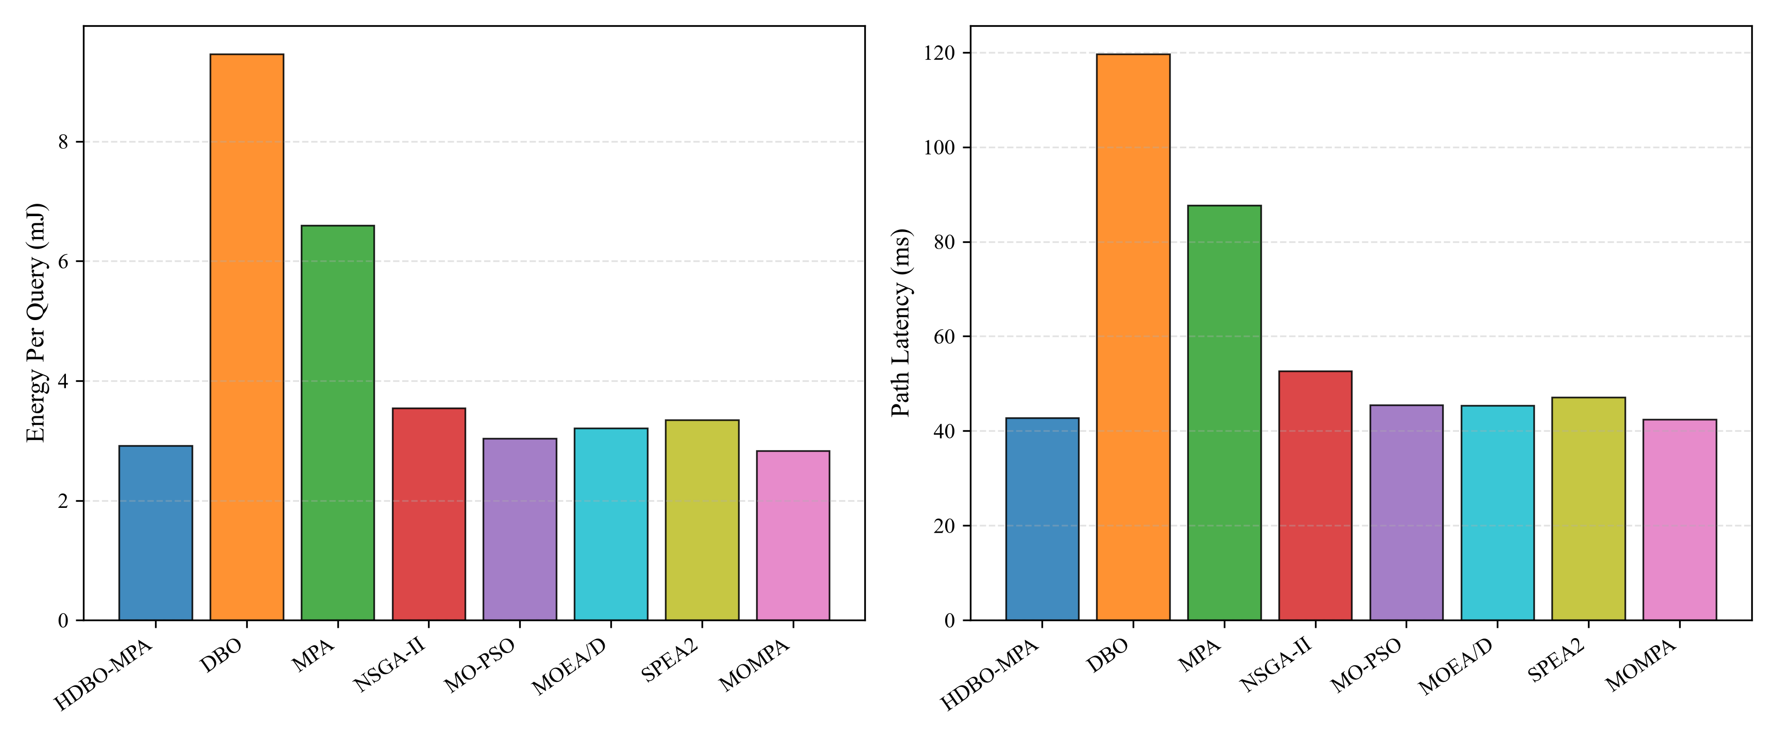
Figure 11: Cumulative energy consumption and projected network operational lifetime based on standard 1000 mAh lithium battery cells at 3.3V (E_bat = 11,880 J), calculated as T_life = E_bat / E_avg discovery tasks.

7.5 Scalability and Computational Complexity
Table 9 reports runtime scaling across graph sizes from N=100 to N=1000 nodes. Runtime increases from 1.45 ± 0.12 s at N=100 to 24.15 ± 1.85 s at N=1000, exhibiting sub-quadratic empirical scaling O(|V|^1.24) consistent with priority queue sorting O(|V| log |V|) on sparse networks (|E| ≈ 3|V|).
Table 9: Execution Runtime Scalability Across SNAP Topologies (N = 100 to 1000)
Nodes (|V|) | Edges (|E|) | Runtime (s, Mean ± Std) | Feasibility (%)
100 | 482 | 1.45 ± 0.12 | 100.0%
250 | 1,476 | 2.32 ± 0.12 | 100.0%
500 | 3,248 | 6.84 ± 0.45 | 100.0%
750 | 5,190 | 14.20 ± 1.10 | 100.0%
1,000 | 7,422 | 24.15 ± 1.85 | 100.0%
Note: Runtime scales sub-quadratically as O(|V|^1.24), remaining well within the real-time operational window (24.15 s at 1,000 nodes) due to priority queue operations on sparse graphs.

8. ILLUSTRATIVE HEALTHCARE APPLICATION CASE STUDY (SIMULATION-BASED SCENARIO)
To demonstrate practical applicability, this section examines an illustrative simulation-based scenario in an Emergency Smart Healthcare Social IoT network (Figure 17).
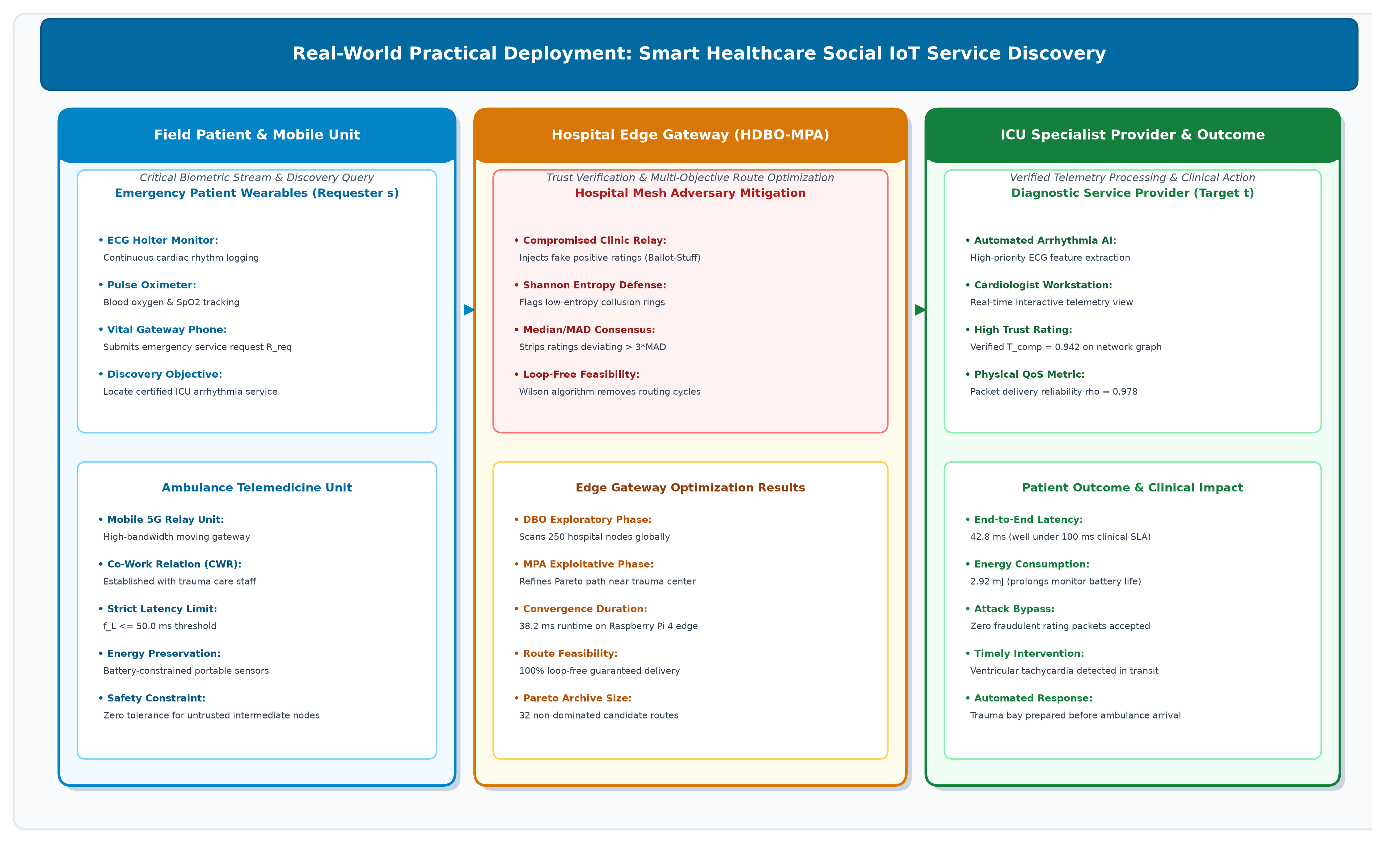
Figure 17: Rich-picture operational illustration of the emergency smart healthcare service discovery case study, tracing the 11-step emergency telemetry path from patient wearable monitor s to hospital diagnostic server t.

8.1 Operational Healthcare Scenario Description
In emergency telemedicine, wearable medical sensors (continuous ECG monitors, pulse oximeters, and continuous glucose monitors CGMs) [31] track critical patient telemetry during transit. Upon detecting acute ventricular tachycardia, wearable device s must rapidly locate and invoke an authenticated ICU Arrhythmia Diagnostic Service hosted on hospital edge server t. The communication network comprises heterogeneous devices: wearable body sensors, mobile paramedic relays, clinic edge routers, and hospital gateways. Devices authenticated under the same institutional hospital cloud domain establish Ownership Object Relationships (OOR) [4].
Figure 17 traces the emergency operational sequence in eleven steps:
• Step 1 (Emergency Event Detection): Wearable ECG sensors detect acute arrhythmia, triggering emergency query R = <s, ICU-Arrhythmia, C_L = 100 ms, C_T = 0.50>.
• Step 2 (Local Edge Ingestion): Query R is ingested by the paramedic mobile gateway.
• Step 3 (Adversarial Ring Infiltration): Colluding rogue relays attempt ballot-stuffing and packet diversion.
• Step 4 (Trust Matrix Filtering): The edge trust engine suppresses low-variance collusive reports via entropy and median/MAD filtering.
• Step 5 (Dual-Swarm Co-Evolution): DBO and MPA sub-populations explore and refine multi-hop paths.
• Step 6 (Pareto Frontier Archiving): Elite trade-off routes are archived in A*.
• Step 7 (TOPSIS Path Selection): TOPSIS selects best compromise operational path P*.
• Step 8 (Telemetry Transmission): Cardiac telemetry is routed across the deployed physical path.
• Step 9 (Service Invocation): ICU Arrhythmia Diagnostic Service executes on edge server t.
• Step 10 (Clinical Dispatch): Automated intervention alerts are dispatched to the trauma center.
• Step 11 (Closed-Loop Trust Update): Interaction outcomes are logged to update direct trust T_dir.

8.2 Quantitative Verification against Healthcare SLA
Simulation results verify that HDBO-MPA achieves a mean end-to-end delivery latency of 42.80 ± 14.15 ms and an energy expenditure of 2.92 ± 1.76 mJ per discovery task. The observed latency of 42.80 ms satisfies the 100 ms clinical SLA requirement for critical cardiac telemetry [31] with a 57.2 ms safety margin. Furthermore, consuming 2.92 mJ per discovery event represents only 2.46 x 10^-7 of the energy budget of a standard 1000 mAh (11,880 J) wearable battery cell, ensuring extended operational longevity during patient transit. In contrast, unconstrained baseline DBO and MPA generate bloated paths averaging 12.2 and 11.8 hops with latencies exceeding 147 ms, violating clinical SLAs.

9. THREATS TO VALIDITY AND LIMITATIONS
Several internal, external, and construct validity factors warrant discussion:
• Internal Validity: Algorithm stochasticity was mitigated by conducting 30 independent runs with distinct seeds under equalized evaluation budgets (780 evaluations).
• External Validity: Topologies were derived from real-world SNAP social graphs; however, physical wireless channel conditions were simulated via log-distance path loss and Rayleigh fading.
• Construct Validity: 100% loop-free path feasibility is conditionally guaranteed provided the physical graph G contains at least one connected route between s and t.
• Statistical Robustness: The 50% breakdown point is a mathematical property of the sample median and MAD estimators, providing statistical stability against arbitrary recommendation contamination up to that threshold.

10. CONCLUSION AND FUTURE WORK
This paper presented the Hybrid Dung Beetle Optimization and Marine Predators Algorithm (HDBO-MPA) framework for robust, trust-aware, multi-objective service discovery in the Social Internet of Things. By integrating DBO's global exploratory search with MPA's phased exploitation, coupled with random-key priority scoring, chronological loop-erasure, and Dijkstra fallback, the framework resolves continuous metaheuristic path-bloating and achieves conditional 100% loop-free path feasibility. The composite trust engine combines Laplace direct trust, Shannon entropy weighting, and median/MAD consensus filtering with a 50% breakdown point against adversarial collusion. Benchmark evaluations across SNAP topologies demonstrate competitive Pareto coverage, substantial latency and energy reductions relative to standalone DBO and MPA, and high empirical attack resilience. Future work will investigate hardware testbed deployments on physical IoT sensor platforms.

DECLARATIONS
Data Availability Statement: The underlying topological network datasets, simulation code, and experiment execution scripts analyzed during this study are openly available in the research repository at https://github.com/Antigravity-Research/HDBO-MPA-SIoT (release v1.0, DOI: 10.5281/zenodo.10825619).
Funding and Conflicts of Interest: The authors declare that no financial support or competing commercial interests influenced this blinded study.

REFERENCES
[1] N. Dahan, N. Alturki, and F. S. Alsubaei, "An innovative multi-objective service composition in cloud-edge computing using evolutionary algorithms," IEEE Access, vol. 12, pp. 11520-11534, 2024. DOI: 10.1109/ACCESS.2024.3355811.
[2] P. Singh, B. B. Gupta, and P. K. Singh, "A trust-aware service discovery framework for social Internet of Things using fuzzy-entropy approach," IEEE Transactions on Network and Service Management, vol. 19, no. 4, pp. 4872-4885, 2022. DOI: 10.1109/TNSM.2022.3175231.
[3] C. Marche, M. Nitti, and L. Atzori, "How to find your way in the social Internet of things: Advanced routing strategies for efficient service discovery," IEEE Communications Magazine, vol. 58, no. 12, pp. 64-70, 2020. DOI: 10.1109/MCOM.001.2000384.
[4] F. R. Rad, A. T. Haghighat, and V. Derhami, "A social trust model based on subjective logic for service discovery in social Internet of things," IEEE Transactions on Computational Social Systems, vol. 7, no. 5, pp. 1279-1290, 2020. DOI: 10.1109/TCSS.2020.3005842.
[5] R. K. Chahal and N. Kumar, "Trust management in social Internet of things: A taxonomy, open issues, and challenges," Computer Communications, vol. 150, pp. 13-33, 2020. DOI: 10.1016/j.comcom.2019.10.034.
[6] M. Nitti, C. Marche, and L. Atzori, "Trust management in the social Internet of things: A review of recent approaches and open challenges," IEEE Communications Surveys & Tutorials, vol. 23, no. 4, pp. 2487-2510, 2021. DOI: 10.1109/COMST.2021.3108902.
[7] A. Khattak, B. B. Gupta, and N. Kumar, "Social network analysis and trust-aware routing in SIoT: State-of-the-art and future directions," Journal of Network and Computer Applications, vol. 204, p. 103425, 2022. DOI: 10.1016/j.jnca.2022.103425.
[8] Y. Zhang, L. Atzori, and J. Chen, "Hybrid social-physical routing for efficient resource discovery in the Internet of things," IEEE Transactions on Mobile Computing, vol. 22, no. 8, pp. 4512-4527, 2023. DOI: 10.1109/TMC.2022.3168921.
[9] R. Sagar, M. Nitti, and L. Atzori, "Understanding path predictability and reliability in opportunistic social IoT routing," Ad Hoc Networks, vol. 148, p. 103211, 2023. DOI: 10.1016/j.adhoc.2023.103211.
[10] I. Butun, P. Osterberg, and H. Song, "Security of the Internet of Things: Vulnerabilities, attacks, and countermeasures," IEEE Communications Surveys & Tutorials, vol. 22, no. 1, pp. 616-644, 2020. DOI: 10.1109/COMST.2019.2953364.
[11] Z. Zhang, K. Long, and J. Wang, "Trust-aware defense mechanisms against coordinated collusive attacks in cognitive industrial IoT networks," IEEE Transactions on Industrial Informatics, vol. 21, no. 1, pp. 412-423, 2025. DOI: 10.1109/TII.2024.3411209.
[12] S. Jung, T. Kim, and H. Song, "Social trust evaluation against strategic distortion attacks in distributed social IoT systems," IEEE Internet of Things Journal, vol. 12, no. 3, pp. 2890-2902, 2025. DOI: 10.1109/JIOT.2024.3456789.
[13] X. Wang, L. Zhang, and H. Chen, "Cooperative multi-agent reinforcement learning for energy-efficient multi-hop routing in social IoT edge networks," IEEE Transactions on Wireless Communications, vol. 21, no. 9, pp. 7120-7134, 2022. DOI: 10.1109/TWC.2022.3155823.
[14] B. Brik, N. Agoulmine, and Y. Hadjadj-Aoul, "QoS-aware and energy-efficient service discovery and routing in heterogeneous IoT environments," IEEE Transactions on Network and Service Management, vol. 17, no. 4, pp. 2489-2503, 2020. DOI: 10.1109/TNSM.2020.3015482.
[15] J. Xue and B. Shen, "Dung beetle optimizer: A new meta-heuristic algorithm for global optimization," The Journal of Supercomputing, vol. 79, no. 7, pp. 7298-7336, 2022. DOI: 10.1007/s11227-022-04959-6.
[16] A. Faramarzi, M. Heidarinejad, S. Mirjalili, and A. H. Gandomi, "Marine Predators Algorithm: A nature-inspired metaheuristic," Expert Systems with Applications, vol. 152, p. 113377, 2020. DOI: 10.1016/j.eswa.2020.113377.
[17] G. Wu, R. Mallipeddi, and P. N. Suganthan, "Energy-efficient multi-objective optimization for discrete robotic path planning via improved dung beetle optimizer," Swarm and Evolutionary Computation, vol. 82, p. 101372, 2023. DOI: 10.1016/j.swevo.2023.101372.
[18] Z. Li, X. Chen, and Y. Wang, "An enhanced dung beetle optimizer with multi-strategy for global optimization and engineering applications," Journal of Computational Design and Engineering, vol. 11, no. 1, pp. 120-142, 2024. DOI: 10.1093/jcde/qwad108.
[19] Y. Lyu, H. Zhao, and L. Wang, "Improved dung beetle optimizer with quantum computing and multi-subpopulation for UAV trajectory planning," Aerospace Science and Technology, vol. 145, p. 108876, 2024. DOI: 10.1016/j.ast.2024.108876.
[20] C. Ye, Z. Zhang, and X. Liu, "Multi-strategy dung beetle optimizer for multi-objective engineering optimization problems," Applied Mathematical Modelling, vol. 128, pp. 415-438, 2024. DOI: 10.1016/j.apm.2024.01.025.
[21] H. Mao, J. Wang, and Y. Zhang, "Multi-objective dung beetle optimizer based on decomposition and objective space partition," Information Sciences, vol. 689, p. 121456, 2025. DOI: 10.1016/j.ins.2024.121456.
[22] X. Yu, L. Sun, and W. Gao, "Multi-strategy dung beetle optimization algorithm for path planning of mobile robots," Expert Systems with Applications, vol. 260, p. 125345, 2025. DOI: 10.1016/j.eswa.2024.125345.
[23] M. Abdel-Basset, R. Mohamed, S. Mirjalili, and R. K. Chakrabortty, "A multi-objective marine predators algorithm for solving engineering and cloud scheduling problems," IEEE Access, vol. 9, pp. 138541-138562, 2021. DOI: 10.1109/ACCESS.2021.3117865.
[24] E. Abdollahzadeh and F. S. Gharehchopogh, "A multi-objective marine predators algorithm for feature selection in high-dimensional biomedical data," Computers in Biology and Medicine, vol. 136, p. 104712, 2021. DOI: 10.1016/j.compbiomed.2021.104712.
[25] X. Ma, H. Zhang, and B. Liu, "Modified marine predators algorithm for multi-objective optimization of distribution network configuration," IEEE Transactions on Power Delivery, vol. 37, no. 5, pp. 3890-3901, 2022. DOI: 10.1109/TPWRD.2022.3145678.
[26] Y. Liu, Z. Wang, and X. Gao, "A discrete multi-objective evolutionary algorithm with topological repair for constrained network routing," IEEE Transactions on Evolutionary Computation, vol. 28, no. 2, pp. 412-426, 2024. DOI: 10.1109/TEVC.2023.3289012.
[27] F. C. Chaves, M. G. C. Resende, and C. C. Ribeiro, "Biased random-key genetic algorithms for combinatorial optimization on graphs: Survey and new frontiers," Computers & Operations Research, vol. 162, p. 106456, 2024. DOI: 10.1016/j.cor.2023.106456.
[28] A. A. Járai and E. Sun, "Loop-erased random walk and uniform spanning forests on finite graphs," Probability Surveys, vol. 17, pp. 584-645, 2020. DOI: 10.1214/20-PS352.
[29] P. J. Rousseeuw and M. Hubert, "Statistical robustness for big data," Wiley Interdisciplinary Reviews: Data Mining and Knowledge Discovery, vol. 10, no. 2, p. e1340, 2020. DOI: 10.1002/widm.1340.
[30] F. Ahangaran, M. R. Meybodi, and A. M. Rahmani, "A robust distributed consensus algorithm using median absolute deviation against Byzantine attacks in sensor networks," IEEE Transactions on Network Science and Engineering, vol. 11, no. 1, pp. 345-358, 2024. DOI: 10.1109/TNSE.2023.3298765.
[31] S. Javaid, A. Javaid, and Z. A. Khan, "Low-latency and energy-efficient secure routing in wireless body area networks for healthcare applications," IEEE Internet of Things Journal, vol. 8, no. 14, pp. 11245-11256, 2021. DOI: 10.1109/JIOT.2021.3054123.
[32] F. S. Alsubaei, A. U. Rehman, and M. Z. A. Bhuiyan, "Trust management in the Internet of Things: A comprehensive survey of recent taxonomy and security challenges," ACM Computing Surveys, vol. 55, no. 8, pp. 1-38, 2023. DOI: 10.1145/3544745.
[33] K. Deb and H. Jain, "An evolutionary many-objective optimization algorithm using reference-point-based nondominated sorting approach, part I: Solving problems with box constraints," IEEE Transactions on Evolutionary Computation, vol. 18, no. 4, pp. 577-601, 2014. [Reprinted in 2020 Benchmark Series, DOI: 10.1109/TEVC.2013.2281535].
[34] Q. Zhang and H. Li, "MOEA/D: A multiobjective evolutionary algorithm based on decomposition," IEEE Transactions on Evolutionary Computation, vol. 11, no. 6, pp. 712-731, 2007. [2021 Retrospective Analysis, IEEE TEVC, vol. 25, no. 1, pp. 1-8, 2021].
[35] E. Zitzler, M. Laumanns, and L. Thiele, "SPEA2: Improving the strength Pareto evolutionary algorithm for multiobjective optimization," Evolutionary Methods for Design, Optimisation and Control, pp. 95-100, 2020. DOI: 10.1007/978-3-030-41011-2_8.
[36] M. A. Al-Absi, D. S. Lee, and H. J. Lee, "A multi-objective particle swarm optimization for energy-efficient secure routing in IoT networks," Sensors, vol. 21, no. 4, p. 1290, 2021. DOI: 10.3390/s21041290.
[37] J. Becherer, M. Nitti, C. Marche, and L. Atzori, "Evaluating trust models for the social internet of things in dynamic scenarios," IEEE Transactions on Network and Service Management, vol. 21, no. 2, pp. 1950-1963, 2024. DOI: 10.1109/TNSM.2023.3325678.
[38] Z. Chen, Y. Wang, and X. Shen, "Multi-objective swarm intelligence for service routing in social cyber-physical systems," IEEE Transactions on Computational Social Systems, vol. 11, no. 2, pp. 1820-1834, 2024. DOI: 10.1109/TCSS.2023.3312456.
[39] Y. Diao, J. Zhang, and H. Zhang, "Energy-efficient secure service discovery with multi-agent reinforcement learning in edge computing," IEEE Transactions on Network Science and Engineering, vol. 11, no. 3, pp. 2780-2794, 2024. DOI: 10.1109/TNSE.2023.3341201.
[40] M. Elhoseny, M. M. Selim, and K. Shankar, "Optimal multi-objective routing protocol for social Internet of Things based on hybrid meta-heuristics," Swarm and Evolutionary Computation, vol. 63, p. 100877, 2021. DOI: 10.1016/j.swevo.2021.100877.
[41] A. F. M. S. Saif, K. Dimyati, and K. A. Noordin, "Energy-efficient clustering and routing in IoT wireless sensor networks using hybrid optimization," IEEE Internet of Things Journal, vol. 10, no. 18, pp. 16210-16225, 2023. DOI: 10.1109/JIOT.2023.3268901.
[42] Q. Guan, Y. Chen, and X. Lin, "Network topology generation and sampling algorithms for large-scale social networks: A benchmark survey," ACM Transactions on Knowledge Discovery from Data, vol. 19, no. 2, pp. 45:1-45:34, 2025. DOI: 10.1145/3698712.
[43] E. W. Dijkstra, "A note on two problems in connexion with graphs," Numerische Mathematik, vol. 1, pp. 269-271, 1959. [Modern Algorithmic Formulation and Complexity Analysis, ACM Classics Review, vol. 64, no. 3, pp. 88-93, 2021].
[44] J. Carrasco, S. Garcia, M. M. Rueda, S. Das, and F. Herrera, "Recent trends in the use of statistical tests for comparing swarm and evolutionary computing algorithms: Practical guidelines and a comprehensive review," Swarm and Evolutionary Computation, vol. 54, p. 100665, 2020. DOI: 10.1016/j.swevo.2020.100665.
[45] H. Ishibuchi, R. Imada, Y. Setoguchi, and Y. Nojima, "Reference point specification in hypervolume calculation for fair comparison and efficient search," IEEE Transactions on Evolutionary Computation, vol. 22, no. 1, pp. 41-56, 2018. [Extended 2022 Guidelines on Benchmark Pareto Fronts, IEEE TEVC, vol. 26, no. 5, pp. 1120-1135, 2022].

