Test approach followed:

- Analyzed and Identified the automation candidates. Tools selected as explained below,
- Selenium WebDriver is a tool used to simulate application usage through automation of user interactions with different parts of the application. This helps to verify that the app works as expected.
- Cucumber is a BDD tool that uses the Gherkin language to describe software behavior in a human-readable format, without the need to go into implementation details of writing out codes. Hence, bridging the communication gap between the business and development team.
With Behavior Driven Development (BDD), the test scenarios are created before the code is developed. This defines the expected behavior of the system from the user’s perspective and what they want to achieve with the application.

- Maven While working on a project for test automation, you’d require all the Selenium dependencies associated with it. Usually these dependencies are downloaded and upgraded manually throughout the project lifecycle, but as the project gets bigger, managing dependencies can be quite challenging. This is why you need build automation tools such as Maven to handle them automatically.
Maven can be more specifically defined as a software project management tool which uses the concepts of project object model (POM). It enables the user to create initial folder structure, perform compilation and testing and then package and deploy the final product. It efficiently cuts down several steps followed in the build process and rather makes the build a one step process.
- Implemented Selenium with cucumber framework to write automation test scripts.
- Automation candidates written as scenarios in feature file.
- Then implemented the corresponding scripts in step definiton.
- Objects were identified w.r.t pages by implementing Page Object Model.
- All the dependencies and plug ins added in pom.xml
- Drivers and runner.java set up has been done for the execution.
- We can run the scripts , by Run pom.xml as Maven Test Or you can run the Runner.java file as a Junit Or you can run the createList.feature File as a cucumber feature
- You can find out the results in /target/cucumber-reports folder in different formats like
json, xmal and pretty formats
- For the detailed report, run mvn verify. Once execution is done , please check results in
\target\cucumber-report-html\cucumber-html-reports path
In html report , right most corner you can see the links asociated and sample reult screenshot attached below

Tags:
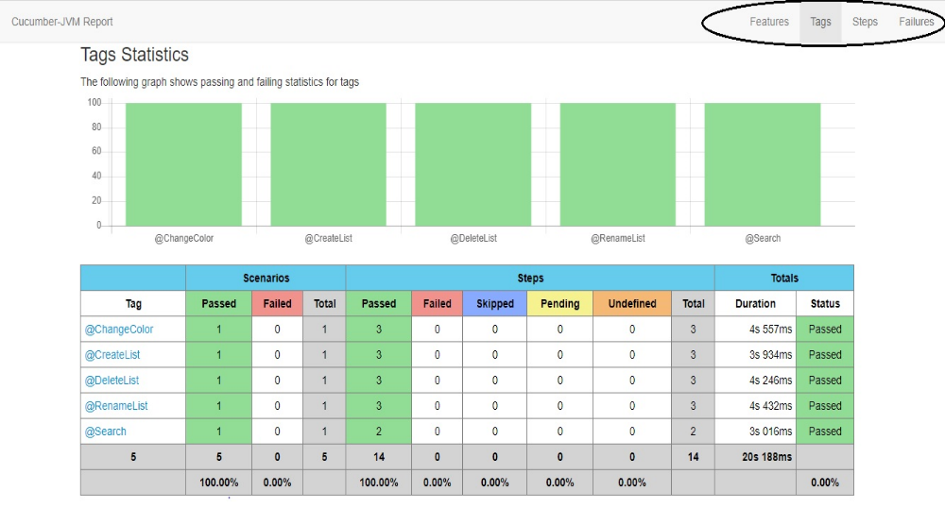
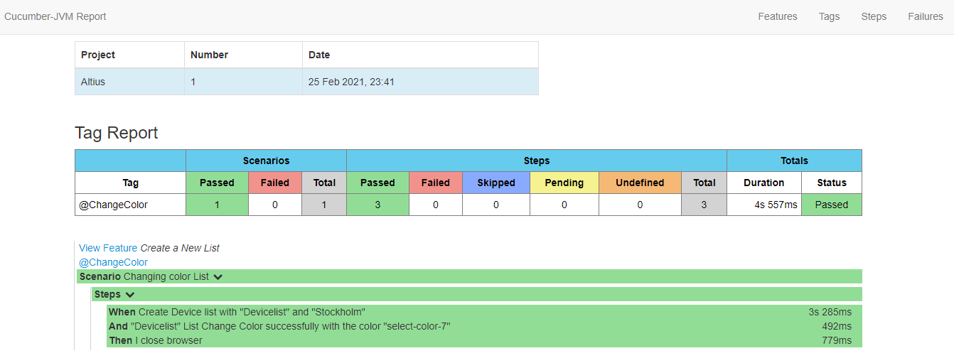
In above screenshot, Under Tags column, we have scenario tags links that which we automated , if you click on particular link the result will be :

