**09- Functions**

**Ex. No. : 9.1 Date: 31.05.24**

**Register No.: 231401082** **Name: Ramya Rani .P**



# Christmas Discount

An e-commerce company plans to give their customers a special discount for Christmas. They are planning to offer a flat discount. The discount value is calculated as the sum of all the prime digits in the total bill amount.

Write an python code to find the discount value for the given total bill amount.

**Constraints**

1 <= orderValue< 10e100000

Input

The input consists of an integer orderValue, representing the total bill amount.

Output

Print an integer representing the discount value for the given total bill amount.

Example Input

578

Output

12

**For example:**

| **Test** | **Result** |
| --- | --- |
| print(christmasDiscount(578)) | 12 |

**Program:** def is_prime_digit(digit): return digit in [2,3,5,7]

def christmasDiscount(n): s=discount=0 prime_digitis=[2,3,5,7] for digit in str(n): digit=int(digit)

if is_prime_digit(digit):

discount+=digit return discount

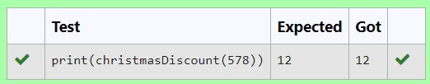

**Ex. No. : 9.2 Date: 31.05.24**

**Register No.: 231401082** **Name: Ramya Rani .P**



# Check Product of Digits

Write a code to check whether product of digits at even places is divisible by sum of digits at odd place of a positive integer.

Input Format:

Take an input integer from stdin.

Output Format:

Print TRUE or FALSE.

Example Input:

1256

Output:

TRUE

Example Input:

1595

Output:

FALSE

For example:

| **Test** | **Result** |
| --- | --- |
| print(productDigits(1256)) | True |
| print(productDigits(1595)) | False |

**Program:**

def productDigits(n):

a=n

temp=[]

list1=[]

list2=[]

rem=0

while a!=0:

rem=a%10 temp.append(rem) a=a//10

for i in range(len(temp)): if(i+1)%2==0: list1.append(temp[i]) else:

list2.append(temp[i]) pro=1

sum=0

for i in list1: sum+=i

for i in list2: pro*=i

if pro%sum==0:

return True else:

return False

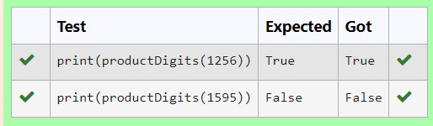

if pro%sum==0:

return True else:

return False



**Ex. No. : 9.3 Date: 31.05.24**

**Register No.: 231401082** **Name: Ramya Rani .P**



# Abundant Number

An abundant number is a number for which the sum of its proper divisors is greater than the number itself. Proper divisors of the number are those that are strictly lesser than the number.

**Input Format**:

Take input an integer from stdin **Output Format:**

Return Yes if given number is Abundant. Otherwise, print No **Example input:**

12

**Output**:

Yes

Explanation

The proper divisors of 12 are: 1, 2, 3, 4, 6, whose sum is 1 + 2 + 3 + 4 + 6 = 16. Since sum of proper divisors is greater than the given number, 12 is an abundant number. **Example input:**

13

**Output**:

No

**Explanation**

The proper divisors of 13 is: 1, whose sum is 1. Since sum of proper divisors is not greater than the given number, 13 is not an abundant number.

For example:

Test Result

print(abundant(12)) Yes

print(abundant(13)) No

**Program:**

def abundant(number):

d_s=sum([divisor for divisor in range(1,number) if number % divisor == 0]) if d_s>number:

return"Yes"

else:

return "No"

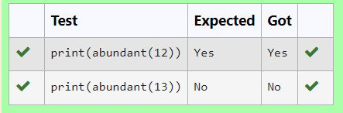

**Ex. No. : 9.2 Date: 31.05.24**

**Ex. No. : 9.4 Date: 31.05.24**

**Register No.: 231401082** **Name: Ramya Rani .P**



# Ugly number

A number is considered to be ugly if its only prime factors are 2, 3 or 5. [1, 2, 3, 4, 5, 6, 8, 9, 10, 12, 15, …] is the sequence of ugly numbers.

Task:

complete the function which takes a number n as input and checks if it's an ugly number.

return ugly if it is ugly, else return not ugly Hint:

An ugly number U can be expressed as: U = 2^a * 3^b * 5^c, where a, b and c are nonnegative integers. **For example:**

| **Test** | **Result** |
| --- | --- |
| print(checkUgly(6)) | ugly |
| print(checkUgly(21)) | not ugly |

**Program:**

def checkUgly(n):

if n <= 0:

return "not ugly” while n % 2 == 0:

n //= 2

while n % 3 == 0:

n //= 3

while n % 5 == 0:

n //=5

return "ugly" if n == 1 else "not ugly"

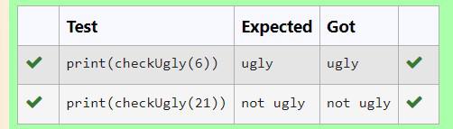

**Ex. No. : 9.5 Date: 31.05.24**

**Register No.: 231401082** **Name: Ramya Rani .P**



# Automorphic number or not

An automorphic number is a number whose square ends with the number itself. For example, 5 is an automorphic number because 5*5 =25. The last digit is 5 which same as the given number.

If the number is not valid, it should display “Invalid input”.

If it is an automorphic number display “Automorphic” else display “Not Automorphic”.

Input Format:

Take a Integer from Stdin Output Format:

Print Automorphic if given number is Automorphic number, otherwise Not Automorphic

Example input: 5 Output: Automorphic Example input: 25 Output: Automorphic Example input: 7 Output: Not Automorphic **For example:**

Test Result

print(automorphic(5)) Automorphic **Program:**

def automorphic(n):

if(n<0):

return "Invalid input" square = n * n

n_s=str(n) s_s=str(square)

if s_s.endswith(n_s): return "Automorphic"

else:

return "Not Automorphic"

