Ex.no:8 | MINI PROJECT – GLOBAL RENEWABLE ENERGY DATA ANALYTICS

Aim:
To clean, transform, store, and analyze global renewable-energy data using Python, MySQL, Power BI and Tableau to identify patterns in energy production, energy types, countries, environmental indicators, economic indicators and renewable-energy employment.
Algorithm:
- Load the CSV dataset using Pandas.
- Inspect dimensions, column names, data types, missing values and duplicate records.
- Remove duplicate records and standardize column names.
- Handle missing numeric values using appropriate numeric imputation and categorical values using an Unknown category.
- Create useful analytical fields when the required source columns are present.
- Store the cleaned dataset in a MySQL database named renewable_energy_analytics.
- Connect MySQL to Power BI.
- Create DAX measures for renewable-energy production and other available indicators.
- Create Power BI and Tableau dashboards.
- Interpret country-wise, energy-type-wise, environmental and economic patterns.
- End the process.
.

Architecture:
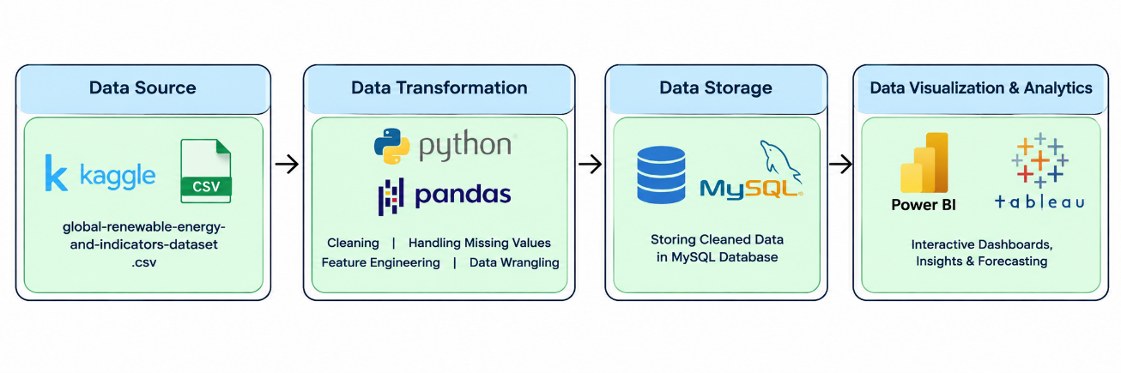
Program:
1. Python – Data Cleaning & Transformation
import pandas as pd
import numpy as np

# Load dataset
df = pd.read_csv("complete_renewable_energy_dataset.csv")
renewable = df.copy()

# Remove duplicates
renewable.drop_duplicates(inplace=True)

# Standardize column names
renewable.columns = (
renewable.columns.str.strip().str.lower()
.str.replace(r"[^a-z0-9]+", "_", regex=True)
.str.strip("_")
)

# Handle missing numeric values
numeric_cols = renewable.select_dtypes(include=np.number).columns
renewable[numeric_cols] = renewable[numeric_cols].fillna(
renewable[numeric_cols].median()
)

# Handle missing categorical values
categorical_cols = renewable.select_dtypes(exclude=np.number).columns
renewable[categorical_cols] = renewable[categorical_cols].fillna("Unknown")

print("Original Shape:", df.shape)
print("Cleaned Shape:", renewable.shape)
print(renewable.head())

import matplotlib.pyplot as plt

# Example: production by country
country_summary = (
renewable.groupby("country")["production_gwh"]
.sum().sort_values(ascending=False).head(10)
)
country_summary.plot(kind="bar")
plt.title("Top 10 Countries by Renewable Energy Production")
plt.xlabel("Country")
plt.ylabel("Production (GWh)")
plt.tight_layout()
plt.show()

2. MySQL – Database and Data Loading
MySQL Command Prompt:
net start MySQL80
mysql -u root -p
MySQL:
CREATE DATABASE IF NOT EXISTS hotel_analytics;
Python/Jupyter:
username = "root"
password = "YOUR_MYSQL_PASSWORD"
host = "localhost"
port = 3306
# Connect to MySQL database
db_engine = create_engine(
f"mysql+pymysql://{username}:{password}@{host}:{port}/renewable_energy_analytics"
)
renewable.to_sql(
"renewable_energy",
con=db_engine,
if_exists="replace",
index=False,
chunksize=5000
)
print("Data loaded successfully into MySQL.")
Verify:
pd.read_sql(
"SELECT COUNT(*) AS total_rows FROM renewable_energy ",
db_engine
)OUTPUT: 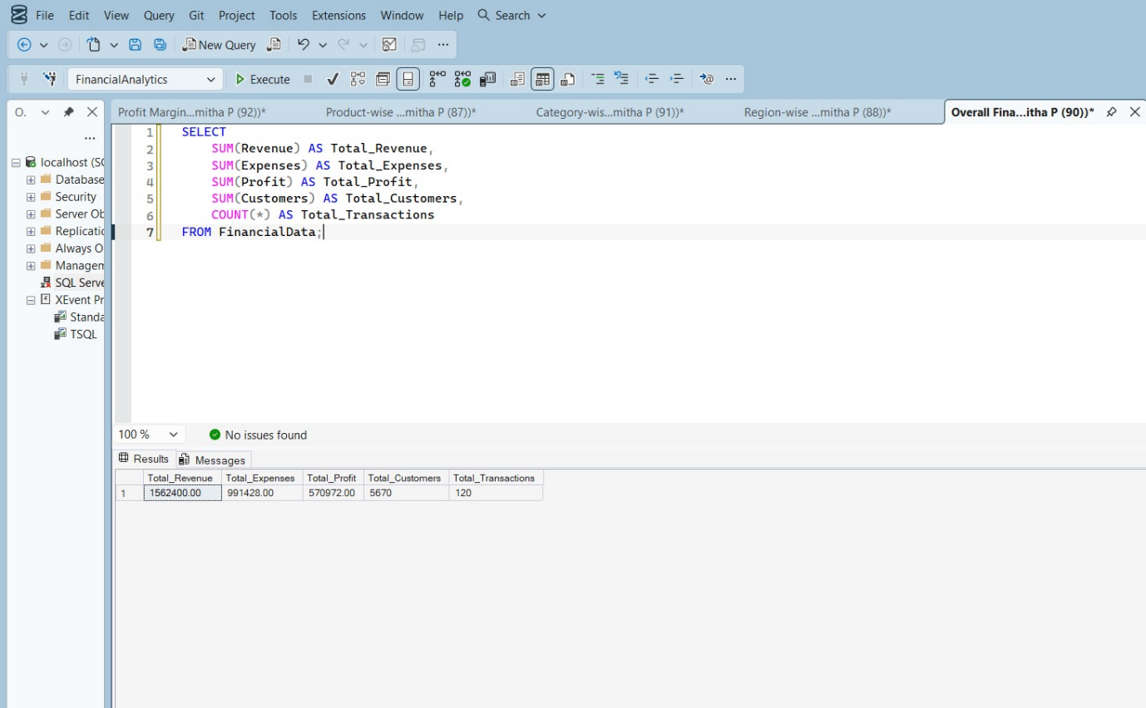
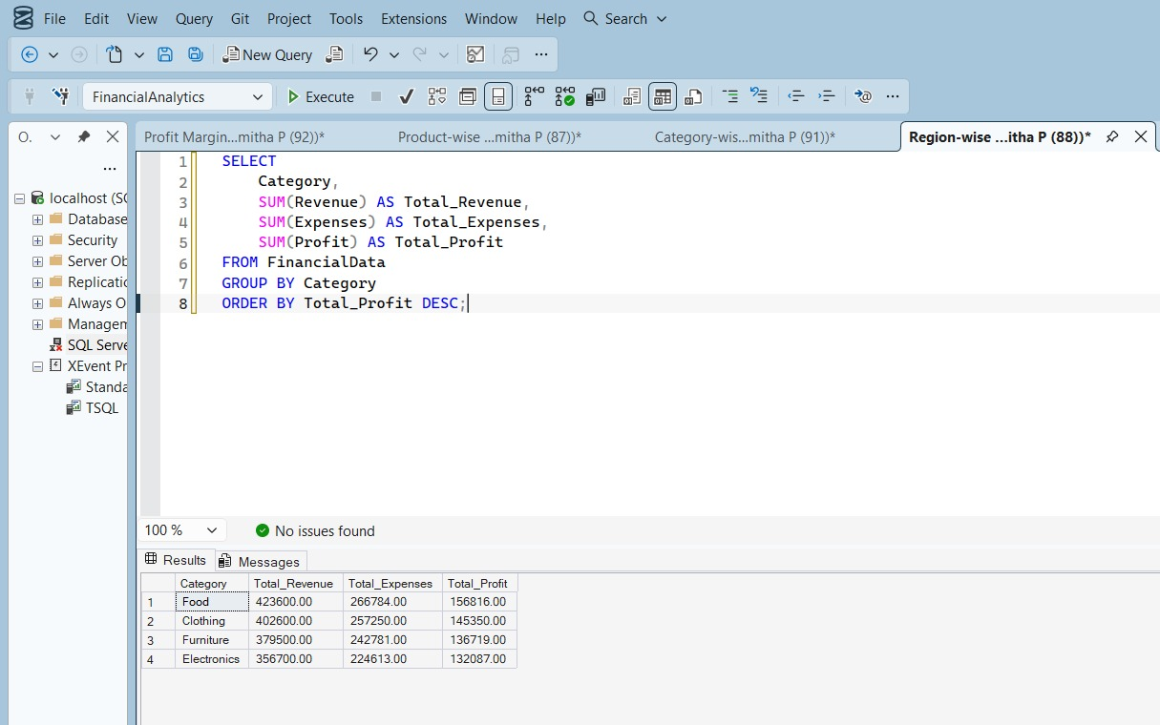
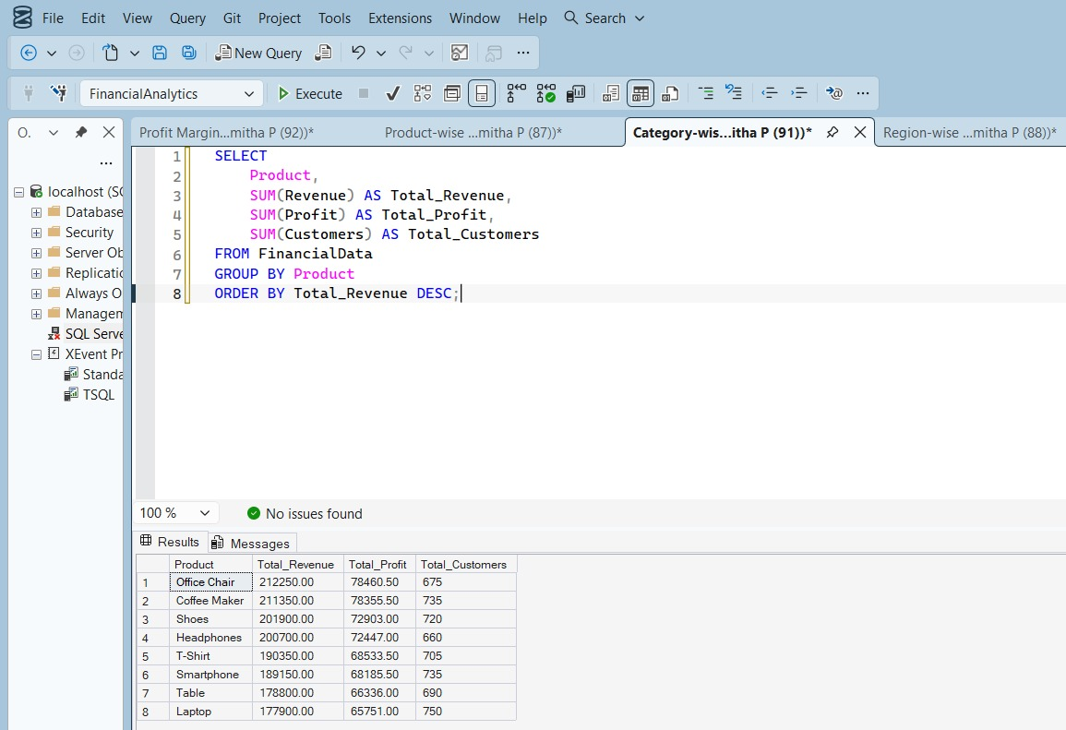
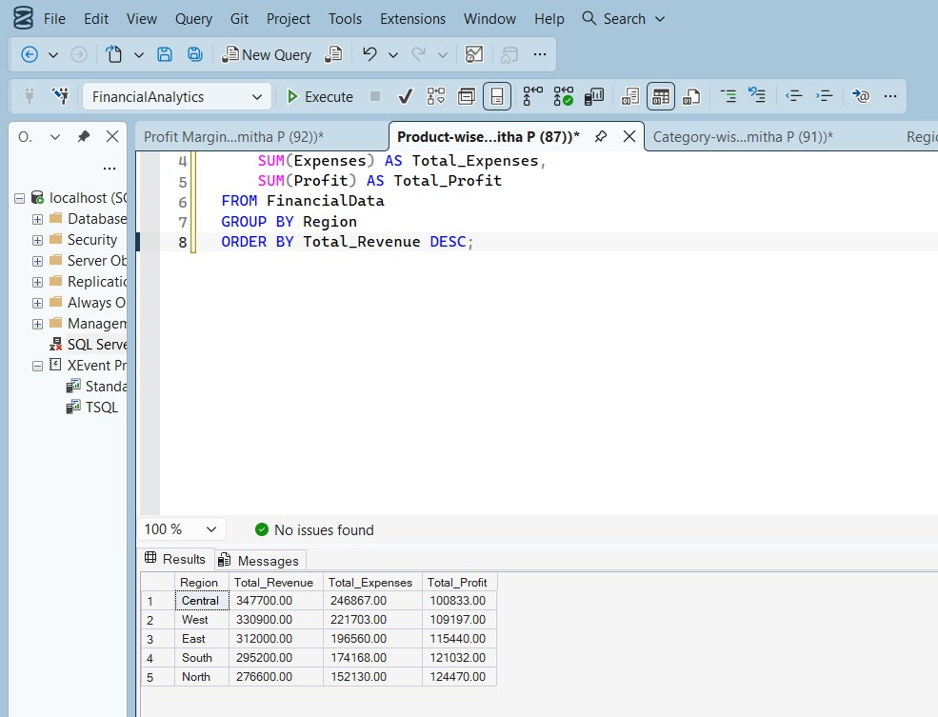
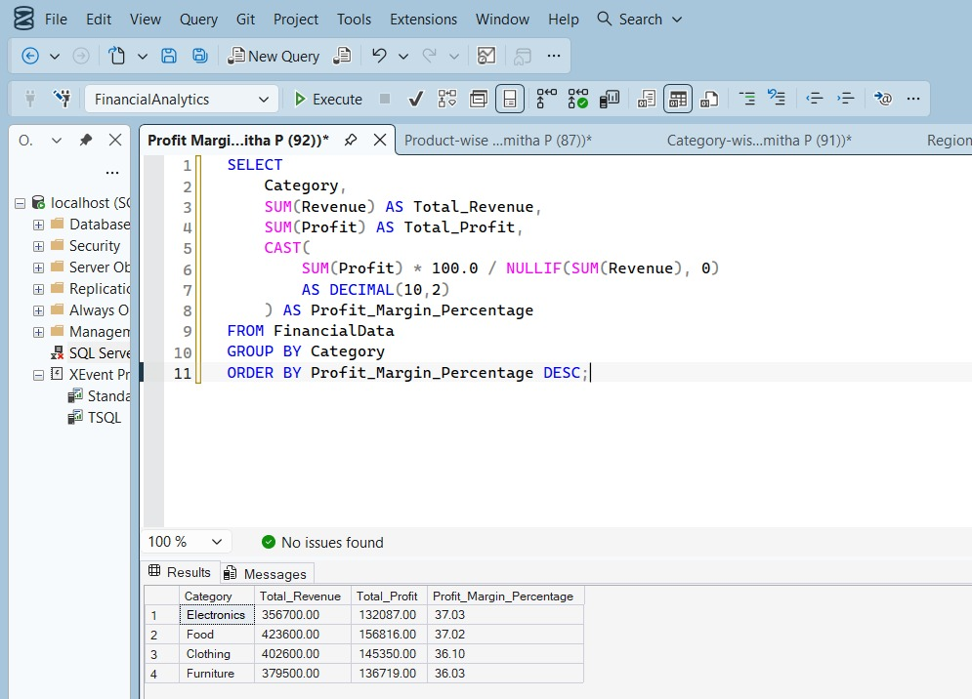

3. Power BI – DAX Measures
Total Production = SUM('renewable_energy'[production_gwh])
Average Production = AVERAGE('renewable_energy'[production_gwh])
Total Renewable Energy Jobs = SUM('renewable_energy'[renewable_energy_jobs])
Average GDP = AVERAGE('renewable_energy'[gdp])
Average CO2 Emissions = AVERAGE('renewable_energy'[co2_emissions])
Country Count = DISTINCTCOUNT('renewable_energy'[country])

Output:
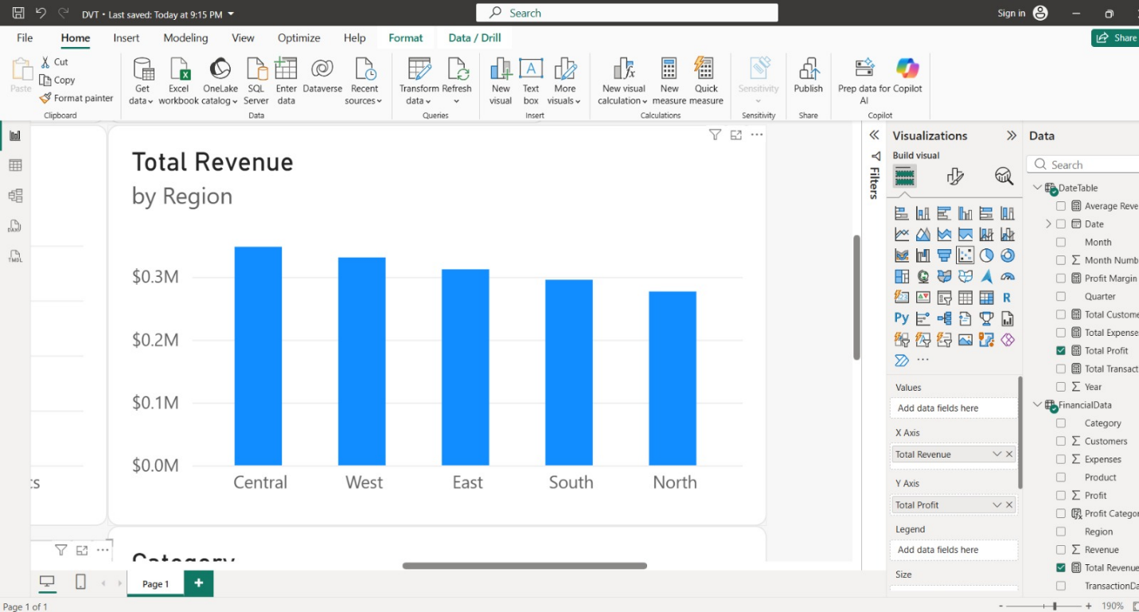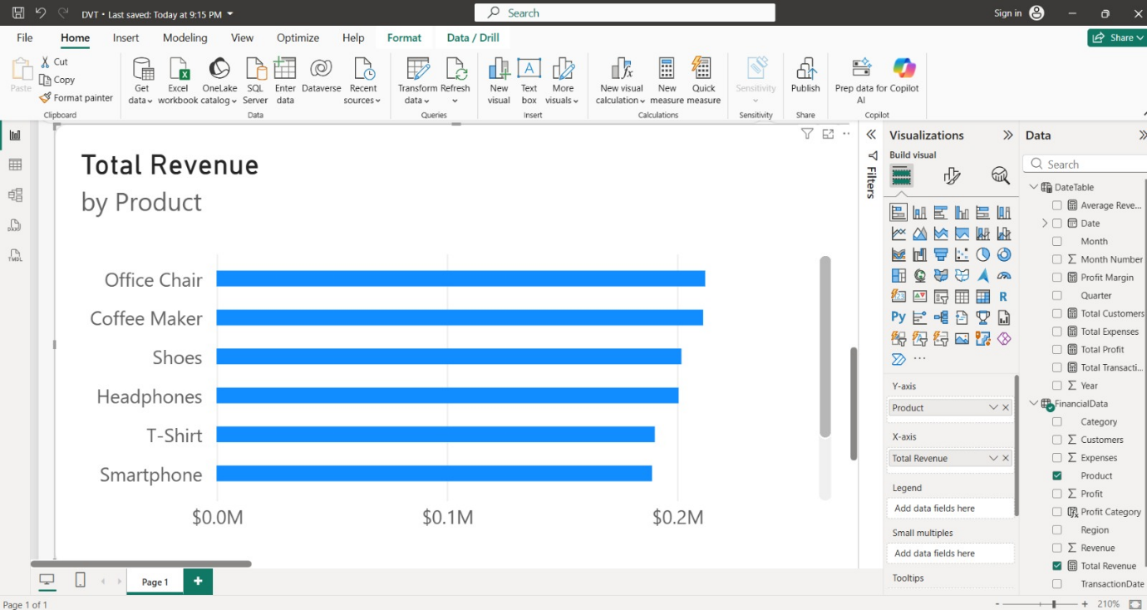
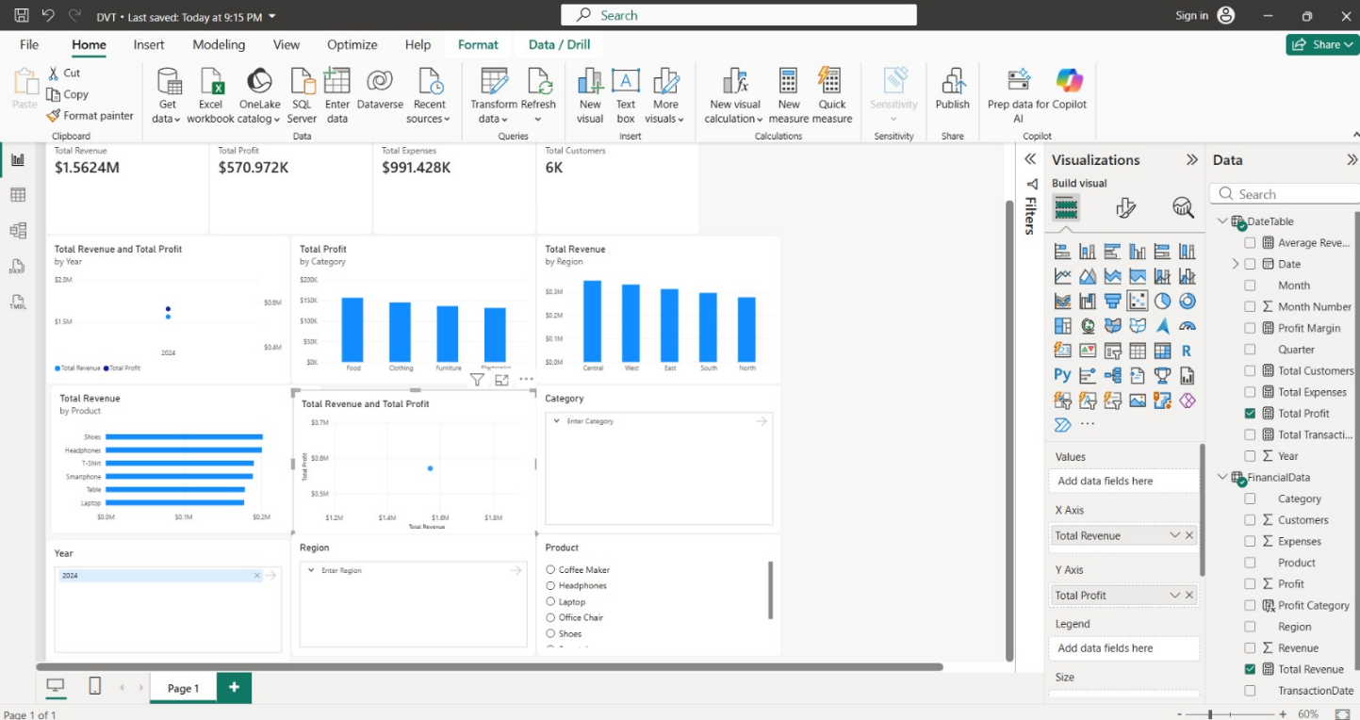

4. Tableau Dashboard
Created visuals in tableau in separate sheets and created a dashboard

Output:
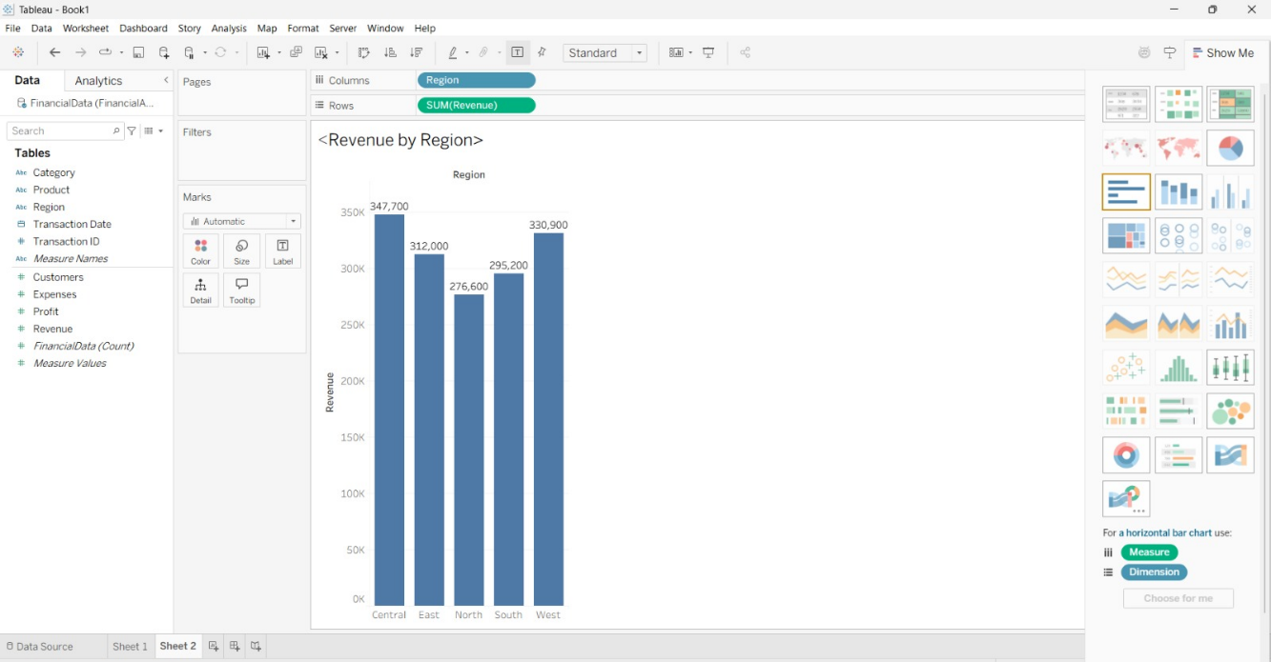

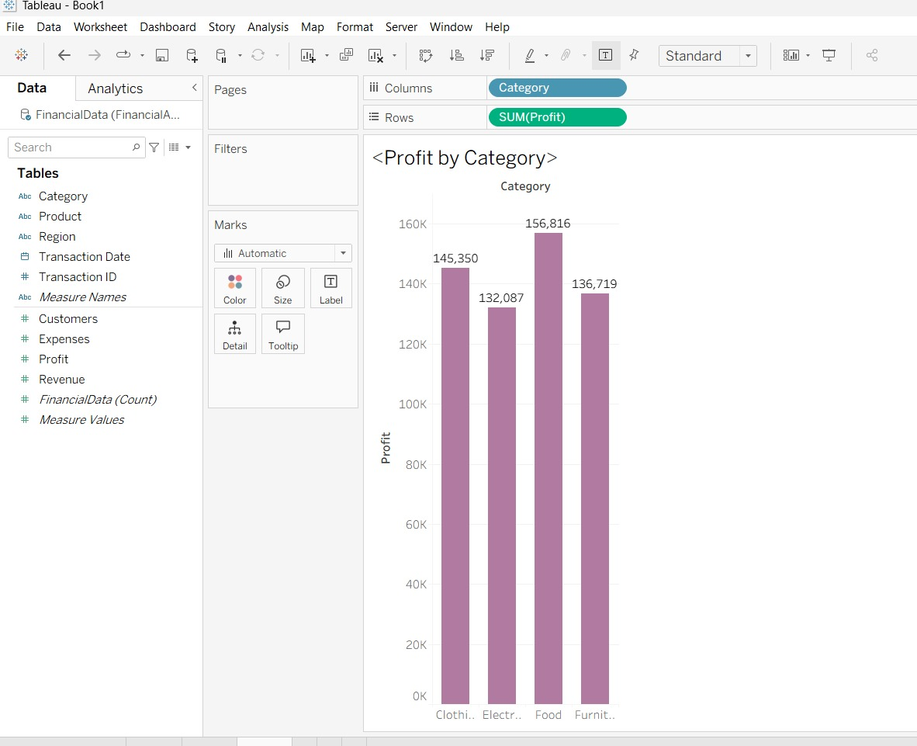

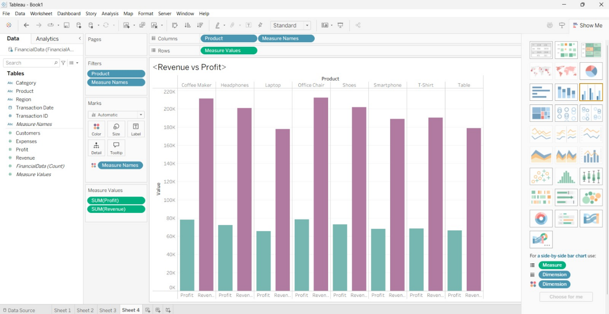

Result:

