Ex.no:7b | DATA VISUALIZATION USING TABLEAU-  Global Renewable Energy and Indicators Dataset

Aim

To connect, analyze, visualize, and create an interactive dashboard using Tableau with the Global Renewable Energy and Indicators Dataset to analyze renewable energy production, installed capacity, investments, energy sources, country-wise performance, renewable energy trends, and factors influencing renewable energy development.

Software Requirements

• Tableau Desktop / Tableau Public
• Microsoft Excel
• CSV Dataset
• Windows Operating System

Theory

Tableau is a powerful Business Intelligence (BI) and Data Visualization tool used to create interactive dashboards and reports.

The Global Renewable Energy and Indicators Dataset contains information related to renewable energy production, installed capacity, investments, energy consumption, environmental indicators, policies, infrastructure, and other factors associated with renewable energy development.

The dataset includes:
- Country
- Year
- Energy Type
- Production (GWh)
- Installed Capacity (MW)
- Investments (USD)
- Population
- GDP
- Energy Consumption
- Energy Exports
- Energy Imports
- CO2 Emissions
- Renewable Energy Jobs
- Government Policies
- R&D Expenditure
- Renewable Energy Targets

Tableau allows users to analyze this data and identify renewable energy trends, compare countries, analyze energy types, study investments and capacity, and understand renewable energy development patterns.

Tableau Architecture

Global Renewable Energy Dataset
↓
Data Connection
↓
Worksheets
↓
Visualizations
↓
Dashboard
↓
Story

Learning Outcomes

After completing this experiment, students will be able to:

✓ Connect the Global Renewable Energy Dataset to Tableau

✓ Create worksheets using dimensions and measures

✓ Generate different charts and visualizations

✓ Analyze renewable energy trends over time

✓ Compare renewable energy production across countries

✓ Analyze renewable energy production by energy type

✓ Study installed capacity and investment patterns

✓ Apply filters and parameters

✓ Create calculated fields

✓ Build interactive renewable energy dashboards

✓ Create stories for renewable energy analysis

Sample Dataset

Food Waste Prediction Dataset
Field | Description
Country | Country associated with the record
Year | Year of observation
Energy Type | Type of renewable energy
Production (GWh) | Renewable energy production
Installed Capacity (MW) | Installed renewable energy capacity
Investments (USD) | Investment in renewable energy
CO2 Emissions | CO2 emissions indicator
Renewable Energy Jobs | Jobs associated with renewable energy
Energy Storage Capacity | Energy storage capacity
Proportion of Energy from Renewables | Share of energy from renewable sources

The actual GTD contains a much larger number of records and columns.

Algorithm 1 – Connecting Data Source

Step 1
Open Tableau Desktop.

Step 2
Select Connect.

Step 3
Choose Text File because the dataset is in CSV format.

Step 4
Browse and select the complete_renewable_energy_dataset.csv file.

Step 5
Open the dataset.

Step 6
Verify the imported fields such as:
- Country
- Year
- Energy Type

Procedure

Tableau

↓

Connect

↓

Text File

↓

Global Renewable Energy Dataset

↓

Open

↓

Verify Data

Output

Global Renewable Energy and Indicators Dataset loaded into Tableau successfully.

Algorithm 2 – Creating Country-wise Renewable Energy Worksheet

Objective

To compare renewable energy production across different countries.

Step 1

Open Sheet 1.

Step 2

Drag:

Country → Rows

Step 3

Drag:

Production (GWh) → Columns

Step 4

Select Bar Chart from Show Me.

Step 5

Enable Show Mark Labels.

Step 6

Sort the countries in descending order based on renewable energy production.

Step 7

Add the title:

Renewable Energy Production by Country

Output

Worksheet created successfully.

Interpretation

The bar chart displays the total renewable energy production for different countries. It helps compare country-wise renewable energy production and identify countries with relatively higher and lower production
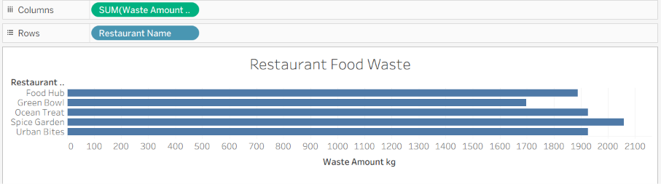

Algorithm 3 – Energy Type Comparison

Objective

To compare renewable energy production among different energy types.

Step 1

Drag: Energy Type → Rows

Step 2

Drag: Production (GWh) → Columns

Step 3

Select Bar Chart from Show Me.

Step 4

Enable Show Mark Labels.

Step 5

Sort the energy types in descending order.

Output Visualization

Renewable Energy Production by Energy Type

Interpretation

The bar chart compares renewable energy production among different energy types available in the dataset. It helps identify the energy sources contributing the most to renewable energy production.

Algorithm 4 – Pie Chart Creation

Objective

To analyze the distribution of renewable energy production based on different energy types.

Step 1

Drag: Energy Type → Color

Step 2

Select Pie Chart from Show Me.

Step 3

Drag: Production (GWh) → Angle

Step 4

Drag: Production (GWh) → Label

Step 5

Enable Show Labels.

Output Visualization

Renewable Energy Production by Energy Type

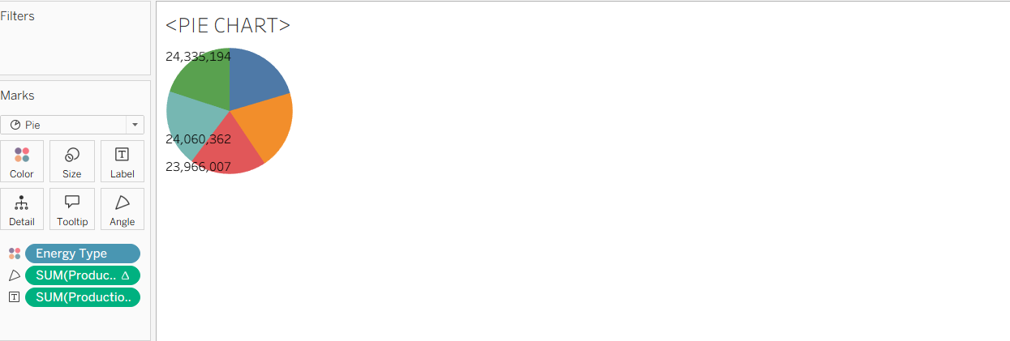

Interpretation

The pie chart shows the contribution of different renewable energy types to the overall renewable energy production.

It provides a quick visual comparison of the proportion contributed by each energy source.

Algorithm 5 – Line Chart Creation

Objective

To analyze the trend of renewable energy production over different years.

Step 1

Drag: Year → Columns

Step 2

Drag: Production (GWh) → Rows

Step 3

Select Line Chart.

Step 4

Enable data labels if required.

Step 5

Analyze the renewable energy production trend over different years.

Output Visualization

Renewable Energy Production Trend Over Time

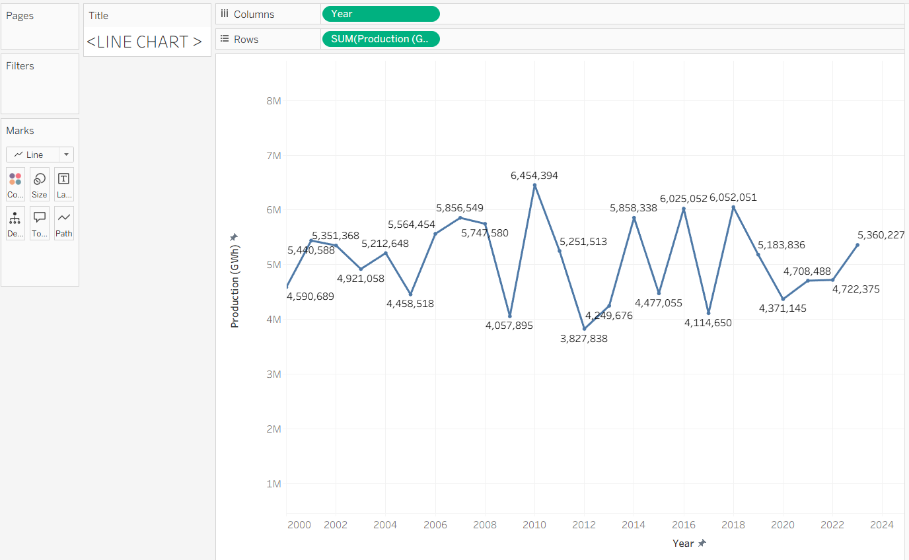

Interpretation

The line chart shows how renewable energy production changes over time.

It helps identify:
- Increasing production trends
- Decreasing production trends
- Peak production periods
- Low production periods
- Changes in renewable energy generation

Algorithm 6 – Creating Calculated Field

Objective

To calculate renewable energy production relative to installed capacity.

Step 1

Select:

Analysis → Create Calculated Field

Step 2

Enter the field name:

Production per Installed Capacity

Step 3

Enter the formula:

[Production (GWh)] / [Installed Capacity (MW)]

Step 4

Click OK.

Output

The calculated field is added to Tableau and can be used in worksheets for analyzing renewable energy production relative to installed capacity.

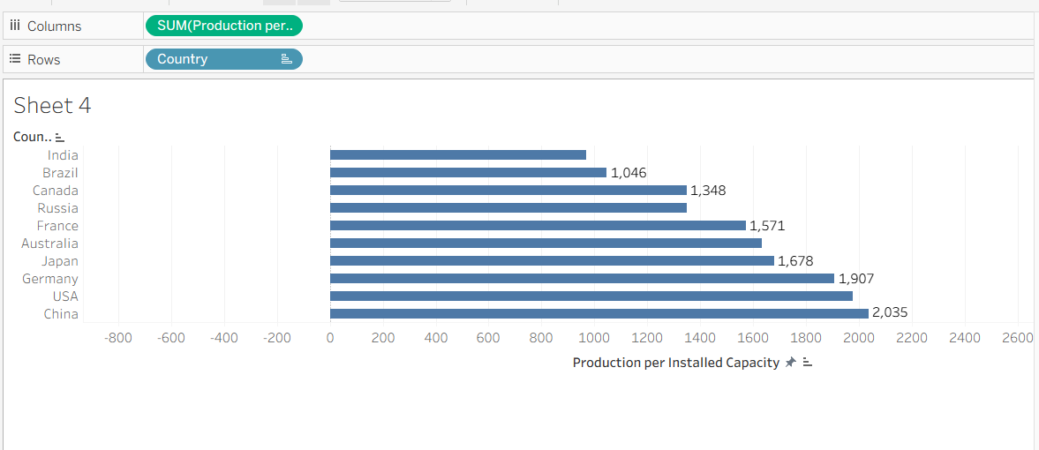

Interpretation

The calculated field provides a production-to-capacity measure that can be used to compare renewable energy performance across countries and energy types.

Algorithm 7 – Applying Filters

Objective

To analyze renewable energy data for a specific country, year, or energy type.

Step 1

Drag:

Country → Filters

Step 2

Select the required country.

Step 3

Click:

Show Filter

Step 4

Select a country from the filter.

Step 5

Observe the updated charts.

You can similarly add:
- Year
- Energy Type

as filters.

Example

Filter: Country = USA

Output

The visualizations display only the renewable energy records belonging to the selected country.

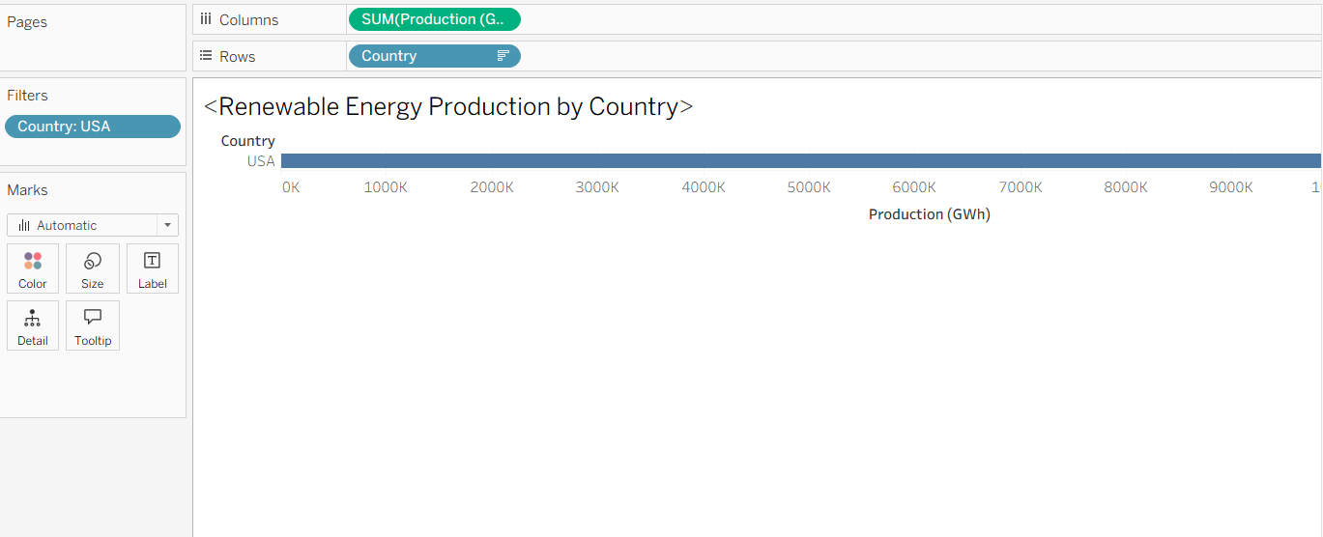

Interpretation

The filters allow users to focus on specific countries, years, or renewable energy types and perform detailed analysis.

Algorithm 8 – Creating Parameter

Objective

To dynamically identify renewable energy records based on a user-defined minimum production value.

Step 1

Select:

Create Parameter

Step 2

Specify the parameter name:

Minimum Renewable Production

Step 3

Set the data type as:

Float

Step 4

Set the required minimum value.

Step 5

Create a calculated field using the parameter.

Formula

[Production (GWh)] >= [Minimum Renewable Production]

Example

Minimum Renewable Production = 50000

Output

The visualization displays records where renewable energy production is equal to or greater than the selected threshold.

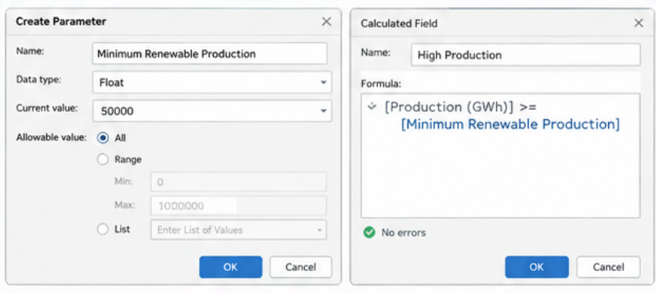

Interpretation

The parameter allows users to dynamically identify high-production renewable energy records based on a selected threshold.

Algorithm 9 – Dashboard Creation

Objective

To create an interactive Global Renewable Energy Analysis Dashboard.

Step 1

Create multiple worksheets.

Recommended worksheets:
- Renewable Energy Production by Country
- Renewable Energy Production by Energy Type
- Renewable Energy Trend Over Time
- Installed Capacity Analysis
- Investment Analysis

Step 2

Select:

Dashboard → New Dashboard

Step 3

Drag the required worksheets into the dashboard.

Step 4

Arrange the charts clearly.

Step 5

Add filters for:
- Country
- Year
- Energy Type

Step 6

Add the Minimum Renewable Production parameter.

Step 7

Add appropriate titles and labels.

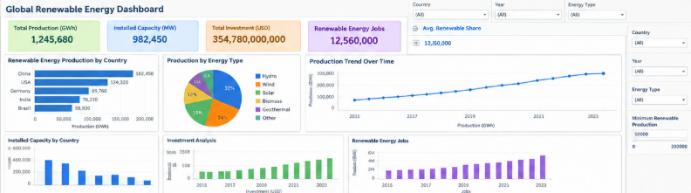

Dashboard Analysis

The dashboard can contain the following key indicators:

Total Renewable Energy Production

SUM(Production (GWh))

Total Installed Capacity

SUM(Installed Capacity (MW))

Total Investment

SUM(Investments (USD))

Total Renewable Energy Jobs

SUM(Renewable Energy Jobs)

Average Renewable Energy Proportion

AVG(Proportion of Energy from Renewables)

Interpretation

The dashboard provides a consolidated view of renewable energy production, installed capacity, investment, employment, energy types, and trends.

Users can interact with the dashboard using country, year, and energy-type filters to perform detailed analysis.

Algorithm 10 – Story Creation

Objective

To present the analysis of global renewable energy development through a sequence of visual insights.

Step 1

Create the required worksheets.

Step 2

Create the Global Renewable Energy Analysis Dashboard.

Step 3

Select:

Story → New Story

Step 4

Add the dashboard and required worksheets as story points.

Step 5

Arrange the story points in a logical sequence.

Step 6

Present the findings.

Example Story

Story Point 1

Overall Renewable Energy Analysis

Displays total renewable energy production, installed capacity, investment, jobs, and renewable energy proportion.

Story Point 2

Renewable Energy Trend Over Time

Shows how renewable energy production changes across different years.

Story Point 3

Country-wise Renewable Energy Analysis

Compares renewable energy production across countries.

Story Point 4

Energy Type Analysis

Shows the contribution of different renewable energy sources.

Story Point 5

Investment and Capacity Analysis

Analyzes investment and installed renewable energy capacity.

Story Point 6

Final Renewable Energy Analysis

Summarizes the major patterns and observations obtained from the dataset.

Applications

Renewable Energy Planning

Analysis of renewable energy production and installed capacity for better energy planning.

Sustainable Energy Management

Identification of renewable energy sources and trends that support sustainable energy development.

Investment Analysis

Analysis of renewable energy investments across countries and energy types.

Environmental Analysis

Study of renewable energy development and its relationship with CO2 emissions.

Energy Policy Development

Analysis of government policies, renewable energy targets, subsidies, and other indicators.

Infrastructure Planning

Analysis of installed capacity, energy storage, grid integration, and renewable energy resources.

Business Intelligence

Interactive visualization and dashboard-based renewable energy analysis.

Decision Making

Identification of countries, energy types, and periods with significant renewable energy activity.

Data Analytics

Interactive visualization and exploratory analysis of global renewable energy patterns.

Result

The Global Renewable Energy and Indicators Dataset was successfully connected to Tableau and analyzed using different visualization techniques. Bar charts, pie charts, line charts, calculated fields, filters, parameters, dashboards, and stories were created to analyze renewable energy production, energy types, country-wise performance, installed capacity, investments, and renewable energy trends.

