Discrete Probability Distributions
Binomial, Poisson, Geometric
1.Open the Binomial module
2. Enter the values of n and p
In the Binomial module:
- Number of trials (n) = 20
- Probability of defect (p) = 0.05
20 products are inspected and the probability of finding a defect in each product is 5%.
3. Calculate the mean, variance and probability of exactly 2 defects
For the Binomial distribution, the mean is calculated as np and the variance is calculated as np(1-p).
Mean:
Mean = 1
Variance:
Variance = 0.95
Probability of exactly 2 defects:
P (X = 2) = 0.188677
Therefore, the probability of finding exactly 2 defective products is approximately 18.87%.
4. Observe the Binomial PMF graph
The horizontal axis represents the number of defects, while the vertical axis represents the probability of each defect count. The graph shows that the highest probability is around one defect. The probability generally decreases for larger numbers of defects.
The dashed vertical line indicates the mean, which is 1 for the selected values.
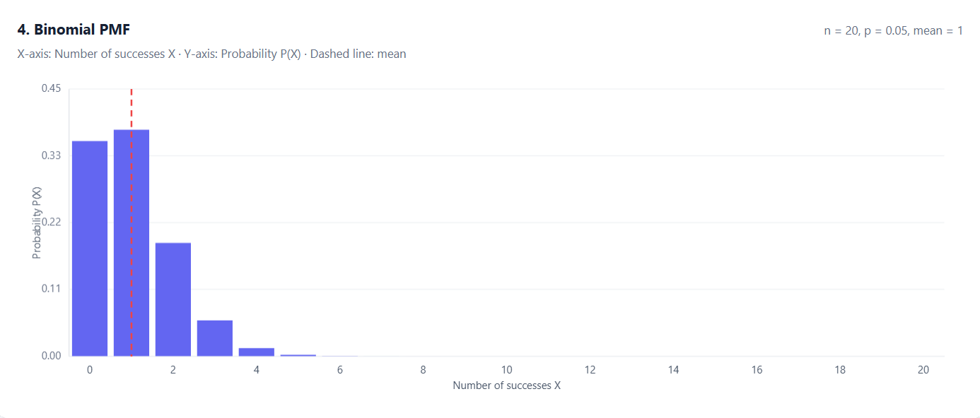
5. Change the defect probability from 0.05 to 0.10
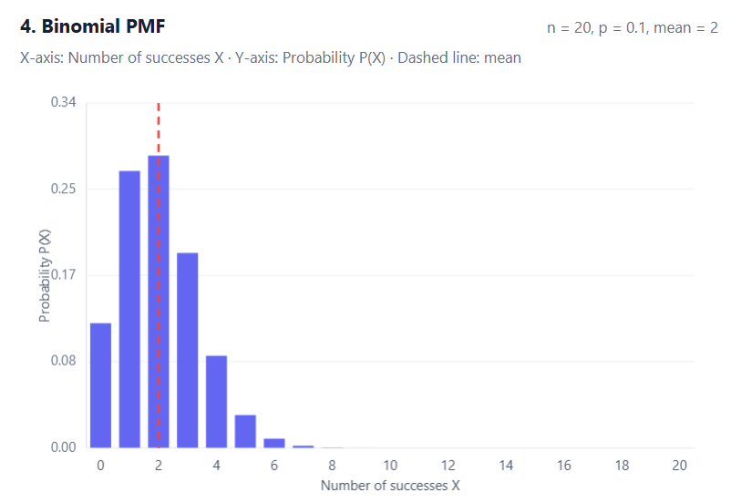
I changed the probability of a defect from 0.05 to 0.10 while keeping the number of trials at 20.
The updated results are:
- Mean = 2
- Variance = 1.8
- Probability of exactly 2 defects = 0.285180 (28.52%)
Observation:
After increasing the defect probability, the graph shifts towards larger defect counts. The expected number of defects increases from 1 to 2, showing that a higher defect rate leads to more defective products on average.
6. Compare the Poisson and Binomial distributions
I entered λ = 5 in the Poisson module for 100 inspected products.
For a fair comparison, I used n = 100 and p = 0.05 in the Binomial module because np = 100 × 0.05 = 5.
The probability of exactly 2 defects was calculated using both distributions.
Binomial distribution:
P (X = 2) = 0.081182 (8.12%)
Poisson distribution:
P (X = 2) = 0.084224 (8.42%)
The two probabilities are close to each other. This shows that the Poisson distribution can provide a good approximation to the Binomial distribution when the number of trials is large and the probability of a defect is small.
7. Examine the Geometric distribution
I entered p = 0.05 in the Geometric module. This distribution represents the number of inspection attempts required to detect the first defective product.
The probability is calculated using:
P (X = k) = p(1-p) ᵏ⁻¹
The results for the first few attempts are:
Inspection attempt (k) | Probability of first defect
1 | 0.050000 (5.00%)
2 | 0.047500 (4.75%)
3 | 0.045125 (4.51%)
4 | 0.042869 (4.29%)
5 | 0.040725 (4.07%)
The probability of detecting the first defect on a particular attempt decreases as the attempt number increases. The Geometric distribution helps estimate how many inspections may be needed before the first defect is detected.
8. Numerical results, graph observations and inference
From this experiment, I observed that the Binomial distribution is useful for calculating the number of defective products in a fixed number of inspections. When the defect probability increased from 5% to 10%, the expected number of defects increased from 1 to 2.
The Binomial and Poisson distributions gave similar probabilities for exactly 2 defects when 100 products were inspected with a 5% defect probability. The Binomial result was approximately 8.12%, while the Poisson result was approximately 8.42%.
The Geometric distribution showed how the probability of finding the first defect changes across successive inspection attempts.
Overall, these distributions help estimate defect counts, understand inspection results and support quality-control decisions. They can help identify possible problems in a production process and determine whether further inspection may be needed.

Submitted by:
Name: Ramya Reddy Bonagiri
USN: 1BY25AI055
Semester: III Semester

