Contact Centre WFM Analysis
1. Project Overview and Objective
This project involves cleaning, transforming, and analysing raw contact centre operations data using Excel and creating an interactive Power BI dashboard to derive meaningful business insights for Workforce Management (WFM), real-time and performance reporting.
The main objective is to demonstrate data pre-processing techniques using Excel and to build an interactive, four-page Power BI report that tracks call volumes, answer and abandon rates, agent availability and leave, forecast versus scheduled staffing, and agent quality (QA) and customer satisfaction (CSAT), so that supervisors and WFM analysts can make informed staffing and performance decisions.

2. Data Sources
- Source Description and Timeline: Contact centre operational data covering call volumes, agent details, agent availability, leave, QA/CSAT evaluations and weekly WFM forecasts.
Source – Github (Claude)
Domain: Contact Centre / Workforce Management (WFM) Analytics

3. Problem Statement
- To analyse call volume, answer rate and abandon rate by skill, day and month to identify peak periods and service-level gaps.
- To compare forecast and required agents with scheduled agents so that staffing gaps (over/under-staffing) can be seen early.
- To study agent availability (Talk, Ready, ACW, Aux and logged-in time) and leave patterns by agent, site and month for better shift planning.
- To evaluate agent performance through QA score and CSAT score to find coaching opportunities for team leads.

4. Attribute (Column /Features) Details:
The model has 8 tables. Data types below are based on how each column is used in the report.
Attribute Name | Data Type | Description
Agent_Details (2) | Table | Dimension table: agents
AgentName | Text | Name of the agent
Site | Categorical | Site/location the agent works from
TeamLead | Categorical | Team lead the agent reports to
Shift | Categorical | Shift assigned to the agent
Agents_Availability (2) | Table | Fact table: agent availability
Shift | Categorical | Shift during which availability was recorded
CallsHandled | Whole number | Number of calls handled by the agent
LoggedInMin | Whole number | Total minutes the agent was logged in
ReadyMin | Whole number | Minutes the agent was in Ready state
TalkMin | Whole number | Minutes spent talking to customers
ACWMin | Whole number | Minutes spent in after-call work
AuxMin | Whole number | Minutes spent in Aux / not-ready states
Call_Volume (2) | Table | Fact table: call volume
SkillID | Categorical | Skill group the calls were routed to
Day | Date / Whole number | Day of the call record
CallsOffered | Whole number | Calls offered to the skill
CallsAnswered | Whole number | Calls answered
CallsAbandoned | Whole number | Calls abandoned before being answered
Skills | Table | Dimension table: skills
SkillID | Categorical | Unique skill identifier (lookup table)
Calendar (2) | Table | Dimension table: dates
Date | Date | Calendar date
DayName | Text | Day of the week
MonthName | Text | Month name
Leave (2) | Table | Fact table: leave
LeaveDate | Date | Date on which the agent was on leave
LeaveType | Text / Categorical | Type of leave taken
QA_CSAT (2) | Table | Fact table: QA and CSAT
EvalID | Text / Whole number | Unique identifier of each evaluation
QAScore | Numeric (Decimal) | Quality assurance score of the evaluation
CSAT_Score | Numeric | Customer satisfaction score
wfm_weekly_Forecast | Table | Fact table: weekly forecast
RequiredAgents | Whole number | Agents required as per the forecast
ScheduledAgents | Whole number | Agents actually scheduled

5. Tools & Technologies
- Excel: Data cleaning, transformation, and Pivot Tables.
- Power BI: Power Query, data modelling, DAX measures, visualization, and interactive dashboard creation (4 report pages)

6. Data Pre-Processing (Excel / Power Query)
Tasks Performed:
- Data Cleaning & Transformation: Removed duplicates, handled missing values, standardized formats and created calculated fields, fixed date formats, trimmed categorical values.
- Filtering & Sorting: Organized data to focus on relevant records (by skill, site, shift and month).
- Pivot Tables: Generated Pivot Tables for data summarisation and initial insights.
- Fact and Dimension Tables: Data was organised into dimension tables (Agent_Details, Skills, Calendar) and fact tables (Call_Volume, Agents_Availability, Leave, QA_CSAT, wfm_weekly_Forecast).

7. Data Modelling and DAX (Power BI)
- Data Model: A star-schema style model with 3 dimension tables and 5 fact tables. Agent_Details, Skills and Calendar act as lookup tables that filter the fact tables.
SCREENSHOT OF DATA MODELLING
- Calculated Columns & DAX Measures: The report uses the following measures:
Measure | Table | Purpose
Total Calls Offered | Call_Volume (2) | Total calls offered across the selected period/skill  Total Calls Offered = sum('Call_Volume (2)'[CallsOffered])
Total calls Answered | Call_Volume (2) | Total calls answered  Total calls Answered = sum('Call_Volume (2)'[CallsAnswered])
Total Calls Abandoned | Call_Volume (2) | Total calls abandoned Total Calls Abandoned = sum('Call_Volume (2)'[CallsAbandoned])
Answer Rate % | Call_Volume (2) | Answered calls as a percentage of calls offered  Answer Rate % = 'Call_Volume (2)'[Total calls Answered]/'Call_Volume (2)'[Total Calls Offered]
Abandon Rate % | Call_Volume (2) | Abandoned calls as a percentage of calls offered  Abandon Rate % = 'Call_Volume (2)'[Total Calls Abandoned]/'Call_Volume (2)'[Total Calls Offered]
Forecast_calls | wfm_weekly_Forecast | Forecasted call volume  Forecast_calls = Sum(wfm_weekly_Forecast[ForecastCalls])
Forecast Variance | wfm_weekly_Forecast | Difference between forecast and actual calls  Forecast Variance = 'Call_Volume (2)'[Total Calls Offered]-wfm_weekly_Forecast[Forecast_calls]
Total Leaves | Leave (2) | Count of leave days taken (used by the leave-type donut)  Total Leaves = counta('Leave (2)'[LeaveType])
Total Days | Calendar (2) | Total days in the selected period  Total Days = COUNTA('Calendar (2)'[DayName])
Working Days | Agent_Details (2) | Days available for work after weekends and holidays  Working Days = NETWORKDAYS('Calendar (2)'[Start Date],'Calendar (2)'[End Date])
Weekends | Agent_Details (2) | Number of weekend days in the period  Weekends = CALCULATE(COUNTROWS('Calendar (2)'), 'Calendar (2)'[IsWeekend]="Y")
Holidays | Agent_Details (2) | Number of holidays in the period  Holidays = COUNTA('Calendar (2)'[HolidayName])
100% CSAT | QA_CSAT (2) | Maximum value used as the target of the CSAT gauge  100% CSAT = COUNT('QA_CSAT (2)'[QAScore]) * 5

8. Analysis and Visualizations (Power BI)
Dashboard Features:
- Multiple visualizations based on the problem statement across four report pages:
  - Call Analysis Dashboard: KPI and card visuals (Total Calls Offered, Total calls Answered, Total Calls Abandoned, Answer Rate %, Abandon Rate %), KPI visual (answered vs offered), line chart of calls handled by agent, 100% stacked bar of calls handled vs calls offered, funnel of calls offered by skill.
  - WFM Dashboard: Card of Working Days, Weekends, Holidays and Total Days, clustered column chart of leave availed by agent and month, donut chart of total leaves by leave type, combo chart of required vs scheduled agents by date, and an agent table (agent, site, team lead).
  - Call Forecast: Card of calls offered, forecast calls and forecast variance, line chart of calls offered vs answered, column chart of calls answered vs abandoned, and calls handled by shift.
  - Performance and CSAT Dashboard: CSAT score gauge (target 100%), CSAT score bar chart, QA score by agent and evaluation, 100% stacked bar of Active Hours Analysis (talk, ready, ACW, aux, logged-in minutes), cards for calls offered/answered/abandoned and an agent/shift/site table.
- Interactive layout: 12 slicers across the pages (Month, Agent, Skill, Site, Day, Leave Type, Team Lead and Day Name) let users filter every page; visuals also cross-filter each other.
- Bookmarks, titles and labels:
Bookmarks - Call Analysis, WFM, Call Forecast, Performance CSAT
Call Analysis – Calls Handled By Agents, Calls Handled Over Calls Offered
WFM – Leaves Availed By Agents, Total Leaves, Required Agents Vs Scheduled Agents
Call Forecast – Calls Offered Vs Calls Answered, Calls Answered Vs Calls Abandoned, CallHandled in Shifts
Performance CSAT – Active Hours Analysis, QA Scores, CSAT Score Gauge, CSAT Score, Agent Detail Table

SCREENSHOT OF DASHBOARD /REPORT

Call Analysis Dashboard
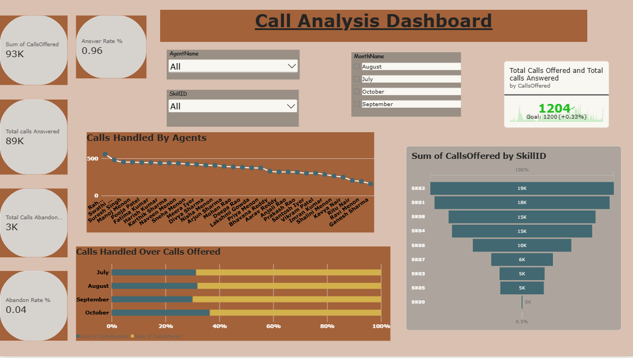

Call Forecast Dashboard
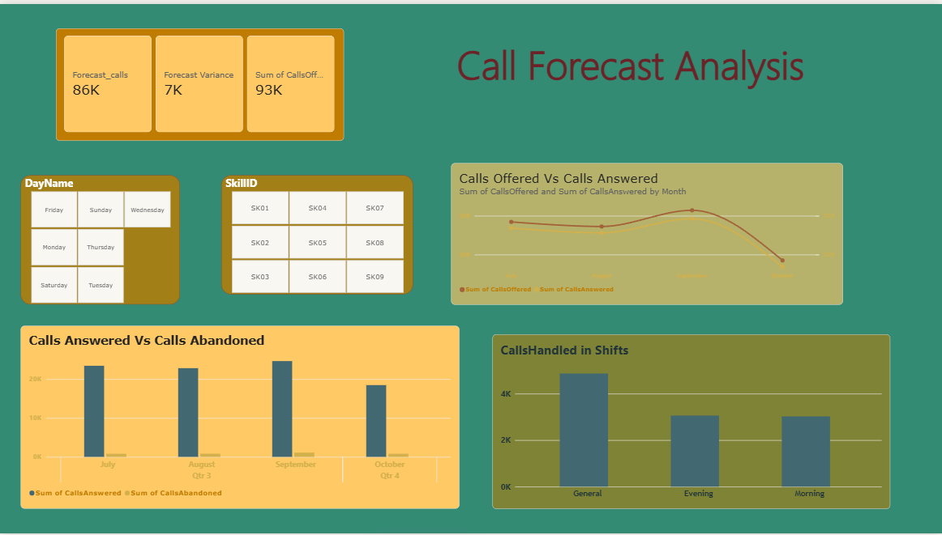

WFM Dashboard
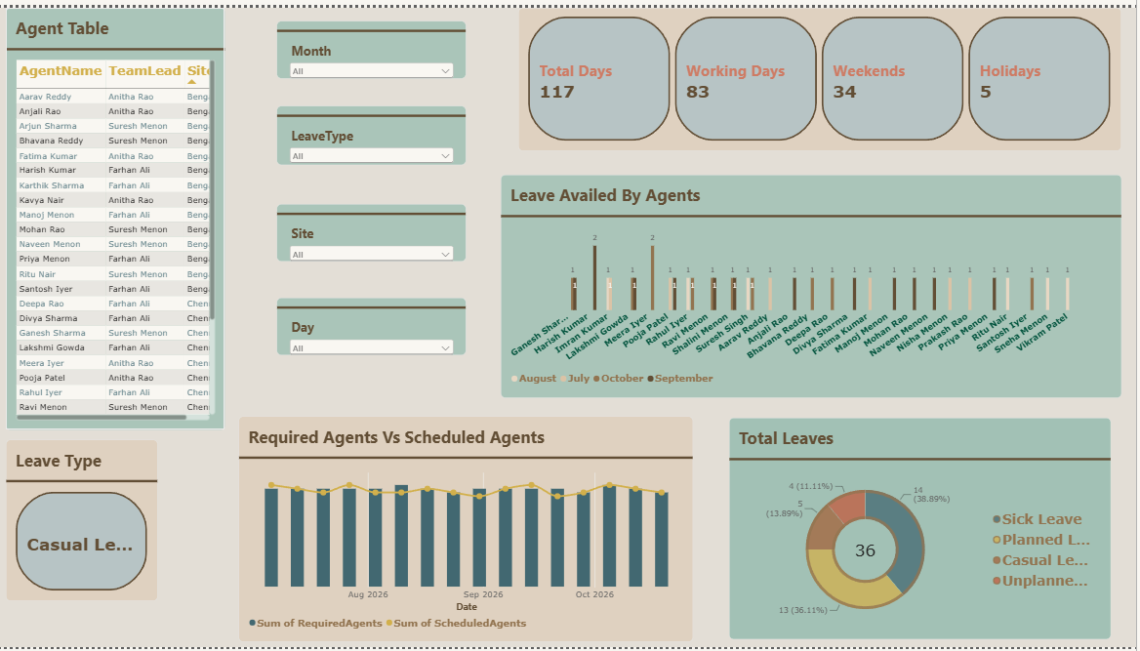

Performance And CSAT Dashboard
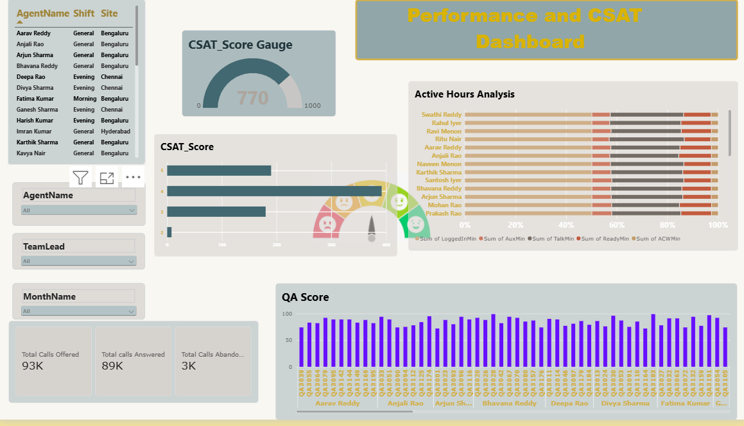

9. Insights & Conclusions
- Key Findings: Volume and service level: 93K calls offered, 89K answered and 3K abandoned. That gives a 96% answer rate and a 4% abandon rate.
- Peak month: September has the highest volume, about 24K answered and about 1K abandoned, or roughly a 4% abandon rate. October is lower, about 18K answered, probably because the month is incomplete.
- Forecast miss: Forecast was 86K against 93K offered, a variance of 7K (about 8% under-forecast).
- Skill concentration: SK02 (19K) and SK01 (18K) carry about 40% of all calls. The top four skills (SK02, SK01, SK08, SK04) carry about 72%. SK09 is close to zero.
- Shift workload: General shift handles the most calls (about 4.8K). Evening (about 3.1K) and Morning (about 3.0K) are roughly equal.
- Agent workload: Calls handled per agent range from about 550 (top, starting “Rah…”) down to about 170 (Ganesh Sharma). Ravi Menon, Kavya Nair and Ritu Nair are also at the low end, at about 190 to 250.
- Quality: CSAT score is 770 out of 1000. Most ratings are 4 (about 395), then 5 (about 190) and 3 (about 180), with very few 2s (about 8). QA scores mostly sit between 72 and 100.
- Leave: 36 leaves in total: Sick 14 (38.9%), Planned 13 (36.1%), Casual 5 (13.9%) and Unplanned 4 (11.1%). The calendar has 117 days: 83 working, 34 weekends and 5 holidays.
- Agent time: Across agents, about 50% of logged-in time, with talk about 28%, ready about 11%, aux about 8% and ACW about 3%. No irregular work hours noticed,

- Provide the analysis insights:
  - Descriptive: Descriptive: what happened
- Metric | - Value
- Calls offered | - 93K
- Calls answered | - 89K
- Calls abandoned | - 3K
- Answer rate / abandon rate | - 96% / 4%
- Leaves taken | - 36 (Sick 14, Planned 13, Casual 5, Unplanned 4)
- CSAT | - 770 on the 0–1000 gauge, with most ratings at 4
- QA | - Mostly 72–100, with a visible cluster around 71–75
  - Diagnostic: why it happened
  - Understaffing doesn’t explain the abandons overall. On Required vs Scheduled Agents (Aug–Oct), the scheduled line tracks the required bars closely. The gap is small and flips between days, so staffing was broadly matched on paper.
  - Volume above forecast is the more likely driver. Calls came in about 8% over the forecast, so staffing built to the forecast would have been short on busy days.
  - Leave is hard to plan around. Sick plus unplanned leave is 18 of 36 leaves (50%), so half of absences can’t be scheduled around. This may explain the days when scheduled agents dip below required.
  - Skill mix is uneven. SK02 and SK01 take the heaviest load, while SK03, SK05 and SK07 are light and SK09 is negligible. This points to a routing or skill-coverage issue rather than a total headcount issue.
  - Month pattern: September is the peak, with the highest absolute abandons. The abandon rate looks fairly flat at 3–4% across months, so the problem is volume spikes rather than a single bad month.
  - Shift pattern: General takes about 44% of the shift workload, so Morning and Evening are the lighter shifts.

  - Predictive: what is likely to happen
  - Actuals ran about 8% above forecast, so expect that to repeat unless the forecast model is corrected. Plan staffing on forecast plus 8–10%.
  - Volume peaks like September’s are likely to recur in high-volume weeks. Expect abandon rates to move above 4% in those weeks if staffing stays flat.
  - SK01, SK02, SK04 and SK08 will keep driving most volume (about 72%), so they will drive staffing needs.
  - With sick and unplanned leave at about 50% of all leave, expect unexpected absences on any given day. Keep a buffer of roughly 5–8% above required agents on peak days.

  - Prescriptive: what to do
Shift schedules: Move agents toward peak intervals and the busiest days. Add coverage to Morning and Evening where General is absorbing extra load.
  - Leave planning: Limit planned leave on high-volume days. Because sick and unplanned leave can’t be planned, use a standby or cross-skilled pool for those days.
  - Skill coverage: Cross-train agents from lighter skills (SK03, SK05, SK07) into SK01, SK02, SK04 and SK08. Review whether SK09 needs to exist as a separate queue.
  - Forecast: Add an 8% uplift to the next forecast cycle and review weekly forecast variance.
  - Coaching: Coach agents in the lowest QA group (the bars at about 71–75) and the lowest CSAT scorers. Review agents with the lowest calls handled (Ganesh Sharma, Ravi Menon, Kavya Nair, Ritu Nair), checking for leave, skill or aux-time reasons before coaching.
  - Quality focus: Most CSAT is a 4, so the biggest gain is moving 4s to 5s. Review calls with 3s for common causes.

10. Conclusions
The integration of Excel and Power BI proved effective for end-to-end contact centre analysis, from raw operational data to an interactive report that supports forecasting, staffing and agent-performance decisions.

