WEEK 4 REPORT
Interactive Dashboard Creation for Beauty and Wellness

1. Introduction
The Week 4 activity focused on creating an interactive Excel dashboard for a beauty and wellness business. The purpose of the dashboard is to convert transaction-level data into a clear management view that supports monitoring, comparison, and decision-making. The dashboard combines key performance indicators, PivotTables, PivotCharts, slicers, conditional formatting, and advanced Excel functions in one reporting environment.
The workbook contains cleaned information such as Order ID, Date, City, Category, Product, Age, Gender, Sales, Quantity, Channel, Payment Mode, Rating, and Age Group. The dashboard was designed to answer practical questions about product performance, customer segments, city performance, monthly sales, and interactive filtering.
2. Objectives of the Task
- Create an interactive management dashboard using advanced Excel features.
- Present important sales, customer engagement, and business performance indicators.
- Use PivotTables and PivotCharts to summarize transaction-level information.
- Use slicers to filter the dashboard by City, Category, Gender, Channel, and Age Group.
- Apply conditional formatting to improve visual interpretation.
- Use INDEX, MATCH, and MAX to generate automatic business insights.
- Review the dashboard for usability, readability, and professional presentation.
3. Business Problem and Dashboard Planning
Raw transaction data contains useful information but does not immediately show which products, customer groups, cities, or months require attention. A manager needs a compact view of important business measures. The dashboard was therefore planned as a decision-support tool rather than a simple data table.
The dashboard was organized into KPI cards, interactive slicers, PivotCharts, and automatic business insights. This structure allows a user to move from an overall summary to filtered analysis without changing the source data.
4. Dataset and Data Preparation
The cleaned dataset contains 120 transaction records. The main fields used include Order ID, Date, City, Category, Product, Age, Gender, Sales, Quantity, Channel, Payment Mode, Rating, and Age Group. The Age Group field was already available and was used directly for customer segmentation.
The cleaned data was converted into an Excel Table named BeautyData. Structured references make formulas easier to maintain and provide a consistent source for KPI calculations and PivotTables.
Cleaned Data and Table Structure
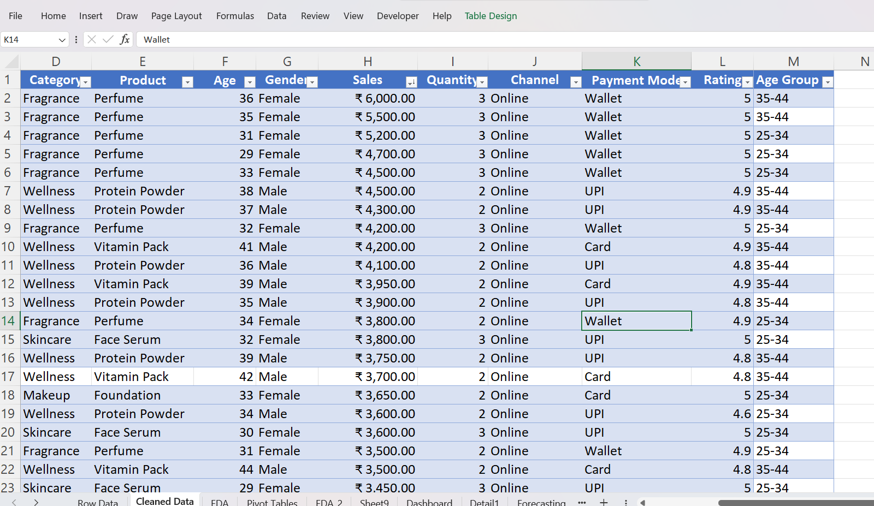
Cleaned_Data_Table
Show the cleaned dataset, Age Group column, and Excel Table structure.

5. KPI Design and Calculation
Key Performance Indicators were created on the Dashboard Data sheet. The selected KPIs were Total Sales, Total Orders, Average Order Value, Total Quantity, Average Rating, and Highest Sale.
SUM was used for total sales and quantity, COUNTA for transaction count, AVERAGE for average order value and rating, and MAX for the highest sale. These calculations provide a transparent summary layer that can be linked to the final dashboard.
KPI Calculations
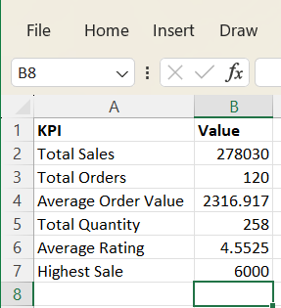
KPI_Calculations
Show the KPI table and the Excel formulas used to calculate the indicators.
6. Product Performance Analysis
A Top 10 Products PivotTable was created using Product as the row field and Sales as the value field. The values were sorted from largest to smallest. A PivotChart was then created to compare product sales visually.
A Bottom 5 Products PivotTable and chart were also created. This gives management a complementary view of lower-sales products and avoids focusing only on high-performing products.

Top 10 Products by Sales
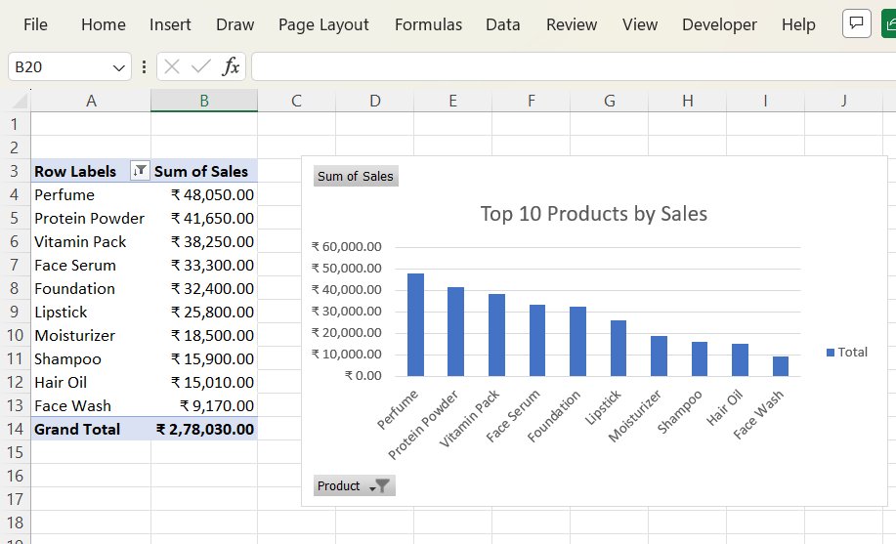
Top_10_Products
Show the Top 10 Products PivotTable and PivotChart.
Bottom 5 Products by Sales
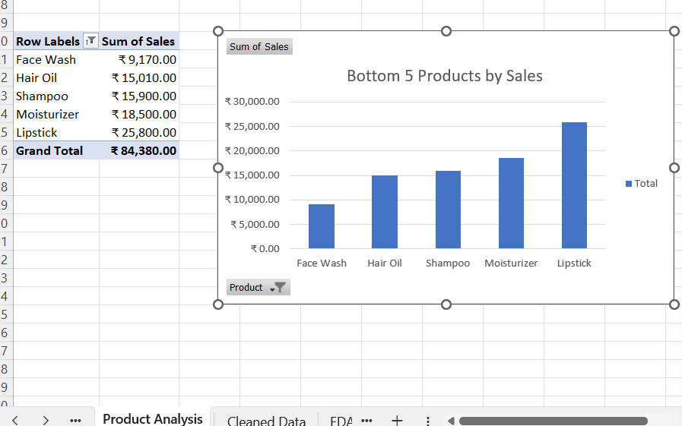
Bottom_5_Products
Show the Bottom 5 Products PivotTable and PivotChart.
7. Customer Segmentation and Engagement
Customer segmentation was created using Age Group. The PivotTable contains Age Group as the row field and includes Sales and Order ID count. The related chart compares sales and transaction activity across customer segments.
Customer rating distribution was also summarized using Rating and a count of Order ID. This provides a view of the distribution of customer ratings in the available dataset.
Customer Segment Performance by Age Group
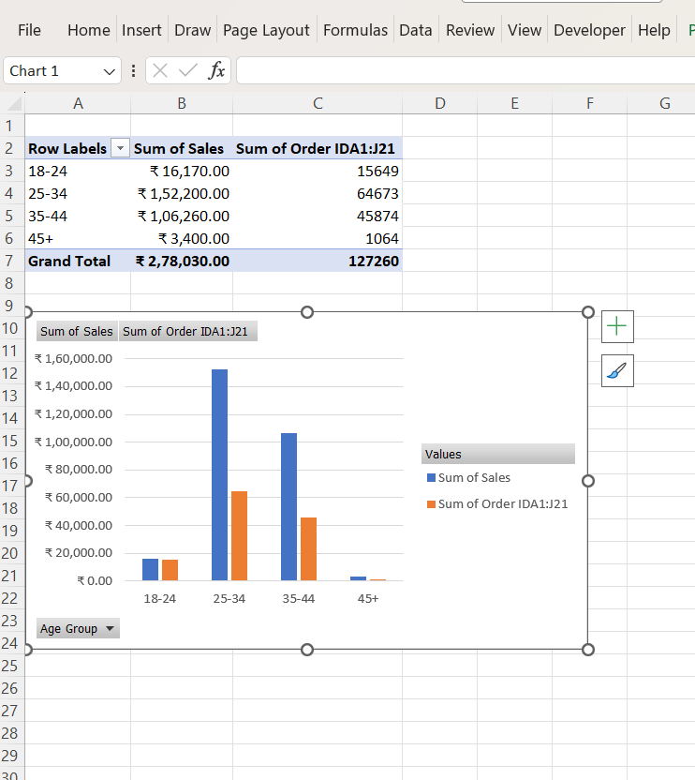
Customer_Segment_Age_Group
Show the Age Group PivotTable and Customer Segment Performance chart.
Customer Rating Distribution
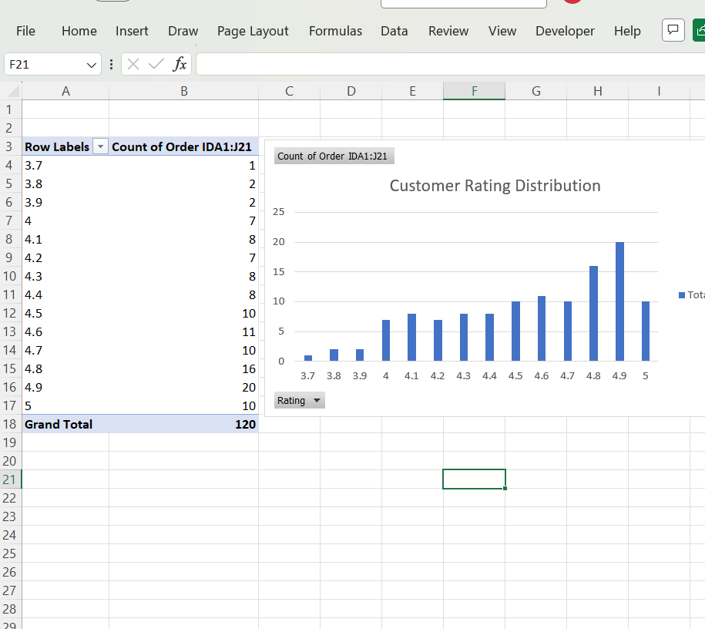
Customer_Rating_Distribution
Show the Rating PivotTable and Customer Rating Distribution chart.
8. Sales Channel and City Analysis
Channel-level analysis was created to compare sales, transaction count, and quantity across channels. This provides a business view of channel activity and can be filtered through the dashboard.
City-level analysis was created using City as the row field with Sales and Order ID count as measures. This supports geographical comparison and helps identify locations with stronger sales activity.

Channel Performance PivotTable
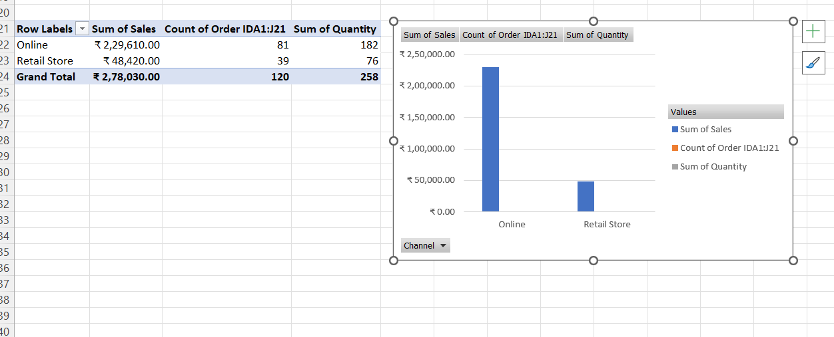
Channel_Performance
Show the Channel Performance PivotTable and chart if available.
City Performance
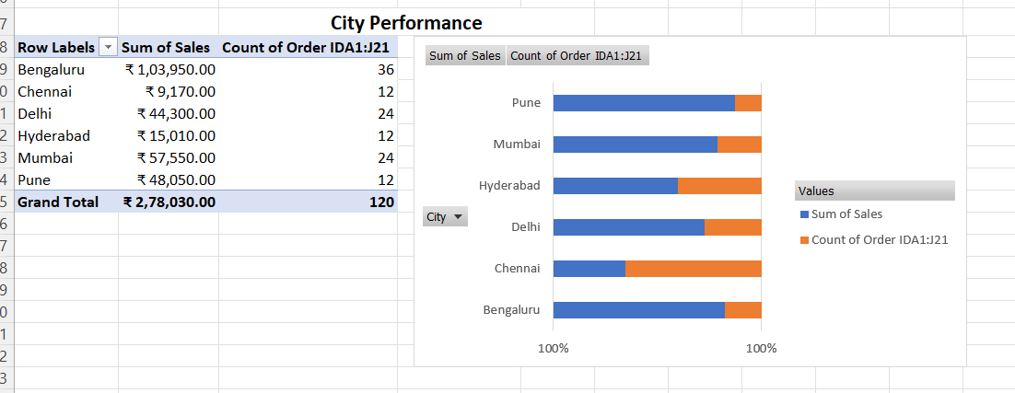
City_Performance
Show the City Performance PivotTable and chart.
9. Monthly Sales Performance
Monthly sales performance was analyzed by placing Date in the PivotTable row field and Sales in the values field. The dates were grouped by month where required. A line PivotChart was used because a line chart is suitable for showing an ordered time trend.
The monthly results show an increasing pattern toward the later months, with December recording the highest monthly sales value in the available dataset. However, because only one year of data is available, this should not be treated as conclusive evidence of recurring seasonality. Additional years of historical data would be required to identify reliable seasonal behavior.
Monthly Sales Performance
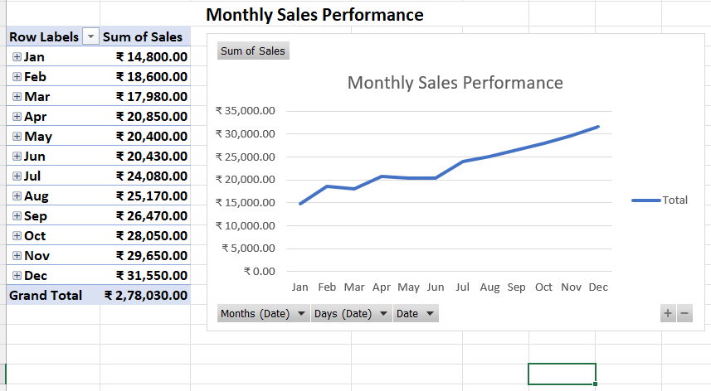
Monthly_Sales_Performance
Show the monthly sales PivotTable and line chart.
10. Interactive Slicers
Five slicers were added: City, Category, Gender, Channel, and Age Group. Slicers provide a visual filtering mechanism and allow users to change the dashboard view without manually editing PivotTable filters.
The slicers were connected to relevant PivotTables through Report Connections. For example, selecting Bengaluru changes the connected analysis to the selected city.

Dashboard Slicers
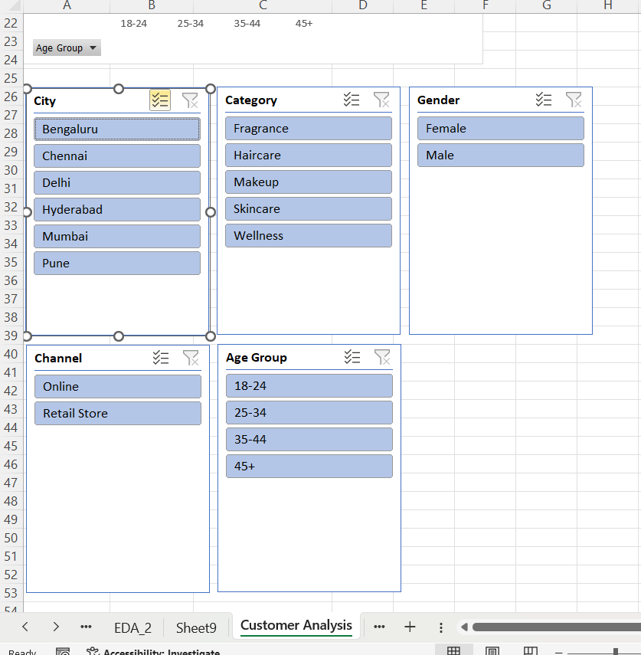
All_Slicers
Show the five slicers together: City, Category, Gender, Channel, and Age Group.

Slicer Interaction with Bengaluru Selected
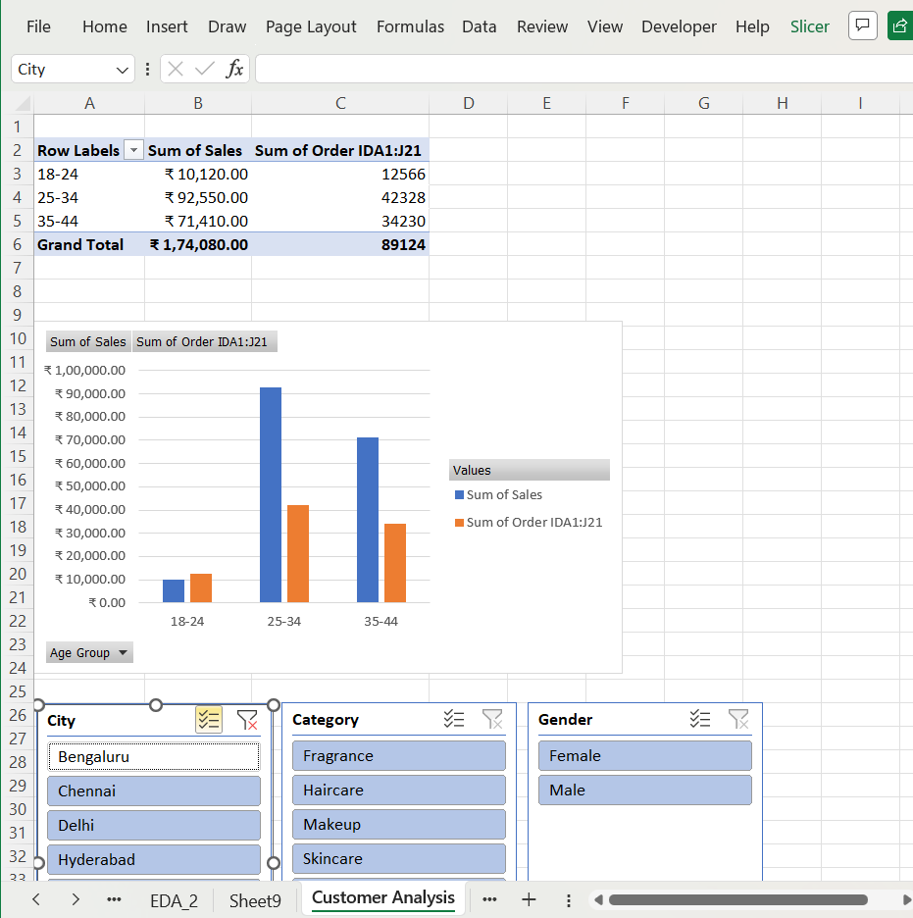
Bengaluru_Slicer_Interaction
Show Bengaluru selected and the connected PivotTables or charts updated.
11. Conditional Formatting
Conditional formatting was applied to selected PivotTable values. Data bars were used for sales values so that larger values are visually stronger. A color scale was used for rating analysis to make differences easier to identify.
This reduces the time needed to compare individual values and makes important differences easier to recognize.
Conditional Formatting
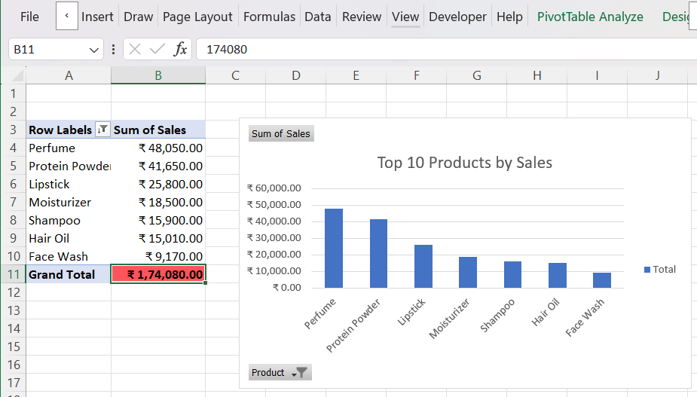
Conditional_Formatting
Show the PivotTable values with the applied data bars and/or color scale.
12. Advanced Excel Functions and Business Insights
INDEX, MATCH, and MAX were combined to identify the item associated with the highest sales value. MAX finds the highest sales value, MATCH finds its position, and INDEX returns the corresponding product name.
The Top Performing Product formula followed the structure =INDEX(product_range,MATCH(MAX(sales_range),sales_range,0)). The resulting top-performing product in the available data was Perfume. The same method can be applied to city or channel analysis when the relevant ranges are available.

Advanced Excel Functions and Business Insights
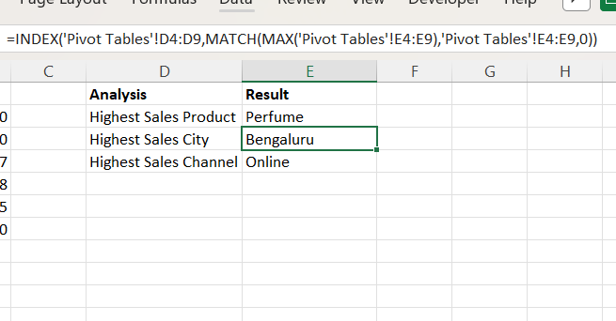
Advanced_Excel_Business_Insights
Show the advanced formula and the resulting business insight, including the Top Performing Product result.
13. Final Dashboard Design
The final dashboard was arranged as a management-oriented reporting page. KPI cards were placed near the top, the five slicers were grouped together, and the main visual section contained Monthly Sales Performance, Customer Segment Performance by Age Group, Top 10 Products by Sales, City Performance, and Bottom 5 Products by Sales.
The dashboard was reviewed for readability and unnecessary duplication. Gridlines were removed from the dashboard sheet and chart positions were adjusted for a cleaner presentation.
Final Clean Dashboard
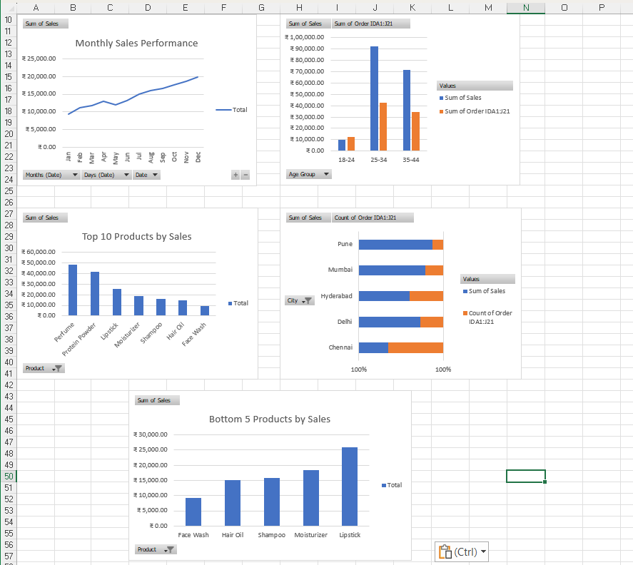
Final_Clean_Dashboard
Show the complete dashboard with title, KPI cards, slicers, and main charts with no active City filter.
14. Dashboard Interactivity Testing
The completed dashboard was tested using a slicer selection. Bengaluru was selected in the City slicer to verify that connected PivotTables and charts respond to the filter. The test demonstrates that users can explore a focused view without rebuilding the analysis.
Final Dashboard with Interactive Slicer
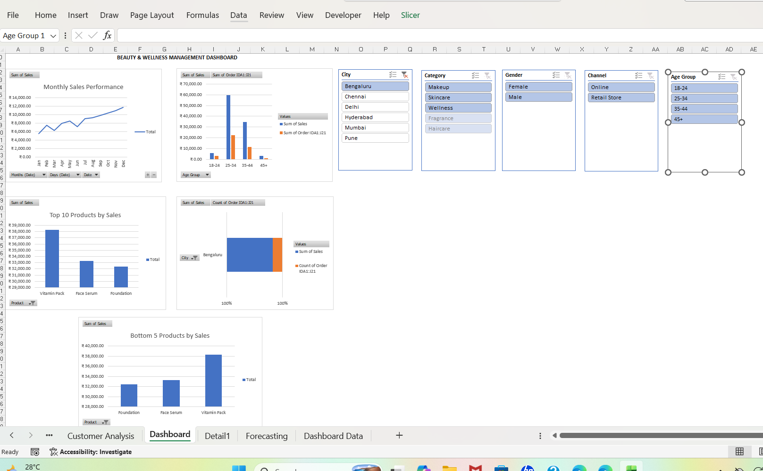
Final_Dashboard_Bengaluru_Filter
Show the final dashboard with Bengaluru selected and the KPI values and charts updated.
15. Business Insights
- Total sales in the available dataset are ₹278,030 across 120 transactions.
- Perfume has the highest sales value among the products in the available dataset.
- Age Group analysis provides a comparison of sales and transaction activity across customer segments.
- City analysis allows management to compare sales activity between locations.
- December records the highest monthly sales value in the available dataset.
- Bottom 5 Products analysis identifies products with lower sales values for further review.
- Slicers allow the same analysis to be viewed by City, Category, Gender, Channel, and Age Group.
16. Dashboard Usability Review
The dashboard was reviewed for readability, navigation, interactivity, and presentation. KPI cards provide a quick starting point, slicers allow filtering, PivotCharts provide visual comparisons, and the advanced formula provides an automatic summary insight. The dashboard is suitable for exploratory management reporting because users can change filters and immediately observe the corresponding results.
17. Limitations
- The dataset contains 120 transactions, so the dashboard represents the available sample rather than complete business history.
- Only one year of monthly information is available, limiting reliable identification of recurring seasonal patterns.
- The dataset does not include profit margin, product cost, discount amount, or marketing expenditure, so sales should not be interpreted as profit.
- Inventory availability is not included, so stock-outs and inventory turnover cannot be measured directly.
- Customer retention and repeat-purchase information is not explicitly available.
- The Excel dashboard is interactive within the workbook but is not connected to a live operational database.
18. Future Improvements
- Add multiple years of historical data for stronger seasonal analysis.
- Include cost, discount, and profit fields for profitability analysis.
- Add inventory and stock-level information.
- Add customer retention and repeat-purchase metrics.
- Add targets versus actual performance.
- Use Power Query to automate cleaning and refresh processes.
- Connect the dashboard to a live database or Power BI for automated reporting.
- Add alerts for unusually low sales, low ratings, or declining performance.
19. Conclusion
The Week 4 project successfully developed an interactive Beauty and Wellness Management Dashboard using Excel. The work combined structured data preparation, KPI calculations, PivotTables, PivotCharts, slicers, conditional formatting, and advanced Excel functions. The dashboard provides a consolidated view of sales performance, customer segmentation, product performance, city performance, and monthly trends.
The interactive slicers allow users to filter the analysis according to business dimensions, while the charts provide a visual summary of the filtered information. The INDEX, MATCH, and MAX combination adds an automatic insight layer by identifying the item associated with the highest sales value. The dashboard provides a practical Excel-based decision-support solution for the available dataset and a foundation for future automation using Power Query, Power BI, or a live data source.

