Assessing North Carolina’s Aging Population and Affordable Housing Crisis

Ramya Subramanian

2025-11-02

knitr::opts_chunk$set(echo = TRUE)

Affordable housing is minimal in many parts of North Carolina. Specifically, the elderly population are increasingly at risk of displacement due to being on fixed incomes. I will be examining where our aging population who are owners and renters of homes are found across North Carolina and its relationship to median monthly housing costs in 2023.

Source: <https://nciom.org/aging-with-dignity-in-north-carolina/>

### Loading Libraries

library(ggplot2)  
library(tidycensus)  
library(tmap)  
library(tmaptools)  
library(dplyr)   
library(sf)   
library(RColorBrewer)  
library(classInt)   
library(tidyverse)   
library(cartography)   
library(SpatialPosition)  
library(maptiles)   
library(terra)  
library(potential)

### Access API Code and Load Census Data

#census_api_key("f3d78e8619bc671c28d7a271bf415a2377086d51", install = TRUE)  
# Using 2023 census data from American Community Survey 5 Year Data  
v2023 <- load_variables(2023, "acs5", cache = FALSE)  
# North Carolina's Median Monthly Housing Costs and Age 65-74 Owners and Renters  
variables <- c(  
 MedianHouse = "B25105_001",  
 NCOwner65 = "B25007_009",  
 NCRenter65 = "B25007_019"  
)  
  
NCarolina <- get_acs(state = "NC", geography = "tract", variables = variables, geometry = TRUE, cb = FALSE)

### Cleaning Data

NCarolina1 <- NCarolina # easy to make changes without downloading census data multiple times  
NCarolina1$variable <- as.factor(NCarolina1$variable) # make variables factors  
  
#Group the variables by county tract and make each variable its own column  
NCarolina1_wide <- NCarolina1 %>%  
 group_by(NAME, variable) %>%  
 summarise(  
 estimate = mean(estimate, na.rm = TRUE),  
 .groups = "drop"  
 ) %>%  
 pivot_wider(  
 names_from = variable,  
 values_from = estimate,  
 values_fn = mean, # or first, if each combo is unique  
 values_fill = 0  
 )  
# Split county tract variable to access just county name  
NCarolina1_wide <- NCarolina1_wide %>%  
 mutate(  
 County = trimws(strsplit(NAME, ";") %>% sapply(`[`, 2)) # get 2nd item  
 )  
# Grouping Tracts into County  
NCarolina_county <- NCarolina1_wide %>%  
 group_by(County) %>%  
 summarize(  
 MedianHouse = mean(MedianHouse, na.rm = TRUE),  
 NCOwner65 = sum(NCOwner65, na.rm = TRUE),  
 NCRenter65 = sum(NCRenter65, na.rm = TRUE),  
 geometry = st_union(geometry),  
 .groups = "drop"  
 ) %>%  
 st_as_sf() #make into spatial feature  
  
head(NCarolina_county)

## Simple feature collection with 6 features and 4 fields  
## Geometry type: POLYGON  
## Dimension: XY  
## Bounding box: xmin: -82.08108 ymin: 34.80671 xmax: -79.2366 ymax: 36.58814  
## Geodetic CRS: NAD83  
## # A tibble: 6 × 5  
## County MedianHouse NCOwner65 NCRenter65 geometry  
## <chr> <dbl> <dbl> <dbl> <POLYGON [°]>  
## 1 Alamance County 995. 8707 2208 ((-79.39252 35.8438, -79.38…  
## 2 Alexander County 645 2573 273 ((-81.02985 35.89012, -81.0…  
## 3 Alleghany County 741 1138 105 ((-81.15358 36.57008, -81.1…  
## 4 Anson County 795. 1401 321 ((-80.17853 35.14996, -80.1…  
## 5 Ashe County 725. 2011 340 ((-81.74193 36.41115, -81.7…  
## 6 Avery County 673. 1334 173 ((-81.97563 36.20508, -81.9…

### Visual 1: Median Monthly Housing Costs by County in North Carolina

tm_shape(NCarolina_county) +  
 tm_polygons(  
 col = "MedianHouse",  
 palette = "-RdYlGn",  
 style = "quantile",  
 border.col = NA,  
 title = "Median Housing Costs ($)"  
 ) +  
 tm_layout(  
 legend.outside = TRUE,  
 legend.outside.position = "right",  
 main.title = "North Carolina Median Housing Costs Per County in 2023",  
 main.title.size = 1.2,  
 main.title.fontface = "bold"  
 ) +  
 tm_compass(position = c("left", "top"), size = 1.5) +  
 tm_scale_bar(position = c("left", "bottom"))

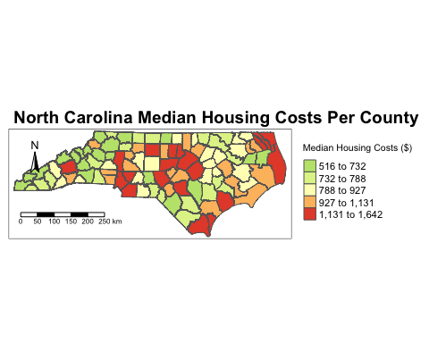

From this visualization, we can see the median housing costs are generally higher on mid-east counties of the state.

### Visual 2: Median Housing Costs with 65-74 Homeowner Distribution

# Centroid for the proportional symbol  
NCarolina_centroids <- st_centroid(NCarolina_county)

## Warning: st_centroid assumes attributes are constant over geometries

tm_shape(NCarolina_county) + #Mean Housing Chloropleth  
 tm_polygons(  
 col = "MedianHouse",  
 palette = "-RdYlGn",  
 style = "quantile",  
 border.col = NA,  
 title = "Median Housing Costs ($)"  
 ) +  
 tm_shape(NCarolina_centroids) + #Proportional Symbol  
 tm_symbols(  
 size = "NCOwner65",   
 col = "black",   
 alpha = 0.6,  
 scale = 1.5,  
 border.col = "white",  
 legend.size.show = TRUE,  
 title.size = "# of Home Owners Aged 65-74"  
 ) +  
 tm_layout(  
 main.title = "North Carolina Elderly Adult Homeownership \n& Housing Costs in 2023",  
 main.title.position = c("center", "top"),  
 main.title.size = 1.2,  
 main.title.fontface = "bold",  
 outer.margins = c(0.1, 0.02, 0.02, 0.02),  
 legend.text.size = 0.61,  
 legend.outside = TRUE,  
 legend.outside.position = "left"  
 ) +  
 tm_compass(position = c("left", "top"), size = 1.5) +  
 tm_scale_bar(position = c("left", "bottom"))

## Legend labels were too wide. Therefore, legend.text.size has been set to 0.46. Increase legend.width (argument of tm_layout) to make the legend wider and therefore the labels larger.

## The legend is too narrow to place all symbol sizes.

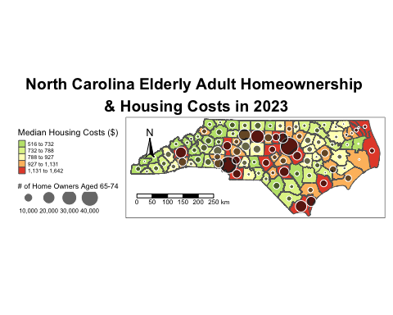

In the center of the state, the counties that are red with high median housing costs and high number of older home owners may face a higher risk of housing crisis. The west side of the state seems to have both less housing costs and elderly home owners.

### Visual 3: Ratio of Owners verus Renters Aged 65-74

# Create a logical flag for top 25% renter tracts  
NCarolina_county <- NCarolina_county %>%  
 mutate(  
 OwnerRenterRatio = NCOwner65 / NCRenter65  
 )  
  
tm_shape(NCarolina_county) +  
 tm_polygons(  
 col = "OwnerRenterRatio",  
 palette = "RdBu", # Red = more renters, Blue = more owners  
 style = "quantile", # Try "pretty" or "jenks" if it looks off  
 border.col = NA,  
 title = "Owner-to-Renter Ratio"  
 ) +  
 tm_layout(  
 main.title = "North Carolina Ratio of Owners to Renters \nAged 65-74 by County in 2023",  
 main.title.position = c("center", "top"),  
 main.title.size = 1.2,  
 main.title.fontface = "bold",  
 outer.margins = c(0.1, 0.02, 0.02, 0.02),  
 legend.outside = TRUE,  
 legend.outside.position = "right"  
 ) +  
 tm_compass(position = c("left", "top"), size = 1.5) +  
 tm_scale_bar(position = c("left", "bottom"))

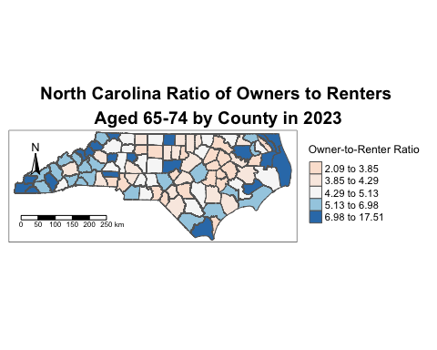

It seems there are more elderly owners than renters in the areas on the edges of the states while the center is more renter heavier. Interestingly, the center of the state is where we saw the higher housing costs. This may explain why we find more elderly renters and more struggling elderly owners in these counties.

### Assignment Questions

**1. Discuss the advantages and challenges associated with an open data science approach. Provide an example based on this week’s reading. (1-2 paragraphs)**

An advantage of the open data science approach is the increase in innovation and efficiency when data sets are able to be reused for new projects by new people. Kitchin (2013) discusses how useful big data has become in supplying detailed and low-cost data that can help promote the value of geography to a wider audience like Obama’s team collecting voter data before the election. With all this new data accessible, having an open data science approach can make big data even more powerful. This also helps data creators to reach broader audiences when data is openly shared as their information is more accessible. A challenge with the open data science approach is data quality issues. Kitchin (2013) explains how big data can make it difficult to extract useful and valid information from the data deluge of vast information. When there is so much data, it can be hard to discern what data is actually useful which is common in open data science approaches that leave you with too much information.

**2. Create a markdown document that showcases an analysis of this week’s data or any other dataset of your choice. Include descriptive text that explains your analysis, and incorporate figures and geovisualizations.Include 1 chart and 1 map. Structure and explain your analysis with text, headings, highlights, images and other markdown basics.**

For my maps, I chose to answer the research question: how do the mean housing costs and the aging population of home owners and renters in North Carolina inform us of the rising affordable housing crisis. I created a chloropleth map visualizing the mean housing costs in all the counties of North Carolina to get an understanding of which areas have higher housing costs. For the next map, I chose to create a proportional symbol map layered on top of the chloropleth map I previously made to showcase the number of aged 65-74 homeowners for each state in comparison to the mean housing cost level of that county. The specific steps I took to mitigate bias is I chose to classify the data by quantiles to ensure the data was represented as accurately as possible while differentiating between classes. The final map I created is a ratio of owners to renters aged 65-74 to visually understand what type of elderly population is more prevalent when concerned with hosuing costs in North Carolina counties. As a chloropleth map, this can be useful to easily point out the counties with more owners compared to renters to better inform the other maps about where housing costs being high is more of a problem. I minimized bias by calculating a ratio versus simply showing owners versus renters to normalize the data.